Title | Baseline D2D Capture and Print Images | Test Case Execution Engineer
Test Case Creation Engineer | N/A | Test Platform Used
Date Test Case Created | 12/30/2010 | Release Version on Testbed
CI | D2D | Logged in User’s Role
Site Specific | N/A | Start Date / Time
TC Updated for Version | AWIPS II | Completion Date/Time
Last Modified By | William Smith 01/31/2012 | Total Test Time
Executable Steps | 17 (unique) + 00 (repeats) = 17 | Pass/Fail/Pending

Test Case: | Baseline D2D Capture and Print Images
Test Case Description: | This test case demonstrates functionality of D2D to capture images of the D2D application and save them to PNG files and for D2D to print the images in the main pane to an AWIPS printer.
Requirements: | N/A
Data Input: | N/A
Prerequisite Conditions: | None

Table 1.1-1. Test Steps and Expected Results
Step # | Actions / Inputs | Expected Results | P/F | Comments
 | Left click on the desk top and select Start CAVE from the list.  Select the D2D perspective. | CAVE opens and the D2D system launches.
 | From the Scale pull-down menu (left side of toolbar), select CONUS. | Main pane map scale changes to selected scale.
 | Open the Window Capture GUI:  File > Capture Window | Window Capture GUI opens.
 | Enter a filename (e.g. TestImage01) in the “Name” field. | Filename is entered.
 | Select “File System” from the “Save in folder” pull down menu. | “File System” is selected.
 | Click on “Browse for other folders” and select the /tmp directory. | The /tmp directory is selected as the file destination.
 | Select the .png filetype from the menu in the lower right of the GUI. | .png is selected.
 | Click on OK | The GUI closes and the image is saved.
 | Click on the main KDE menu and click on the Home icon (towards the bottom). | Konqueror window opens displaying the contents of the current user’s home directory.
 | In the location bar, delete what is listed and type: /tmp | The contents of /tmp are displayed.
 | Scroll down and observe the Testimage01.png file that was saved. You may double click them to display full size. | TestImage01.PNG is displayed.
 | Close Konqueror: Location > Quit | Konqueror closes.
 | In D2D load 2 products: NCEP/Hydro > HPC > Temps and Weather > MSL Pressure Analysis and Surface Front Analysis | Products are displayed in the main pane.
 | Open the D2D Print GUI:  File > Print | The Print GUI opens.
 | Make the following choices:  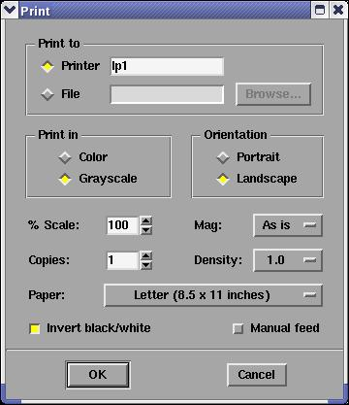 | Print GUI accepts those changes with no errors.
 | Click OK with MB1. | Print job is sent to printer. The printing process will take at least thirty seconds. Paper has an image of the CONUS map background as well as the MSL Pressure Analysis and the Surface Front Analysis printed on it.
 | Close all windows and log out. | All windows close.
The test case is completed.

Table 1.1-2. Requirements Verification Traceability Matrix (RVTM)
Number | Description | Test Step (s)
1 | N/A

