Title | B_GFE_Color_Table | Test Case Execution Engineer | <Test Case Execution Engineer Name>
Test Case Creation Engineer | Vada Dreisbach | Test Platform Used | <Name of Testbed Platform>
Date Test Case Created | 11/6/2009 | Release Version on Testbed | <Release Verison>
CI | GFE | Logged in User’s Role | (user / root / oper / fxa . . .)
Site Specific | N/A | Start Date / Time | <mm/dd/yyyy hh:mm>
TC Updated for Version | AWIPS II | Completion Date/Time | <mm/dd/yyyy hh:mm>
Last Modified By | Vada Dreisbach | Total Test Time | Nn min
Executable Steps | 6 (unique) + 192 (repeats) = 198 | Pass/Fail/Pending | <Results of Test Case execution>

Test Case: | B_GFE_Color_Table
Test Case Description: | This test case ensures that the GFE Hazards ColorTable is correct from release to release.
Requirements: | Each GFE hazard is assigned a specific color. The color for each hazard must remain constant from release to release even if hazards are added, removed or changed.
Data Input: | N/A
Prerequisite Conditions: | N/A

Table 1.1-1. Test Steps and Expected Results
Step # | Actions / Inputs | Expected Results | P/F | Comments
 | Open GFE and select a Hazard grid or create one then select it if none exists.  To create a Hazard grid select an empty hazard grid location in the Grid Manager. Right click and select Create From Scratch from the pop–up menu. An empty Hazard grid is created.  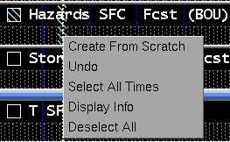 | A hazard grid is selected.
 | Right click on the Spatial Editor Hazards legend and select Edit Colors…. | The Color Table Editor window showing the Hazards (w/w/a) color table is displayed.
 | Examine the hazard labels and color values and compare it to the hazard labels and color values from the previous release shown in Figure A. Make sure the same color values are assigned to the same hazards as in the previous release.  To do this, step through each hazard by clicking the double arrows circled in red in the image below:  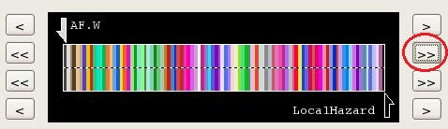  Begin with the first hazard on the left which is labeled None. Note the hazard label.  Note: The example shows the second hazard for better illustration.  Note: In some cases a DR may be used to add or remove hazards. Adjust to account for any changes made in the release. | The current hazard label is noted.
 | Click on the color below the hazard label and above the dashed line as shown below:  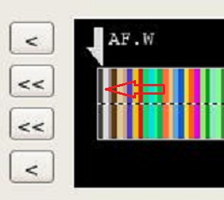  When the color under the hazard label is clicked, the color values will be shown in the Upper Color section of the GFE/Hazards dialog as shown below:  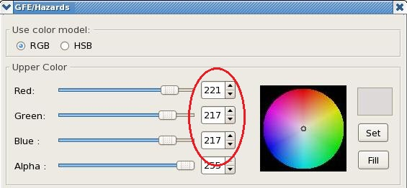  Note the color values for the selected hazard.  Note: If the color is clicked below the dashed line, the value will be shown in the Lower Color section. | The color value for the selected hazard is noted.
Compare the hazard labels and color values and compare it to the hazard labels and color values shown in Figure A. Make sure the same color values are assigned to the same hazards as in the previous release.

If there are new hazards in the release, make sure the color table has not “shifted” so that other colors are now miss-assigned.

Repeat steps 3 and 4 for each hazard.

(Adds 192 steps.)
 | Close all windows and log out. | All windows close.
The test case is completed.

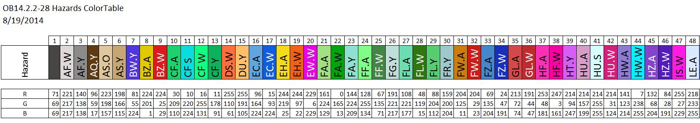

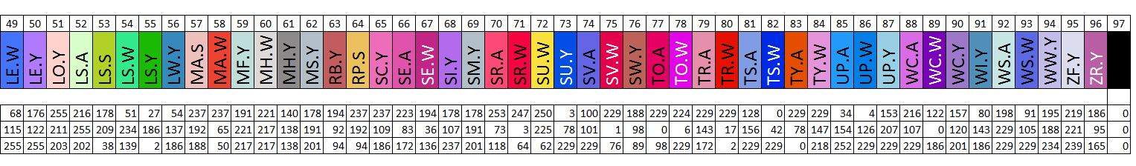
Figure A – Annotated AWIPS II GFE OB14.2.1 - OB14.2.2-28 Hazards ColorTable (8/19/14)

