Title | ESPADP | Test Case Execution Engineer
Test Case Creation Engineer | Carolina Fayos | Test Platform Used
Date Test Case Created | 11/21/2006 | Release Version on Testbed
CI | RF | Logged in User’s Role
Site Specific | RFC | Start Date / Time
TC Updated for Version | AWIPS2 | Completion Date/Time
Last Modified By | Shen Zhao (03/15/2012) | Total Test Time
Executable Steps | 31 (unique) + 6 (repeats) = 37 | Pass/Fail/Pending

Test Case: | B_RFC_ESPADP
Test Case Description: | This test case will test the functionality of both the ESPADP program and the Batch Builder that coincides with it.
Requirements: | N/A
Data Input: | N/A
Prerequisite Conditions: | N/A

Table 1.1-1. Test Steps and Expected Results
Step # | Actions / Inputs | Expected Results | P/F | Comments
 | Open terminal and execute the following commands:  - xhost +  - sudo su – oper <password> | Oper user is logged in.
 | Set the environment by typing:  - export db_name=hd_hd_ob92rha  - export PGUSER=awips  - export PGHOST=dx1-<testbed with an AWIPS2 database>  - export XAPPLRESDIR=/awips/hydroapps/lx/rfc/app-defaults  - unset XUSERFILESEARCHPATH | Environment variables have been set.
 | Type in the following:  - go ens_rls  - espadp –nomap | ESPADP will start. The main ESPADP window will pop up.
 | Search the ESPTrace Manager list under  *FFH  *CANNYDEL  *CANNYDEL.CANNYDEL.QINE.06 | The Display window will open up.
 | Select Display -> Set Low Flow/Stage in the Display menu. | A Set Low Flow Value window will pop up allowing for the low flow/stage value and text to be entered.
 | Input a value of 1500 and text of “Low Flow Test”. Click on the Show Low Flow/Stage button. | The Display window should look like Figure 1.
 | Click on Cancel. | The window will close.
 | Select PlotType -> Exceedance Probability Plot. | The Display window will change and look like Figure 2.
 | Select Display -> Hide Low Flow/Stage. | The coloring and low flow level will be removed from the plot.
 | Select File -> Close. | The Display window will close.
 | Repeat steps 4-9, but select EMYSW.EMYSW.SSTG.06 from the ESPTrace Manager window, and set the low flow/stage value to be 9.5 in the Set Low Flow/Stage window. | The Display window will look like Figure 3 after step 6 and Figure 4 after step 8. |  | Repeat 6 steps
 | Select Display -> Show Flood Level. | Three flood levels will be displayed on the plot.
 | Select PlotType -> Flood Exceedance Probabilities. Set Manual Settings (ascending) 9.5, 10.5 in the Flood Levels Frame, and select Apply. | The Display window will change to look like Figure 5.
 | Select File -> Exit in the ESPADP main window. | The program will shut down.
ESPADP Batch Builder Test
 | Type in the following:  - go ens_scripts  - bbuilder | The ESPADP Batch Builder will start. The ESPADP Batch Builder main window will open up.
 | Click on the Data Type tab and select items on the left-hand side of the window as shown in Figure 6. Click on the Insert button. | The ESPADP Batch Builder window and Command List (on the right) will look like that in Figure 6.
 | Click on the Misc(1) tab and select items on the left-hand side of the window as shown in Figure 7. Click on the Insert button. | The ESPADP Batch Builder window and Command List (on the right) will look like that in Figure 7.
 | Click on the Misc(2) tab and select items on the left-hand side of the window as shown in Figure 8. Click on the Insert button. | The ESPADP Batch Builder window and Command List (on the right) will look like that in Figure 8.
 | Click on the ESPTS Files tab and select items on the left-hand side of the window as shown in Figure 9. Click on the Insert button. | The ESPADP Batch Builder window and Command List (on the right) will look like that in Figure 9.
 | Click on the Action tab and select items on the left-hand side of the window as shown in Figure 10. Click on the Insert button. | The ESPADP Batch Builder window and Command List (on the right) will look like that in Figure 10.
 | Select line 17 from the Command List and select Commands -> Comment Out Command. | Line 17 will have a ‘#’ inserted as the first character.
 | From the plot type choice box that is currently displaying “traces”, select the plot type “excprob” and click Append. | The ESPADP Batch Builder window and Command List (on the right) will look like that in Figure 11.
 | Save the batch file by selecting File  -> Save As and choosing a file name, then click Open to save the file. | The chosen file name will be displayed above the Command List on the right.
 | Click Run. | A window will pop up to confirm the run.
 | Click OK in the confirmation window. | ESPADP will execute the batch file with commands as specified in the Command List. A Batch Output Viewer window will open up after execution, displaying two file names.
 | Select both files listed in the Batch Output Viewer by clicking on them and using the <shift> key. Click View. | Both images will popup in separate windows. The title of each window will be the name of the file being displayed. The first window should be the same as that in Figure 12 and the second as that in Figure 13.
 | Click Close in the Batch Output Viewer. | The window will close.
 | Select File -> Exit in the ESPADP Batch Builder main window. | The program will shut down. Test case is concluded
 | Review the terminal window for any errors or other abnormalities before closing the terminal. | Verify there are no errors or other abnormalities.
 | Select File -> Exit in the terminal window. | This closes the terminal window.
 | Log out and exit user access. | User exits from user access without incident.
The test case is completed.

Figure 1:

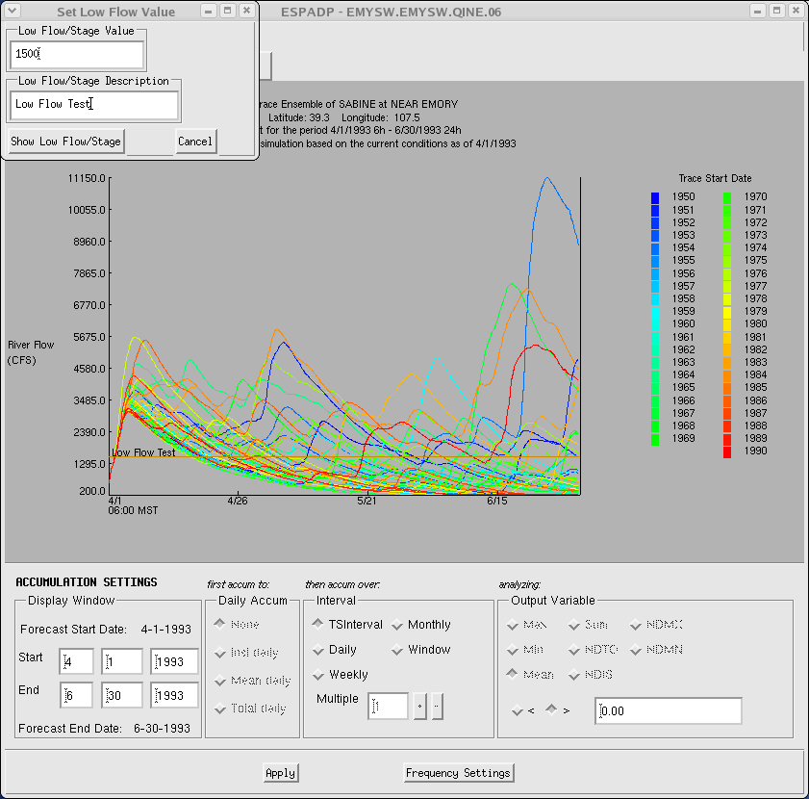

Figure 2

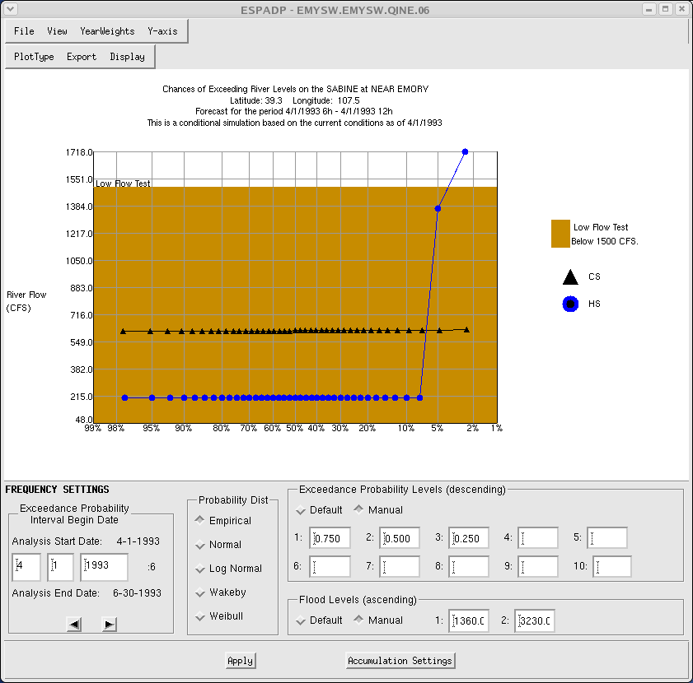

Figure 3

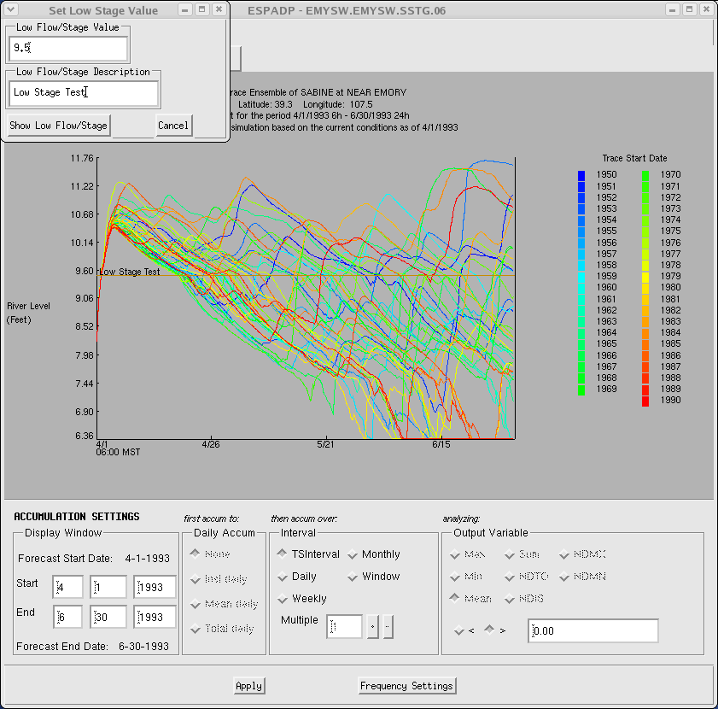

Figure 4

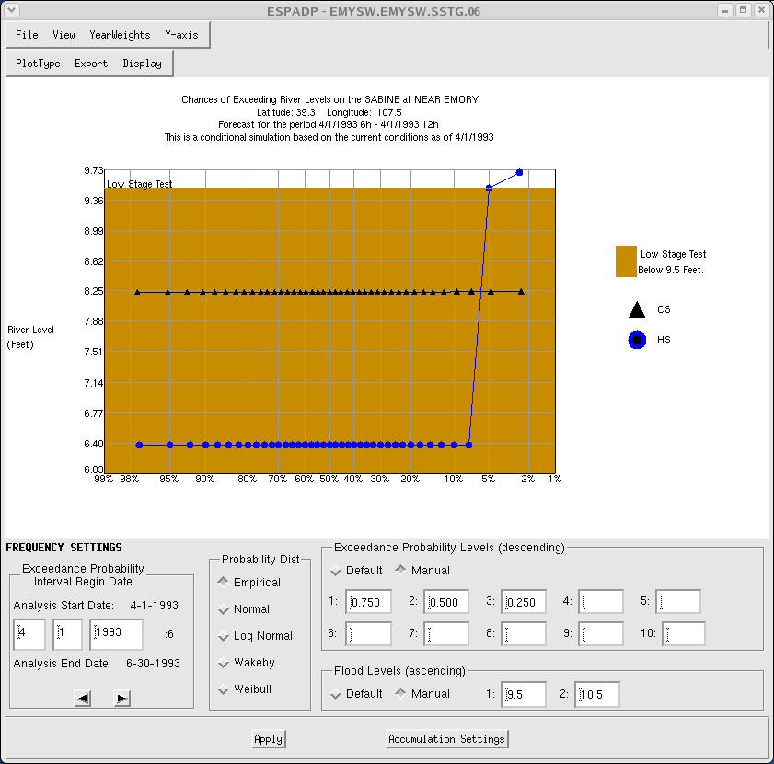

Figure 5

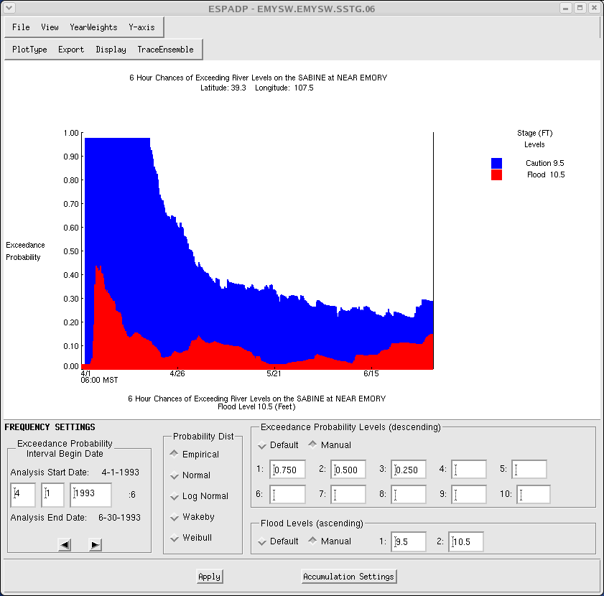

Figure 6

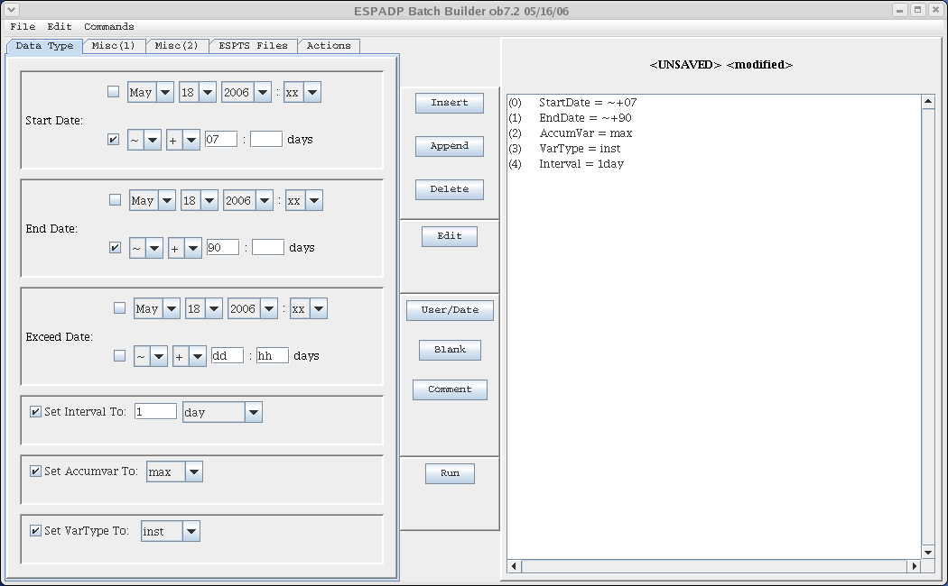

Figure 7

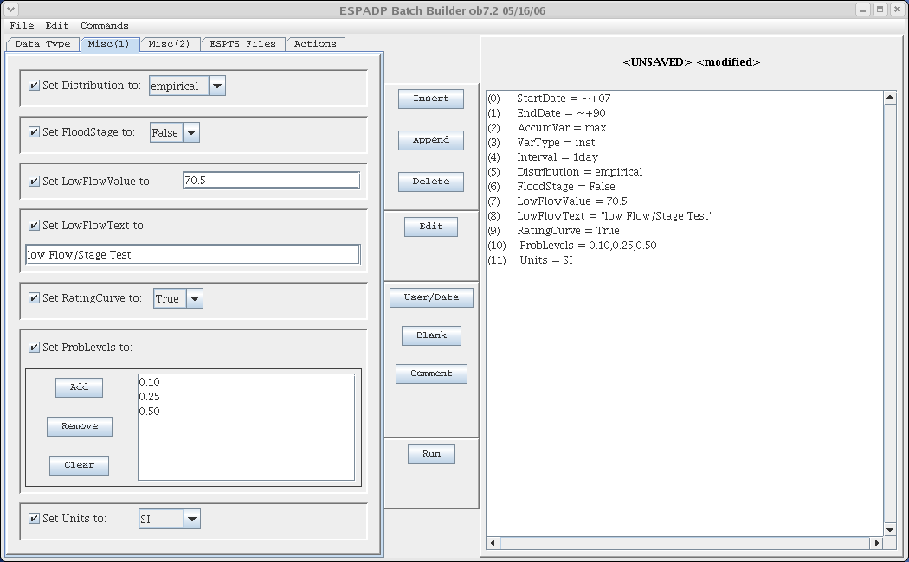

Figure 8

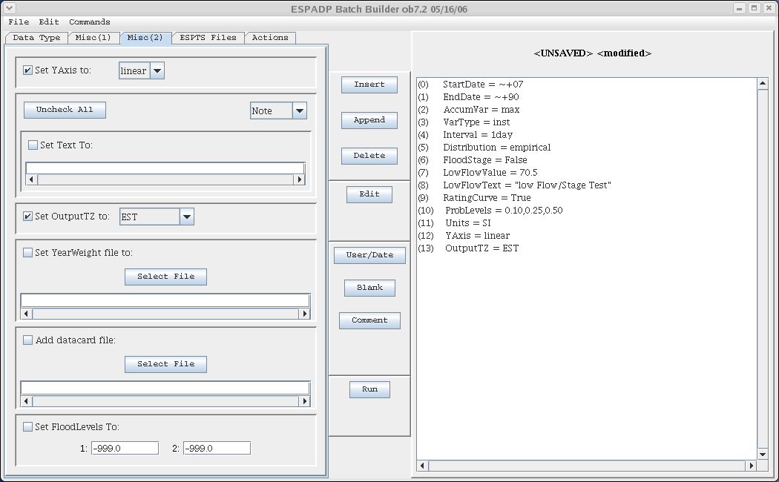

Figure 9

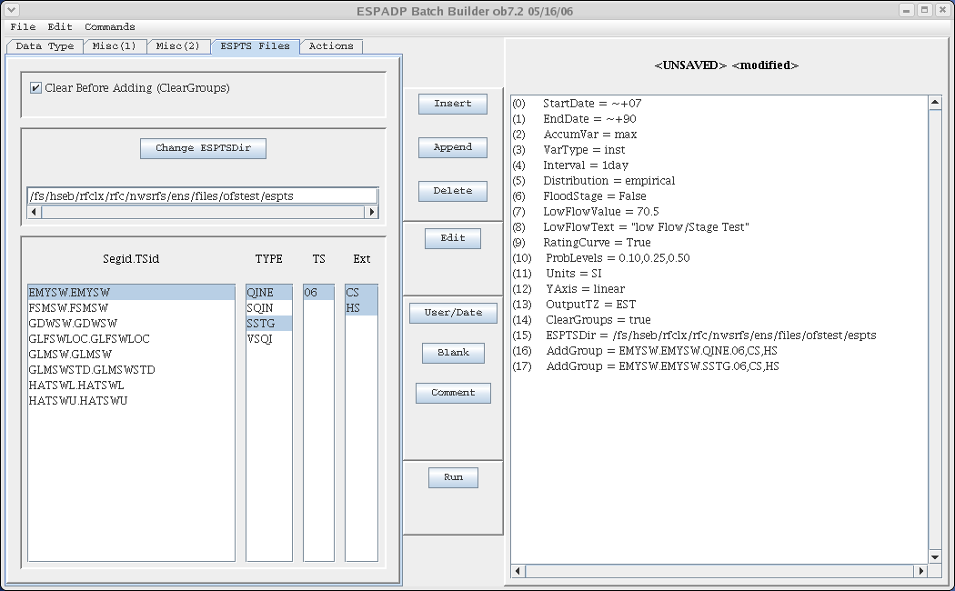

Figure 10

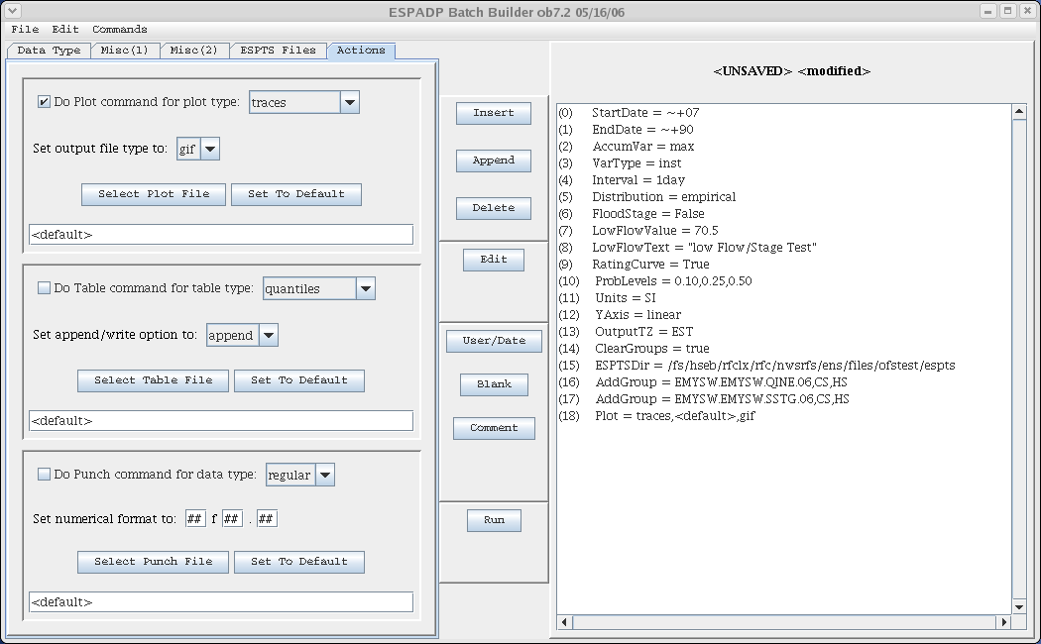

Figure 11

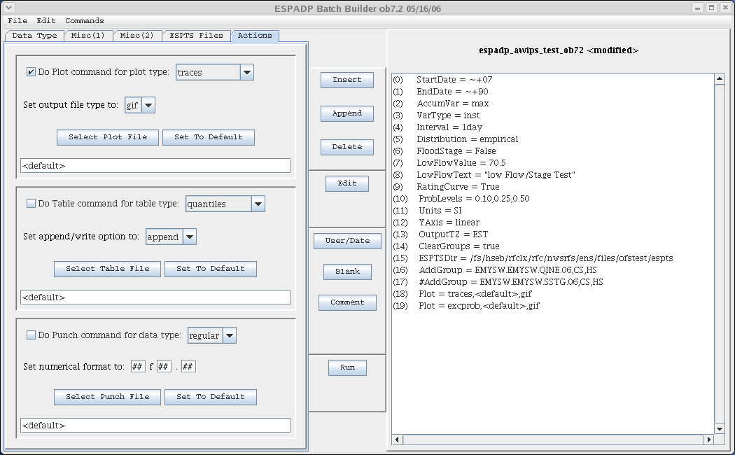

Figure 12

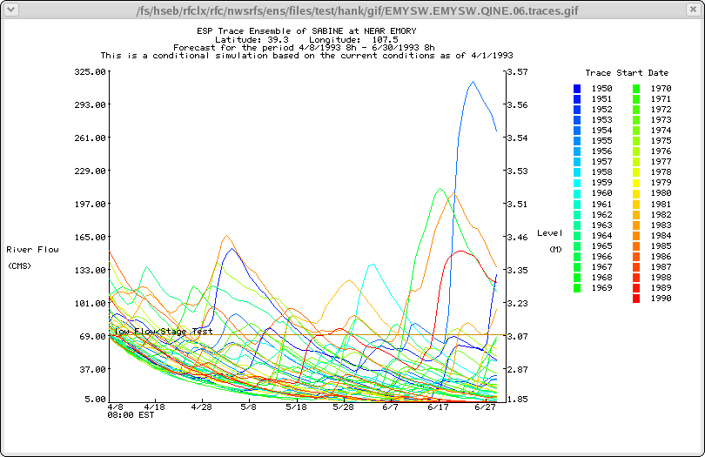

Figure 13

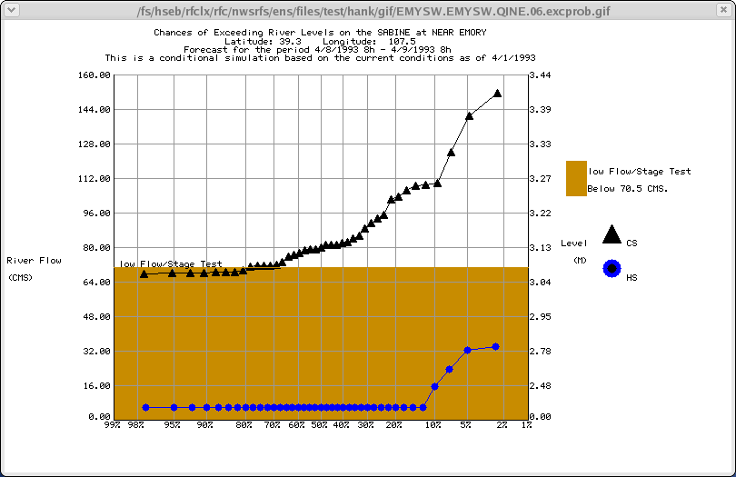

Table 1.1-2. Requirements Verification Traceability Matrix (RVTM)
Number | Description | Test Step (s)
1

