Title | Interactive Calibration Program (ICP) Replacement | Test Case Execution Engineer
Test Case Creation Engineer | Shen Zhao | Test Platform Used
Date Test Case Created | 10/22/2007 | Release Version on Testbed
CI | RF | Logged in User’s Role
Site Specific | RFC | Start Date / Time
TC Updated for Version | AWIPS2 | Completion Date/Time
Last Modified By | Shen Zhao (03/19/2012) | Total Test Time
Executable Steps | 174 (unique) + 0 (repeats) = 174 | Pass/Fail/Pending

Test Case: | B_RFC_ICP
Test Case Description: | This test case demonstrates the re-implementation and modernization of the NWSRFS Interactive Calibration Program (ICP) in order to facilitate future maintenance and enhancements to the program.
Requirements: | AWIPS-DCS-3481
Data Input: | It will be provided by the OHD Developer as a tar_gzipped file.
Prerequisite Conditions: | - The test case assumes that ICP has been installed. The graphics shown in the following test steps may vary slightly based on window manager preferences and changes made during development that have not been reflected in an updated test plan.  - Refer to the ICP User Manual documentation (http://www.nws.noaa.gov/oh/hrl/general/indexdoc.htm) for an explanation of the behavior of software features. It is expected that the person executing the test plan is familiar with basic ICP features.  - The test package located under the directory /awips/hydroapps/test_data/DCS_3481. To extract the test package:  tar –zxvf icp_testpackage.ob83.yyyymmdd.tar.gz

Table 1.1-1. Test Steps and Expected Results
Step # | Actions / Inputs | Expected Results | P/F | Comments
Part 1. ICP Main Window
 | Open a terminal, type:  - sudo su - oper  then enter <password> | User oper is logged in.
 | Set the environment by typing:  - export calb_gzio_write=off  - export calb_gzio_read=off | Environment variables are now set.
 | Launch Window:  Go to the test_scripts directory /awips/hydroapps/test_data/DCS_3481/icptest/test_scripts/. Launch the ICP by typing “run_icpnew_testdata rls” (the argument is “rls”). | The ICP Main Window appears. Verify the following in the dialog that appears: (1) The only button enabled on the toolbar should be the Open Deck button. (2) Hover over the Open Deck button on the toolbar – the tooltip should read “Select a control deck”. (3) Title bar shows the text “ICP”. (4) Verify status bar: Shows “Select a control deck”.
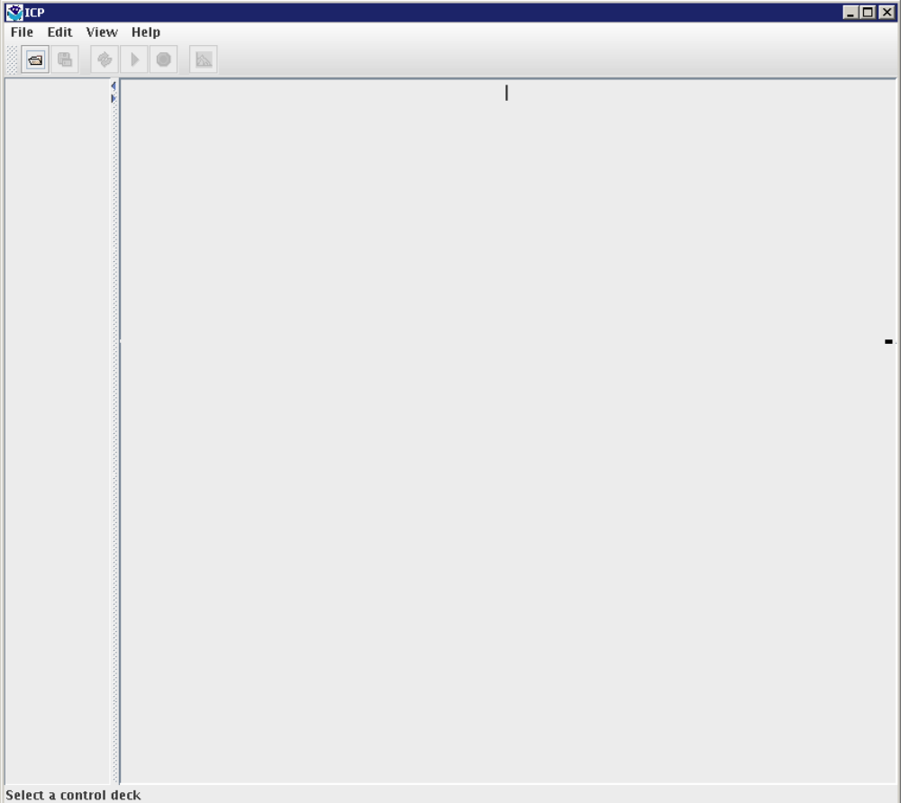
 | Verify File Menu:  Select the File menu item. | Verify that there are menu items enabled under the File menu as shown in the figure below.  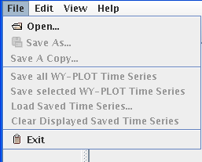
 | Verify Edit Menu:  Select the Edit menu item. | Verify that there are five menu items and that all are disabled: Control Deck, SAC-SMA…,  SNOW-17…, UNIT-HG, WY-PLOT Scale…  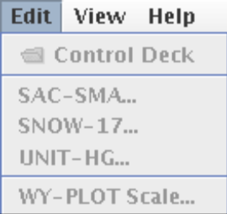
 | Verify View Menu:  Select the View menu item. | Verify that the following menus are available: “Output Listing…” (disabled), “PLOT-TS…” (disabled), “Include Graphs in MCP3 Output File”.  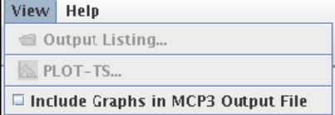
 | Launch the Help -> About dialog:  Select the menu item Help -> About ICP. | The Help About dialog is displayed (see screenshot below, although version will be for the current software).  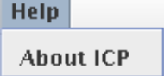  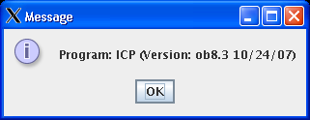
 | Click on OK button. | The Message dialog is dismissed.
 | Verify Window Closes using File -> Exit  Click on menu item File -> Exit. | The ICP main window closes.
 | Verify Main Closes with X button:  Change to the test_scripts directory (if not already there). Launch the ICP by typing “run_icpnew_testdata rls”. | The ICP main window appears.
 | Click on the X button in the upper right hand corner of the frame. | Verify that the ICP Main Window closes.
Part 2. Open Deck Dialog
 | Launch Open Deck Dialog:  Change to the test_scripts directory. Type “run_icpnew_testdata rls” at the command line. Open deck by selecting File -> Open… | Verify Open Deck Dialog appears as shown below.  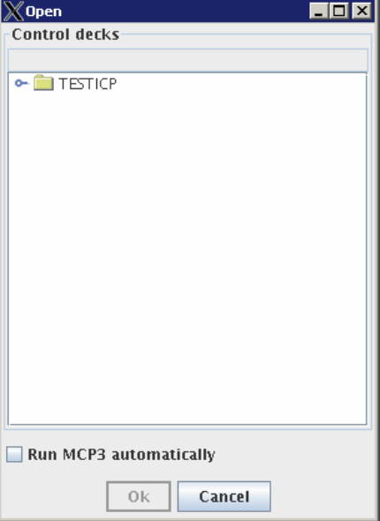
 | Expand Region:  Click on the node named TESTICP. Resize the window to see the full selection (the location will vary by user). | Region node expands to show children – PETE. 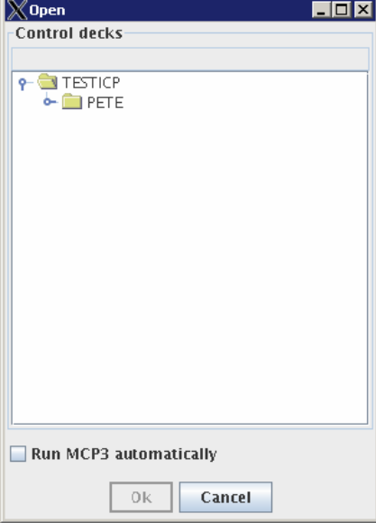
 | Expand Basin:  Click on the node labeled “PETE” (this is a basin) – either double-click on the word “PETE” or click on the key symbol to the left of the folder. | Basin node expands to show children.  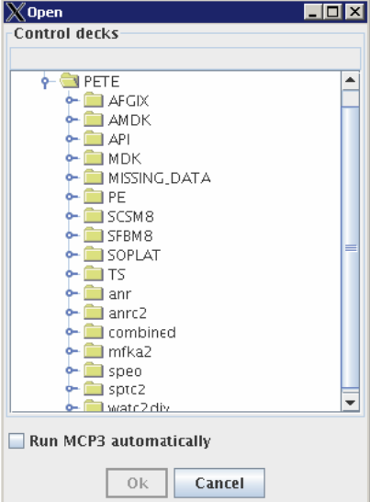
 | Expand Watershed:  Click on the node labeled “AMDK” (this is a watershed) – double click on the word “AMDK” or single click on the key symbol to the left of the folder. | Watershed node expands.  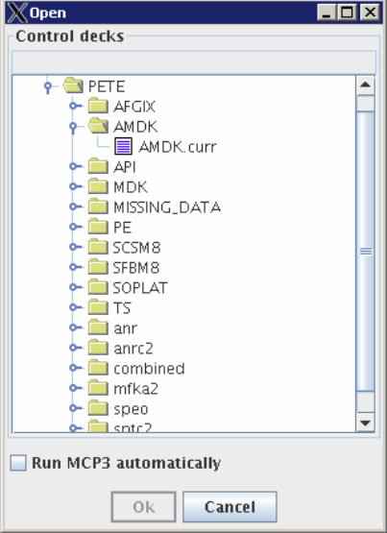
 | Verify that double-clicking on Region/Basin/Watershed collapses the children below that node:  Expand the node Basin node “PETE” (TESTICP->PETE) if it’s not already expanded. Double-click the PETE node (word) or single click symbol to left of folder. | Verify that the all children underneath the PETE node collapse.
 | Verify that double-clicking on Region/Basin/Watershed expands the children below that node:  Double-click on the PETE node (word) or single click symbol to left of folder. | Verify that the PETE node expands to show its children (same as it was before the node was collapsed.).
 | Verify Cancel button does not save selection upon cancel:  Expand the nodes TESTICP -> PETE -> MDK and select the deck MDK.curr then click the Cancel button. | Verify that the Open dialog dismisses, and no deck has been selected by the following: (1) The title bar shows only ICP. (2) The status bar still shows the text “Select a control deck”.
 | Verify Deck Selection (Double-clicking on deck):  Re-open the Deck Dialog by selecting the Open Deck toolbar button. Expand the nodes TESTICP -> PETE -> AFGIX. Select the deck AFGIX.curr. Double-click on the deck. | Verify that the Open Deck dialog is dismissed. MCP3 should automatically run and display WY-PLOT results. The title bar now shows the name of the selected deck: ICP: AFGIX.curr. The status bar now shows the text “MCP3 Stop Number: 4”.
 | Verify Deck Selection (OK Button):  Re-open Deck Dialog by clicking on the Open Deck toolbar button. Expand the nodes TESTICP -> PETE -> API. Select the deck API.curr. Then click the OK button. | The Open Deck Dialog is dismissed. MCP3 will automatically run and display the WY-PLOT. The title bar now shows the name of the selected deck: API.curr. The status bar now shows the text “MCP3 Stop Number: 4”. Verify that the “Save deck as” (disc symbol), “Reload deck” (circular arrows), and “Run MCP3” (arrow symbol) buttons on the ICP Main Window toolbar are now enabled.  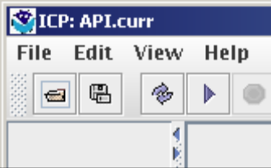
 | Execute MCP and Verify the Run Automatically Checkbox (Double-clicking):  Re-open Deck Dialog by clicking the Open Deck (“Select a control deck”) button on the toolbar. Check the checkbox “Run MCP3 Automatically”. Expand the nodes TESTICP -> PETE -> AMDK. Select the deck AMDK.curr. Double-click the selected deck. | The Open Deck Dialog disappears. The status bar shows the text “Running MCP3….” while MCP is executing. After MCP has executed the status bar displays the text “MCP3 Stop Number: 4” to indicate that the MCP execution was successful. The title bar also changes to show “ICP: AMDK.curr”. Verify that no exceptions have occurred by looking at the text that is output to the terminal window. Operations will be displayed in the left side of the main window.
 | When the plot appears, deselect the Log Scale in the lower left. | Initial water year plot data will be displayed at the bottom of the main window with the legend in the lower left corner.
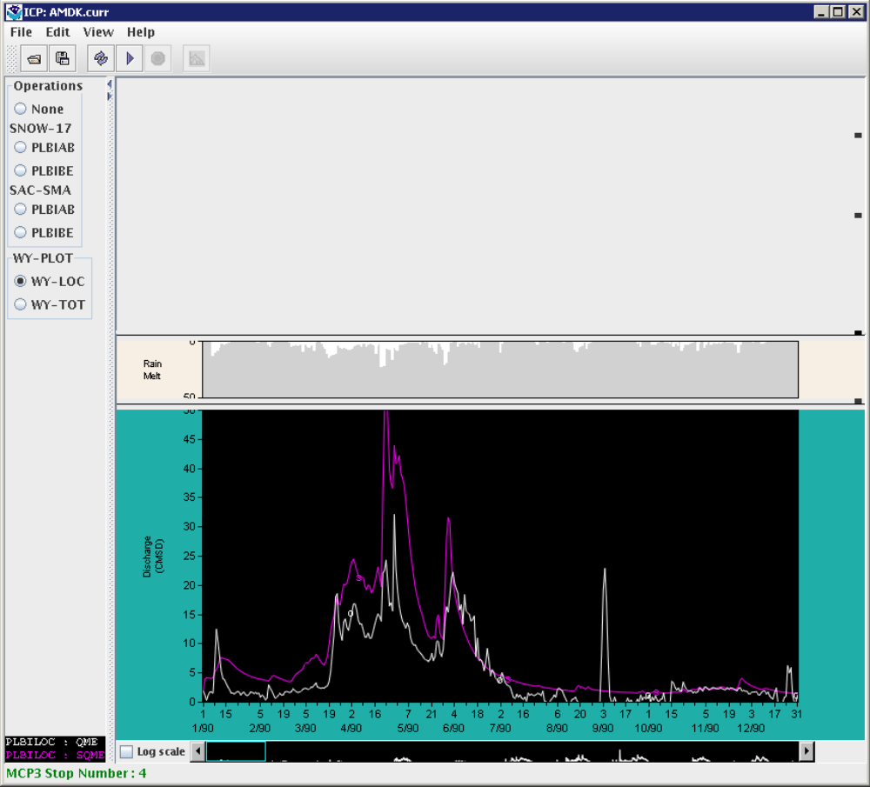
 | Verify Run MCP3 Automatically checkbox is still enabled:  Re-open the Deck Dialog by clicking on the Open Deck toolbar button. | Verify that the “Run MCP3 Automatically” checkbox is still checked.
 | Execute MCP and Verify the Run Automatically Checkbox (OK Button):  Select the deck API.curr (TESTICP -> PETE -> API -> API.curr). Click the OK button. | The Open Deck Dialog disappears. The status bar displays the text “Running MCP3…” while MCP is executing. After MCP has executed the status bar displays the text “MCP3 Stop Number: 4” to indicate that the MCP execution was successful. The title bar shows “ICP: API.curr”. The main window is updated to display a new water year plot and list of operations. Verify that no exceptions have occurred by looking at the text that is output to the command prompt.
 | Execute MCP3 via the Run button in the toolbar:  Open the Open Deck Dialog by clicking on the toolbar button. Select the deck AFGIX.curr (TESTICP -> PETE -> AFGIX  -> AFGIX.curr). Check the “Run MCP3 Automatically” checkbox (verify). Click OK. | While MCP is executing the status bar displays the text “Running MCP3…” The status bar displays the text “MCP3 Stop Number: 4” to indicate that the MCP execution was successful.
 | After the Open Deck Dialog is dismissed, on the ICP Main Window toolbar click the Run button (forward arrow button). | A run will automatically occur when the deck is opened.
 | Execute MCP on a Deck that Returns a non-4 Stop Code:  Open the Deck Dialog by clicking on the toolbar button. Select the deck TESTICP -> PETE -> AFGIX -> AFGIX.err1  Check the Run MCP3 Automatically checkbox. Click OK. | The Open Deck Dialog is dismissed. An Error Dialog appears displaying that the stop number was > 4. An Error Dialog appears displaying that the stop number was > 4. See screenshot below:
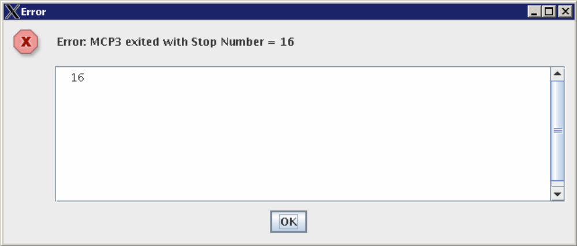
 | Dismiss Stop Number Error Dialog:  Click OK on the Error dialog. | The Error Dialog disappears. Prior to OK, the status bar shows the text “MCP3 Stop Number: 16”. It subsequently says  “No WY-PLOT operation defined for this deck.”
 | Close ICP Main Window:  Click File -> Exit on the ICP Main Window menu bar. | The ICP Main Window closes.
Part 3. Control Deck Editor – NOTE: the “icp_editor” environment variable should NOT be set. If it is set, the user’s editor of choice will be used instead of the build-in editor shown below.
 | Launch the Control Deck Editor:  Launch ICP by going to the test_scripts directory /awips/hydroapps/test_data/DCS_3481/icptest/test_scripts/.  Type “run_icpnew_testdata rls” at the command line (argument is “rls”). | The ICP Main Window appears.
 | Open the Open Deck Dialog by choosing File -> Open… from the ICP Main Window menu bar. Select the deck TESTICP -> PETE-> MDK -> MDK.curr. Check the Run MCP3 Automatically checkbox and click OK. | The Open Deck Dialog disappears. The status bar displays the text “Running MCP3…” while MCP is executing.
 | Open the Control Deck Editor by choosing Edit -> Control Deck. | The Deck Dialog appears with the contents of the deck. See screenshot below.
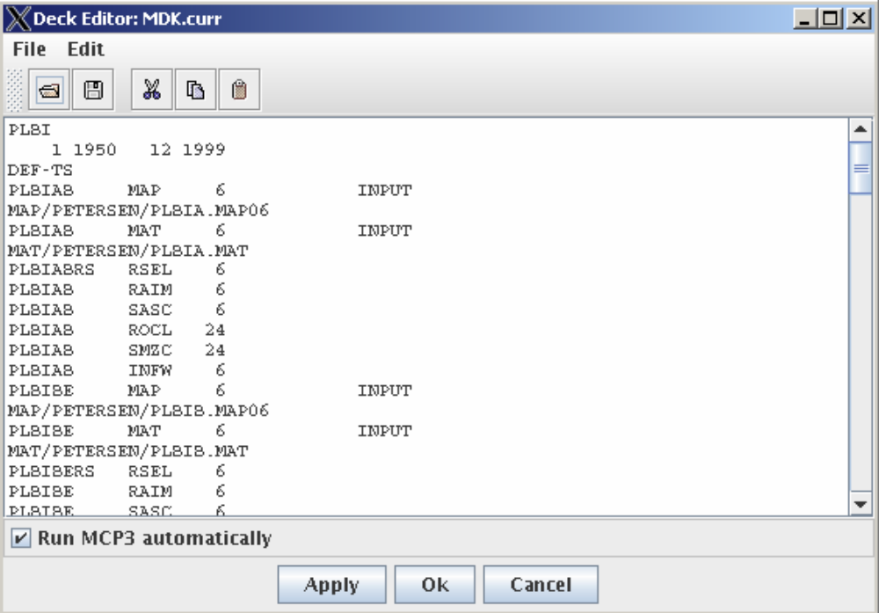
 | Verify Scrolling:  Scroll up/down. | Scrollbar moves to show more on the lower or upper part of the window.
 | Dialog closes using X button:  Close using the “X” button at the top right hand corner. | Deck editor closes.
 | Edit a new deck in the Control Deck Dialog:  Open the Open Deck Dialog by clicking on the open button in the main window toolbar  Select the deck TESTICP -> PETE -> TS -> APLOTTS.curr  Click OK. | The Control Deck Dialog appears with the contents of the newly selected deck.
 | Open the Control Deck Editor by choosing Edit -> Control Deck. | The Control Deck Editor appears.
 | Edit control deck and verify changes are not saved:  Now edit a parameter in the dialog. Find the 4th line of the text displayed in the dialog. | The text is:  PMKIBE MAP 6 INPUT
 | Change the text in the editor by deleting the 6 in this line and typing a 5. | The 6 is changed to a 5 in the text.
 | Click the X button in the upper right hand corner of the dialog. | The dialog is dismissed.
 | Re-open the same deck disk by selecting Edit -> Control Deck again. | Verify that the change was NOT saved to the deck. The 4th line of text in the dialog should still be  PMKIBE MAP 6 INPUT
 | Edit control deck and verify changes are saved:  Open the Control Deck Editor again by selecting Edit -> Control Deck. | The Control Deck Editor appears.
 | Find the 4th line of text in the dialog | The text is  PMKIBE MAP 6 INPUT
 | Change the text in the editor by deleting the 6 in this line and typing a 5. | The 6 is changed to a 5 in the text.
 | Click the Save file button on the toolbar of the Control Deck Editor Dialog. If Run MCP3 automatically is selected, an error should be generated because the input is not valid. | An error should be displayed.
 | Click the X button in the upper right hand corner of the dialog. | Verify that the dialog is dismissed after clicking X in the upper-right corner of the window.
 | Re-open the Control Deck dialog by selecting Edit -> Control Deck. | The 4th line of text displayed in the editor is  PMKIBE MAP 5 INPUT
 | Re-set changed value to the original value:  Change the 4th line of text displayed in the dialog to its original value. Delete the 5 and type a 6 in the 4th line. Click the Save button on the Control Deck Dialog toolbar. | The 5 is changed to a 6 in the text and saved.
 | Click the X button in the upper right hand corner of the dialog. | The Control Deck dialog is dismissed.
 | Control deck that returns a stop code > 4 can still be opened using the Control Editor:  Use the Open tool on the main window to select the TESTICP  -> PETE -> AFGIX -> AFGIX.err1. Click OK. | Dismiss the Stop Number Error dialog when it appears.
 | Select Edit -> Control Deck. | The Control Deck dialog displays the AFGIX.err1 deck.
 | Close the Control Deck Editor and the ICP Main Window:  Click the X button in the upper right hand corner of the Control Deck Dialog. | The Control Deck Editor dialog is dismissed.
 | Select File -> Exit from the ICP Main Window. | The ICP Main Window frame closes.
Part 4. SAC-SMA Parameter Dialog
 | Open the SAC-SMA Parameter dialog and verify general layout:  Start the ICP by going to the test_scripts directory /awups/hydroapps/test_data/DCS_3481/icptest/test_scripts/, type the following at the command line: run_icpnew_testdata | The ICP main window appears.
 | After the ICP main window appears, select a deck by clicking on the Open toolbar button. | The Open dialog appears.
 | In the Open dialog, select the deck TESTICP -> PETE -> AMDK -> AMDK.curr  Check the “Run MCP3 Automatically” checkbox. Click the OK button. | The Open Deck Dialog disappears. The status bar displays the text “Running MCP3…” while MCP is executing.
 | Open the deck by selecting Edit -> Control Deck… | The Control Deck Editor Window appears.
 | Now open the SAC-SMA parameter dialog by selecting Edit -> SAC-SMA… | The Edit SAC-SMA dialog appears.
 | Position the windows so that both the SAC-SMA parameter editor and control deck editor are visible. | Verify that both the SAC-SMA parameter dialog editor and control deck editor appear. See screenshot below for look and feel (values may be slightly different):
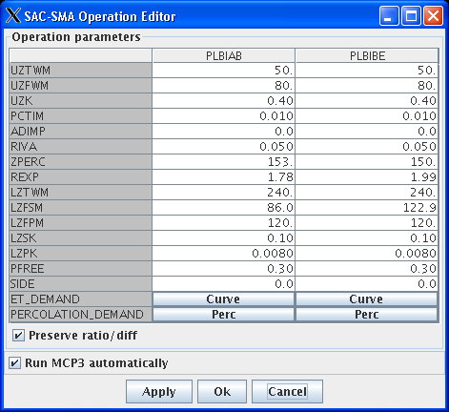
 | SAC-SMA Parameter dialog closes using the X button:  Close the SAC-SMA parameter dialog by clicking the upper right-hand X button. | The SAC-SMA parameter dialog is dismissed.
 | Edit SAC-SMA Parameter:  Open the SAC-SMA parameter editor with Edit -> SAC-SMA  Click on the UZTWM PLBIAB cell (first column).  Enter 100 (change the value from 50 to 100). | Value in UZTWM PLBIAB cell is 100.
 | Press the Apply button.  Press the X in upper right to close the window. | The control deck editor value is also 100 for the operation PLBIAB and parameter UZTWM.
 | Open the SAC-SMA parameter editor again with Edit -> SAC-SMA and inspect the data values. | Verify the data values are changed.
 | Edit SAC-SMA ET Demand Curve by entering value in table:  Click on the Curve button in the first column. | The ET/Demand editor dialog should appear.
 | Click in the cell under “Jan”. | The cell under “Jan” is clicked.
 | Change the value to .50 – press Enter. The curve should show the new values in dashed lines (for both January values that are shown). See figure below. | Value in the Jan Cell is .50.
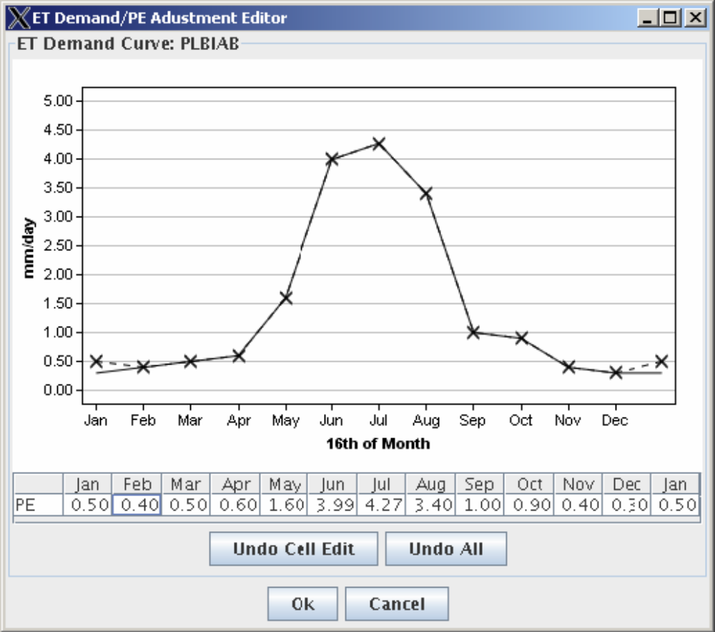
 | Press the OK button in the dialog to apply the change and close the dialog. | The dialog is closed.
 | Press Apply in the SAC-SMA parameter dialog. If “Run MCP3 automatically” is checked MCP3 will run. | The output displays will be updated.
 | Open the curve editor again by pressing the Curve button in the SAC-SMA parameters dialog. | The parameter values will also be updated if the control deck editor is open.
 | Check that the value for Jan is .50. | Curve shows new Jan values as .50 in dashed lines initially and as solid lines later.
 | Press the OK button in the dialog to close. | The dialog is closed.
 | Edit SAC-SMA Parameter by dragging curve:  Click on the Curve button in the second column of the SAC-SMA parameters dialog. | The ET/Demand editor dialog should appear.
 | Press the left mouse button down over the highest point on the curve (Jul) and slowly drag downwards. The point on the curve will follow the mouse (see image below). | Value in Jul cell in the table should adjust as the curve is dragged. See image below.  Note the y-axis is scaled to the new values.
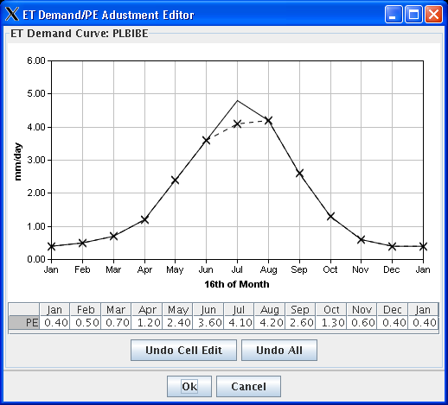
 | Press the OK button and then press the Apply button in the SAC-SMA parameters window.  Press the Curve button in the second column for the ET_DEMAND parameter. | Curve shows the new values as solid lines. Control deck is also updated.
 | Verify that the change is recognized for the PLBIBE operation. Press the OK button in the curve window. | The ET/Demand editor dialog disappears.
 | In the SAC-SMA operation parameters dialog, press OK. | If the Run MCP3 automatically checkbox is selected, an MCP3 run will run automatically and the main WY-PLOT will be updated. The curve edits will only be saved to the deck if Apply or  OK is pressed in the SAC-SMA parameters window.
 | Test Preserve ratio/diff:  Open the SAC-SMA parameter editor with Edit -> SAC-SMA. | Verify that the Preserve ratio/diff checkbox is NOT checked.
 | Change the value of UZK in the PLBIAB column to .8 and press Enter. | The value of UZK in the PLBIAB column changed to .8.
 | Change the Preserve ratio/diff checkbox to be checked. Change the value of UZK in the PLBIAB column to .2 and press Enter.  Press OK in the SAC-SMA parameter editor dialog. | Verify that value in second column for UZK (.1) will be half of that entered in the first column (.2).
 | After verifying the results exit ICP by pressing the upper right X in the main window. | Dialog is dismissed.
Part 5. View Output Listing Dialog
 | Open the Output Listing Dialog and verify general layout:  Start the ICP by going to the test_scripts directory  Type the following at the command line: run_icpnew_testdata | The ICP main window appears.
 | Select a deck by clicking on the Open toolbar button. Select deck TESTICP -> PETE -> PE -> AFGIXPE.curr. Check the “Run MCP3 Automatically” checkbox  Click the OK button. | The Open Deck Dialog disappears. The status bar displays the text “Running MCP3…” while MCP is executing.
 | After MCP has finished executing, open the Output Listing Dialog by selecting the menu item View -> Output Listing… | The Wide Output Listing Dialog should appear (see screenshot below). Title bar shows “Output Viewer” and shows the name of the selected deck “AFGIXPE.curr”
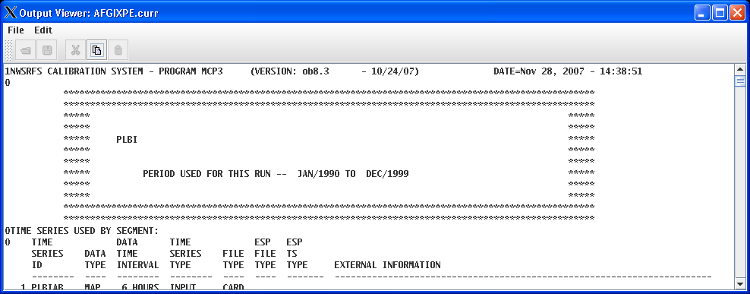
 | Verify scrollbars are working:  Scroll horizontally and vertically (may need to resize window to demonstrate horizontal scrolling). | Verify that the rest of the dialog can be viewed by scrolling horizontally or vertically.
 | View new output listing in the Wide Output Listing Dialog:  Leave the output viewer window open. Click the Open Deck (“Select a control deck”) toolbar button to select a new deck. Select deck TESTICP -> PETE -> TS -> TS.curr. The “Run MCP3 Automatically” checkbox should be checked. Click the OK button. After the MCP has finished executing (MCP3 Stop Number is 0), the Output Listing Dialog will display output from the new run. | The Output Listing Dialog should correspond to the new deck (look for “PMKI” in header).  While running, the output listing window reads “Run MCP3 to generate output listing”.
 | Close Output Listing Dialog (X Button):  Close the Wide Output Listing Dialog and the ICP main window by clicking on the X button in the upper right hand corner. | The Wide Output Listing dialog and the ICP main window dismiss.
Part 6. WY-PLOT
 | Generate WY-PLOT results and show SAC-SMA Plot:  Start the ICP by going to the test_scripts directory. Type: run_icpnew_testdata | The ICP main window appears.
 | Select a deck by clicking on the Open toolbar button. Select deck TESTICP -> PETE -> AFGIX -> AFGIX.curr. Check the “Run MCP3 Automatically” checkbox.  Click the OK button. After MCP has finished executing, the WY-PLOT graph will be shown in the bottom of the ICP main window. | Verify the WY-PLOT graph appears in the bottom of the ICP main window.
 | Select the PLBIBE SAC-SMA operation from the choices in the upper left of the main window.  Make sure the Log scale checkbox in the lower left of the WY-PLOT is checked. | The ICP main window will show the select SAC-SMA and WY-PLOT output as shown below.
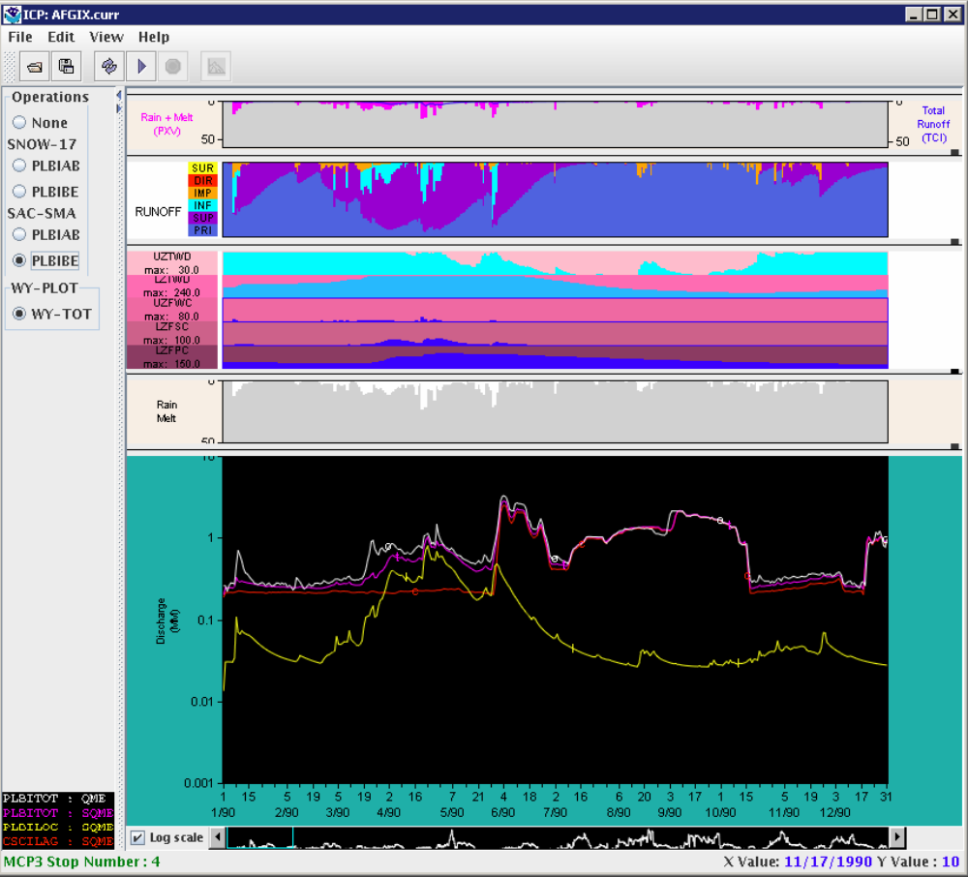
 | Resize subplots by clicking on small rectangle handles on right side of plot and dragging to resize the plot. | The plots on either side of the divider resize.
 | Display frozen ground:  Continue from previous test.  Select the PLBIAB SAC-SMA operation from the choices on the left. | The ICP main window will show the selected SAC-SMA and WY-PLOT output as shown below – in this case the frozen ground (Frost Index) graph will be shown at the top.
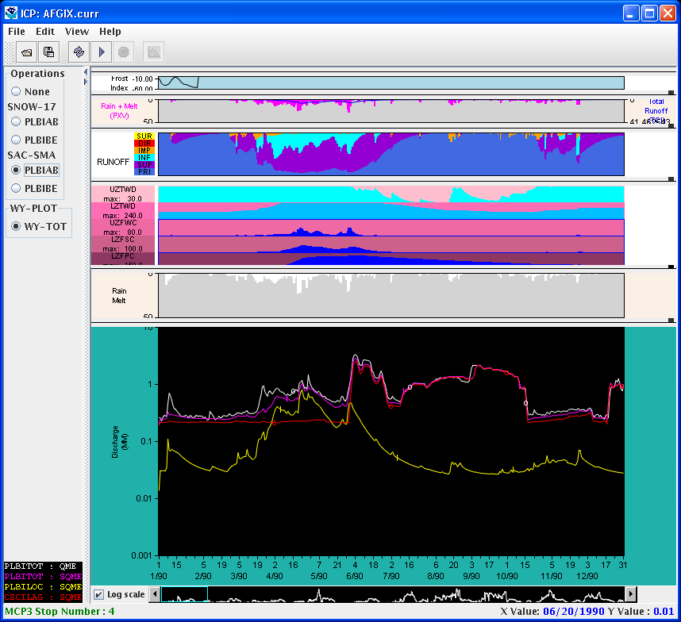
 | Display SNOW-17 plots:  Continue from previous test. Select the PLBIBE SNOW-17 operation from the choices on the left. The snow plots should display instead of the SAC-SMA plots. Select the PLBIAB SNOW-17 operation from the choices on the left. The snow plots should update for the selected operation. | The ICP main window will show the selected SNOW-17 and WY-PLOT output as shown below.
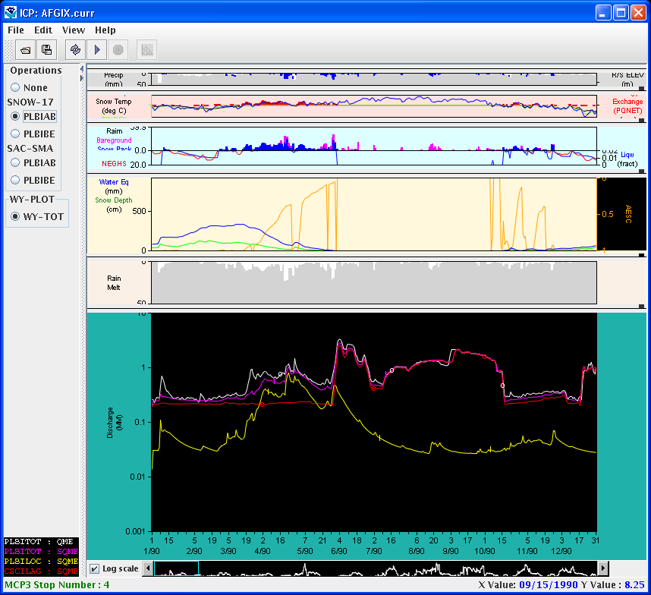
 | WY-PLOT Plot panner:  Continue from previous test. The panner window shown at the bottom of the main window shows the visible extent of the graph. Click with the left mouse button to the right of the highlighted cyan box. | The cyan box in the panner should move to the next position to the right of the previous location and the graphs will be updated to reflect the new period being shown. See below.
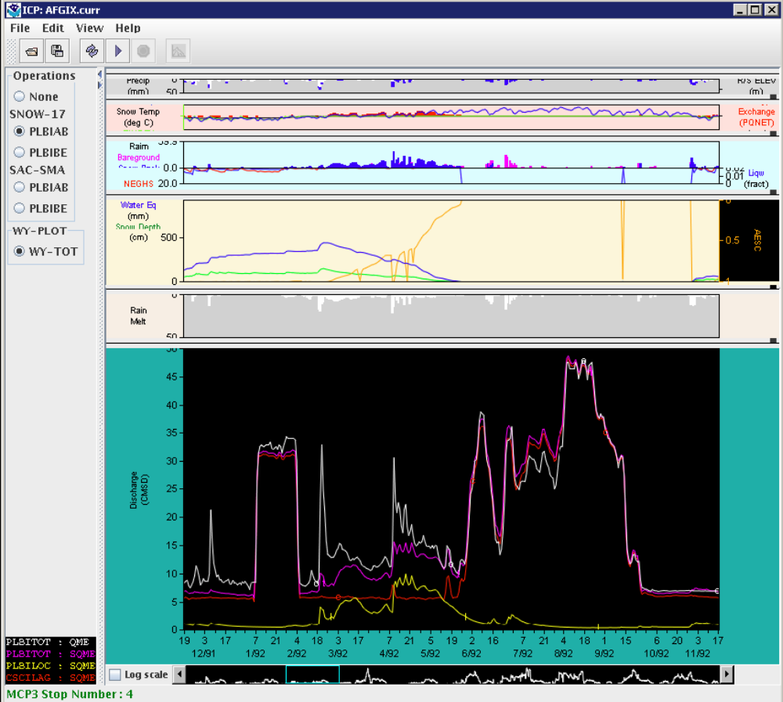
 | Click on the right scroll-bar arrow. | The graph should scroll to the right by one day.
 | Hold the mouse down on the right scroll-bar arrow. | The graph should continuously scroll by one day at a time.
 | Drag the cyan box in the panner. | The graph should scroll as the box is dragged.
 | Using the left or right mouse button, click to the right or left of the cyan box in the panner. | The graph should page one screen to the right or left, on the same side that was clicked.
 | Using the middle mouse button, click in the panner. | The graph should reposition to be left-justified on the selected point.
 | Drag the main graph. | The main graph will scroll as it is graphed and the panner box will scroll similarly.
 | Log Scale:  Continue from previous test.  Select the “Log scale” checkbox in the lower left of the window, next to the panner. | The lower (discharge) graph should be redrawn using log scale. Note that the units are also changed to mm. See below.
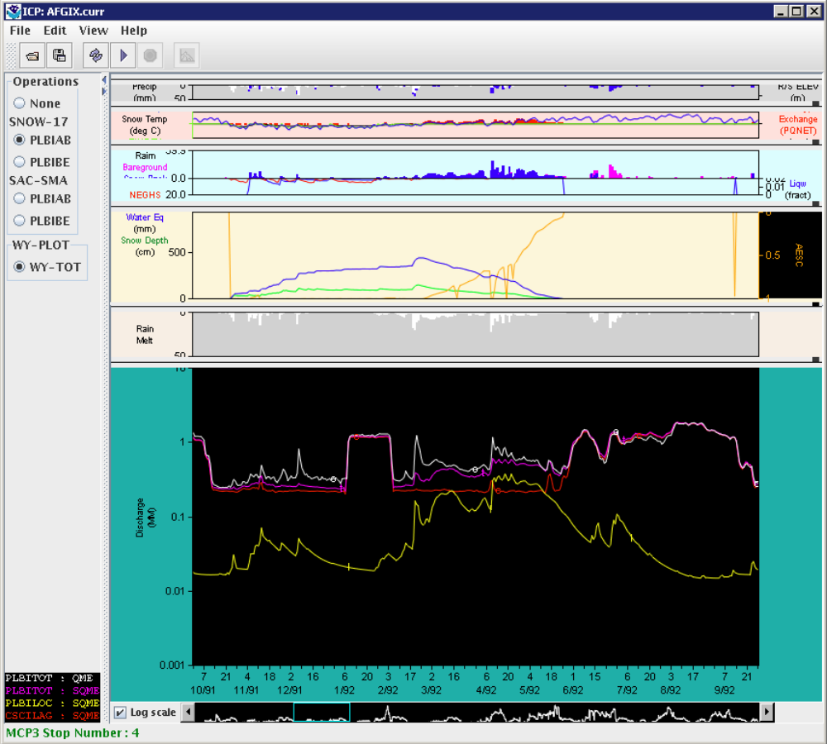
 | WY-PLOT Data Value Display – Mouse-over:  Continue from previous test.  Position the cursor over any point on any time series in the bottom graph. | The position of the mouse is shown in the lower right and is updated as the mouse moves.
 | WY-PLOT – Change Scale:  Continue from previous test (WY-PLOT discharge plot should NOT be in log scale). Select Edit -> WY plot Scale… In the dialog, change the Duration to 90 days and change the maximum discharge to 100. Press OK in the dialog. After verifying the results (below) exit ICP by pressing the upper right X in the main window. | The X and Y axis scales are changed as requested. The visible period in the graphs will change to 90 days as shown below.
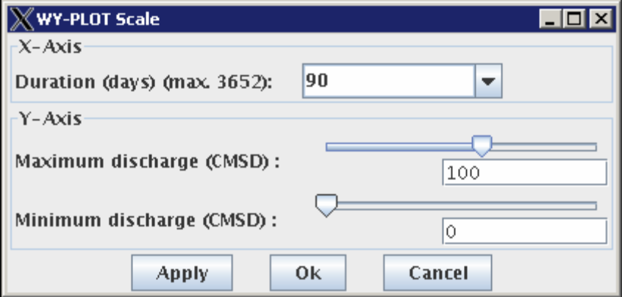

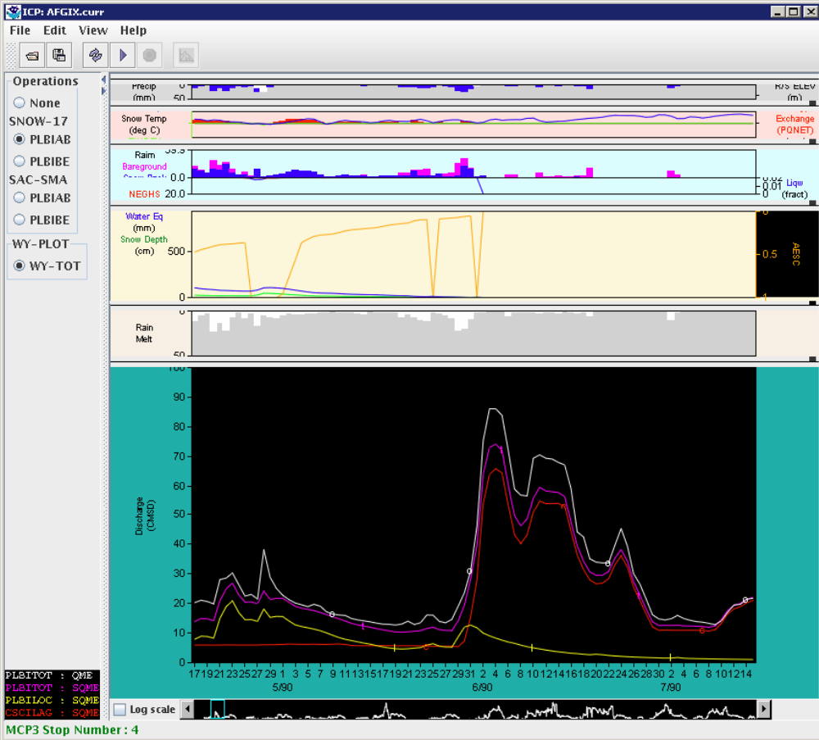
 | WY-PLOT – Save and Display SQME:  If necessary, restart ICP by running the run_icpnew_testdata script, or continue from previous tests. Select deck with the Open (“Select a control deck”) tool and select: TESTICP -> PETE -> AFGIX -> AFGIX.curr. Make sure that the Run MCP3 Automatically checkbox is selected and press OK. After the run is complete, select File -> Save all WY-PLOT Time Series. | All WY-PLOT Time Series are saved.
 | Open the SAC-SMA parameter editor with Edit -> SAC-SMA…  Change the UZTWM parameter by a large amount (e.g., from 30 to 300, or the opposite) and press Ok. | MCP3 will rerun and the graphs will redraw.
 | Load a saved SQME using File -> Load Saved Time Series... Select the PLBILOC SQME time series as shown below and press OK:  The graph should update as shown below. | The previously saved SQME time series will be loaded and displayed as an orange dashed line with + symbol and be listed in the legend.
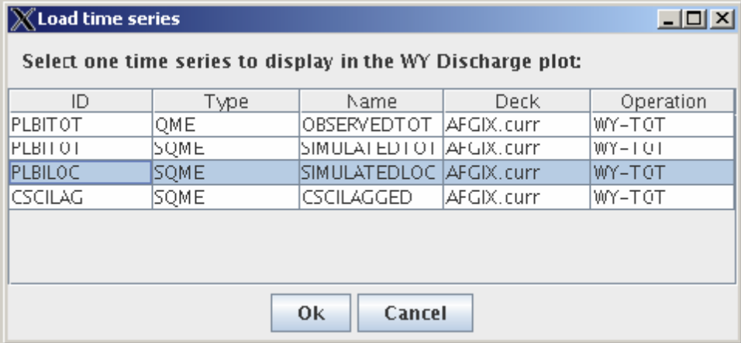

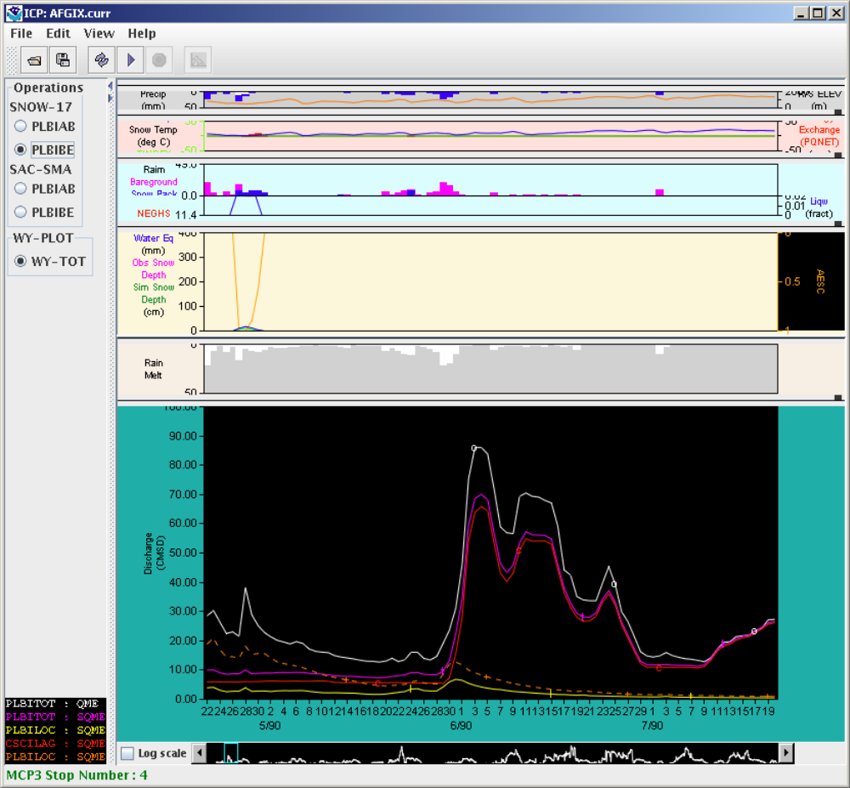
 | WY-PLOT – Clear Saved Time Series:  Continue from the previous test.  Clear the displayed time series by selecting File -> Clear Displayed Saved Time Series | The SQME time series as shown in the previous test should be cleared from the graph and the legend.
Part 7. Saving Decks
 | Rename current Deck using Save As:  Start the ICP by going to the test_scripts directory  Type the following at the command line: run_icpnew_testdata  Select a deck by clicking on the Open toolbar button. Select deck TESTICP -> PETE -> AFGIX -> AFGIX.curr. Verify that “Run MCP3 Automatically” is checked.  Click the OK button. After MCP has finished executing, the WY-PLOT graph will be shown in the bottom of the ICP main window. The reason that MCP3 must rerun is to update the files in the MCP3 to ICP interface directory. Save the deck with a new name by selecting File -> Save As. Enter AFGIX.test and press Save. WARNING: for MCP3 the file extension can be no more than 4 characters because of file naming conventions in the MCP3 to ICP transfer directory. MCP3 will rerun automatically. | The ICP main window will display AFGIX.test in the title bar.
 | Edit the deck with Edit -> Control Deck. Make a change and save the deck. | The file system will show the new file (check in the data directory). Verify that the new deck is different from the original deck.
 | Archive current deck using Save a Copy:  Continue the previous test.  Save a copy of the file using File -> Save a Copy. Enter “AFGIX.copy” for the file name and press Save. WARNING: for MCP3 the file extension can be no more than 4 characters because of file naming conventions in the MCP3 to ICP transfer directory. | A file named AFGIX.copy will be created in the MCP3 decks directory. The ICP main window will continue showing the current file. AFGIX.test in the title bar.
Part 8. PLOT
 | Verify that PLOT-TS view is disabled when no PLOT-TS operations are present:  Open deck TESTICP -> PETE -> AFGIX -> AFGIX.curr and run MCP3. | Verify that the View -> PLOT-TS… menu item is disabled.
 | Verify that the WY-PLOT display does not show results when no WY-PLOT operations are used:  Open the TESTICP -> PETE -> TS -> TS.curr deck and run MCP3. | MCP3 executes successfully but no WY plots should be displayed in the ICP main window. The View -> Plot-TS… menu item is enabled as shown below.
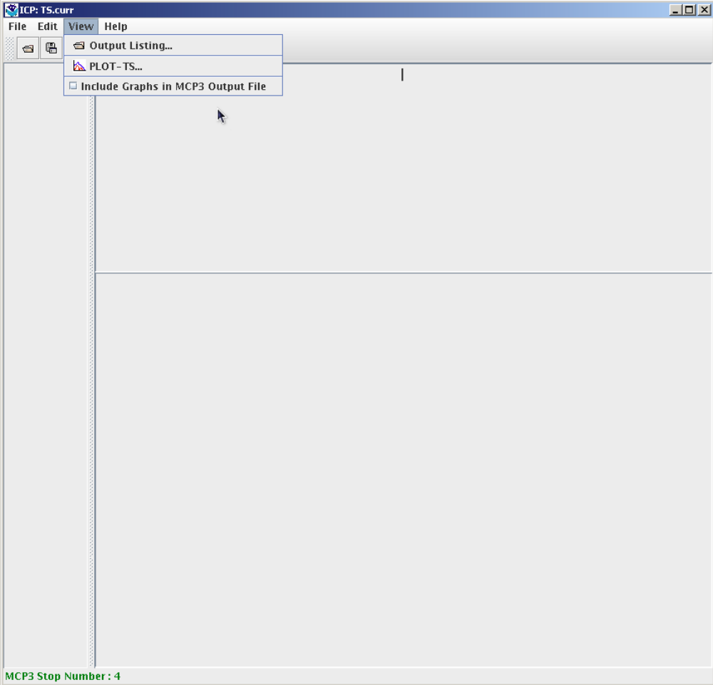
 | Verify that PLOT-TS window shows results:  Continue the previous test.  Select View -> PLOT-TS…: | PLOT-TS window opens.
 | Select the PLOT-PMK operation from the choices on the left. | The PLOT-PMK operation displays two subplots with 2 and 3 time series displays in the subplots as shown below.
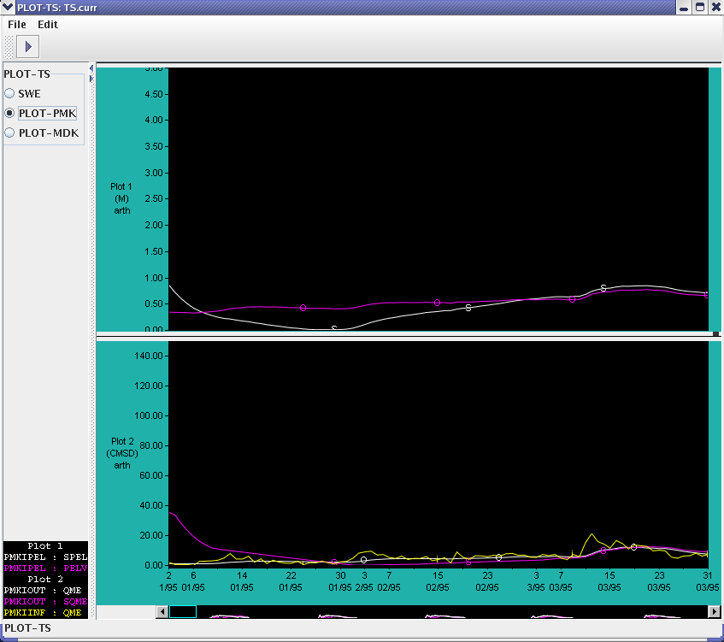
 | Select File -> Close. | The PLOT-TS window closes.
 | Verify that WY-PLOT and PLOT-TS operations can both be displayed:  Open the TESTICP -> PETE -> SCSM8 -> SCSM8.smll deck and run MCP3. | MCP3 executes successfully and WY plots should be displayed in the main window. The View -> PLOT-TS… menu item is enabled.
 | Select the PLOT-TS window (and/or position to make visible). Press “Run MCP3” (arrow symbol) button in the PLOT-TS window. | The PLOT-TS window that was previously shown is updated with the SCSM8 plot output. The FIRST operation is selected by default and displays one subplot with 3 time series as shown below.
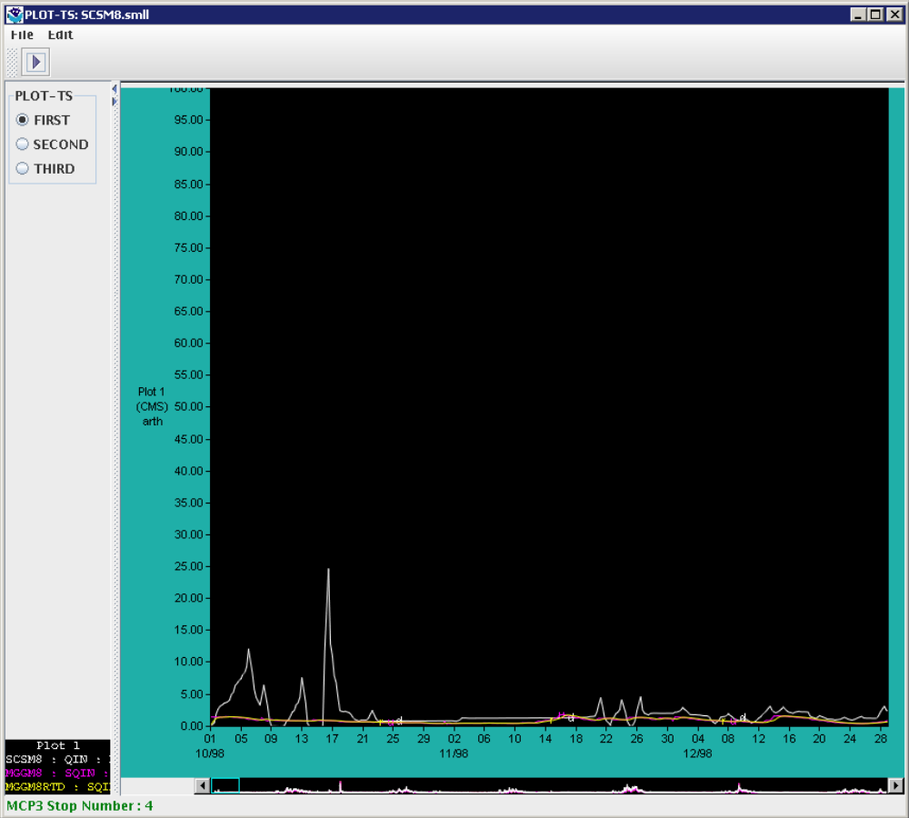
 | Verify PLOT-TS Scrolling:  Continue previous test with the SCSM8.smll deck. Scroll by clicking on the scrollbar arrows at the edges of the panner window. Hold the mouse down on a scrollbar to continuously scroll. | The X-axis of the plot shifts by one day at a time to display a different range of dates.
 | Scroll by clicking in the panner to the right or left of the box. | The X-axis of the plot shifts by one screen at a time to display a different range of dates.
 | Scroll by holding the mouse down in the panner on either side of the panner box: | The plot scrolls one screen at a time.
 | Scroll by dragging the panner box to the left or right. | The X-axis of the plot shifts to follow the panner box.
 | Reposition the plot by clicking with the middle mouse button anywhere in the panner window. | The plot will reposition to be left-justified on the selected point.
 | Scroll by dragging the plot window. | The X-axis of the plot shifts quickly and the panner box moves parallel to the visible period in the plot window.
 | Verify Shifting Between PLOT-TS Operations:  Continue the previous test with the SCSM8.smll deck and PLOT-TS window open. Switch between the operations displayed in the navigator (FIRST, SECOND, THIRD). | The window updates to display the subplots defined for the selected operation.
 | Change PLOT-TS Scale:  Continue the previous test with the SCSM8.smll deck still selected.  Choose the FIRST radio button in the navigator. Choose Edit -> Plot-TS scale…. | The Edit PLOT-TS scale dialog appears.
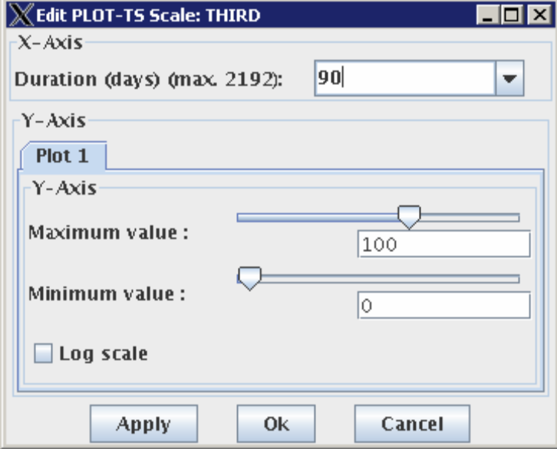
 | Change the duration of the plot from 90 to 730 by changing the “Duration” field. Click OK. Slide the panner to the left edge of the period. | The Edit Plot-TS scale dialog disappears and the dates displayed now range from 10/98 to 7/00. The panner range (the cyan colored box in the panner) also updates to a bigger rectangle to reflect the new number of days that are displayed in the main plot.
 | Select the SECOND operation. Choose Edit -> PLOT-TS scale…  Change the following for each tab:  a. On the “Plot 1” tab, change the maximum value to 60  b. On the “Plot 2” tab change the minimum value to 10 and the maximum value to 40  c. On the “Plot 3” tab click the Log Scale checkbox. Note that when log scale is used, the plot limits cannot be changed.  d. Click Apply.  The Edit PLOT-TS Scale dialog remains open. | The plots change to show the specified min/max or log scales:
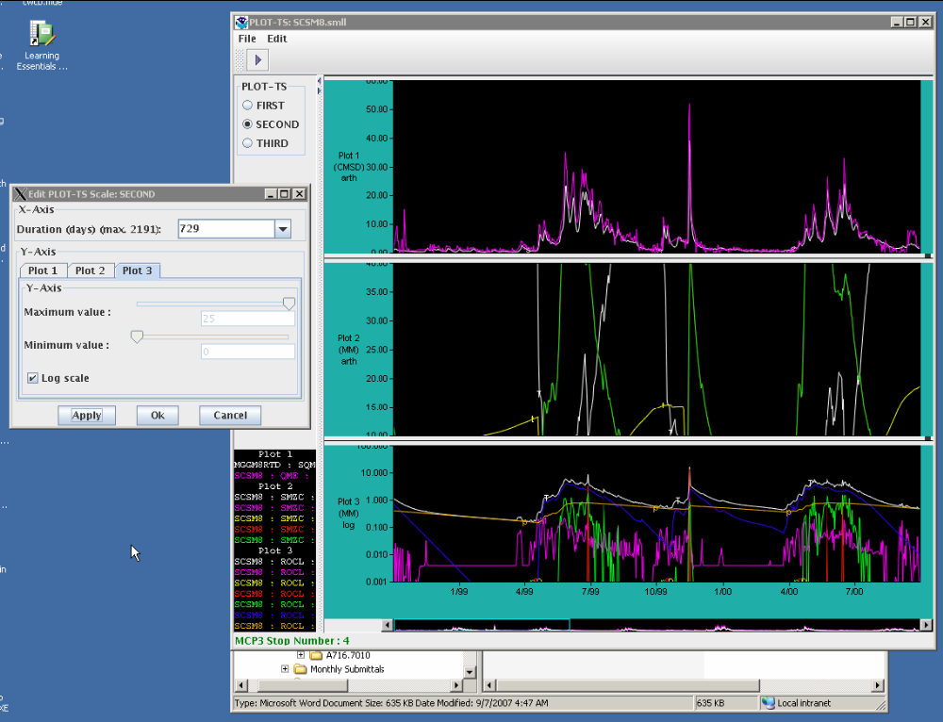
 | Move mouse over the different plots. | Verify that the date and value information displayed in the lower right hand corner of the status bar is correct, for plots showing log or linear scales.
 | In the Edit PLOT-TS scale dialog, change the duration to 365. Press OK. | The PLOT-TS scale window closes. The plot now shows dates 10/98-10/99. The panner range (the cyan colored box in the panner) updates to show a smaller colored rectangle for the new dates that are displayed.
 | Save Time Series and Load to Display:  Continue using the SCSM8.smll deck. Select the THIRD operation if not already selected. Save the time series by selecting File -> Save the Time Series for selected PLOT-TS subplot. | Saving of time series succeeds. The PLOT-TS status area will display “Save Time Series: Successful”.
 | Still looking at THIRD operation  Load a saved time series by selecting File -> Load Saved Time Series. | The Load Saved Time Series dialog appears.
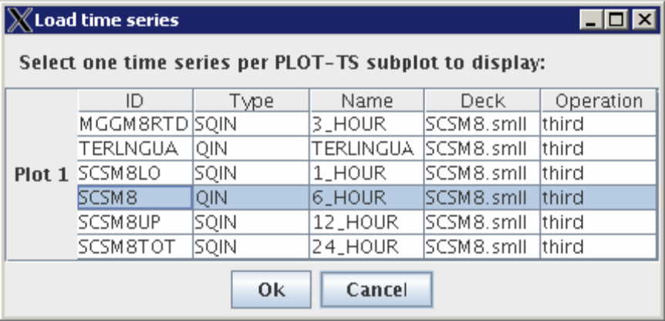
 | Select the time series with the Name “6_HOUR” (as shown above). | The selection is highlighted in the table. Note: Only one time series can be selected at a time in the table. The OK button is enabled after a selection is made.
 | Click OK. | The plot updates to display the selected saved time series as an orange dashed line, and the legend updates to show the saved time series. Note that since parameters were not changed, the saved time series will display on top of another time series as shown below.
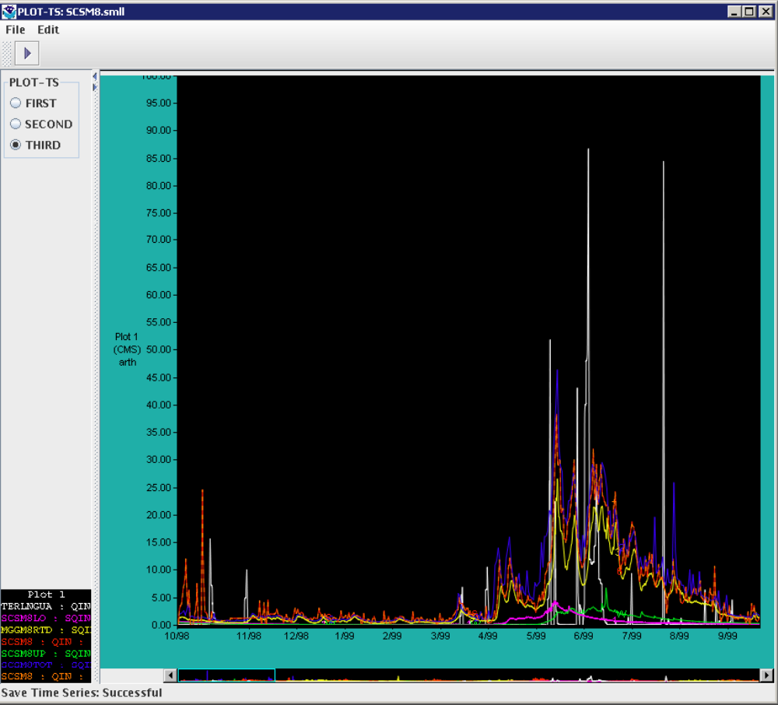
 | With the THIRD operation still displayed, and the saved time series displayed, select File ->  Clear Displayed Saved Time Series…. | The plot updates and clears the saved time series from the plot.
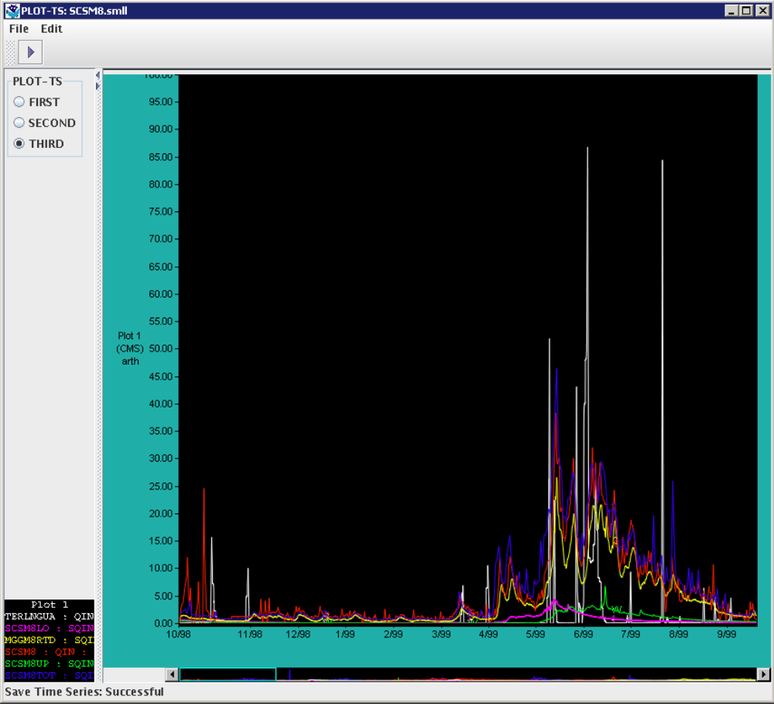
 | Change Time Series Used in the PLOT-TS Panner:  Continue with the SCSM8.smll deck THIRD operation.  To change the time series displayed in the panner/scrollbar, select File -> Change Panner  Time Series…. | The change panner time series dialog appears displaying the subplots and available time series for the selected operation.
 | Select the “SCSM8 - QIN” radio button under the Plot 1 heading (as shown below). Click OK. | The panner image updates to show only the SCSM8 – QIN time series at the bottom of the scroll bar.
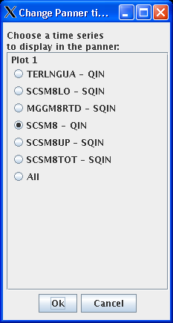
 | Scroll by clicking the arrow buttons on the left or right side of the panner. | The plot X-axis shifts by ~ 1 day up or down.
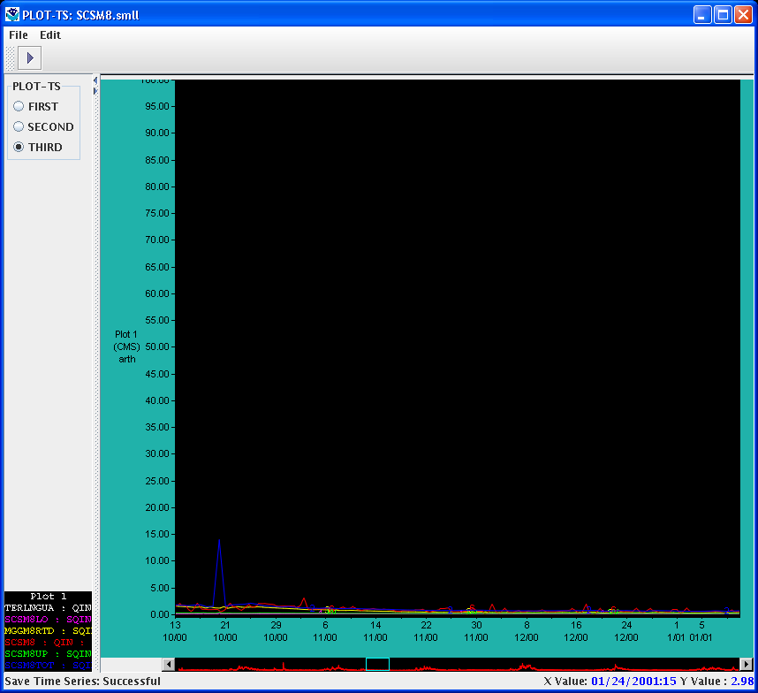
 | Scroll by pressing and holding down the arrow buttons on the left or right side of the panner. | The plot X-axis continuously scrolls left or right.
 | Verify Automatic Update of PLOT-TS Window:  Leave the PLOT-TS window open but go back to the ICP main window. Choose a different deck by selecting File -> Open… Choose the TS/TS.curr deck. Click OK. Run MCP3 (manually or automatically). | The PLOT-TS window automatically updates to display the most recent PLOT-TS results as shown below (select the PLOT-PMK operation from the choices on the left).
 | Editing Percolation Curve:  Select the deck AFGIX.curr (TESTICP -> PETE -> AFGIX -> AFGIX.curr) if not already shown. Open the parameter window with Edit -> SAC-SMA… Click the Perc button on the PLBIAB column to open the Percolation Analysis window. | The window should display similar to the following, with the operation name in the upper left and the tabular parameters matching those in the control deck.
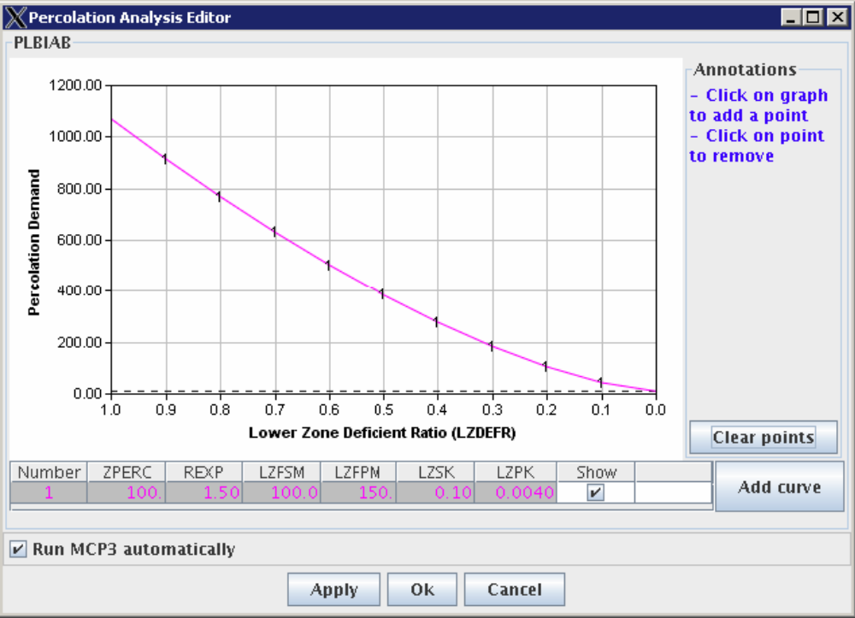
 | Verify that a new set of parameters can be added:  Continue the previous test. Click “Add curve” to add a row the table. | A row will be added at the bottom of the table with the same values as the previous last row. An additional curve with the same data points as those corresponding to the previous last row will be drawn on the graph.
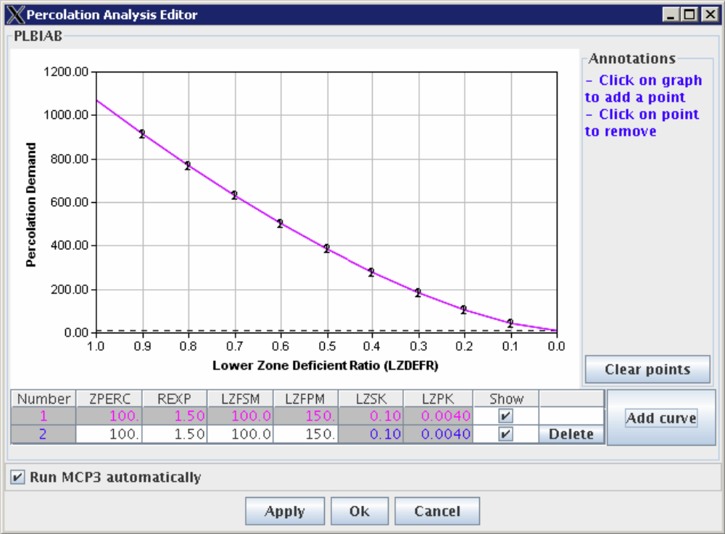
 | Verify that the selected row is highlighted by a blue rectangle:  Continue the previous test. Select the first row. | The selected row will have a blue rectangle around the cells.
 | Verify that the display of a curve resulting from a parameter set can be selectively displayed:  Continue the previous test. Click on the checkbox in the “Show” column in the second row (the first row is always shown). | When the check is displayed in the “Show” column a curve will be displayed. If the check is not displayed, then the corresponding curve will not be displayed.
 | Verify that a parameter set can be deleted:  Continue the previous test. Click on the “Delete” button in the second (new) row. | The row containing the “Delete” button and the corresponding curve will be removed.
 | Verify that parameters can be edited:  Continue the previous test. Press Cancel in the Percolation Analysis Editor to close the previous window. Press Perc in the SAC-SMA editor (first column) to restart the Percolation Analysis Editor window. Press Add Curve to create a new curve.  Click in a cell in the new curve and change data values. For example, change LZFSM from 100 to 80. Press Enter or tab when editing values. | The curve shape will change, as shown in the following figure (the  original curve will continue to be displayed):
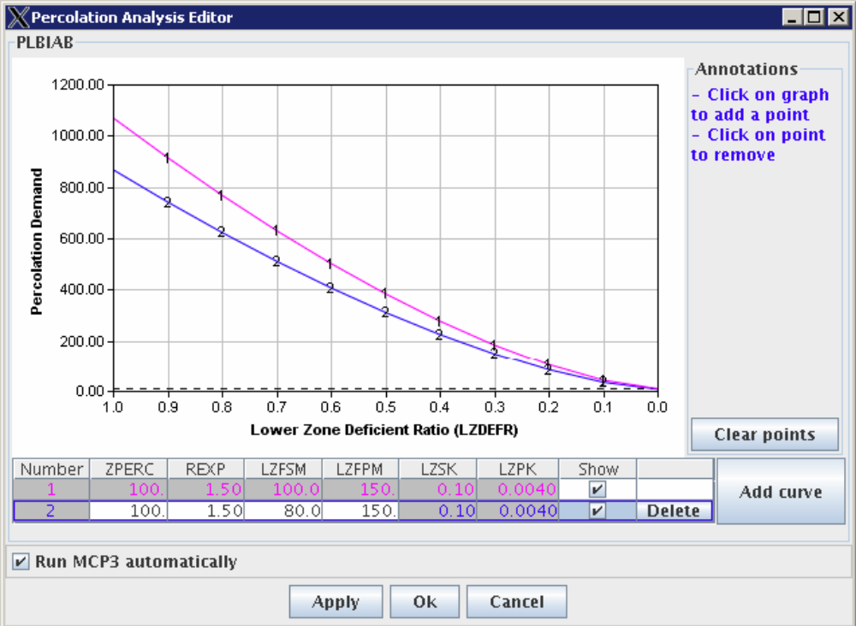
 | Select the second row. Press Apply to save the results and cause MCP3 to be run. | The SAC-SMA parameters will be updated based on the values in the percolation analysis window (for the selected row), MCP3 will run, and output plots will be updated reflecting the changes.
 | Verify that when out-of-range values are entered a range message is displayed:  Enter a value of –10 for ZPERC in the second row and press Enter. | A warning will be shown that the value must be >= 0.
 | Change the value of ZPERC back to 100 and press Enter or press Esc. | The value will be accepted as valid.
 | Click the Cancel button in the Percolation Analysis Editor window and the SAC-SMA Operation Editor window. | The Percolation Analysis Editor window and the SAC-SMA Operation Editor window are closed.
Part 10. Editing SNOW-17 Parameters
 | Open the SNOW-17 Parameter dialog and verify general layout:  Select the deck AFGIX.curr (TESTICP -> PETE -> AFGIX -> AFGIX.curr) if not already shown. Open the parameter window with Edit -> SNOW-17… | Window should display similar to below.
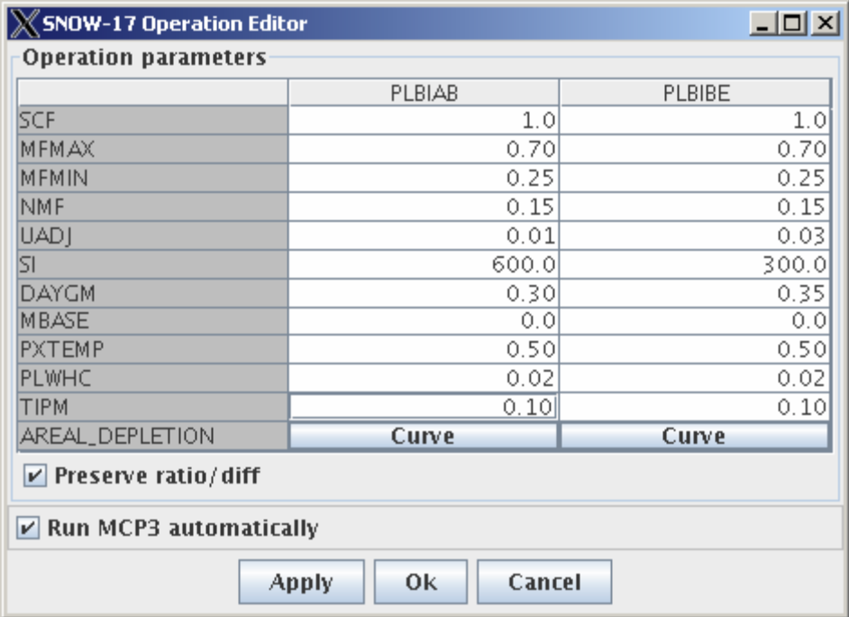
 | Edit a parameter in the table & verify:  Continue the previous test. Enter a value for SCF (change 1.0 to 0.50 in first column). Press OK to close the window. Reopen the parameter window with Edit -> SNOW-17. | The edited value should be shown.
 | Verify that pressing ESC in a data cell restored the value:  Continue with the previous test (open SNOW-17 editor if not already shown). Enter a value of 2.0 in SCF cell in first column. DO NOT press enter. Press ESC | The value in the cell should revert back to the previous value.
 | Verify that when out-of-range values are entered a range message is displayed:  Enter a value of –1.0 for SCF in the first column and press Enter. | A warning will be shown indicating that the value must be greater than zero and less than 999.9.
 | Enter a value of 1.0 for SCF in the first column and press Enter. | The correct value will be accepted.
 | Test Preserve ratio/diff:  Continue previous test. Verify that the Preserve ratio/diff checkbox is NOT checked.  Change the value of SCF in the PLBIAB column to .5 and press Enter. Only the edited value should change. Change the value in the PLBIBE column to 1.  Change the Preserve ratio/diff checkbox to be checked. Change the value of SCF in the PLBIAB column to .2 and press Enter. The value in the PLBIBE column will change to .4 (twice that of the first value). | Value in second column for SCF will be twice that entered in the second column.
 | Press OK in the SNOW-17 parameter editor dialog. | Dialog is dismissed.
Part 11. Editing SNOW
 | Open the AESC Editor by clicking on a “Curve” button in the SNOW-17 Parameters dialog and verify general layout:  Select the deck AFGIX.curr (TESTICP -> PETE -> AFGIX -> AFGIX.curr) if not already shown. Open the parameter window with Edit -> SNOW-17… Press the Curve button in the first column. | The AESC curve editor should display similar to the following:
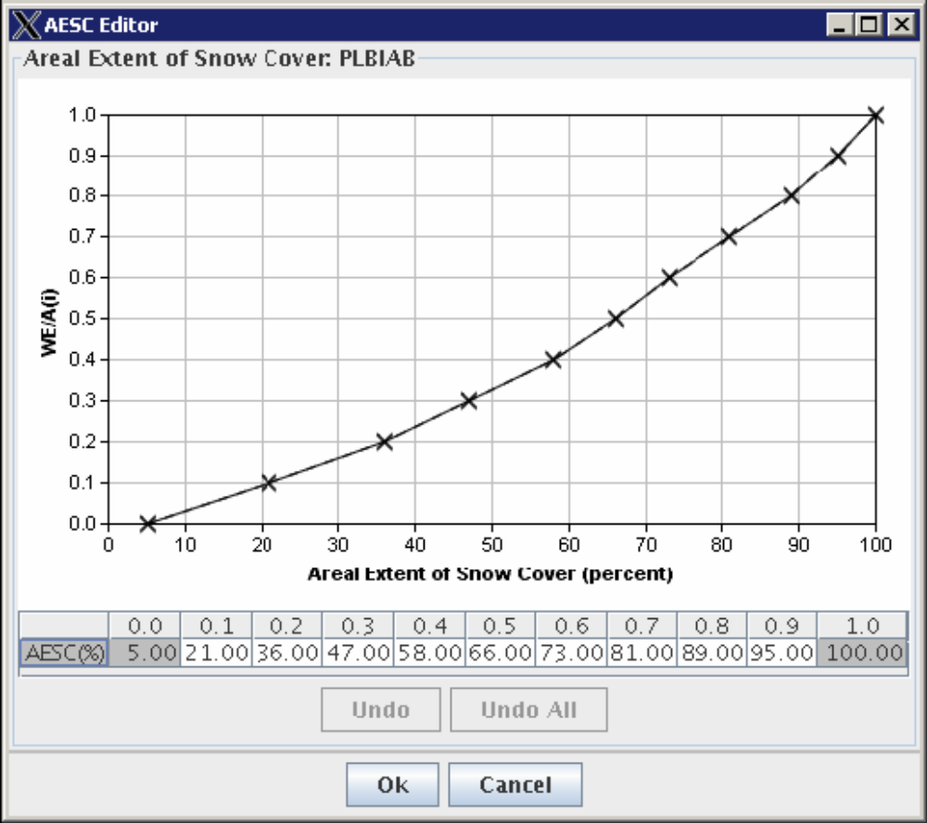
 | Edit a parameter in the table & verify that the data point on the curve updates:  Continue the previous test. Change the Y-axis WE/A(i) value by changing the table value under 0.3. For example, click in the cell and enter 55, press Enter. | The graph will change in response to the cell edit, as shown below:
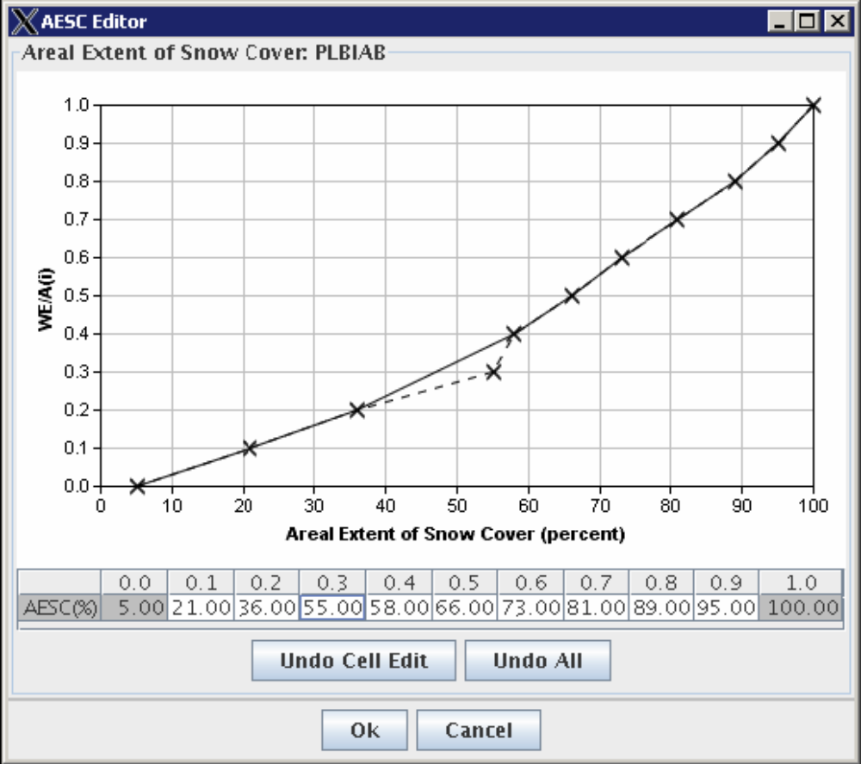
 | Press OK to save the result. | The AESC curve window closes.
 | Press Apply in the SNOW-17 parameter window to apply the changes and run MCP3. | The new output will be shown in plots.
 | Edit a parameter by dragging symbols to right or left & verify that the corresponding table cell updates as the point is being dragged:  Continue the previous test. Open the parameter window with Edit -> SNOW-17… Press the Curve button in the first column. Select a point and drag (for example, see the following example). | As the point is dragged on the graph, the corresponding value will be updated in the table as shown below.
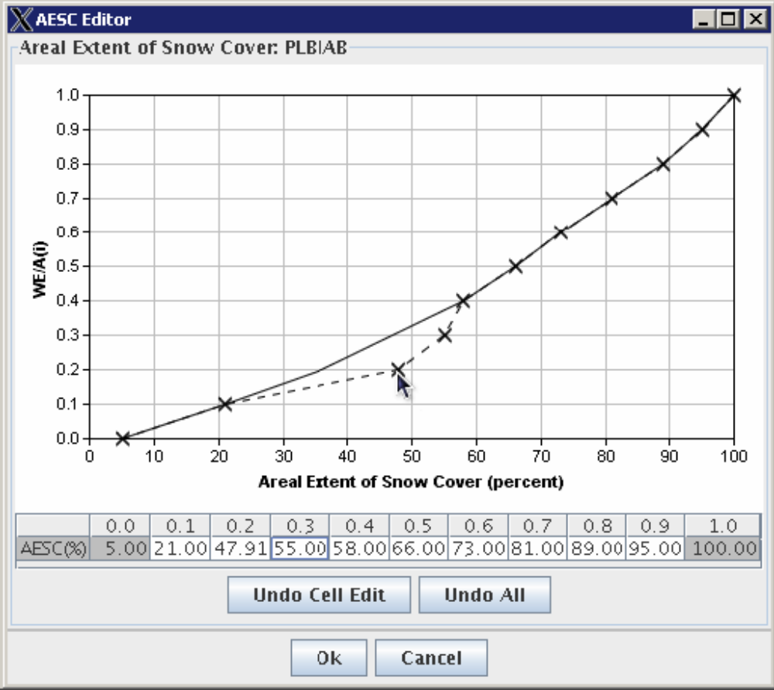
 | Undo the most recent change by pressing the Undo Cell Edit button. | The data will revert to the previous values.
 | Make several edits in the table and/or by dragging points.  Undo all changes by pressing the Undo All button. | The data will revert to the original values when the curve was first opened.
 | Click the Cancel button in the AESC Editor window and the SNOW-17 Operation Editor window. | The AESC Editor window and SNOW-17 Operation Editor window close.
Part 12. Editing UNIT
 | Open the Unit Hydrograph Editor and Verify Layout:  Select the deck AFGIX.curr (TESTICP -> PETE -> AFGIX -> AFGIX.curr) if not already shown. Open the parameter window with Edit -> UNIT-HG… | The UNIT-HG Operation Editor window will be shown similar to below. Note that all fields are disabled because editing occurs through the curve.
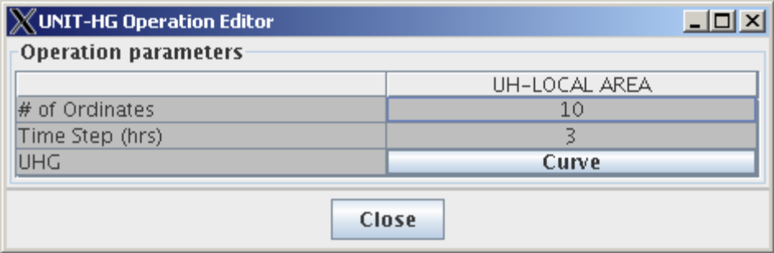
 | Open the UNIT-HG curve window by pressing the Curve button in the UNIT-HG parameter editor window. | The UNIG-HG curve editor window will be shown similar to below. Verify that the first and last cells are grayed out indicating they are not editable. Using the deck editor, review the UNIT-HG operation definition and verify that the ordinates agree with the deck.
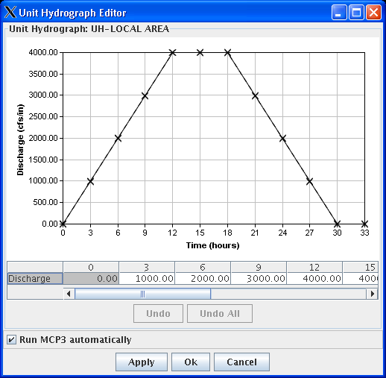
 | Edit a coordinate in the table & verify that the data point on the curve updates:  Continue from previous test. Edit values in the table. Press Enter after each value. Note that the entire curve will adjust, not just the single point. | The graph will update to display the updated values.
 | Press Apply to save changes. | MCP3 will run and the plot output will be updated to reflect results.
 | Edit a parameter by dragging symbols up or down & verify that the corresponding table cell updates after the drag is completed:  Continue previous test (the UNIT-HG Curve window should be open). Drag a point vertically to change the curve shape. | The curve will adjust to respond to the new data.
 | Press Apply to save results. | MCP3 will rerun and display output corresponding to the new values.
 | Verify that Undo reverts a data cell to the original value and reverts the curve data point:  Continue the previous test. Drag a point vertically to change the curve shape. Press Undo Cell Edit. | The curve should revert to its values prior to the previous edit.
 | Verify that Undo All reverts all data cells and curve data points to the original values:  Continue the previous test. Drag some points vertically to change the curve shape. Press Undo All. | The curve should return to its original shape.
 | Verify that all columns of the table can be displayed by scrolling:  Use the scrollbar handle to scroll through all the unit hydrograph data. | The number of ordinates in the Unit Hydrograph table + 2 should be visible, with the zero endpoints being non-editable.
 | Verify the functionality of automatic slope calculation:  Edit any point to the left of the last editable point. Edit any point to the right of that point. | Any intervening points between the edited points will be adjusted to lie on a straight line between the edited points.
 | Exit application. | Application closes.
 | Log out and exit user access. | User exits from user access without incident.
The test case is completed.

Table 1.1-2. Requirements Verification Traceability Matrix (RVTM)
Number | Description | Test Step (s)
1

