Title | Baseline WarnGen Hydro | Test Case Execution Engineer
Test Case Creation Engineer | Carolina Fayos | Test Platform Used
Date Test Case Created | 04/06/2006 | Release Version on Testbed
CI | WG | Logged in User’s Role
Site Specific | N/A | Start Date / Time
TC Updated for Version | AWIPS II | Completion Date/Time
Last Modified By | William Smith 5/22/2012 | Total Test Time
Executable Steps | 123 (unique) + 3 (repeats) = 126 | Pass/Fail/Pending

Test Case: | Baseline WarnGen Hydro
Test Case Description: | WarnGen is the warning software tool used to create and issue NWS short and long duration severe weather advisories, watches, and warnings. The testing of WarnGen functionality has been broken up into two test cases: meteorological and hydrological. In pre-OB8 builds, warnings are issued, disseminated, and verified for an entire county or cluster of counties. Beginning in OB8.1, these short duration warnings will no longer use geopolitical (county) boundaries, but will be outlined by geographically based polygons. Polygon warnings show the specific meteorological threat area and are not restricted to county boundaries. This test case demonstrates the capability of the AWIPS system to issue, disseminate, and verify geographically based polygon warnings.
Requirements: | N/A
Data Input: | N/A
Prerequisite Conditions: | - IMPORTANT: To insure that the system is properly set-up to prevent dissemination of test products to the field, please follow the Raytheon Test Message Procedure or, if not in a Raytheon lab, use the proper procedure for that environment.  - Perform ad-hoc testing on every test run! (create different products, select different optional bullets, etc., each time the test is run.)  You MUST check that your testbed is configured to send products to TNCF. This is VERY important – your job may depend on it!!!  Hydro products have a header line called Hydro VTEC. Most of this line can only be filled out by RiverPro when issuing point warnings. Most of the line is irrelevant in polygon warnings. The only thing that should be affected is the immediate cause section, indicating: excessive rainfall, dam break, ice jam, etc.

Table 1.1-1. Test Steps and Expected Results
Step # | Actions / Inputs | Expected Results | P/F | Comments
 | You MUST check that your testbed is configured to send products to TNCF. | This is VERY important – your job may depend on it!!!
 | Login to a Linux workstation as an AWIPS user. Click and hold MB1 on the desktop background. Select AWIPS start-up menu, select CAVE, then the D2D perspective. | The 5-pane D2D GUI opens.
 | From the Scale option of the D2D toolbar, select State or WFO. | State or WFO scale is selected.
 | Load local radar or if not available load 5 min. lightning data from the obs menu. | Data are loaded.
 | Launch another D2D and re-execute steps 1-3 on another LX monitor. This other D2D will be referred to as “D2D #2” and the first D2D will simply be referred to as “D2D.” | Another D2D launches and the re-executed steps are completed successfully.
 | In D2D #2, load all regional warnings. Do this by following the D2D menu path below:  Obs → Other Warning Displays → All Regional Warnings  This will load all regional warnings, which will also include local warnings. | The warning boxes will display in D2D #2.
 | Create a NEW FFW:  Launch WarnGen by clicking on the yellow WarnGen icon in the upper right of D2D. | The WarnGen GUI opens up and a centroid is displayed in the main pain of D2D labeled, "Drag me to Storm."
 | Select the Other radio button from the Product type section. | The button is selected.
 | From the other product type pull-down menu, select FFW - Dam Break. | The product type is selected.
 | Select “Dam break – site specific (pick below) – failure has occurred” under the PRIMARYCAUSE in the Optional bullets box. | The selection is now highlighted.
 | Select “Corps of Engineers” under DAM FAILURE REPORTED BY. | The selection is now highlighted.
 | Click Create Text at the bottom of the WarnGen GUI. | Text is displayed along with the Header Block Window on the associated text workstation.
 | Compare the content of the warning on the text workstation with Figure 1. It should be generally the same, aside from dam names and times. | Verification is made.
 | Ensure the following information is included in the warning text:  - Primary cause  - Name of Dam  - Name of River  - County Name  - Affected Locations | Verification is made.  Note: OCONUS sites may use regions instead of county names.
 | Replace text similar to the below with what is appropriate.  !** TEXT **! | Text is replaced.
 | Add appropriate test verbiage. | Text is added if needed.
 | Click the send button. | Product is sent to the DEFAULTNCF.
 | Create a follow-up:  In WarnGen, select “FFS – Dam Break Followup” or “FFS Update Cancel Expire FFW” from the other product type pull-down menu. | Product is selected.
 | Click UPDATE LIST and then select CON-<SITE>. | Ensure the polygon that was previously issued shows up on D2D.
 | The original area that the warning was issued for is shown as a polygon on the main pane of D2D . | Verification is made.
 | Click Create Text at the bottom of the WarnGen GUI. | Text is displayed along with the Header Block Window on the associated text workstation.
 | Compare the content of the warning on the text workstation with Figure 2. It should be generally the same, aside from dam names and times. | Verification is made.
 | Ensure the following information is included in the warning text:  - Primary Cause  - Name of Dam  - Name of River  - County Name  - Affected Locations | Verification is made.  Note: OCONUS sites may use regions instead of county names.
 | Insert required test verbiage and send out the warning. | Warning is sent.
 | Ensure that the polygon & header info that was just issued displays properly in D2D #2. | The polygon that was just issued displays properly in D2D #2.
 | Create an extension:  In WarnGen, select “FFW - Dam Break” from the Other product type pull-down menu. | Product is selected.
 | Click UPDATE LIST and then select EXT-<SITE>. | Ensure the polygon that was previously issued shows up on D2D and is un-editable (represented by dots and not open triangles).
 | Note the amount of time that the warning is set to be extended. | Time noted
 | Ensure that the items selected in the Optional bullets box when the NEW warning was created are still highlighted. | Verification is made.
 | The original area that the warning was issued for is shown as a polygon on the main pane of D2D and is un-editable. | Verification is made.
 | Click Create Text at the bottom of the WarnGen GUI. | Text is displayed along with the Header Block Window on the associated text workstation.
 | Compare the content of the warning on the text workstation with Figure 3. It should be generally the same, aside from dam names and times. Also, specifically note that the warning expiration time has been extended. | Verification is made.
 | Ensure the following information is included in the warning text:  - Primary Cause  - Name of dam  - Name of River  - County name  - Affected locations | Verification is made.  Note: OCONUS sites may use regions instead of county names.
 | Insert required test verbiage and send out the warning. | Warning is sent.
 | Ensure that the polygon & header info that was just issued displays properly in D2D #2. | The polygon that was just issued displays properly in D2D #2.
 | Create a cancellation:  In WarnGen, select “FFS – Dam Break Followup” or “FFS Update Cancel Expire FFW” from the other product type pull-down menu. | Product is selected.
 | Click UPDATE LIST and then select CAN-<SITE>. | Ensure the polygon that was previously issued shows up on D2D and is un-editable (represented by dots and not open triangles.
 | The original area that the warning was issued for is shown as a polygon on the main pane of D2D and is un-editable. | Verification is made.
 | Click Create Text at the bottom of the WarnGen GUI. | Text is displayed along with the Header Block Window on the associated text workstation.
 | Compare the content of the warning on the text workstation with Figure 4. It should be generally the same, aside from dam names and times.
 | Ensure the following information is included in the warning text:  – Primary cause  – Name of dam  – Name of river  – County name | Verification is made.  Note: OCONUS sites may use regions instead of county names.
 | Insert required test verbiage and send out the warning. | Warning is sent.
 | Ensure that the polygon & header info that was just issued is deleted from D2D #2. | The warning polygon and test should disappear.
 | Create a new FFW:  Re-run steps 8-17. Make sure the warning is only valid for 30 minutes before you send it. | Steps are run and outputs are as expected.
 | Create an expiration:  In WarnGen, select “FFS – Dam Break Followup” or “FFS – Update Cancel Expire FFW” from the other product type pull-down menu. Expirations can only be issued within ten minutes of a warning’s expiration. | Product is selected.
 | Click UPDATE LIST and then select EXP-<SITE>. | Ensure the polygon that was previously issued shows up on D2D and is un-editable (represented by dots and not open triangles.
 | Ensure that the items selected in the Optional bullets box when the NEW warning was created are still highlighted. | Verification is made.
 | The original area that the warning was issued for is shown as a polygon on the main pane of D2D and is un-editable. | Verification is made.
 | Click Create Text at the bottom of the WarnGen GUI. | Text is displayed along with the Header Block Window on the associated text workstation.
 | Compare the content of the warning on the text workstation with Figure 5. It should be generally the same, aside from dam names and times. Also, specifically not that the warning expiration time has been extended.
 | Ensure the following information is included in the warning text:  – Primary cause  – Name of dam  – Name of river  – County name | Verification is made.
 | Insert required test verbiage and send out the warning. | Warning is sent.
 | Ensure that the polygon & header info that was just issued is deleted in D2D #2. | The polygon that was just issued is deleted from D2D #2.
 | Issue a new Flash Flood Warning for a period starting now and ending 2 hours from issuance.  Mode: O  Action code: NEW  Immediate cause: DM  Dam or levee break  - From the Other product type pull-down menu, select FFW - Dam Break.  - Select time of 120 min  - In optional bullets, under PRIMARY CAUSE, select dam failure-generic  - Select one or more optional bullets, including a specific dam name  - Click the “Dam Break Threat Area” under the Redraw Box on Screen From section  - Click on Create Text  - Insert appropriate test verbiage, and fill in text between !** **! and send. | AWIPS ID: FFWxxx  UGC: stC###-ddhhmm-  VTEC String:  /O.NEW.Kxxx.FF.W.####.yymmddThhmmZ-yymmddThhmmZ/  /00000.0.DM.000000T0000Z.000000T0000Z.000000T0000Z.OO/  NOTE: Use a generic name for a dam to fill in the text between !** **!.  Compare again to Figure 1 to confirm all text is locked properly.
 | Ensure that the polygon & header info that was just issued displays properly in D2D #2. | The polygon that was just issued displays properly in D2D #2.
 | Use Warngen to issue a corrected Flash Flood Warning, changing the wording in the <warning basis statement and expected impacts>.  Mode: O  Action code: COR  Immediate cause: DM  - Click on the UPDATE LIST (CORRECT/EXTEND) button  - Select COR-Kxxx.FF.W.nnnn, where nnnn is the same message number that was generated in Step 54  - Click on Create Text  - Make some corrections, inset the test verbiage and send | AWIPS ID: FFWxxx  UGC: stC###-ddhhmm-  VTEC String:  /O.COR.Kxxx.FF.W.####.yymmddThhmmZ-yymmddThhmmZ/  /00000.0.DM.000000T0000Z.000000T0000Z.000000T0000Z.OO/  nnnn should be the same as the original warning.  Compare again to Figure 1 to confirm all text is locked properly.
 | Ensure that the polygon & header info that was just issued displays properly in D2D #2. | The polygon that was just issued displays properly in D2D #2.
 | Use Warngen to continue the Flash Flood Warning after initial issuance.  Mode: O  Action code: CON  Immediate cause: DM  - From the Other product type pull-down menu, select “FFS – Dam Break Followup” or “FFS – Update Cancel Expire FFW”  - Click on the Followup button  - Select Update List  - Select CON-Kxxx.FF.W.nnnn, where nnnn is the same message number that was generated in Step 54  - Click on Create Text  - Insert test verbiage and send | AWIPS ID: FFSxxx  UGC: stC###-ddhhmm-  VTEC String:  /O.CON.Kxxx.FF.W.####.yymmddThhmmZ-yymmddThhmmZ/  /00000.0.DM.000000T0000Z.000000T0000Z.000000T0000Z.OO/  Compare again to Figure 2 to confirm all text is locked properly.
 | Ensure that the polygon & header info that was just issued displays properly in D2D #2. | The polygon that was just issued displays properly in D2D #2.
 | Use Warngen, after the initial issuance, to extend the time of the Flash Flood Warning by one hour.  Mode: O  Action code: EXT  Immediate cause: DM  - From the Other product type pull-down menu, select FFW - Dam Break  - Click on the CORRECT/EXTEND button  - Select Update List  - Select EXT-Kxxx.FF.W.nnnn, where nnnn is the same message number that was generated in Step 54  - Select time of 60 min  - Click on Create Text  - Insert test verbiage and send | AWIPS ID: FFWxxx  UGC: stC###-ddhhmm-  VTEC String:  /O.EXT.Kxxx.FF.W.####.yymmddThhmmZ-yymmddThhmmZ/  /00000.0.DM.000000T0000Z.000000T0000Z.000000T0000Z.OO/
 | Ensure that the polygon & header info that was just issued displays properly in D2D #2. | The polygon that was just issued displays properly in D2D #2 and the end time should update.
 | Use Warngen to cancel the Flash Flood Warning before the expiration time in the initial product.  Mode: O  Action code: CAN  Immediate cause: DM  - From Other product type pull-down menu, select select “FFS – Dam Break Followup” or “FFS – Update Cancel Expire FFW”  - Click on the Followup button  - Select Update List  - Select CAN-Kxxx.FF.W.nnnn, where nnnn is the same message number that was generated in Step 54  - Click on Create Text  - Insert test verbiage and send | AWIPS ID: FFSxxx  UGC: stC###-ddhhmm-  VTEC String:  /O.CAN.Kxxx.FF.W.####.yymmddThhmmZ-yymmddThhmmZ/  /00000.0.DM.000000T0000Z.000000T0000Z.000000T0000Z.OO/
 | Ensure that the polygon & header info that was just issued is deleted from D2D #2. | The polygon that was just issued is deleted from D2D #2.
 | Use Warngen to issue a new Flash Flood Warning for a 2 hour period.  Mode: O  Action code: NEW  Immediate cause: DM  - From the Other product type pull-down menu, select non-convective FFW - Dam Break.  - Select time of 30 min  - In optional bullets, under PRIMARY CAUSE, select dam failure-generic  - Select one or more optional bullets including a specific dam name  - Click the “Dam Break Threat Area” under the Redraw Box on Screen From section  - Click on Create Text  - Insert appropriate test verbiage and send. | AWIPS ID: FFWxxx  UGC: stC###-ddhhmm-  VTEC String:  /O.NEW.Kxxx.FF.W.####.yymmddThhmmZ-yymmddThhmmZ/  /00000.0.DM.000000T0000Z.000000T0000Z.000000T0000Z.OO/  Compare again to Figure 1 to confirm all text is locked properly.
 | Ensure that the polygon & header info that was just issued displays properly in D2D #2. | The polygon that was just issued displays properly in D2D #2.
 | Use Warngen to expire the Flash Flood Warning. This can not be issued more than 10 minutes after the warning expiration time.  Mode: O  Action code: EXP  Immediate cause: DM  - From the Other product type pull-down menu, select FFS – Update Cancel Expire FFW  - Click on the Followup button  - Select Update List  - Select EXP-Kxxx.FF.W.nnnn, where nnnn is the same message number that was generated in Step 64  - Click on Create Text  - Insert test verbiage and send | AWIPS ID: FFSxxx  UGC: stC###-ddhhmm-  VTEC String:  /O.EXP.Kxxx.FF.W.####.yymmddThhmmZ-yymmddThhmmZ/  /00000.U.DM.000000T0000Z.000000T0000Z.000000T0000Z.OO/
 | Ensure that the polygon & header info that was just issued is deleted in D2D #2. | The polygon should be deleted.
 | Use Warngen to issue a new Flash Flood Warning for a period starting now and ending 2 hours from issuance.  Mode: O  Action code: NEW  Immediate cause: ER  - Select the Flash Flood Warning radio button.  - Select time of 120 min  - Move the Drag me to Storm centroid and assign polygon vertices.  - Select one or more optional bullets  - Click on Create Text  - Insert appropriate test verbiage and send. | AWIPS ID: FFWxxx  UGC: stC###-ddhhmm-  VTEC String:  /O.NEW.Kxxx.FF.W.####.yymmddThhmmZ-yymmddThhmmZ/  /00000.0.ER.000000T0000Z.000000T0000Z.000000T0000Z.OO/  Compare again to Figure 6 to confirm all text is locked properly.
 | Ensure that the polygon & header info that was just issued displays properly in D2D #2. | The polygon that was just issued displays properly in D2D #2.
 | Use Warngen to issue a corrected Flash Flood Warning, changing the wording in the <warning basis statement and expected impacts>.  Mode: O  Action code: COR  Immediate cause: ER  - Click on the CORRECT/EXTEND button  - Select COR-Kxxx.FF.W.nnnn, where nnnn is the same message number that was generated in Step 68  - Click on Create Text  - Make some corrections and send | AWIPS ID: FFWxxx  UGC: stC###-ddhhmm-  VTEC String:  /O.COR.Kxxx.FF.W.####.yymmddThhmmZ-yymmddThhmmZ/  /00000.0.ER.000000T0000Z.000000T0000Z.000000T0000Z.OO/
 | Ensure that the polygon & header info that was just issued displays properly in D2D #2. | The polygon that was just issued displays properly in D2D #2.
 | Use Warngen to continue the Flash Flood Warning after initial issuance.  Mode: O  Action code: CON  Immediate cause: ER  - Select the Other radio button and from the product pull-down menu, select FFS – Update Cancel Expire FFW  - Click on the Followup button  - Select Update List  - Select CON-Kxxx.FF.W.nnnn, where nnnn is the same message number that was generated in Step 68  - Click on Create Text  - Insert test verbiage and send | AWIPS ID: FFSxxx  UGC: stC###-ddhhmm-  VTEC String:  /O.CON.Kxxx.FF.W.####.yymmddThhmmZ-yymmddThhmmZ/  /00000.0.ER.000000T0000Z.000000T0000Z.000000T0000Z.OO/  Compare again to Figure 7 to confirm all text is locked properly.
 | Ensure that the polygon & header info that was just issued displays properly in D2D #2. | The polygon that was just issued displays properly in D2D #2.
 | Use Warngen, after the initial issuance, to extend the time of the Flash Flood Warning by one hour.  Mode: O  Action code: EXT  Immediate cause: ER  - Select the Flash Flood Warning radio button.  - Click on the CORRECT/EXTEND button  - Select Update List  - Select EXT-Kxxx.FF.W.nnnn, where nnnn is the same message number that was generated in Step 68  - Select time of 60 min  - Click on Create Text  - Insert test verbiage and send | AWIPS ID: FFWxxx  UGC: stC###-ddhhmm-  VTEC String:  /O.EXT.Kxxx.FF.W.####.yymmddThhmmZ-yymmddThhmmZ/  /00000.0.ER.000000T0000Z.000000T0000Z.000000T0000Z.OO/
 | Ensure that the polygon & header info that was just issued displays properly in D2D #2. | The polygon that was just issued displays properly in D2D #2.
 | Use Warngen to cancel the Flash Flood Warning before the expiration time in the initial product.  Mode: O  Action code: CAN  Immediate cause: ER  - Select the Other radio button and from the product pull-down menu, select FFS – Update Cancel Expire FFW  - Click on the Followup button  - Select Update List  - Select CAN-Kxxx.FF.W.nnnn, where nnnn is the same message number that was generated in Step 68  - Click on Create Text  - Insert test verbiage and send | AWIPS ID: FFSxxx  UGC: stC###-ddhhmm-  VTEC String:  /O.CAN.Kxxx.FF.W.####.yymmddThhmmZ-yymmddThhmmZ/  /00000.0.ER.000000T0000Z.000000T0000Z.000000T0000Z.OO/
 | Ensure that the polygon & header info that was just issued is deleted in D2D#2 | Polygon should be deleted.
 | Use Warngen to issue a new Flash Flood Warning for a 2 hour period.  Mode: O  Action code: NEW  Immediate cause: ER  - Click on the “Restart” button Warngen  - Select the Flash Flood Warning radio button.  - Select time of 30in  - Move the Drag me to Storm centroid and assign polygon vertices.  - Select one or more optional bullets  - Click on Create Text  - Insert appropriate test verbiage and send. | AWIPS ID: FFWxxx  UGC: stC###-ddhhmm-  VTEC String:  /O.NEW.Kxxx.FF.W.####.yymmddThhmmZ-yymmddThhmmZ/  /00000.0.ER.000000T0000Z.000000T0000Z.000000T0000Z.OO/  Compare again to Figure 6 to confirm all text is locked properly.
 | Ensure that the polygon & header info that was just issued displays properly in D2D #2. | The polygon that was just issued displays properly in D2D #2.
 | Use Warngen to expire the Flash Flood Warning. This can not be issued more than 10 minutes after the warning expiration time.  Mode: O  Action code: EXP  Immediate cause: ER  - From the Other product type pull-down menu, select FFS – Update Cancel Expire FFW  - Click on the Followup button  - Select Update List  - Select EXP-Kxxx.FF.W.nnnn, where nnnn is the same message number that was generated in Step 78  - Click on Create Text  - Insert test verbiage and send | AWIPS ID: FFSxxx  UGC: stC###-ddhhmm-  VTEC String:  /O.EXP.Kxxx.FF.W.####.yymmddThhmmZ-yymmddThhmmZ/  /00000.0.ER.000000T0000Z.000000T0000Z.000000T0000Z.OO/
 | Ensure that the polygon & header info that was just issued is deleted in D2D#2 | Polygon should be deleted.
 | Use Warngen to issue a new Areal Flood Warning for a county for period starting now and ending 3 hours from issuance.  Mode: O  Action code: NEW  Immediate Cause: IJ  Ice Jam  - From the Other product type pull-down menu, select Areal Flood Warning.  - Select time of 3 hours  - In optional bullets select Ice Jam  - Select one or more optional bullets  - Click on Create Text  - Insert appropriate test verbiage and send. | AWIPS ID: FLWxxx  UGC: stC###-ddhhmm-  VTEC String:  /O.NEW.Kxxx.FA.W.####.yymmddThhmmZ-mmddThhmmZ/  /00000.0.IJ.000000T0000Z.000000T0000Z.000000T0000Z.OO/  Compare again to Figure 8 to confirm all text is locked properly.
 | Ensure that the polygon & header info that was just issued displays properly in D2D #2. | The polygon that was just issued displays properly in D2D #2.
 | Use Warngen to correct the Areal Flood Warning in the warning basis statement and expected impacts.  Mode: O  Action code: COR  Immediate Cause: IJ  - Click on the CORRECT/EXTEND button  - Select COR-Kxxx.FA.W.nnnn, where nnnn is the same message number that was generated in Step 82  - Click on Create Text  - Make some corrections and send | AWIPS ID: FLWxxx  UGC: stC###-ddhhmm-  VTEC String:  /O.COR.Kxxx.FA.W.####.yymmddThhmmZ-mmddThhmmZ/  /00000.0.IJ.000000T0000Z.000000T0000Z.000000T0000Z.OO/
 | Ensure that the polygon & header info that was just issued displays properly in D2D #2 and all text is locked correctly. | The polygon that was just issued displays properly in D2D #2. |  | DR 15664
 | Use Warngen to extend the time of the Areal Flood Warning by 3 hours.  Mode: O  Action code: EXT  Immediate Cause: IJ  - Click on the CORRECT/EXTEND button  - Select EXT-Kxxx.FA.W.nnnn, where nnnn is the same message number that was generated in Step 82  - Select time of 3 Hours  - Ensure you are unable to move polygon  - Click on Create Text  - Insert test verbiage and send | AWIPS ID: FLWxxx  UGC: stC###-ddhhmm-  VTEC String:  /O.EXT.Kxxx.FA.W.####.yymmddThhmmZ-mmddThhmmZ/  /00000.0.IJ.000000T0000Z.000000T0000Z.000000T0000Z.OO/ |  | DR 15799
 | Ensure that the polygon & header info that was just issued displays properly in D2D #2 and all text is locked correctly. | The polygon that was just issued displays properly in D2D #2. |  | DR 15664
 | Use Warngen to continue the Areal Flood Warning after issuance of the extension.  Mode: O  Action code: CON  Immediate Cause: IJ  - Select the Other radio button and from the product pull-down menu, select Areal Flood Warning Followup  - Click on the Followup button  - Select CON-Kxxx.FA.W.nnnn, where nnnn is the same message number that was generated in Step 82  - Click on Create Text  - Insert test verbiage and send | AWIPS ID: FLSxxx  UGC: stC###-ddhhmm-  VTEC String:  /O.CON.Kxxx.FA.W.####.yymmddThhmmZ-mmddThhmmZ/  /00000.0.IJ.000000T0000Z.000000T0000Z.000000T0000Z.OO/  Compare to Figure 9 to confirm all text is locked properly.
 | Ensure that the polygon & header info that was just issued displays properly in D2D #2. | The polygon that was just issued displays properly in D2D #2.
 | Use Warngen to cancel the Areal Flood Warning before the expiration time in the initial product.  Mode: O  Action code: CAN  Immediate cause: IJ  - Click on the Followup button  - Select Update List  - Select CAN-Kxxx.FA.W.nnnn, where nnnn is the same message number that was generated in Step 82  - Click on Create Text  - Insert test verbiage and send | AWIPS ID: FLSxxx  UGC: stC###-ddhhmm-  VTEC String:  /O.CAN.cccc.FA.W.####.yymmddThhnnZB-yymmddThhnnZE/  /00000.0.IJ.000000T0000Z.000000T0000Z.000000T0000Z.OO/
 | Ensure that the polygon & header info that was just displayed is deleted in D2D#2. | Polygon is deleted.
 | Use Warngen to issue a new Areal Flood Warning for a county for period starting now and ending 3 hours from issuance.  Mode: O  Action code: NEW  Immediate Cause: IJ  - From the Other product type pull-down menu, select Areal Flood Warning.  - Select time of 60 min  - In optional bullets select Ice Jam  - Select one or more optional bullets  - Click on Create Text  - Insert appropriate test verbiage and send. | AWIPS ID: FLWxxx  UGC: stC###-ddhhmm-  VTEC String:  /O.NEW.Kxxx.FA.W.####.yymmddThhmmZ-mmddThhmmZ/  /00000.0.IJ.000000T0000Z.000000T0000Z.000000T0000Z.OO/  Compare again to Figure 8 to confirm all text is locked properly.
 | Ensure that the polygon & header info that was just issued displays properly in D2D #2. | The polygon that was just issued displays properly in D2D #2.
 | Use Warngen to expire the Areal Flood Warning. This can not be issued more than 10 minutes after the warning  iration time.  Mode: O  Action code: EXP  Immediate Cause: IJ  - From the Other product type pull-down menu, select Areal Flood Warning Followup  - Click on the Followup button  - Select Update List  - Select EXP-Kxxx.FF.W.nnnn, where nnnn is the same message number that was generated in Step 92  - Click on Create Text  - Insert test verbiage and send | AWIPS ID: FLSxxx  UGC: stC###-ddhhmm-  VTEC String:  /O.EXP.Kxxx.FA.W.####.yymmddThhmmZ-mmddThhmmZ/  /00000.0.IJ.000000T0000Z.000000T0000Z.000000T0000Z.OO/
 | Ensure that the polygon & header info that was just issued is deleted in D2D #2. | The polygon that was just issued displays properly in D2D #2. Polygon is deleted.
 | Use Warngen to issue a new Areal Flood Warning for a county for period starting now and ending 12 hours from issuance.  Mode: O  Action code: NEW  Immediate Cause: UU  Unknown  - From the Other product type pull-down menu, select Areal Flood Warning.  - Select time of 12 hours  - In optional bullets select Unknown Cause  - Select one or more optional bullets  - Click on Create Text  - Insert appropriate test verbiage and send. | AWIPS ID: FLWxxx  UGC: stC###-ddhhmm-  VTEC String:  /O.NEW.Kxxx.FA.W.####.yymmddThhmmZ-mmddThhmmZ/  /00000.0.UU.000000T0000Z.000000T0000Z.000000T0000Z.OO/  Compare again to Figure 8 to confirm all text is locked properly.
 | Ensure that the polygon & header info that was just issued displays properly in D2D #2. | The polygon that was just issued displays properly in D2D #2.
 | Use Warngen to correct the Areal Flood Warning in the warning basis statement and expected impacts.  Mode: O  Action code: COR  Immediate Cause: UU  - Click on the CORRECT/EXTEND button  - Select COR-Kxxx.FA.W.nnnn, where nnnn is the same message number that was generated in Step 96  - Click on Create Text  - Make some corrections and send | AWIPS ID: FLWxxx  UGC: stC###-ddhhmm-  VTEC String:  /O.COR.Kxxx.FA.W.####.yymmddThhmmZ-mmddThhmmZ/  /00000.0.UU.000000T0000Z.000000T0000Z.000000T0000Z.OO/
 | Ensure that the polygon & header info that was just issued displays properly in D2D #2. | The polygon that was just issued displays properly in D2D #2.
 | Use Warngen to extend the time of the Areal Flood Warning by 3 hours.  Mode: O  Action code: EXT  Immediate Cause: UU  - Click on the CORRECT/EXTEND button  - Select EXT-Kxxx.FA.W.nnnn, where nnnn is the same message number that was generated in Step 96  - Select time of 3 Hours  - Click on Create Text  - Insert test verbiage and send | AWIPS ID: FLWxxx  UGC: stC###-ddhhmm-  VTEC String:  /O.EXT.Kxxx.FA.W.####.yymmddThhmmZ-mmddThhmmZ/  /00000.0.UU.000000T0000Z.000000T0000Z.000000T0000Z.OO/
 | Ensure that the polygon & header info that was just issued displays properly in D2D #2. | The polygon that was just issued displays properly in D2D #2.
 | Use Warngen to continue the Areal Flood Warning after issuance of the extension.  Mode: O  Action code: CON  Immediate Cause: UU  - Select the Other radio button and from the product pull-down menu, select Areal Flood Warning Followup  - Click on the Followup button  - Select CON-Kxxx.FA.W.nnnn, where nnnn is the same message number that was generated in Step 96  - Click on Create Text  - Insert test verbiage and send | AWIPS ID: FLSxxx  UGC: stC###-ddhhmm-  VTEC String:  /O.CON.Kxxx.FA.W.####.yymmddThhmmZ-mmddThhmmZ/  /00000.0.UU.000000T0000Z.000000T0000Z.000000T0000Z.OO/  Compare again to Figure 9 to confirm all text is locked properly.
 | Ensure that the polygon & header info that was just issued displays properly in D2D #2. | The polygon that was just issued displays properly in D2D #2.
 | Use Warngen to cancel the Areal Flood Warning before the expiration time in the initial product.  Mode: O  Action code: CAN  Immediate cause: UU  - Click on the Followup button  - Select Update List  - Select CAN-Kxxx.FA.W.nnnn, where nnnn is the same message number that was generated in Step 96  - Click on Create Text  - Insert test verbiage and send | AWIPS ID: FLSxxx  UGC: stC###- ddhhmm-  VTEC String:  /O.CAN.cccc.FA.W.####.yymmddThhnnZB-yymmddThhnnZE/  /00000.0.UU.000000T0000Z.000000T0000Z.000000T0000Z.OO/
 | Ensure that the polygon & header info that was just is deleted in D2D #2. | The polygon that was just issued displays properly in D2D #2. Polygon is deleted.
 | Use Warngen to issue a new Areal Flood Warning for a county for period starting now and ending 3 hours from issuance.  Mode: O  Action code: NEW  Immediate Cause: UU  - From the Other product type pull-down menu, select Areal Flood Warning.  - Select time of 60 min  - In optional bullets select Unknown Cause  - Select one or more optional bullets  - Click on Create Text  - Insert appropriate test verbiage and send. | AWIPS ID: FLWxxx  UGC: stC###-ddhhmm-  VTEC String:  /O.NEW.Kxxx.FA.W.####.yymmddThhmmZ-mmddThhmmZ/  /00000.0.UU.000000T0000Z.000000T0000Z.000000T0000Z.OO/  Compare again to Figure 8 to confirm all text is locked properly.
 | Ensure that the polygon & header info that was just issued displays properly in D2D #2. | The polygon that was just issued displays properly in D2D #2.
 | Use Warngen to expire the Areal Flood Warning. This can not be issued more than 10 minutes after the warning expiration time.  Mode: O  Action code: EXP  Immediate Cause: UU  - From the Other product type pull-down menu, select Areal Flood Warning Followup  - Click on the Followup button  - Select Update List  - Select EXP-Kxxx.FA.W.nnnn, where nnnn is the same message number that was generated in Step 106  - Click on Create Text  - Insert test verbiage and send | AWIPS ID: FLSxxx  UGC: stC###-ddhhmm-  VTEC String:  /O.EXP.Kxxx.FA.W.####.yymmddThhmmZ-mmddThhmmZ/  /00000.0.UU.000000T0000Z.000000T0000Z.000000T0000Z.OO/
 | Ensure that the polygon & header info that was just issued is deleted in D2D #2. | The polygon is deleted.
 | Use Warngen to issue a new Urban and Small Stream Flood Advisory for a period starting now and ending 3 hours from issuance.  Mode: O  Action code: NEW  Immediate Cause: RS  - From the Other product type pull-down menu, select Areal Flood Advisory  - Select time of 3 hours  - In optional bullets, select Rain and Snowmelt  - Select one or more optional bullets  - Click on Create Text  - Insert appropriate test verbiage and send. | AWIPS ID: FLSxxx  UGC: stC###-ddhhmm-  VTEC String:  /O.NEW.Kxxx.FA.Y.####.yymmddThhmmZ-mmddThhmmZ/  /00000.N.RS.000000T0000Z.000000T0000Z.000000T0000Z.OO/  Compare to Figure 10 to confirm all text is locked properly.
 | Ensure that the polygon & header info that was just issued displays properly in D2D #2. | The polygon that was just issued displays properly in D2D #2.
 | Use Warngen to issue a corrected Urban and Small Stream Flood Advisory, changing the wording in the < basis for advisory >.  Mode: O  Action code: COR  Immediate Cause: RS  - Click on the CORRECT/EXTEND button  - Select Update List  - Select COR-Kxxx.FA.Y.nnnn, where nnnn is the same message number that was generated in Step 110  - Click on Create Text  - Make some corrections and send | AWIPS ID: FLSxxx  UGC: stC###-ddhhmm-  VTEC String:  /O.COR.Kxxx.FA.Y.####.yymmddThhmmZ-mmddThhmmZ/  /00000.N.RS.000000T0000Z.000000T0000Z.000000T0000Z.OO/
 | Ensure that the polygon & header info that was just issued displays properly in D2D #2. | The polygon that was just issued displays properly in D2D #2.
 | Use Warngen to continue the Urban and Small Stream Flood Advisory after issuance.  Mode: O  Action code: CON  Immediate Cause: RS  - Select the Other radio button and from the product pull-down menu, select Areal Flood Adisory Followup  - Click on the Followup button  - Select CON-Kxxx.FA.Y.nnnn, where nnnn is the same message number that was generated in Step 110  - Click on Create Text  - Insert test verbiage and send | AWIPS ID: FLSxxx  UGC: stC###-ddhhmm-  VTEC String:  /O.CON.Kxxx.FA.Y.####.yymmddThhmmZ-mmddThhmmZ/  /00000.N.RS.000000T0000Z.000000T0000Z.000000T0000Z.OO/
 | Ensure that the polygon & header info that was just issued displays properly in D2D #2. | The polygon that was just issued displays properly in D2D #2.
 | Use Warngen to extend, the time of the Urban and Small Stream Flood Advisory by 3 hours.  Mode: O  Action code: EXT  Immediate Cause: RS  - From the Other product type pull-down menu, select Areal Flood Advisory  - Click on the CORRECT/EXTEND button  - Select EXT-Kxxx.FA.Y.nnnn, where nnnn is the same message number that was generated in Step 110  - Select time of 3 Hours  - Click on Create Text  - Insert test verbiage and send | AWIPS ID: FLSxxx  UGC: stC###-ddhhmm-  VTEC String:  /O.EXT.Kxxx.FA.Y.####.yymmddThhmmZ-mmddThhmmZ/  /00000.N.RS.000000T0000Z.000000T0000Z.000000T0000Z.OO/
 | Ensure that the polygon & header info that was just issued displays properly in D2D #2. | The polygon that was just issued displays properly in D2D #2.
 | Use Warngen to issue a product canceling the Urban and Small Stream Flood Advisory.  Mode: O  Action code: CAN  Immediate Cause: RS  - From the Other product type pull-down menu, select Areal Flood Advisory Followup  - Click on the Followup button  - Select CAN-Kxxx.FA.Y.nnnn, where nnnn is the same message number that was generated in Step 110  - Click on Create Text  - Insert test verbiage and send | AWIPS ID: FLSxxx  UGC: stC###-ddhhmm-  VTEC String:  /O.CAN.Kxxx.FA.Y.####.yymmddThhmmZ-mmddThhmmZ/  /00000.N.RS.000000T0000Z.000000T0000Z.000000T0000Z.OO/  Compare to Figure 11 to confirm all text is locked properly.
 | Ensure that the polygon & header info that was just issued is deleted in D2D #2. | The polygon that was just issued displays properly in D2D #2. Polygon is deleted.
 | Use Warngen to issue a new Urban and Small Stream Flood Advisory for a period starting now and ending 3 hours from issuance.  Mode: O  Action code: NEW  Immediate Cause: RS  - From the Other product type pull-down menu, select Areal Flood Advisory  - Select time of 3 hours  - In optional bullets, select Rain and Snowmelt  - Select one or more optional bullets  - Click on Create Text  - Insert appropriate test verbiage and send. | AWIPS ID: FLSxxx  UGC: stC###-ddhhmm-  VTEC String:  /O.NEW.Kxxx.FA.Y.####.yymmddThhmmZ-mmddThhmmZ/  /00000.N.RS.000000T0000Z.000000T0000Z.000000T0000Z.OO/  Compare again to Figure 10 to confirm all text is locked properly.
 | Ensure that the polygon & header info that was just issued displays properly in D2D #2. | The polygon that was just issued displays properly in D2D #2.
 | Use Warngen to expire the Areal Flood Warning. This can not be issued more than 10 minutes after the warning expiration time.  Mode: O  Action code: EXP  Immediate Cause: RS  - From the Other product type pull-down menu, select Areal Flood Advisory Followup  - Click on the Followup button  - Select Update List  - Select EXP-Kxxx.FA.Y.nnnn, where nnnn is the same message number that was generated in Step 110  - Click on Create Text  - Insert test verbiage and send | AWIPS ID: FLSxxx  UGC: stC###-ddhhmm-  VTEC String:  /O.EXP.Kxxx.FA.Y.####.yymmddThhmmZ-mmddThhmmZ/  /00000.N.RS.000000T0000Z.000000T0000Z.000000T0000Z.OO/
 | Ensure that the polygon & header info that was just issued is deleted in D2D #2. | The polygon is deleted.
The test case is completed.

Table 1.1-2. Requirements Verification Traceability Matrix (RVTM)
Number | Description | Test Step (s)
1 | N/A

WGUS51 KLWX 272135
FFWLWX
VAC069-171-WVC027-031-272230-
/O.NEW.KLWX.FF.W.0065.081027T2135Z-081027T2230Z/
/00000.1.DM.000000T0000Z.000000T0000Z.000000T0000Z.OO/

BULLETIN - EAS ACTIVATION REQUESTED
FLASH FLOOD WARNING
NATIONAL WEATHER SERVICE BALTIMORE-WASHINGTON
535 PM EDT MON OCT 27 2008

THE NATIONAL WEATHER SERVICE IN STERLING VIRGINIA HAS ISSUED A

* FLASH FLOOD WARNING FOR
A DAM FAILURE IN...
SOUTHERN HAMPSHIRE COUNTY IN EASTERN WEST VIRGINIA...
EASTERN HARDY COUNTY IN EASTERN WEST VIRGINIA...
SOUTHWESTERN FREDERICK COUNTY IN NORTHWEST VIRGINIA...
NORTHERN SHENANDOAH COUNTY IN NORTHWEST VIRGINIA...

* UNTIL 630 PM EDT

* AT 533 PM EDT...THE TEST DAM FAILED CAUSING FLASH FLOODING
DOWNSTREAM ON THE TEST RIVER.

* LOCATIONS IMPACTED INCLUDE WOODSTOCK

AUTHORITIES BELIEVE THAT TRENTON LAKE SHOULD BE ABLE TO CONTAIN THE FLOOD WATERS.

PRECAUTIONARY/PREPAREDNESS ACTIONS...

DO NOT UNDERESTIMATE THE POWER OF FLOOD WATERS. ONLY A FEW INCHES OF RAPIDLY FLOWING WATER CAN QUICKLY CARRY AWAY YOUR VEHICLE. TURN AROUND. . .DON’T DROWN.

&&

LAT...LON 3923 7836 3883 7841 3885 7885 3923 7885

$$
Figure 1 – New FFW- Dam Break

WGUS71 KLWX DDHHMM
FFSLWX

FLASH FLOOD STATEMENT
NATIONAL WEATHER SERVICE BALTIMORE-WASHINGTON
548 PM EDT MON OCT 27 2008

VAC069-171-WVC027-031-272230-
/O.CON.KLWX.FF.W.0065.000000T0000Z-081027T2230Z/
/00000.1.DM.000000T0000Z.000000T0000Z.000000T0000Z.OO/
SHENANDOAH VA-HARDY WV-HAMPSHIRE WV-FREDERICK VA-
548 PM EDT MON OCT 27 2008

...A FLASH FLOOD WARNING FOR A DAM FAILURE REMAINS IN EFFECT UNTIL 630 PM EDT FOR SOUTHWESTERN FREDERICK...SOUTHERN HAMPSHIRE...EASTERN HARDY AND NORTHERN SHENANDOAH COUNTIES...

AT 548 PM EDT...THE FAILURE OF TEST DAM IS CAUSING FLOODING
AT...TEST.

LOCATIONS IMPACTED INCLUDE TEST.

PRECAUTIONARY/PREPAREDNESS ACTIONS...

MOST FLOOD DEATHS OCCUR IN AUTOMOBILES. NEVER DRIVE YOUR VEHICLE INTO AREAS WHERE THE WATER COVERS THE ROADWAY. FLOOD WATERS ARE USUALLY DEEPER THAN THEY APPEAR. JUST ONE FOOT OF FLOWING WATER IS POWERFUL ENOUGH TO SWEEP VEHICLES OFF THE ROAD. WHEN ENCOUNTERING FLOODED ROADS MAKE THE SMART CHOICE...TURN AROUND...DONT DROWN.

&&

LAT...LON 3923 7836 3883 7841 3885 7885 3923 7885

$$

Figure 2 – Follow-up

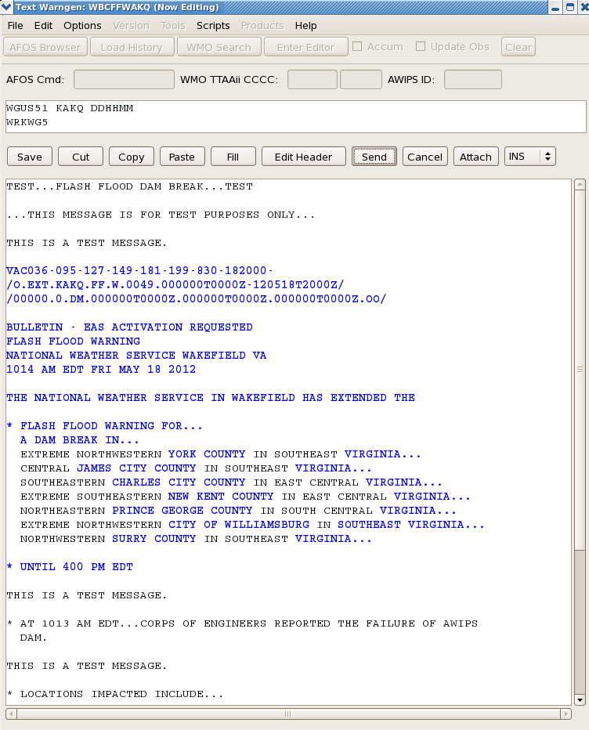
Figure 3 - Extension

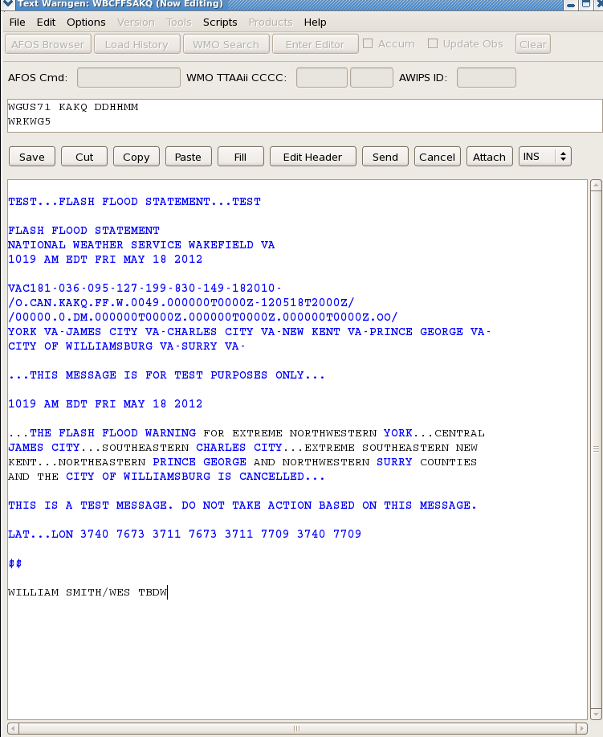
Figure 4 - Cancellation

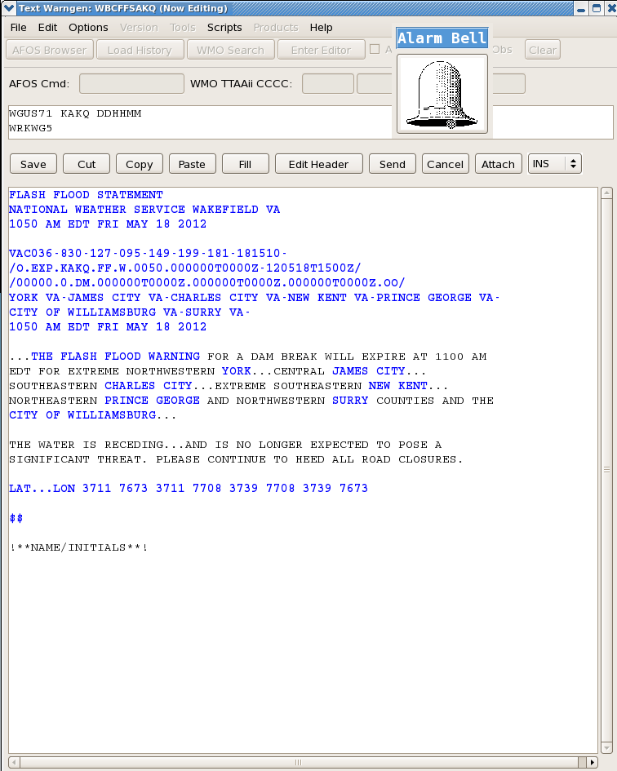
Figure 5 - Expiration

000
WGUS53 KEAX 251518
FFWEAX
MOC101-107-252130-
/O.NEW.KEAX.FF.W.0008.120525T1518Z-120525T2130Z/
/00000.0.ER.000000T0000Z.000000T0000Z.000000T0000Z.OO/

BULLETIN - EAS ACTIVATION REQUESTED
FLASH FLOOD WARNING
NATIONAL WEATHER SERVICE KANSAS CITY/PLEASANT HILL MO
1018 AM CDT FRI MAY 25 2012

THE NATIONAL WEATHER SERVICE IN PLEASANT HILL HAS ISSUED A

* FLASH FLOOD WARNING FOR...
NORTHERN JOHNSON COUNTY IN WEST CENTRAL MISSOURI...
SOUTHERN LAFAYETTE COUNTY IN WEST CENTRAL MISSOURI...

* UNTIL 430 PM CDT FRIDAY

* AT 1016 AM CDT...NATIONAL WEATHER SERVICE DOPPLER RADAR INDICATED
SLOW MOVING THUNDERSTORMS WITH VERY HEAVY RAINFALL ACROSS THE
WARNED AREA. RADAR ESTIMATES THAT BETWEEN 3 AND PERHAPS AS MUCH AS
5 INCHES HAS FALLEN WITH SEVERAL ROUNDS OF STORMS THIS MORNING.
WITH ADDITIONAL STORMS MOVING THROUGH THE AREA ANOTHER INCH OR
TWO OF RAINFALL IS POSSIBLE IN THE NEXT HOUR TO TWO HOURS.

* RUNOFF FROM THIS EXCESSIVE RAINFALL WILL CAUSE FLASH FLOODING TO
OCCUR. SOME LOCATIONS THAT WILL EXPERIENCE FLOODING INCLUDE...
CONCORDIA AND ODESSA.

THIS WILL IMPACT

I-70 BETWEEN MILE MARKERS 30 AND 62.

PRECAUTIONARY/PREPAREDNESS ACTIONS...

DO NOT UNDERESTIMATE THE POWER OF FLOOD WATERS. ONLY A FEW INCHES OF
RAPIDLY FLOWING WATER CAN QUICKLY CARRY AWAY YOUR VEHICLE. TURN
AROUND... DONT DROWN.

&&

LAT...LON 3897 9412 3897 9411 3901 9411 3906 9350
3883 9350 3878 9412

$$

Figure 6 – Flash Flood Warning - New

000
WGUS73 KEAX 251719
FFSEAX

FLASH FLOOD STATEMENT
NATIONAL WEATHER SERVICE KANSAS CITY/PLEASANT HILL MO
1219 PM CDT FRI MAY 25 2012

KSC091-MOC037-095-252000-
/O.CON.KEAX.FF.W.0007.000000T0000Z-120525T2000Z/
/00000.0.ER.000000T0000Z.000000T0000Z.000000T0000Z.OO/
JOHNSON KS-CASS MO-JACKSON MO-
1219 PM CDT FRI MAY 25 2012

...FLASH FLOOD WARNING REMAINS IN EFFECT FOR SOUTHEASTERN JOHNSON
COUNTY IN EAST CENTRAL KANSAS...AND SOUTHERN JACKSON AND NORTHERN
CASS COUNTIES IN WEST CENTRAL MISSOURI UNTIL 300 PM CDT...

AT 1215 PM CDT...THE HEAVY THUNDERSTORMS FROM EARLIER IN THE
MORNING HAVE ENDED...HOWEVER EXCESSIVE RUNOFF THE EXTREME RAINFALL
WAS CONTINUING TO CAUSE FLOODING PROBLEMS. FLOODING WAS REPORTED
1 MILE EAST SOUTHEAST OF PLEASANT HILL AT 1140 AM CDT WHERE ONE FOOT
OF WATER WAS FLOWING OVER THE INTERSECTION OF COUNTRY CLUB DRIVE
AND MURRAY ROAD IN. EXCESSIVE RUNOFF WILL CONTINUE THROUGH EARLY THIS
AFTERNOON AS WATER DRAINS INTO LARGER STREAMS AND CREEKS.

SOME LOCATIONS THAT WILL EXPERIENCE FLOODING INCLUDE...BELTON...
GRANDVIEW...GREENWOOD...LAKE LOTAWANA...LEE'S SUMMIT...PLEASANT
HILL...RAYMORE...LAKE WINNEBAGO AND LONE JACK.

THIS WILL IMPACT THE FOLLOWING INTERSTATES...

I-435 LOOP FROM MILE MARKERS 71 TO 79.
I-470 BETWEEN MILE MARKERS 0 AND 11.

PRECAUTIONARY/PREPAREDNESS ACTIONS...

DO NOT DRIVE YOUR VEHICLE INTO AREAS WHERE THE WATER COVERS THE
ROADWAY. THE WATER DEPTH MAY BE TOO GREAT TO ALLOW YOUR CAR TO CROSS
SAFELY.

DO NOT UNDERESTIMATE THE POWER OF FLOOD WATERS. ONLY A FEW INCHES OF
RAPIDLY FLOWING WATER CAN QUICKLY CARRY AWAY YOUR VEHICLE.

&&

LAT...LON 3893 9472 3900 9411 3877 9412 3875 9470

$$

Figure 7 – Flash Flood Warning – FFS-Continuation

000
WGUS43 KDDC 241700
FLWDDC

BULLETIN - EAS ACTIVATION REQUESTED
FLOOD WARNING
NATIONAL WEATHER SERVICE DODGE CITY KS
1200 PM CDT FRI OCT 24 2008

KSC145-250500-
/O.NEW.KDDC.FA.W.0024.081024T1700Z-081025T0500Z/
/00000.0.ER.000000T0000Z.000000T0000Z.000000T0000Z.OO/
1200 PM CDT FRI OCT 24 2008

THE NATIONAL WEATHER SERVICE IN DODGE CITY HAS ISSUED A

* FLOOD WARNING FOR SMALL STREAMS IN...
EAST CENTRAL PAWNEE COUNTY IN SOUTH CENTRAL KANSAS...

* UNTIL MIDNIGHT CDT SATURDAY

* AT 1157 AM CDT WATER WAS STILL BEING REPORTED OVER THE
INTERSECTION OF 50TH ROAD AND R ROAD IN NORTHEASTERN PAWNEE
COUNTY, ABOUT 2 MILES SOUTH OF PAWNEE ROCK.

EXCESSIVE WATER FROM HEAVY RAINS TUESDAY NIGHT WERE STILL TRAVELING
DOWNSTREAM ALONG ASH CREEK.

PRECAUTIONARY/PREPAREDNESS ACTIONS...

MOST FLOOD DEATHS OCCUR IN AUTOMOBILES. NEVER DRIVE YOUR VEHICLE INTO AREAS WHERE THE WATER COVERS THE ROADWAY. FLOOD WATERS ARE USUALLY DEEPER THAN THEY APPEAR. JUST ONE FOOT OF FLOWING WATER IS POWERFUL ENOUGH TO SWEEP VEHICLES OFF THE ROAD. WHEN ENCOUNTERING FLOODED ROADS MAKE THE SMART CHOICE...TURN AROUND...DONT DROWN.

EXCESSIVE RUNOFF FROM HEAVY RAINFALL WILL CAUSE ELEVATED LEVELS ON
SMALL CREEKS AND STREAMS...AND PONDING OF WATER ON COUNTRY ROADS AND
FARMLAND ALONG THE BANKS OF CREEKS AND STREAMS.

&&

LAT...LON 3831 9921 3831 9904 3826 9903 3826 9892
3819 9892 3820 9913

$$

Figure 8 – Areal Flood Warning- New

000
WGUS83 KDDC 240536
FLSDDC

FLOOD STATEMENT
NATIONAL WEATHER SERVICE DODGE CITY KS
1236 AM CDT FRI OCT 24 2008

KSC145-241700-
/O.CON.KDDC.FA.W.0023.000000T0000Z-081024T1700Z/
/00000.0.ER.000000T0000Z.000000T0000Z.000000T0000Z.OO/
PAWNEE KS-
1236 AM CDT FRI OCT 24 2008

...THE FLOOD WARNING REMAINS IN EFFECT UNTIL NOON CDT FOR SMALL
STREAMS IN NORTH CENTRAL PAWNEE COUNTY...

AT 1229 AM CDT...LAW ENFORCEMENT REPORTED WATER FLOODING THE ROAD AT
THE INTERSECTION OF HIGHWAY 50...AND R ROAD...ABOUT 2 MILES SOUTH OF
PAWNEE ROCK. ADDITIONALLY...BARRICADES REMAINED OUT OVER SECTIONS OF
TIMKEN ROAD DUE TO WATER FORM ASH CREEK OUT OF ITS BANKS AND OVER
SEVERAL COUNTY ROADS.

WATER WILL BE SLOW TO DRAIN OFF AND THUS RECEDE VERY SLOWLY.
NORTHEASTERN PAWNEE COUNTY WILL REMAIN SATURATED, ESPECIALLY TO THE
NORTH OF LARNED. LOW LYING AGRICULTURAL LAND ALONG AND NEAR ASH
CREEK WILL BE INUNDATED.

PRECAUTIONARY/PREPAREDNESS ACTIONS...

BE ESPECIALLY CAUTIOUS AT NIGHT WHEN IT IS HARDER TO RECOGNIZE THE
DANGERS OF FLOODING. IF FLOODING IS OBSERVED ACT QUICKLY. MOVE UP TO
HIGHER GROUND TO ESCAPE FLOOD WATERS. DO NOT STAY IN AREAS SUBJECT TO
FLOODING WHEN WATER BEGINS RISING.

&&

LAT...LON 3835 9928 3834 9904 3825 9904 3819 9925

$$

Figure 9 – Flood Warning Followup- Continuation

000
WGUS85 KABQ 210642
FLSABQ

FLOOD ADVISORY
NATIONAL WEATHER SERVICE ALBUQUERQUE NM
1242 AM MDT TUE OCT 21 2008

NMC009-037-210845-
/O.NEW.KABQ.FA.Y.0574.081021T0642Z-081021T0845Z/
/00000.N.ER.000000T0000Z.000000T0000Z.000000T0000Z.OO/
CURRY-QUAY-
1242 AM MDT TUE OCT 21 2008

THE NATIONAL WEATHER SERVICE IN ALBUQUERQUE HAS ISSUED AN

* ARROYO AND SMALL STREAM FLOOD ADVISORY FOR...
NORTHERN CURRY COUNTY IN EAST CENTRAL NEW MEXICO
SOUTHEASTERN QUAY COUNTY IN EAST CENTRAL NEW MEXICO

* UNTIL 245 AM MDT

* AT 1238 AM MDT NATIONAL WEATHER SERVICE DOPPLER RADAR INDICATED
HEAVY RAIN FROM SHOWERS AND THUNDERSTORMS IN AN AREA FROM MAINLY
ALONG AND SOUTH OF INTERSTATE 40 FROM SAN JON TO THE TEXAS BORDER
AND SOUTHWARD TO NEAR RANCHVALE AND PLEASANT HILL. RAINFALL
RATES IN EXCESS OF ONE INCH AN HOUR WERE INDICATED BY DOPPLER RADAR.

* STRONG FLOWS AND HIGH WATER LEVELS ARE EXPECTED IN ARROYOS...SMALL
STREAMS AND OVER LOW WATER CROSSINGS.

PRECAUTIONARY/PREPAREDNESS ACTIONS...

HEAVY RAINFALL MAY CAUSE ARROYOS AND SMALL STREAMS TO SPILL OVER THEIR BANKS...RESULTING IN FLOODING OR LOW LYING AREAS AND ROAD INTERSECTIONS. DO NOT ATTEMPT TO DRIVE THROUGH THESE WATERS. WATER IN ARROYOS MAY TRAVEL MANY MILES AND TAKE HOURS TO REACH YOUR LOCATION FROM UPSTREAM RAIN AREAS.

&&

LAT...LON 3518 10341 3529 10305 3454 10306 3451 10352

$$

Figure 10 – Areal Flood Advisory- New

000
WGUS85 KABQ 210642
FLSABQ

FLOOD ADVISORY
NATIONAL WEATHER SERVICE ALBUQUERQUE NM
1242 AM MDT TUE OCT 21 2008

NMC009-037-210845-
/O.NEW.KABQ.FA.Y.0574.081021T0642Z-081021T0845Z/
/00000.N.ER.000000T0000Z.000000T0000Z.000000T0000Z.OO/
CURRY-QUAY-
1242 AM MDT TUE OCT 21 2008

THE NATIONAL WEATHER SERVICE IN ALBUQUERQUE HAS ISSUED AN

* ARROYO AND SMALL STREAM FLOOD ADVISORY FOR...
NORTHERN CURRY COUNTY IN EAST CENTRAL NEW MEXICO
SOUTHEASTERN QUAY COUNTY IN EAST CENTRAL NEW MEXICO

* UNTIL 245 AM MDT

* AT 1238 AM MDT NATIONAL WEATHER SERVICE DOPPLER RADAR INDICATED
HEAVY RAIN FROM SHOWERS AND THUNDERSTORMS IN AN AREA FROM MAINLY
ALONG AND SOUTH OF INTERSTATE 40 FROM SAN JON TO THE TEXAS BORDER
AND SOUTHWARD TO NEAR RANCHVALE AND PLEASANT HILL. RAINFALL
RATES IN EXCESS OF ONE INCH AN HOUR WERE INDICATED BY DOPPLER RADAR.

* STRONG FLOWS AND HIGH WATER LEVELS ARE EXPECTED IN ARROYOS...SMALL
STREAMS AND OVER LOW WATER CROSSINGS.

PRECAUTIONARY/PREPAREDNESS ACTIONS...

HEAVY RAINFALL MAY CAUSE ARROYOS AND SMALL STREAMS TO SPILL OVER THEIR BANKS...RESULTING IN FLOODING OR LOW LYING AREAS AND ROAD INTERSECTIONS. DO NOT ATTEMPT TO DRIVE THROUGH THESE WATERS. WATER IN ARROYOS MAY TRAVEL MANY MILES AND TAKE HOURS TO REACH YOUR LOCATION FROM UPSTREAM RAIN AREAS.

&&

LAT...LON 3518 10341 3529 10305 3454 10306 3451 10352

$$

Figure 11 – Areal Flood Advisory- Cancellation

