Title | MTSAT High Density Winds (MTSAT HDW) | Test Case Execution Engineer
Test Case Creation Engineer | Shen Zhao | Test Platform Used
Date Test Case Created | 6/6/2008 | Release Version on Testbed
CI | GW | Logged in User’s Role
Site Specific |  | Start Date / Time
TC Updated for Version | AWIPS2 | Completion Date/Time
Last Modified By | Shen Zhao (3/22/2012) | Total Test Time
Executable Steps | 15 (unique) + 6 (repeats) = 21 | Pass/Fail/Pending

Test Case: | B_mtsatHDW
Test Case Description: | This test case is used to verify that the High Density Geostationary Winds data from the Japanese Satellite (MTSAT) has been made available in AWIPS. There are four types of products in this implementation: IR, Water Vapor, Visible, and IR 3.9u. All products data is available at Western CONUS and OCONUS Regions (Alaska and Pacific).
Requirements: | AWIPS-DCS-3492  - The MTSAT High Density Winds (HDW) products will be displayable on D-2D at the North Hemisphere scale only for all West CONUS WFO sites. For WFO sites at Alaska, it will be displayable at the North Hemisphere, Marine, and State scales. For WFO sites at Guam, it will be displayable at the Hemisphere, Pacific, and Regional scales. For WFO sites at Hawaii, it will be displayable at the Hemisphere, Pacific, Regional and State scales. The sites at Puerto Rico and East CONUS will not have these products implemented. All normal D-2D image functionality will be available for the MTSAT HDW displays.  - The MTSAT HDW products will be generated two hours or three hours per cycle and eight cycles per day. The winds derived from the visible imagery will be available five times.  - The wind barbs, sampling, and legends will be color coded same as GOES High Density Winds displays.
Data Input: | N/A
Prerequisite Conditions: | This test case assumes that all software and files are completely and correctly installed. The localization has been successfully run since the installation. In order to test end-to-end (data monitoring, WMO header filtering, purge, decoding, etc), the data must be available over the SBN with a sufficient number of data set (33 cycles in this case) must have been received.  Note: The tests shall be performed on a system localized as a local site.

Table 1.1-1. Test Steps and Expected Results
Step # | Actions / Inputs | Expected Results | P/F | Comments
 | Login to a Linux workstation as an AWIPS user. Launch the D2D in CAVE. | D2D GUI opens.
 | Select N. Hemisphere from the scale dropdown menu. | The current scale changed to North Hemisphere. The background map changed to North Hemisphere map. |  | Req. 1
 | Click on Satellite → Derived Products Plots → MTSAT High Density Winds → IR Plot. | The MTSAT IR winds plotted. |  | Req. 1
 | Repeat step 3 with the Water Vapor Plot, Visible Plot, and IR 3.9u Plot. | The Water Vapor, Visible, and IR 3.9u winds plotted. |  | Req. 1  Repeat 3 steps
 | Verify the image as shown below: | The color bar, legend, etc. should match. |  | Req. 3
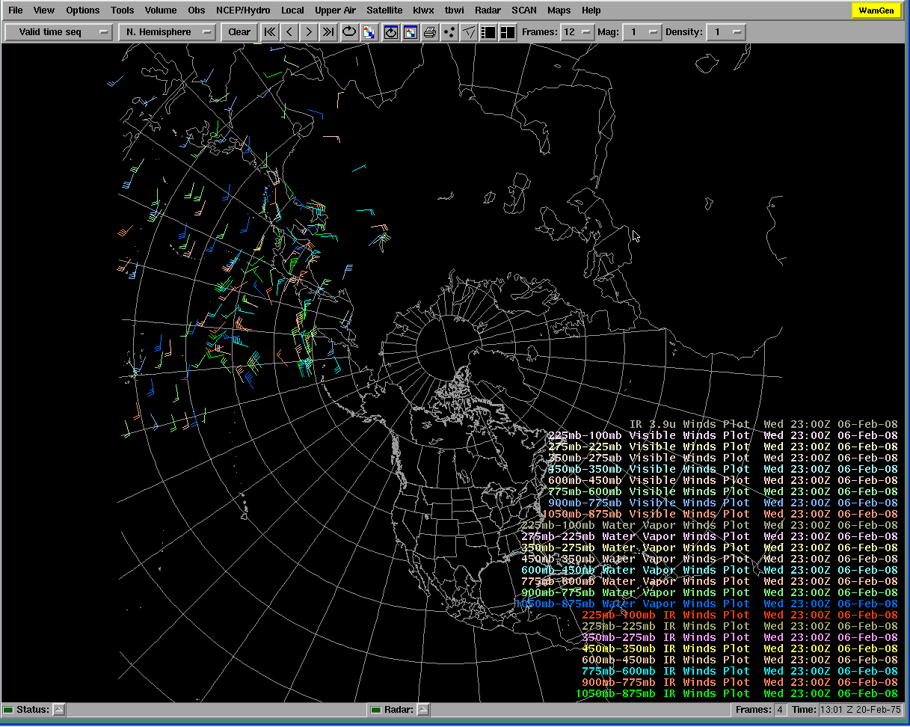
 | Right mouse click on ‘Sample’ check box to turn it on. | The sampling appears where there’s data. The sampling should have format of “hhmmZ ##.#C ###mb ###deg/###kts” where hh is hour, mm is minute, ##.#C is temperature in Celsius, ###mb is pressure in millibar, ###deg is direction, and ###kts is wind speed in knots. |  | Req. 3
 | Click on “<” or “>” button in the top panel of D2D display. | The products should be generated 2 hours or 3 hours per cycle, eight cycles per day, except the Visible are five times per day. |  | Req. 2
 | Click on Clear button. | The plots cleared out.
 | Repeat step 3 with all eight layer plots in the Satellite Layer Winds section. | The winds of all layers are plotted. The plots should be same as the image in step 5, except there are only eight legends. |  | Req. 1  Repeat 3 steps
 | Right mouse click on ‘Sample’ check box to turn it on. | The sampling appears where there’s data. The sampling should have format of “hhmmZ @@ ##.#C ###mb ###deg/###kts” where hh is hour, mm is minute, @@ could be IR, WV, VIS, IR3.9U, ##.#C is temperature in Celsius, ###mb is pressure in millibar, ###deg is direction, and ###kts is wind speed in knots.
 | Verify it with normal D2D features: panning, zooming, etc. | All should work normally. |  | Req. 3
 | Click on “<” or “>” button in the top panel of D2D display. | The products should be generated 2 hours or 3 hours per cycle, eight cycles per day. |  | Req. 2
 | If the MTSAT products are available as live feed, please leave D2D running and check auto-update for MTSAT HDW. Please be patient, it might take more than three hours. | The MTSAT HDW menu and display should update automatically.
 | Click on CAVE → Exit. | D2D GUI closes.
 | Log out and exit user access. | User exits from user access without incident.

Table 1.1-2. Requirements Verification Traceability Matrix (RVTM)
Number | Description | Test Step (s)
1

