Title | C_RFC_ESPADP | Test Case Execution Engineer
Test Case Creation Engineer | Thomas Pepe | Test Platform Used
Date Test Case Created | 07/19/2010 | Release Version on Testbed
CI | RFC | Logged in User’s Role
Site Specific | WFO | Start Date / Time
TC Updated for Version | TO11 | Completion Date/Time
Last Modified By | Richard Barnhill (03/30/12) | Total Test Time
Executable Steps | 15(unique) + 0 (repeats) =15 | Pass/Fail/Pending

Test Case: | C_RFC_ESPADP
Test Case Description: | This test case will test the basic functionality of both the ESPADP program and the Batch Builder that coincides with it.
Requirements: | N/A
Data Input: | N/A
Prerequisite Conditions: | N/A

Table 1.1-1. Test Steps and Expected Results
Step # | Actions / Inputs | Expected Results | P/F | Comments
 | Open a terminal window and execute the following commands:  - xhost +  - sudo su – oper <password> | Oper user is logged in.
 | Set the environment by typing:  If running for AWIPS I:  - export DISPLAY=lx#-tbdr:0.0  - export ofs_level=ofstest  - export db_name=hd_ob7ofstest  - export XAPPLRESDIR=/awips/hydroapps/lx/rfc/app-defaults  - unset XUSERFILESEARCHPATH  - export PGHOST=dx1f  If running for AWIPS II:  - export DISPLAY=lx#-tbdr:0.0  - export ofs_level=ofstest  - export db_name=hd_ob7ofstest  - export XAPPLRESDIR=/awips/hydroapps/lx/rfc/app-defaults  - unset XUSERFILESEARCHPATH  - export PGHOST=dx1-tbw3  - export PGUSER=awips | Environment Variables have been set for testing.
 | Type in the following:  - go ens_rls  - espadp –nomap | ESPADP will start; the main ESPADP window displays.
 | Select each menu at the top of the GUI and verify that they all open and show the correct contents. See Table 1 for details. | All drop down menus on the top of the GUI open and contain the correct contents.
 | Select File -> Exit in the ESPADP main window. | The program will shut down.
ESPADP Batch Builder Test
 | Type in the following:  - go ens_scripts  - bbuilder | The ESPADP Batch Builder will start. The ESPADP Batch Builder main window will open up.
 | Click on the Data Type tab and verify all the options are displayed as shown in Figure 1. | Data type tab opened and all options displayed correctly.
 | Click on the Misc(1) tab and verify all the options are displayed as shown in Figure 2. | Misc(1) tab opened and all options displayed correctly.
 | Click on the Misc(2) tab and verify all the options are displayed as shown in Figure 3. | Misc(2) tab opened and all options displayed correctly.
 | Click on the ESPTS Files tab and verify all the options are displayed as shown in Figure 4. | ESPTS Files tab opened and all options displayed correctly.
 | Click on the Action tab and verify all the options are displayed as shown in Figure 5. | Action tab opened and all options displayed correctly.
 | Select each menu at the top of the GUI and verify that they all open and show the correct contents. See Table 2 for details. | All drop down menus on the top of the GUI open and contain the correct contents.
 | Select File -> Exit in the ESPADP Batch Builder main window. | The program will shut down. Test case is concluded
 | Review the terminal window for any errors or other abnormalities before closing the terminal. | Verify there are no errors or other abnormalities. Make sure the application is “Exiting with status 0”
 | Select File -> Exit in the terminal window. | This closes the terminal window.
Test Case Completed

Table 1.1-2. Requirements Verification Traceability Matrix (RVTM)
Number | Description | Test Step (s)

Table 1:
Menu | Contents | Exists? Y/N
File | Build Calibration Ensemble, Create Basin, Delete Trace, Protect/Unprotect Trace, Reload, ESPINIT, ESPManager, Exit.
Preferences | Default Settings, Environment, Map Overlays.
Adjustments | Error Models, Extended Hydromet, T.S. Regression, Short Term QPF.
Help | About

Table 2:
Menu | Contents | Exists? Y/N
File | New, Open, Save, Save As, Check for Errors, Run Batch, View Output, Exit.
Edit | Undo, Redo, Exit, Delete, Delete All, Copy, Cut, Paste, Select All, Unselect All.
Commands | Insert Command, Append Command, Insert Blanking Command, Insert Comment, Insert User Data, Comment Out Command, Uncomment Command.
Help | About

Figure 1:
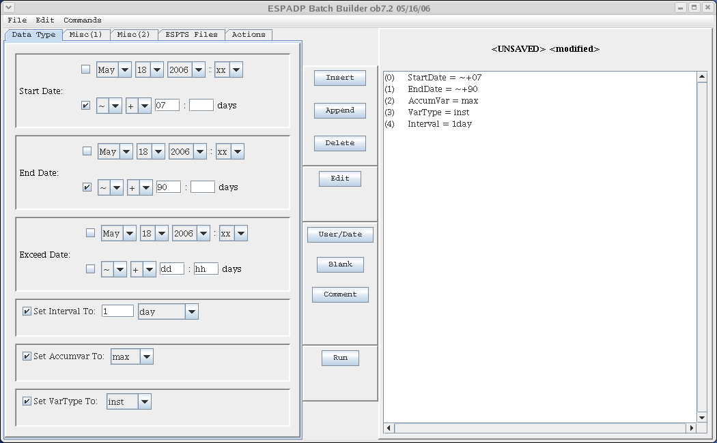

Figure 2
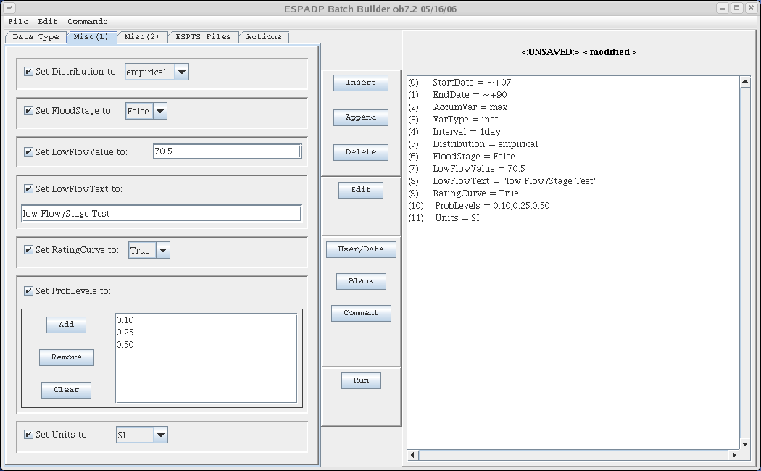

Figure 3
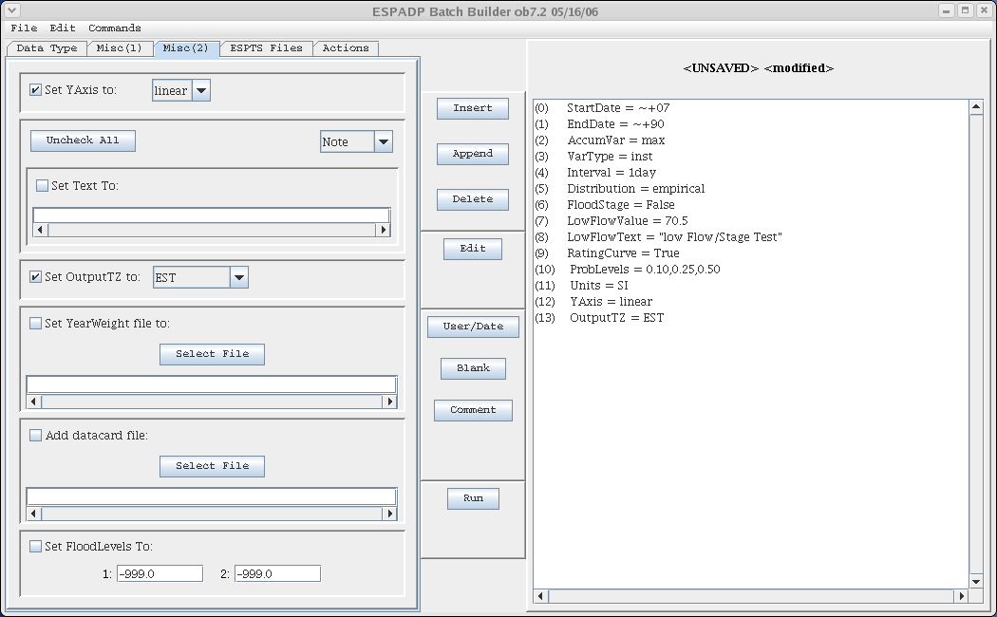

Figure 4
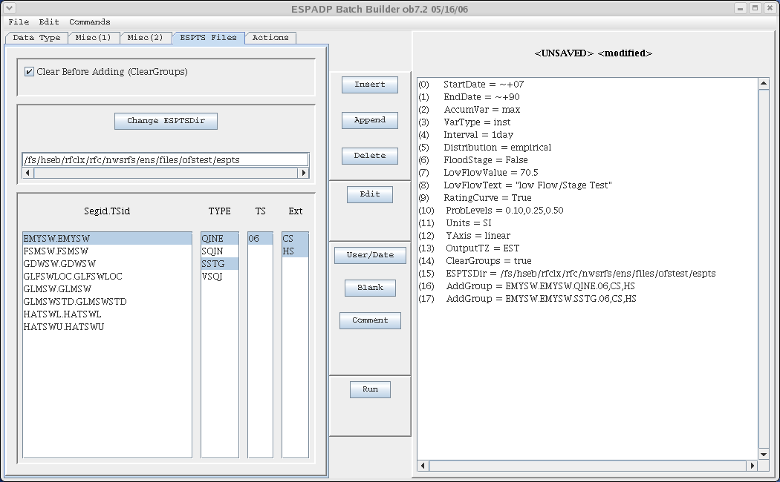

Figure 5
