Title | C_RFC_ICP | Test Case Execution Engineer
Test Case Creation Engineer | Thomas Pepe | Test Platform Used | TBDR
Date Test Case Created | 08/24/2010 | Release Version on Testbed
CI | RF | Logged in User’s Role | oper
Site Specific | RFC | Start Date / Time
TC Updated for Version | TO11 | Completion Date/Time
Last Modified By | Thomas Pepe (11/08/10) | Total Test Time
Executable Steps | 11 (unique) + 0 (repeats) = 11 | Pass/Fail/Pending

Test Case: | C_RFC_ICP
Test Case Description: | This test case demonstrates the basic functionality of the NWSRFS Interactive Calibration Program (ICP). This test must be run on a RFC platform.
Requirements: | - AWIPS-DCS-3481
Data Input: | It will be provided by the OHD Developer as a tar_gzipped file.
Prerequisite Conditions: | - The test case assumes that ICP has been installed. The graphics shown in the following test steps may vary slightly based on window manager preferences and changes made during development that have not been reflected in an updated test plan.  - Refer to the ICP User Manual documentation (http://www.nws.noaa.gov/oh/hrl/general/indexdoc.htm) for an explanation of the behavior of software features. It is expected that the person executing the test plan is familiar with basic ICP features.  - The test package located under the directory /awips/hydroapps/test_data/DCS_3481. To extract the test package: tar –zxvf icp_testpackage.ob83.yyyymmdd.tar.gz

Table 1.1-1. Test Steps and Expected Results
Step # | Actions / Inputs | Expected Results | P/F | Comments
1. | Open a terminal, type:  - xhost +  - sudo su – oper <password> | User oper is logged in.
 | Launch Window:  Go to the test_scripts directory /awips/hydroapps/test_data/DCS_3481/icptest/test_scripts/. Launch the ICP by typing “run_icpnew_testdata rls” (the argument is “rls”). | The ICP Main Window appears. Verify the following in the dialog that appears: (1) The only button enabled on the toolbar should be the Open Deck button. (2) Hover over the Open Deck button on the toolbar – the tooltip should read “Select a control deck”. (3) Title bar shows the text “ICP”. (4) Verify status bar: Shows “Select a control deck”.  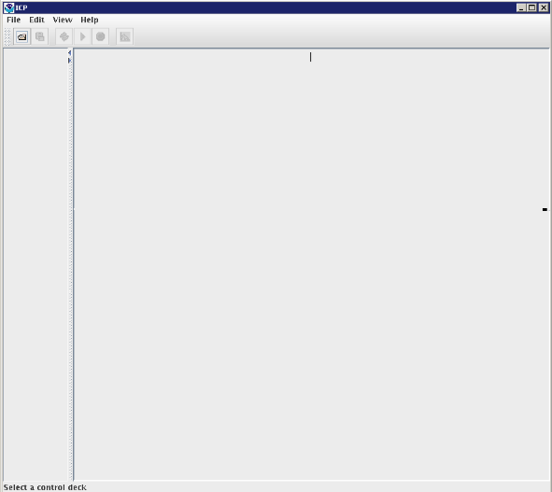
 | Verify File Menu:  Select the File menu item. | Verify that there are menu items enabled under the File menu as shown in the figure below.  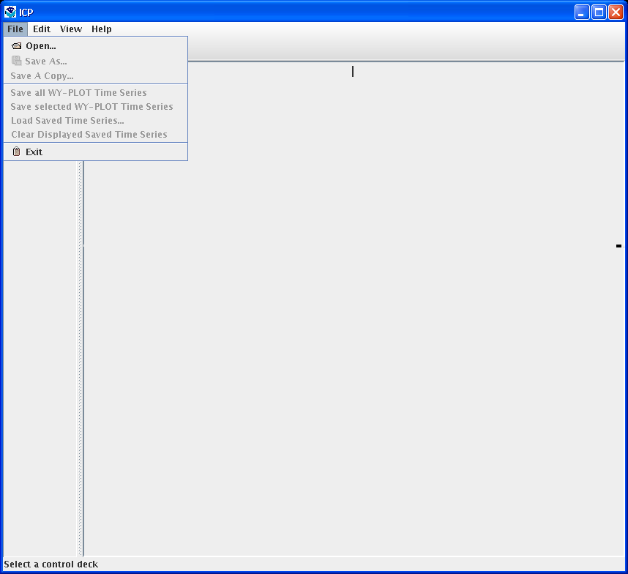
 | Verify Edit Menu:  Select the Edit menu item. | Verify that there are five menu items and that all are disabled: Control Deck, SAC-SMA…,  SNOW-17…, UNIT-HG, WY-PLOT Scale…  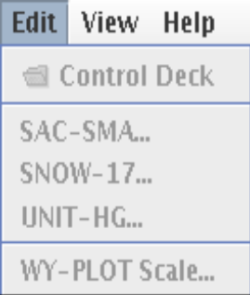
 | Verify View Menu:  Select the View menu item. | Verify that the following menus are available: “Output Listing…” (disabled), “PLOT-TS…” (disabled), “Include Graphs in MCP3 Output File”.  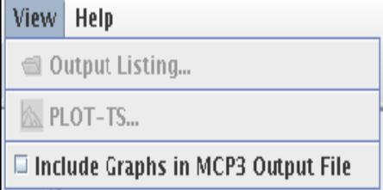
 | Launch the Help -> About dialog:  Select the menu item Help -> About ICP. | The Help About dialog is displayed (see screenshot below, although version will be for the current software).  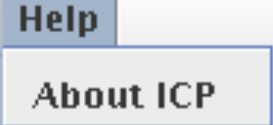  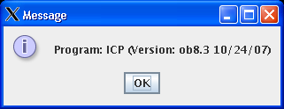
 | Click on OK button. | The Message dialog is dismissed.
 | Launch Open Deck Dialog:  Change to the test_scripts directory. Type “run_icpnew_testdata rls” at the command line. Open deck by selecting File -> Open… | Verify Open Deck Dialog appears as shown below.  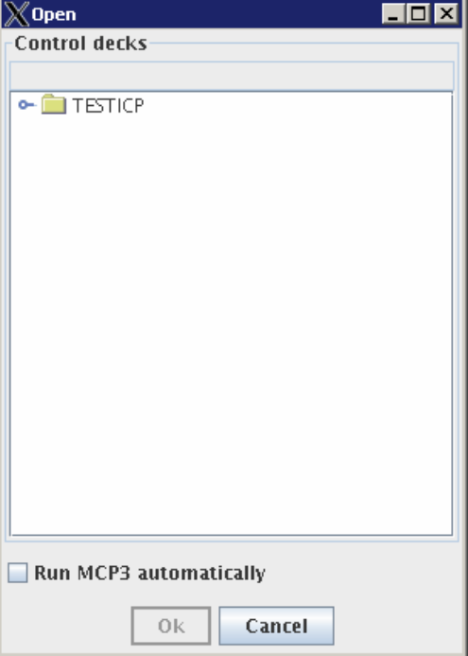
 | Expand Basin:  Click on the node labeled “PETE” (this is a basin) – either double-click on the word “PETE” or click on the key symbol to the left of the folder. | Basin node expands to show children.  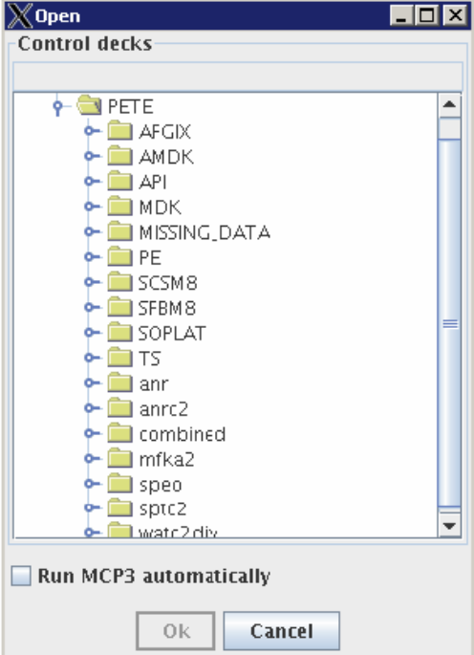
 | Execute MCP and Verify the Run Automatically Checkbox (OK Button):  Select the deck API.curr (TESTICP -> PETE -> API -> API.curr). Click the OK button. | The Open Deck Dialog disappears. The status bar displays the text “Running MCP3…” while MCP is executing. After MCP has executed the status bar displays the text “MCP3 Stop Number: 4” to indicate that the MCP execution was successful. The title bar shows “ICP: API.curr”. The main window is updated to display a new water year plot and list of operations. Verify that no exceptions have occurred by looking at the text that is output to the command prompt.
 | Verify Window Closes using File -> Exit  Click on menu item File -> Exit. | The ICP main window closes.
The test case is completed.

Table 1.1-2. Requirements Verification Traceability Matrix (RVTM)
Number | Description | Test Step (s)
1 | AWIPS-DCS-3481

