Baseline_RFC_Archiver_Database
for
Contract DG133W-05-CQ-1067
Advanced Weather Interactive Processing System (AWIPS)
Operations & Maintenance

AWP.TE.TOTDS-001.01.00

December 8, 2010
Prepared for:
U.S. Department of Commerce
NOAA/NWS Acquisition Management Division
SSMC2, Room 17372
1325 East-West Highway
Silver Spring, MD 20910

Prepared by:


Mission Operations and Services
8401 Colesville Road, Suite 800
Silver Spring, MD 20910

Change History
Doc # | Date | Explanation of Change
N/A | 10/6/2006 | Initial Document
AWP.TE.TODS-001.01.00 | 12/8/2010 | N/A

Release: Baseline | Test Case Creation Engineer: Amanda Wu
Title: RFC Archiver Software Capability Test Case | Date Test Case Created: 10/16/2006
Test Case Execution Engineer: | Pass/Fail/Pending:
Test Platform: TBW4 | Total Test Time:
Start Date: | Run Time for processes or reports:
Complete Date: | Database Instance and Version: PostGres 8.2.x
Logged in User’s Role: | Location of Test Artifacts for this test case: N/A
Notification Server Version: OB9.2 | CI: RF
Last Modified By: Amanda Wu (02/03/2010) | Number of Executable Steps: 169

Test Case #: Baseline_RFC_Archive_Database_M

Test Case Description
This test case demonstrates that the RFC Archiver Software can be successfully utilized. This test case is performed only on the LINUX AX server on the RFC systems.

Requirements: N/A

Data Input: N/A

Prerequisite Conditions:

The general prerequisite conditions for testing apply to this test case. In addition, this test case requires the following:

- The site is an RFC.
- The LINUX machine is properly set up and turned on.
- The /data/flatfiles directory structure (years 2006 and forward) has been updated to the new structure. http://www.nws.noaa.gov/oh/rfcdev/docs/Visio-ArcFFTree5.pdf
4. The PostgreSQL RDBMS is up and running.
5. The RFC Archiver Software package has been properly installed.
6. /awips/hydroapps/.Apps_defaults_site file has been edited with local information

Step # | Action | Expected Results | Pass(P)/  Fail(F)  Pending (Pen) | DR #, Name and Description for failed step | Comments
PART 1: PreTest Set-up Instructions (Steps 1 – 8 should be done by the Environment team)

General Set-up: Before any testing can be performed, a proper user session must be established. In addition test data is loaded
 | Login to an awips workstation as any user (ex. oper) and open a terminal window. From the prompt, type:  ssh ax [Enter]  . /rfc_arc/lib/rax.profile [Enter] | The user is logged into the ax machine.
 | Check to see that the tokens in the file /rfc_arc/cfg/apps_defaults_rax are in the .Apps_defaults and/or .Apps_defaults_site file located in the directory /awips/hydroapps. Add any tokens which are missing to the .Apps_defaults_site file. | Check of the .Apps_defaults and .Apps_defaults_site files has been done.
 | Check to ensure certain environment variables are defined.  echo $APPS_DEFAULTS [Enter]  echo $APPS_DEFAULTS_SITE[Enter] | It should return the value /awips/hydroapps/.Apps_defaults  It should return the value /awips/hydroapps/.Apps_defaults_site
 | If the proper values were returned in step 3, skip this step.  Other wise, enter the following commands.  export APPS_DEFAULTS=/awips/hydroapps/.Apps_defaults [Enter]  export APPS_DEFAULTS_SITE=/awips/hydroapps/.Apps_defaults_site [Enter] | The environment variables have been defined
 | Install adb_ob83krf database from pg_dump file. This is the database that will be used by most the applications in the remainder of the test plan. Enter the following commands:  cd /data/dbbackups [Enter]  createdb –U postgres adb_ob83krf [Enter]  gunzip adb_ob83krf.dump.gz | psql –U postgres adb_ob83krf [Enter] | The test database, adb_ob83krf, has been created and data loaded. This step will take several hours (~10 hours). This can be checked by doing the following commands:  psql –U pguser –d adb_ob83krf [enter]  \d [Enter]  You should now see a list of the tables that reside in the adb_ob83krf database listed. To exit psql: \q [Enter]  Note: this part of the PreTest Set-up actually tests the restore of the RFC Archive db. By installing this database, adb_ob83krf, the dataset needed to do the actual testing is installed. This step of the Pre-Test may take several hours to perform.
 | Make sure the tokens adb_name is set to adb_ob83krf in the .Apps_defaults_site file. And also make sure the token db_name is set to the name of the hydro database (hd_ob83xxx where xxx 3-char site id) on your dx1 system  cd /awips/hydroapps [Enter]  With the editor of your choice, open the .Apps_defaults_site file. Search for the variable adb_name and make sure the value to the right of the colon “:” is adb_ob83krf. Search for the token db_name and make sure it is correct | You have made sure the tokens adb_name and db_name are set correctly for the rest of this test
Change the name of the “/data/flatfiles/2005/grids/mpe” directory to its new name “/data/flatfiles/2005/grids/qpe_xmrg”.

cd /data/flatfiles/2005/grids [Enter]
mv mpe qpe_xmrg [Enter]

 | From the terminal window, enter the command <ps –ef |grep shef> to verify if the raw and processed shefdecoders have been turned on. If it’s not then perform the following to turn them on:  cd /rfc_arc/scripts/decoders [Enter]  ./start_raw_decoder [Enter]  ./start_processed_decoder [Enter] | The raw and processed shefdecoders have been turned on.
PART 2: Section 1 thru 5 will test the applications in arcmenu’s main menu
Section 1 – Test arcmenu.... (arcmenu will be used to launch most of the applications included in this test section 2 thru 25 as well.)
 | Login to an awips workstation as an ‘oper’ user and open a terminal window. Note user needs to belong to group fxalpha. From the prompt, type:  ssh ax [Enter] | The user is logged into the ax machine
 | Set the host to ax by typing:  export PGHOST=ax | PGHOST is set to ax server
 | From the ax system prompt, run arcmenu by typing:  . /rfc_arc/lib/rax.profile [Enter]  cd /rfc_arc/bin [Enter]  arcmenu [Enter] | The Archive Database Programs menu (main menu) appears with the following options:  1. DatView  2. ff_oper_view  3. Display_rc  4. ArcNav  5. ff_oper_viewX (note: flat file view, old directory structure)  V. Other Viewing/Extraction menu  P. Data Processing menu  S. SHEF Encoding menu  A. Admin menu  D. Shefdecoders menu  Q. Quit
 | Display the submenu for the shefdecoders., by typing:  d [Enter] | The submenu displays, as shown below:  - status of shefdecoders  - start_raw_decoder  - start_processed_decoder  - stop_raw_decoder  - stop_processed_decoder  M. Main manu  V. Other Viewing/Extraction menu  P. Data Processing menu  A. Admin menu  S. SHEF Encoding menu  Q. quit
 | Display the status of the raw and processed shefdecoders.  1 [Enter] | Information from a “ps –ef | grep shef” command displays. Example of what this might look like is shown below:  ENTER Selection: 1  oper 23846 1 0 May01 ? 00:05:30 /rfc_arc/bin/shef_decode_raw  oper 32209 1 0 May01 ? 00:05:30 /rfc_arc/bin/shef_decode_pro  oper 12903 12901 0 23:16 pts/1 00:00:00 grep shef  /rfc_arc/scripts/decoders/status_decoders <CR> to continue
 | Return to the menu.  Press the [Enter] key to return to the menu | shefdecoders menu is re-displayed
 | Return to the main menu.  m [Enter] | Main menu is displayed
Section 2 - Test the xmrg viewer, arcnav
 | Select arcnav option from arcmenu’s main menu  4 [Enter] | A Program arcnav GUI window will pop-up on the screen similar to the one below
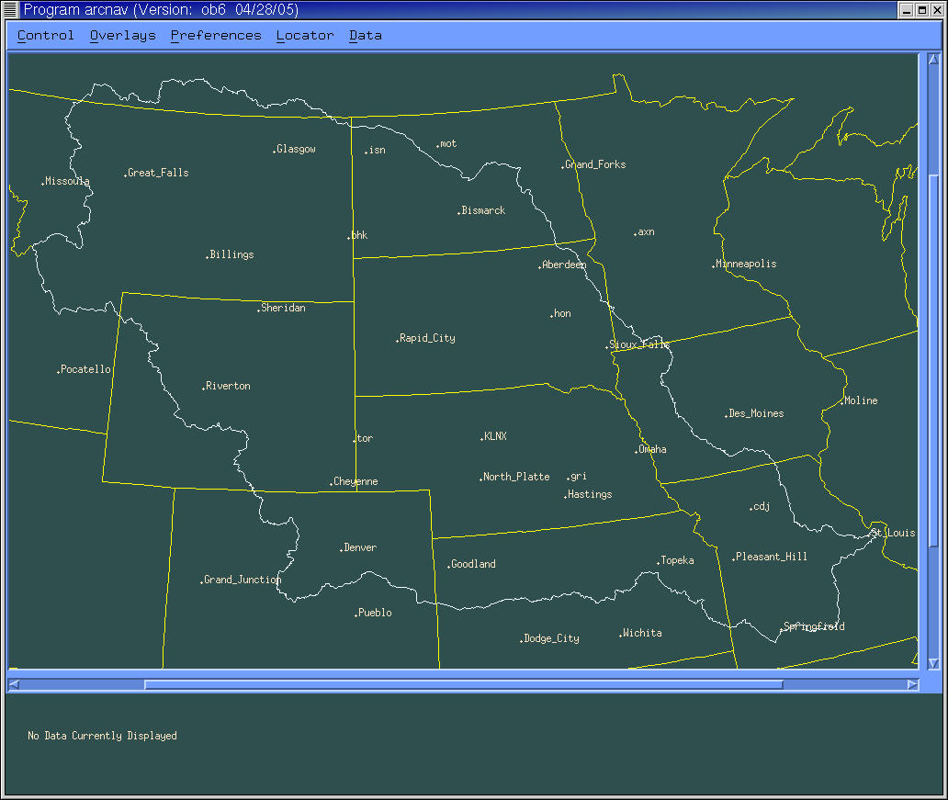
 | Display radar precipitation hourly data selection box.  Go to the pull down menu “data”: and select “radar precipitation”.  Click on hourly option | A selection box will appear on the screen similar to the one shown below.
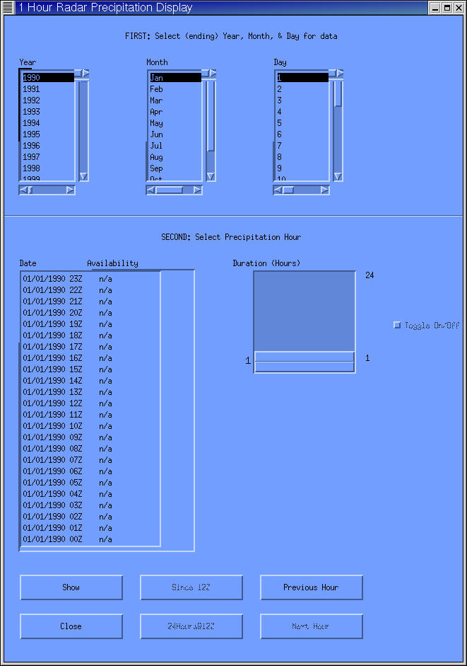
 | Display data for the date 2005-04-20  Select the year 2005. Select the month April. Select the day 20 | A list of available hourly mug files should display in the window in the lower left hand portion of the selection box
 | Display the hourly radar precipitation data for the 12Z hour  Click on the date “04/20/2005 12Z”  Click the “Show” button.  Click on the main map window | The data should display in the main map window. And the selection box should now be in background
 | Close the selection window  Click on the selection box to bring it back on top.  Click the “Close” button in the selection box. | The selection box disappears.
 | Exit arcnav  Go to the “Control” pull down menu and click on “Quit”. | Arcnav window disappears and user is returned to arcmenu’s main menu.
Section 3 - Test the rating curve display program, isplay_rc
 | Start the rating curve viewer by selecting option 3 from the main menu  3[Enter] | The “display_rating table” window appears with a prompt for the user to enter a station identifier for the rating curve to be viewed.
 | Next to “Enter id:” space type APNC2 and select OK | A new window labeled “choose” appears
 | Click the “USGS” button | The “choose” window will disappear and a window labeled “display” will appear with a properly labeled table and plot will appear with rating curve information for the selected location. The table will contain a list of stage and flow values. A plot of stage versus flow will appear in the same window
 | Exit the window by clicking the “QUIT” button in the “display” window | The “display” window disappears
 | Exit the display_rc program by clicking the “QUIT” button in the “display rating table” window | The “display rating table” window disappears and the user is returned to the main menu display
Section 4 - Test the data viewing application, DatView
 | Start the DatView program by selecting option 1 from the main menu  1[Enter] | The DatView window opens
 | Select the Find Ids button in the DatView window | The Find Ids window opens
 | Enter a "KCD" in the Filter String (ID or NAME) box. Select the Find button. | A list of stations appears.
 | Select the KCDM7 location and select Close. | The Find IDs window closes and the location is listed in the DatView window.
 | Enter the following information by clicking the arrow keys next to each field:  PE: HG  Duration: I  Type Source: ALL  Extremum: Z  Probability: Z | The selections are displayed in windows.
 | Find the requested data by selecting the Query button at the bottom left corner of the DatView selection window | Data appear in the DatView plot and text windows.  Note: This could take several minutes.
 | Adjust window scaling by using vertical scale slider bar on plot window. | Window scaling is adjusted.
 | Select a point on the plotted time series using the crosshairs. | The coordinate values for the selected point are displayed.
 | End the test of DatView by selecting the Exit button in the DatView window. | All datview windows are closed and the user is returned to the main menu display.
Section 5 - Test the flat file viewer, ff_oper_view.
 | Start the flat file viewer by selecting option 2 from the main menu.  2[Enter] | The flat file viewer window opens.
 | Select the following options in the left display panel:  3 (use slider bar) /month  2004 (use slider bar) /year  text (click on button) | The list of product types is displayed in the middle panel.
 | From the list of product types, select: other | A list of test file names is displayed in the right panel.
 | View each of the following files individually by double-clicking on the file name.  test.txt (if file exists)  MSR_mpe_2004032518z.jpeg | The file is automatically displayed using the appropriate software.  Note: for the purpose of this test, the user should exit each viewing application prior to selecting a new file. This will minimize screen clutter and provide an independent test for each file
 | End the test of the flat file viewer by selecting the Quit button | All windows associated with the flat file viewer are closed and the user is returned to the main menu display.
Sections 6 thru 13 will test the application in arcmenu’s data processing submenu.
Note: For section 6 – 12 which test the various level 1 processors, logfiles are written to the directory /rfc_arc/logs/process and the data output files are written to /rfc_arc/data/process. Once a level 1 processor completes the any data files it created are copied to the incoming directory for the shef_decode_pro application for posting to the RFC Archive DB.
Section 6 - Test the process_precip application.
 | From arcmenu’s main menu, select the data processing menu.  P[Enter] | Data Processing menu is displayed.
 | Start the level 1 precip processor by selecting option 1 from the data processing menu. | The user is prompted to select the source of stations to be processed.
 | Select the default option, database, by pressing the [Enter] key | The user is prompted to select which stations to process.
 | Select the default option, stations with new reports only, by pressing the [Enter] key. | The user is prompted for the type of processing to be done.
 | Select the default, all, by pressing the [Enter] key. | The user is prompted for a starting date.
 | Press the [Enter] key to select the default. | The user is prompted for an ending date.
 | Press the [Enter] key to select the default | The data is processed (this could take several minutes). The level 1 processor finishes and the user is returned to the data processing menu.
Section 7 - Test the process_stage application.
 | Start the level 1 stage processor by selecting option 2 from the data processing menu.  2[Enter] | The user is prompted to select the source of stations to be processed.
 | Select the default, database, by pressing the [Enter] key. | The user is prompted to select which stations to process.
 | Select the default, stations with new reports only, by pressing the [Enter] key. | The user is prompted for a starting date.
 | Press the [Enter] key to select the default | The user is prompted for an ending date.
 | Press the [Enter] key to select the default | The data is processed (this could take several minutes). The level 1 processor finishes and the user is returned to the data processing menu.
Section 8 - Test the process_temp application.
 | Start the level 1 temperature processor by selecting option 3 from the data processing menu.  3[Enter] | The user is prompted to select the source of stations to be processed.
 | Select the default, database, by pressing the [Enter] key | The user is prompted to select which stations to process.
 | Select the default, stations with new reports only, by pressing the [Enter] key | The user is prompted for a starting date.
 | Press the [Enter] key to select the default. | The user is prompted for an ending date.
 | Press the [Enter] key to select the default. | The data is processed (this could take several minutes). The level 1 processor finishes and the user is returned to the data processing menu
Section 9 - Test the process_sw application.
 | Start the level 1 snow water equivalent processor by selecting option 4 from the data processing menu.  4[Enter] | The user is prompted to select the source of stations to be processed.
 | Select the default, database, by pressing the [Enter] key | The user is prompted to select which stations to process.
 | Select the default, stations with new reports only, by pressing the [Enter] key | The user is prompted for a starting date.
 | Press the [Enter] key to select the default. | The user is prompted for an ending date.
 | Press the [Enter] key to select the default. | The data is processed (this could take several minutes). The level 1 processor finishes and the user is returned to the data processing menu
Section 10 - Test the process_flow application.
 | Start the level 1 flow processor by selecting option 5 from the data processing menu.  5[Enter] | The user is prompted to select the source of stations to be processed.
 | Select the default, database, by pressing the [Enter] key | The user is prompted to select which stations to process.
 | Select the default, stations with new reports only, by pressing the [Enter] key | The user is prompted for a starting date.
 | Press the [Enter] key to select the default. | The user is prompted for an ending date.
 | Press the [Enter] key to select the default. | The data is processed (this could take several minutes). The level 1 processor finishes and the user is returned to the data processing menu
Section 11 - Test the transfer_txn application.
 | Start the level 1 max/min temperature processor by selecting option 6 from the data processing menu.  6[Enter] | The user is prompted to select the source of stations to be processed.
 | Select the default, database, by pressing the [Enter] key | The user is prompted to select which stations to process.
 | Select the default, stations with new reports only, by pressing the [Enter] key | The user is prompted for a starting date.
 | Press the [Enter] key to select the default. | The user is prompted for an ending date.
 | Press the [Enter] key to select the default. | The data is processed (this could take several minutes). The level 1 processor finishes and the user is returned to the data processing menu
Section 12 - Test the trans_precip application.
 | Start the level 1 transfer precip processor by selecting option 7 from the data processing menu.  7[Enter] | The user is prompted to select the source of stations to be processed.
 | Select the default, database, by pressing the [Enter] key | The user is prompted to select which stations to process.
 | Select the default, stations with new reports only, by pressing the [Enter] key | The user is prompted for a starting date.
 | Press the [Enter] key to select the default. | The user is prompted for an ending date.
 | Press the [Enter] key to select the default. | The data is processed (this could take several minutes). The level 1 processor finishes and the user is returned to the data processing menu
Section 13 - Test the slope to stage application (slope_to_stage)
 | Start the slope to stage program by selecting option 8 from the data processing menu.  8[Enter] | A window will appear prompting the user to enter a station identifier and a value marker.
 | Enter: ACLA2 23.0A and press [Enter] | The screen will echo the slope and calculated stage:  ACLA2 SLOPE=23.00A  STAGE = 15.00
 | Repeat the previous step with a  different slope. Type: ACLA2 53.6A and press [Enter] | The screen will echo the slope with a comment:  The ACLA2 SLOPE VALUE 53.6 IS OFF OF THE A SLOPE PROFILE
 | Repeat step 79 with a different slope and alphabetic marker.  Type: ACLA2 0.B | The screen will echo the slope and calculated stage:  ACLA2 SLOPE= 0.00B  STAGE = 7.86
 | Exit the test of the slope to stage  application by typing: QQ at the  prompt. | The slope to stage application windows will close and the user is returned to the data processing menu.
Sections 14 thru 16 will test the applications in arcmenu’s SHEF Encoding submenu.
Section 14 - Test the dcparse application.
 | From main menu choose SHEF Encoding menu  s [Enter] | The Shef Encoding menu is displayed.
 | Start dcparse by choosing option 1.  1[Enter] | The user is prompted for the name of the input file.
 | Enter complete pathname for input file.  /rfc_arc/data/testfiles/dcparse.test [Enter] | The header information from the input file is displayed on the screen and the user is prompted for the LID of the data.
 | Enter LID for the data.  FREQ1 [Enter] | The user is prompted for the 7 character shef code of the data.
 | Enter shef code.  HGI2GZZ [Enter] | A shef encoded file is created in the current directory (filename written to screen). The user is prompted about whether to send it to the database poster.
 | Enter the number of hours of offset from GMT  6[Enter] | The number is entered
 | Enter ‘n’ (or ‘y’ – result is file is copied to /rfc_arc_data/q/processed/ before ending) | The program ends
 | Press the [Enter] key to return to menu. | The user is returned to the SHEF Encoding menu
Section 15 - Test the nrcdlyparse
 | Start nrcsdlyparse by choosing option 2.  2[Enter] | The user is prompted for ‘ALL’ or the name of the input file
 | Enter complete pathname for input file  /rfc_arc/data/testfiles/nrcs.test [Enter] | The user is prompted for the shef type code (or ‘level’)
 | Type the following:  5[Enter] | There is some screen output as the program parses the file (nrcs id’s will be converted to LID’s if the aliasid table is populated) and a shef encoded file is created in the current directory (filename is ‘input_file’.shef). The program ends
 | Press the [Enter] key to return to menu | The user is returned to the SHEF Encoding window
Section 16 - Test the usgsdlyparse application
 | Start usgsdlyparse by choosing option 3. | A window pops up allowing the user to choose an input file.
 | If file is not in current directory, navigate to proper directory and choose file and click ‘OPEN’ button. (/rfc_arc/data/testfiles/usgs.test). | A window pops up allowing the user to specify an output file.
 | Enter an output file name and click SAVE button. Output file name can be any name of your choosing, for example, usgs.out. | A window pops up prompting the user to enter the LID and SHEF CODE for the data.
 | Enter stcu1 in LID box and qrd5zzz in SHEF CODE box and click the OK button. | A shef encoded file is created and a window pops up asking the user whether to send it to the database poster.
 | Select ‘No’ button. (or ‘Yes’ – a window pops up telling you the file was copied to /rfc_arc_data/q/processed/). | A window pops up telling the user the file was not sent.
 | Select the OK button. | The program ends.
 | Press the [Enter] key to return to menu. | The user is returned to the SHEF Encoding window.
Sections 17 – 18 will test the applications in arcmenu’s Other Viewing/Extraction submenu
Section 17 - Test database utility-forms (adb.pl)
 | Enter the “Other Viewing/Extraction” menu by selecting option V from the main menu.  V[Enter] | The “Other Viewing/Extraction” menu is displayed.
 | From the “Other Viewing/Extraction” sub-menu by selection option 1 from the menu.  1[Enter] | A GUI window wills pop-up on the screen. Example is shown below. The table names listed in the left-hand panel may be different then this example.  Note: The default database will the RFC Archive DB and the tables names in the left-hand panel will be the tables for the RFC Archive DB.
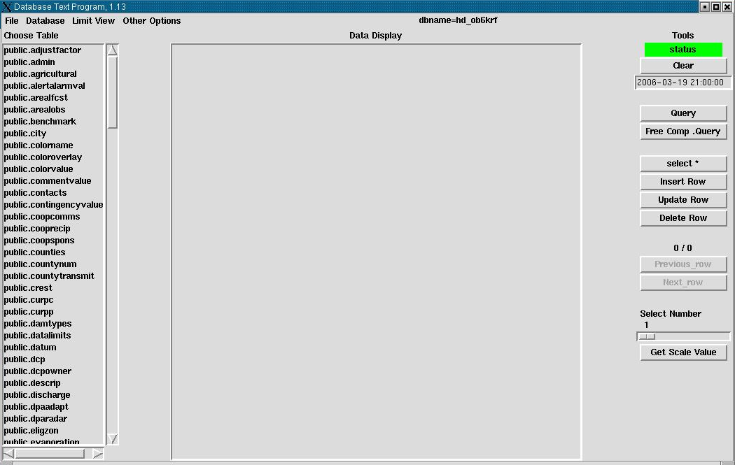
 | In the left-hand panel scroll down until “public.location” is found. Click on “public.location” | In the center panel the form for table location will appear
 | In the right-hand paenel, click the button “select *”. | In the center panel information will be displayed for a site.
 | Exit the database utility application by select Exit from the File pulldown menu in the upper left-hand corner | User will be returned to the “Other Viewing/Extraction” sub-menu.
Section 18 - Test dcextract
 | Select “dcextract” by selecting option 2 from the Other Viewing/Extraction sub-menu.  2[Enter] | A series of prompts for processing information will appear
 | At the station id prompt, type WNLA2 and strike the Enter key. | The id is accepted
 | At the shef parameter code prompt, type PPD1GZZ and strike the Enter key. | The shef parameter code is accepted.
 | At the first year prompt type 1995 and strike the Enter key. | The first year is accepted.
 | At the last year prompt select the default by striking the Enter key | The default last year is accepted (current) and output files are generated. The “Other Viewing/Extraction” sub-menu is displayed. |  |  | /rfc_arc/data/output
Sections 19 – 20 will test the applications in arcmenu’s Admin submenu
Section 19 - Test find_bigfiles script
 | Enter the “Admin” menu by selecting option A from the menu.  A[Enter] | The “Admin” menu is displayed
 | Run “find_bigfiles” by selecting option 1 from the Admin sub-menu.  1[Enter] | The script runs and a nedit window pops up display the results. This script may take a minute or two to run
 | Exit the nedit window | nedit window closes and user is returned to the window with the admin sub-menu
 | Follow the instructions on the screen to return to nthe admin sub-menu by pressing the [Enter] key | The admin sub-menu is now displayed
Section 20 - Test rax_status_df
 | Run “rax_status_df” by selecting option 2 from the Admin sub-menu  2[Enter] | A nedit window pops up displaying the most recent logfile
 | Exit the nedit window | nedit window closes and user is returned to the window with the admin sub-menu with the message <CR> to continue
 | Press the [Enter] key | User is returned to the window with the admin sub-menu with the message <CR> to continue
Sections 21 – 25 will test the applications in arcmenu’s Shefdecoders submenu
Section 21 - Test Check the status of the decoders script
 | Display the submenu for the shefdecoders., by typing:  d[Enter] | The shefdecoders sub-menu is displayed. Example shown below:  -----------------> shefdecoders <-------------------  *** ALWAYS CHECK THE STATUS BEFORE ***  *** STARTING ONE OF THE DECODERS ***  1. status of shefdecoders -- are they running  2. start_raw_decoder  3. start_processed_decoder  4. stop_raw_decoder  5. stop_processed_decoder  M. Main menu V. Other Viewing/Extraction menu  P. Data Processing menu A. Admin menu  Q. quit S. SHEF Encoding menu  ENTER Selection:
 | Select option 1 from the menu  1[Enter] | Information from a “ps –ef | grep shef” command displays. It should show both shefdecoders, shef_decode_raw and shef_decode_pro, are running
 | Return to the sub-menu by pressing the [Enter] key | User is returned to the shefdecoders sub-menu
Section 22 - Test Stop shef_decode_raw application script
 | Select option 4 from the menu.  4[Enter] | The shef_decode_raw program should stop shortly. The user can use option 1 of this menu to check and verify the raw decoder has stopped. Entry for shef_decode_raw should not be returned by option 1 if the decoder has stopped.
 | Return to the sub-menu by pressing the [Enter] key | User is returned to the shefdecoders sub-menu
Section 23 - Test Stop shef_decode_pro application script
 | Select option 5 from the menu.  5[Enter] | The shef_decode_pro program should stop shortly. The user can use option 1 of this menu to check and verify the processed decoder has stopped.
 | Return to the sub-menu by pressing the [Enter] key | User is returned to the shefdecoders sub-menu
Note: The user must verify that both shefdecoders are not running before performing sections 24 and 25. Otherwise the use may unintentionally create a situation where multiple shef_decode_raw and/or shef_decode_pro applications are running. Refer to section 21 for instructions
Section 24 - Test Start shef_decode_raw application script
 | The user must previously have verified that shef_decode_raw is not running, before proceeding. Select option 2 from the menu  2[Enter] | The raw shefdecoder has been restarted. The user can use option 1 of this menu to verify that the shef_decode_raw program has been restarted.
 | Return to the sub-menu by pressing the [Enter] key | User is returned to the shefdecoders sub-menu
Section 25 - Test Start shef_decode_pro application script
 | The user must previously have verified that shef_decode_pro is not running before proceeding. Select option 3 from the menu  3[Enter] | The processed shefdecoder has been restarted. The user can use option 1 of this menu to verify that the shef_decode_pro program has been restarted
 | Return to the sub-menu by pressing the [Enter] key | User is returned to the shefdecoders sub-menu
 | Exit arcmenu by selecting option Q from the menu  Q[Enter] | User is returned to the command line prompt
Note: The remainder of the test is performed from the command line.
Section 26 - Test the shefdecoder check scripts. These scripts normally run in oper’s cron, but for this test plan, will be run manually application
 | As user oper, go to the directory containing the shefdecoder scripts, type:  cd /rfc_arc/scripts/decoders[Enter] | You should now in the directory /rfc_arc/scripts/decoders
 | Run the script “check_raw_decoder”, type:  check_raw_decoder[Enter] | The script check various things, and if need be will restart the shef_decode_raw program.
 | Run the script “check_processed_decoder”, type:  check_processed_decoder[Enter] | The script check various things, and if need be will restart the shef_decode_pro program.
Section 27 - Test the get_states application
 | Enter the directory containing the previously created input file with a non-standard name. Type:  cd /rfc_arc/data/nwsrfs[Enter] | You should now in the directory /rfc_arc/data/nwsrfs
 | Execute the get_states program from the command line by typing:  get_states oper fcst.test.20051226.134652 [Enter] | The program will properly populate the statessacsma and statessnow17 tables within the archive database using the fcst.test.20051226.134652 file as input. A log file called get_states.log is written to the following directory: /rfc_arc/logs/nwsrfs and contains no errors. This apps can take a few minutes to run.
Section 28 - Test get_params and params_del applications
 | Go to the directory containing the test file by typing:  cd /rfc_arc/data/nwsrfs [Enter] | You should now be in the /rfc_arc/data/nwsrfs directory.
 | Execute the get_params program from the command line by typing:  get_params [Enter] | The user is prompted for program option to run
 | Choose option 1 – ‘UNLOAD AND DELETE’ by typing:  1[Enter] | Program runs params_del which unloads and then deletes all rows from the seg, segoper, opersacsma, opersnow17, and operunithg tables. Unload files of each of these tables is created in /rfc_arc/data/nwsrfs. The user is prompted for the input file name.
 | Enter the file name by typing:  seg_punch.test [Enter] | Program parses the segments in the file and properly populate the seg, segoper, opersacsma, opersnow17, and operunithg tables. A log file called get_params.log is created in /rfc_arc/logs/nwsrfs.
Section 29 - Test group_parse and parse_del
Note: Program expects specific file names in /rfc_arc/data/nwsrfs/; test files are: cg.pun, cbbrfc_f.pun
 | Go to the directory containing the test files. Type:  cd /rfc_arc/data/nwsrfs [Enter] | You should now be in the /rfc_arc/data/nwsrfs directory
 | Execute the group_parse program from the command line by typing:  group_parse [Enter] | The program checks whether the cgroup, fgroup, and fgroupseg tables are empty. If any of them contain data, the user is prompted for program option to run. Otherwise, it goes directly to Result (b) below.
 | Choose option 1 – ‘UNLOAD AND DELETE’. Type 1 | (a) Program runs group_del which unloads and then deletes all rows from the cgroup, fgroup, and fgroupseg tables. Unload files of each of these tables is created in /rfc_arc/data/nwsrfs. (b) Program parses the input files and properly populates the cgroup, fgroup, and fgroupseg tables. A log file called group_parse.log is created in /rfc_arc/logs/nwsrfs and contains no errors
Section 30 - Test the loadmods application
Note: The group_parse program must be tested before this, as it uses the information stored in the fgroup and fgroupseg tables; the program expects specific file names in /rfc_arc/data/nwsrfs/mods/; test file is: GB_F
 | Execute the loadmods program from the command line by typing:  loadmods –f GB_F[Enter] | Program parses the modfiles GB_F and stores each mod properly in the corresponding database mod table. In the directory /rfc_arc/data/nwsrfs/mods/ the GB_F file should now be empty and copies of the original files are in GB_F .OLD. Logfile(s) can be found in the /rfc_arc/logs/nwsrfs/mods directory |  |  | Note: If this test case has been executed before & in order for it to be executed again, you’ll have to copy a GB_F.OLD file from the directory /rfc_arc/data/nwsrfs/mods/ and renamed it to GB_F.
Section 31 - Test the fetchmods application
Note: The loadmods program must be tested before this, as it uses the information stored in the database by that program
 | Execute the fetchmods program from the command line by typing:  fetchmods oper 1993040212 5 10 –f GB_F /rfc_arc/data/testfiles/mods [Enter] | Program pulls mods from the database tables and writes them to the GB_F modfiles in the correct format. The GB_F file should contain the same mods it did before the loadmods program was tested. A log file called fetchlog_GB_F is created in /rfc_arc/logs/nwsrfs/mods and contains no errors
Section 32 - Test adbinit suite and pgload application
Note: The adbinit suite was originally designed for initializing the location and ingestfilter tables of the RFC Archive DB. Since no tools for easily keeping the RFC Archive DB in sync with the operational WFHS/IHFS DB exists (will be available in ob8 hopefully). This set of applications was redesigned to help a RFC do some maintenance
 | Go the the directory where the adbinit suite of applications are located and list the directory contents  cd /rfc_arc/bin/adbinit [Enter]  ls [Enter] | User is now in the adbinit directory and list of the files in this directory are displayed |  |  | Note: For our testing purposes, if there was no records inserted in the location.new file then delete a record in location table from adb_ob83krf database.
 | Execute the run_adbinit script. This script runs the applications locatedef and ingestdef  run_adbinit [Enter] | These programs will access the IHFS DB on the dx1 server and create two unload files, location.unl and ingestfilter.unl. Two logfiles, locat.log and ingest.log, are also created |  |  | /rfc_arc/bin/adbinit
 | Execute the load_ingest script. This script uses the pgload program to insert new rows into the ingestfilter table of the RFC Archive DB. Rows that already exist will be skipped and error message indicating duplicate row will be generated.  load_ingest [Enter] | “xx” number of rows are loaded into the ingestfilter table
 | Execute the load_locat script. This script first creates a temporary table and loads the data from the location.unl table into it. A comparison between the location and temporary table is done, and data that is in the temporary table is unloaded to file. The script then uses the pgload program to insert any new data into the location table.  load_locat [Enter] | Information related to load_locat script is written to the screen and user is returned to the command line prompt. Output from the last pgload comman can be found in the file load_loc.err under /rfc_arc/bin/adbinit |  |  | Note: If you receive an error message “ERROR: value “-2147483648” is out of range.....” is because there is a bad data in the hd_ob83xxx database. The workaround is to delete this record -2147483648 from the location.unl file at /rfc_arc/bin/adbinit/location.unl and then rerun the step again.
Section 33 - Test database backups
 | Go to the dbadmin directory and list the directory contents.  cd /rfc_arc/scripts/dbadmin [Enter]  ls [Enter] | The user is now in the dbadmin directory and a listing of the contents of the directory is shown
 | Run the manual database backups script.  run_PGbkups [Enter] | A menu should now be displayed as in the example below:  The following options are available:  1 - pg_dump with no compression  2 - pg_dump with compression using gzip cmd  3 - pg_dump using split cmd  4 - EXIT  Enter option number:
 | Selection option 1.  1[Enter] | A pg_dump to file will be done. The pg_dump will take about 2 hours. The resultant file will be created in the directory /data/dbbackups. Once the pg_dump has completed the user is returned to the menu and enter option prompt.
 | Exit the run_Pgdump script by typing:  4[Enter] | User exits script and is returned to the windows command line prompt.
Section 34 - Test run_vacuumdb script
 | If you are not at the /rfc_arc/scripts/dbadmin directory then type:  cd /rfc_arc/scripts/dbadmin [Enter]  ls [Enter | The user is now in the dbadmin directory and a listing of the contents of the directory is shown
 | Execute the script run_vacuumdb, type:  run_vacuumdb [Enter] | The program runs; this may take about 2 hours. No information is written to the screen. Program has completed when the command line prompt returns. Output is written to a log files located in the /rfc_arc/logs/dbadmin/ directory.
 | To verify the program ran successfully, go to the logs directory type:  cd /rfc_arc/logs/dbadmin [Enter] | You should now be in the directory /rfc_arc/logs/dbadmin
 | Review the log file vdbLog.out, type:  more vdbLog.out [Enter] | logfile is displayed
Section 35 - Test log_stats.tcl
 | From the ax system prompt, change directory to the location of the shef_decode_raw apps daily log files, by typing:  cd /rfc_arc/logs/decoder/raw/logs [Enter]  ls [Enter] | The directory change is successful and a list of available daily log files is shown
 | Execute the log_stats.tcl script by typing:  log_stats.tcl shef_decode_raw_log_”mmdd” [Enter]  or  cd /rfc_arc/scripts/decoders/log_stats.tcl /rfc_arc/logs/decoder/raw/logs/shef_decode_raw_log_”mmdd“ [Enter]  where: mm is today’s two digit month and dd is today’s two digit day  (ex: November 9th is represented as 1109) see list of files names from step 158 to find a value of “mmdd” that exists | Several lines of information will by displayed on the screen. The output written to the screen should look something like the following:  Input file: shef_decode_raw_log_1109  Number of Products = 2663  Number of records processed = 164677  Avg Parse time = 0.00 seconds  Avg Post time = 3.83 seconds  Max Parse Time = 1 seconds  Max Post Time = 354 seconds |  |  | Note: If you did not set a profile (. /rfc_arc/lib/rax.profile) then enter the full path.
Section 36 – Test the utility script run_bounce_postgres
Note: The RFC Archive DB will be temporarily unavailable during this test. Therefore, this test should be coordinated with all other users on the rax system
 | To log in as “root” user, on ax system prompt type:  Exit [Enter]  Exit [Enter]  ssh ax  sudo su – [Enter]  “enter password when prompted”[Enter]  cd /rfc_arc/scripts/sysadmin [Enter] | The directory change is successful
 | Execute the script by typing:  ./run_bounce_postgres [Enter] | The script is executed and initiates the following sequence of events:  - Both shefdecoders and oper’s crontab will be shut down.  - The Informix engine is stopped and restarted.  - oper’s crontab and the shefdecoders are restarted
 | Take steps to verify that the processes have restarted.  Check the status of the shefdecoders by typing the following command from a prompt on the ax machine:  ps –ef | grep shef [Enter] | The shef_decode_raw and shef_decode_pro processes should be displayed
 | Check the status of postgres engine. Typing the following command from a prompt on the ax machine:  ps –ef | grep postmaster [Enter] | The display should indicate that postmaster is running
 | Check the status of oper’s crontab. Login to the ax as user “oper” and type the following command from an ax prompt:  Exit [Enter]  sudo su – oper [Enter]  crontab –l [Enter | If crontab is running, a listing of the cron will scroll on the display
Section 37 – Test the ofsshef
 | Open another terminal, go to the OFS Files oper directory and move the baseline fs5files directory back to fs5files.orig  cd /awips/hydroapps/lx/rfc/nwsrfs/ofs/files/oper [Enter]  mv fs5files fs5files.Orig [Enter]  mkdir fs5files [Enter]  cd fs5files [Enter]  zcat /awips/hydroapps/test_data/DR20801/new_mbrfc_nwsrfsfiles.tar.Z <new file from DEV> | tar –xvf [Enter]  Close terminal | Backing up the original fs5files |  |  | NOTE: If not using new data file then use fs5files.DR20801 under /awips/hydroapps/lx/rfc/nwsrfs/ofs/files/oper by moving fs5files.DR20801 to fs5files as below:  mv fs5files.DR20801 fs5files
 | Switch back to the original terminal and issue the following export commands to set the environment variables:  export TZ=GMT [Enter]  export ofsshef_input=/awips/hydroapps/test_data/DR20801 [Enter]  export ofsshef_output=/awips/hydroapps/test_data/DR20801 [Enter] | Setting up the environment for the ofsshef test.
 | Go to the /rfc_arc/bin directory and run the ofsshef program using the test1 script:  cd /rfc_arc/bin/ [Enter]  ofsshef test1 [Enter] | Runs the ofsshef application using the test1 script.
 | Check the output file by viewing the most recent ofsshef_test1 file:  cd /awips/hydroapps/test_data/DR20801  ls –lart [Enter]  more ofsshef_test1 [Enter] | When viewing the file, (If the updated data is used) one should see a table w/ actual values and not -9999.000 (Missing) data values.
 | Undo changes made in steps 164:  cd /awips/hydroapps/lx/rfc/nwsrfs/ofs/files/oper [Enter]  rm –rf fs5files [Enter]  mv fs5files.Orig fs5files [Enter] | Set everything back to baseline before exiting the application.
 | Close all terminal windows and Exit the application.
This concludes the test case.

