Baseline_RFC_XNAV

for

Contract DG133W-05-CQ-1067

Advanced Weather Interactive Processing System (AWIPS)

Operations & Maintenance

AWP.TE.TOTDS-044.01.00
December 14, 2010

Prepared for:
U.S. Department of Commerce
NOAA/NWS Acquisition Management Division
SSMC2, Room 11220
1325 East-West Highway
Silver Spring, MD 20910

Prepared by:


Mission Operations and Services
8401 Colesville Road, Suite 800
Silver Spring, MD 20910

Change History

Doc # | Date | Explanation of Change
N/A | 20 January 2009 | Initial Draft
AW.TE.TOTDS-044.01.00 | 14 December 2010 | Data Input

Release: Baseline | Test Case Creation Engineer: Carolina Fayos
Title: XNAV | Date Test Case Created: 07/20/2006
Test Case Execution Engineer: | Pass/Fail/Pending:
Test Platform: TBDR | Total Test Time:
Start Date: | Run Time for processes or reports:
Complete Date: | Database Instance and Version: PostGres 9.1.x
Logged in User’s Role: | Location of Test Artifacts for this test case: N/A
Notification Server Version: OB9.1 | CI: RF
Last Modified By: Thomas Pepe (07/20/09) | Test Steps: 53

Test Case #: Baseline_RFC_XNAV_M

Test Case Description: This test case will test the functionality of the XNAV program and how it generates images from RFC Data.
Prerequisite Conditions: Must be logged in into an RFC workstation as an ‘oper’ user
Step # | Action | Expected Results | Pass(P)/  Fail(F)  Pending (Pen) | DR #, Name, Description for failed step | Comments
 | Open a terminal window and set the environment variables by typing the following:  - xhost +  - sudo su – oper  - export DISPLAY=lx#-<testbed>:0.0 (# is what lx you are working on)  - export PGHOST=dx1-<testbed with an AWIPS2 database>  - export PGUSER=awips  - export PGPORT=5432  - export db_name=hd_ob7ofstest  - export xnav_suppress+msg=no  - export xnav_user=ofstest  - export ofs_level=$xnav_user  - export ifp_rfc=$xnav_user  - export xnav_settoday=04/02/1993  - export params=/awips/hydroapps/lx/rfc/xnav/parameters  - export xnav_data =/awips/hydroapps/lx /rfc/xnav/data/$xnav_user  - export xnav_xmrg_dir==/awips/hydroapps/lx /rfc/nwsrfs/ofs/files/ofstest/griddb  - export make24hrxmrg_settoday=$xnav_settoday  - export make6hrxmrg_settoday=$xnav_settoday  - export makeXdaysxmrg_settoday=$xnav_xmrg_dir_out=$xnav_xmrg_dir | The environments are set.
 | If the xmrg files do not exist, then create the xmrg files by executing either one of the commands below:  - cp /awips/hydroapps/lx/rfc/nwsrfs/ofs/files/ofstest/griddb/* $xnav_xmrg_dir | Verified that the files already exist or that the files have been created.
 | Type: go xnav rls (go to directory provided) | Prompted to the directory.
 | Type: xnav (run xnav) | The Program xnav main GUI displays.
 | Select Control -> Load Data -> OFS in the main window. | Item is selected.
 | Select Data -> Radar Precipitation from xmrg files -> 1 Hour Radar in the main window. | 1 Hour Radar Precipitation Display window displays.
 | Click Since 12z in the 1 Hour Radar Precipitation Display window. | Figure 1 should be in the main display window.
 | Click Close in the 1 Hour Radar Precipitation Display window. | 1 Hour Radar Precipitation Display window closes.
 | Select Control -> Restore Image in the main window. | The Image is restored and Figure 1 image disappeared.
 | Select Control -> Load Data -> Postgres in the main window | Item is selected.
 | Select Data -> Gage Precipitation from Postgres in the main window. |  |  | DR #4732 | Option not avail.
 | Select Today 12Z-24 HR PP Data in the Gage Precipitation window. | Figure 2 should be in the main display window. |  | DR #4732 | Step 11
 | Select Data -> Gage Precipitation from Postgres -> Yesterday 12z-24 HR PP Data. | Yesterday 12z-24 HR PP Data displays in the main window. |  | DR #4732 | Step 11
 | Select Control -> Restore Image. | The Image is restored.
 | Select Data -> Gage Precipitation from Postgres -> Other 12z-24 HR PP Data. | The Select Date for PP Data window opens. |  | DR #4732 | Option not avail.
 | Click Display in the Select Date for PP Data window. | Data loads for selected date. |  | DR #4732 | Step 15
 | Click Close in the Select Date for PP Data window. | The Select Date for PP Data window closes. |  | DR #4732 | Step 15
 | Select Control -> Restore Image. | The Image is restored.
 | Select Data -> Gage Precipitation from Postgres -> 6 HR PP Data -> Latest 00z. | Data displays in the main window. |  | DR #4732 | Option not avail.
 | Click MB3 over any Data point in the main window and verify the “Hydrologic Data Site” window appears. | Opens the Hydrologic Data Site window |  | DR #4732 | Postgres warning.
 | Select Close in the Hydrologic Data Site window. Do not click “X” to close this window. | Closes the Hydrologic Data Site window. If “X” is used, it will crash the application with a “Memory Fault” error, |  | DR_20876 XNAV Crashes with Memory Fault error | Step 19
 | Select Control -> Restore Image. | The Image is restored.
 | Select Data -> Gage Precipitation from Postgres -> Hourly PP/PC Data. | The Hourly Gage Precip window opens. |  | DR #4732 | No option avail.
 | In the Hourly Gage Precip window, move the Duration slider, and then click Display. | Hourly Gage Precip with selected Duration displays. |  | DR #4732 | Step 23
 | Click Clear and Close in the Hourly Gage Precip window. | The data clears in the main window and the Hourly Gage Precip window closes. |  | DR #4732 | Step 24
 | Select Data -> Other PE Data from Postgres | The Other PE Data from Postgres window opens.
 | Click Display in the Other PE Data from Postgres window. | The data displays in the main window.
 | Click Clear and Close in the Other PE Data from Postgres window. | The data clears in the main window and the Other PE Data from Postgres window closes.
 | Select Control -> Load Data -> OFS in the main window. | Switches the data from Postgres to OFS.
 | Select Data -> PRDTS Data from OFS Files -> Single Point. | The PRDTS Data from OFS Files window opens.
 | Select MAPX as Data Type and ELRNE as the ID. | A Point plot with the selected data loads.
 | Click the Line Plot radio button. | The Point plot is changed to a Line plot.
 | Click the Bar Plot radio button. | The Line plot is changed to a Bar plot.
 | Click Close in the PRDTS Data from OFS Files window. | The PRDTS Data from OFS Files window closes.
 | Select Control -> Quit in the main window. | The main window closes.
Testing XNAV utility program – make24hrxmrg
 | Type:  - go xnav rls; make24hrxmrg | Verified there should be no error. |  | DR #4732 | Error: Directory not found. This displays in the terminal xnav is being run from.
 | To display 24hr xmrg data file:  Type xnav, select Data -> Radar Precipitation from xmrg files -> 24 Hour Radar. | The 24hr xmrg in the box showing the available xmrgs 04/02/1993 12z is selected. |  | DR #4732 | Step 36.
 | Click Show button. | The xmrg should look like Figure 3 is displayed on the ‘Program xnav’ window. |  | DR #4732 | Step 36
 | Close the 24 Hour Radar Precipitation Display window. | The 24 Hour Radar Precipitation Display window closes. |  | DR #4732 | Step 36
 | Select Control -> Quit in the main window. | The main window closes. |  | DR #4732 | Step 36
Testing - make6hrxmrg
 | Type:  - go xnav rls; make6hrxmrg. | Verified there should be no error. |  | DR #4732
 | To display 6hr xmrg data files:  Type xnav, select Data -> Radar Precipitation from xmrg files -> 6 Hour Radar | There should be 6 hour xmrgs files available. |  | DR #4732 | Step 36
 | Select the first 6hr xmrg(6hrxmrg0402199300z) in the box showing available xmrgs. | The 6hrxmrg0402199300z is selected. |  | DR #4732 | Step 36
 | Click Show button. | The xmrg should look like Figure 4 is displayed on the ‘Program xnav’ window. |  | DR #4732 | Step 36
 | Close the 6 Hour Radar Precipitation Display window. | The 6 Hour Radar Precipitation Display window closes. |  | DR #4732 | Step 36
 | Select Control -> Quit in the main window. | The main window closes. |  | DR #4732 | Step 36
Testing – makeXdaysxmrg
 | Type:  - go xnav rls; makeXdaysxmrg 1 | Verified there should be no error. |  | DR #4732 | No place to type.
 | To display xmrg data file for makeXdaysxmrg:  Type xnav, select Data -> Radar Precipitation from xmrg files -> 24 Hour Radar. | The first 24hr xmrg in the box showing available xmrgs 04/02/1993 12z is selected. |  | DR #4732 | Step 47
 | Click Show. | The xmrg should look like Figure 3. |  | DR #4732 | Step 47
 | Close the 24 Hour Radar Precipitation Display window. | The 24 Hour Radar Precipitation Display window closes. |  | DR #4732 | Step 47
 | Select Control -> Quit in the main window. | This closes the XNAV GUI |  | DR #4732 | Step 47
 | Review the terminal window for any errors or other abnormalities before closing the terminal | Verify there are no errors or other abnormalities |  | DR #4732 | -Plenty of SQL Errors which couldn’t find the hd_ob7ofstest database. In Routine “Get Coops”, “Get hydros”, and “dbase_pe_search”
 | Select File -> Exit in the terminal window. | This closes the terminal window. |  |  | Control>Quit.
This concludes the test case

Figure 1
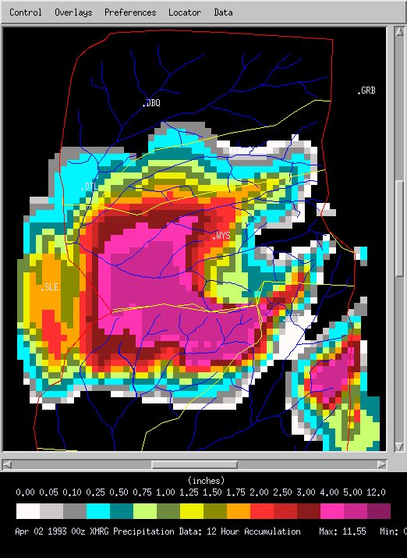

Figure2
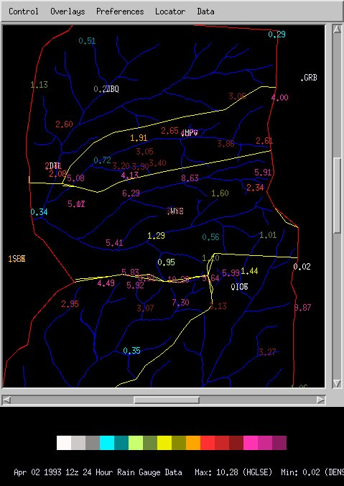

Figure 3
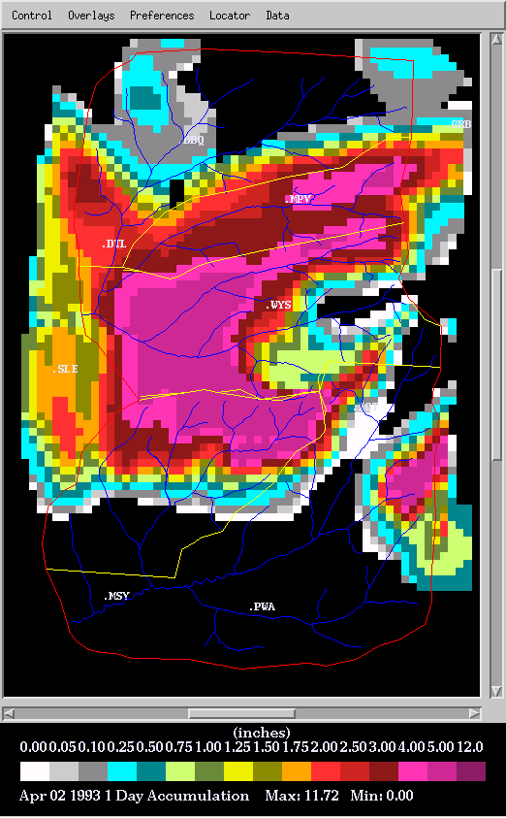

Figure 4
