Title | Baseline Hydrobase | Test Case Execution Engineer
Test Case Creation Engineer | N/A | Test Platform Used
Date Test Case Created | 12/13/2010 | Release Version on Testbed
CI | HY | Logged in User’s Role
Site Specific | N/A | Start Date / Time
TC Updated for Version | AWIPS II | Completion Date/Time
Last Modified By | William Smith 07/08/2013 | Total Test Time
Executable Steps | 112 (unique) + 00 (repeats) = 112 | Pass/Fail/Pending

Test Case: | Baseline Hydrobase
Test Case Description: | This test case demonstrates that AWIPS provides the capability to execute the WFO Hydrologic Forecast System (WHFS) Hydrologic Database Manager (HydroBaseMgr). Hydrobase allows a WFO to manage the IHFS database that supports hydrologic forecasting.
Requirements: | See Table 1.1-2
Data Input: | N/A
Prerequisite Conditions: | None

Table 1.1-1. Test Steps and Expected Results
Step # | Actions / Inputs | Expected Results | P/F | Comments
 | Determine the Hydro Database Manager password by opening a terminal window and typing:  psql -U awips -d hd_obnnxxx -c 'select hb_password from admin;'  (where nnxxx is the release and localized site id, e.g., hd_ob92oax)  nn = 92 | Output from Postgres will display the Hydro Database Manager password:  e.g. on TBDW:  hb_password  -------------  ax3l  (1 row)
 | In CAVE, Mouse Button (MB) 1 click on the Perspectives icon and select ‘Hydro’ from the dropdown menu if available. If not available, select ‘Other…’. Then select ‘Hydro’ from the Open Perspective dialog. | The Hydro Perspective displays in CAVE.
 | Under the ‘HydroApps’ menu, select the ‘Hydro Database Manager’ option.  Enter password the password obtained in Step 1. | The HydroBase window opens, listing all of the forecast points in the site-specific database for the WFO.
 | From the ‘Sort By’ option, select each of the following options in succession:  ‘Station’  ‘Name’  ‘State, County’ | The list is sorted according to the criteria selected.
 | Search for a station (e.g., BLAN1) by using the Search box in the lower right side of the panel. | As each letter is added, the search is further defined.
 | Select ‘Add Location’ from the Location menu. | The Add Location window opens with a template to add new locations. The Add Location window is on the Geophysical Page option.
 | Add a new location named ‘AWIPS2’. See Appendix (end of document) Figure1 1 for input. | None.
 | Select ‘Apply’ and ‘OK’. | The new location is added to the listing of forecast points in the HydroBase window and highlighted.
 | Select ‘Modify Location’ from the Location menu. | The Modify Location window opens with the data just entered for the new location.
 | Select Cancel. | Window closes.
 | Select Contacts from the Location menu. | The Contacts window opens.
 | MB1 click on New. Add the Contact and Phone information shown in Appendix Figure 2. Then MB1 click on ‘Apply’. | Contacts are added.  NOTE: Select New before each entry and Apply after each entry.
 | Select Ok to close the window. | Window closes.
 | Reopen the window by selecting Contacts from the Location menu to verify that the information was added. Then select ‘Close’. | Contacts are there. The window closes.
 | From the River Gage menu, select ‘River Gage’. | The River Gage window opens.
 | With the ‘Page’ option set to ‘Geophysical’, add information to this window from Appendix Figure 3. | See Appendix Figure 3.  NOTE: Application may crash if the Date of Rating field is left blank with the Page option set to Additional Info (DR #19887).
 | Select ‘Apply’ and ‘OK’ to close the window. | The data is added and window closes.
 | Select ‘River Gage’ under the River Gage menu to reopen it. Verify that the information was added. | The data is verifies as saved on the system.
 | Select ‘Cancel’. | The window closes.
 | Select the new station (AWIPS2) from the list of stations. From the ‘River Gage’ menu, select ‘Crest History’ to display the Crest History window. | The window opens.
 | MB1 click ‘New’. Add information to this window from Appendix Figure 4 and Figure 5. Then MB1 click on ‘Apply’.  NOTE: Select ‘New’ before each entry and ‘Apply’ after each entry. | See Appendix Figure 4 and Figure 5.
 | Select ‘OK’ to close the window. | Information is saved and the window closes.
 | Select ‘Crest History’ from the ‘River Gage’ menu to verify that the information was added. Then select ‘Close’. | The data is verified as saved and the window closes.
 | In a terminal window, open the hydro database:  psql –U awips –d hd_ob92xxx  where xxx is the localization ID. | The database is opened.
 | Run the following SQL query  Select lid,lat,lon from riverstat; | Results from the query are displayed.
 | Select a station ID from the query results. | A station ID is selected.
 | In Hydrobase, select the station ID from Step 25 and then select River Gage->River Gage… | River Gage is opened. Observe that the lat/lon is in decimal format instead of deg, min, sec.
 | Make a change to the lat/lon and click on Apply and OK. | The changes are made.
 | In the terminal window, run the following SQL query  Select lid,lat,lon from riverstat where lid=’<LID>’;  <LID> is the station ID you selected in Step 25. | Results from the query are displayed and observe that the changes made in Step 28 have been stored.
 | Select the new station (AWIPS2) from the list of stations. From the ‘Location’ menu, select ‘County/Zone UGC’. | The County/Zone UGC window opens. This window contains counties affected for the forecast point plus all of the available counties in the area.
 | Add information to this window by selecting the county names in the ‘Available’ section and selecting the ‘Add’ button. Repeat for adding Zones after selecting Zones from the Selection drop down menu. | The data are added.
 | Select ‘Apply’ and ‘OK’ to close the window. | The data saved and the window closes.
 | Select ‘County/Zone UGC’ from the ‘Location’ menu to reopen the window. Verify that the information was added.  Verify that the displayed information for zones matches with what’s in the data base with the following query:  psql -U awips -d hd_obnnxxx -c “select * from zoneinfo where lid=’AWIPS2’;”  (where nnxxx is the release and localized site id, e.g., hd_ob92oax) | The data is verified as saved.
 | Select ‘Cancel’. | The window closes.
 | Ensure that the AWIPS2 station is selected and select ‘Flood Category’ from the ‘River Gage’ menu. | The Flood Category window opens, showing definitions of the following flood types: Major, Moderate, and Minor for the station selected.
 | Add information to this window from Appendix Figure 6. | The data is added.
 | Select ‘OK’ to apply and close the window. | The data is saved and the window closes.
 | Select ‘Crest History’ from the ‘River Gage’ menu. | The flood stage categories are depicted as colored lines (See Figure 7 in the Appendix for an example).
 | Select ‘Close’. | The window closes.
 | From the ‘River Gage’ menu, select the ‘Impact Statement’ option. | The Impact Statement window opens with the following types of information: Impact Value, Impact PE, Begin, End, and Tendency.
 | MB1 click on ‘New’. Add information to this window from Appendix Figure 8. Then MB1 click on ‘Apply’.  NOTE: Select ‘New’ before each entry and ‘Apply’ after each entry. | The data is added.
 | Select ‘OK’ to close the window. | The data is saved and the window closes.
 | Select ‘Impact Statement’ from the ‘River Gage’ menu to verify that the data were added. Then select ‘Cancel’. | The data is verified as saved and the window closes.
 | Select a station that is a Reservoir in the Hydro Database (The only stations what will work are ones that have a Reservoir.)  Note: The station icons with a solid bar beneath the triangle are reservoirs. Point Data Control on Hydroview, under the MapData menu, may also be used to locate other reservoirs using the Time-step Query Mode and filtering by Reservoir in the Stations selections.. | The station is selected.
 | Select ‘Reservoir’ from the ‘Reservoir’ menu. | The Reservoir window opens with information on the selected reservoir.
 | Select ‘Cancel’. | The window closes.
 | From the ‘Setup’ on the menu bar option, select the ‘Reference Fields’ option. | The Reference Fields window opens containing a ‘Fields’ option and ‘Add’, ‘Update’, and ‘Delete’ buttons.
 | Select ‘Close’ from the Reference Fields window. | The window closes.
 | Select ‘AWIPS2’ from the HydroBase window. | ‘AWIPS2’ is selected.
 | Select ‘Rating Curve’ from the ‘River Gage’ menu. | The Rating Curve window opens. Verify that flood stage is a red line and the record flood stage is a blue line.
 | Click on the “Import Curve” button. | The resulting GUI should reference the following default file path:  /awips2/edex/data/share/hydroapps/whfs/local/data/import
 | Select ‘Cancel”.  Select ‘Close’. | The windows close.
 | Select ‘Flood Report’ from the ‘Reports’ menu. | The Flood Report window opens with a flood report for the Area of Responsibility.
 | Select ‘Last 12 Months’ from the ‘Reporting Period’ option. | A graphic history of flooding displays.
 | Select a location from the main table and note which location was selected (e.g. BURM4) | A location is selected.
 | Select a Crest Data row from the smaller table and record the values. | Crest Data are selected.
 | Click on the “Insert into Crest Table” button | An Insert Confirmation dialog appears
 | Click on “OK” | The dialog closes.
 | Select ‘Close’ from the Flood Report window. | The Flood Report is closed.
 | Select the location from the list of stations in the main table that was chosen in Step 55. | The Station is selected.
 | Select River Gage->Crest History | Verify that the data entered from Step 55 is listed in the table.
 | Click on the Close button to close the Crest History.  Select Reports->Flood Report…  Then, select ‘Last 12 Months’ from the ‘Reporting Period’ option. | Flood Report is opened
 | Click on the “Save Events to File…” button. Proceed to save the data to a local file. | A dialog appears and the file is saved.
 | Verify that the file was created and contains data. | The saved file is verified.
 | Select ‘Close’ from the Flood Report window. | The Flood Report is closed.
 | Select ‘AWIPS2’ from the listing of forecast points, and select ‘Ingest Filter’ from the ‘Data Ingest’ menu. | The Data Ingest Filter window opens.
 | Select ‘New’. In the ‘NEW Item’ section, add the following:  Location: AWIPS2  Physical Element : HT Tailwater Elev  Duration: Instantaneous (0)  TypeSource: GOES (RG)  Extremum: Null Character (Z)  Also, toggle on the ‘Master Switch’ button. | The data are added.
 | Select ‘Apply’ and then ‘OK’. | The window closes.
 | Select ‘Ingest Filter’ from the ‘Data Ingest’ menu. | The Data Ingest window opens.
 | Find the ‘AWIPS2’ entry in the ‘Ingest Filter Contents for Locations’ section and click on the entry. | Verifies that the information entered in Step 66 is present.
 | Select ‘Cancel’. | The window closes.
 | In the HydroBase window, select ‘Station List Filter Options’. | The Station List Filter Options window opens.
 | Select an HSA under ‘Filter by HSA’. | The item is selected.
 | Select ‘Apply’. | The stations in the HydroBase window are filtered. Only stations in counties with the selected responsible WFO are shown. To redisplay all stations, deselect the HSA selected in Step 72 by holding down the CTL key and clicking on the highlighted HSA.Then select ‘Apply.’
 | Select ‘Close’. | The window closes.
 | Select ‘QC/Alert/Alarm Limits’ from the ‘Data Ingest’ menu. | The QC/Alert/Alarm Limits window opens. Verify that the data are displayed and can be selected.
 | Select ‘Cancel’. | The window closes.
 | Select ‘Time Series Group Configuration’ from the ‘Setup’ menu. | The Time Series Group Configuration window opens from the Localization perspective (group_configuration.cfg). Verify that the file is displayed and can be edited.
 | Close the Localization perspective. | The Localization perspective closes.
 | Select ‘Radar Locations’ from the ‘Setup’ menu in the Hydro perspective. | The Radar Locations window opens. Verify that the data is displayed and can be selected.
 | Select ‘Close’. | The window closes.
 | Select ‘RiverPro General Parameters’ from the ‘Setup’ menu. | The RiverPro General Parameters window opens. Verify that the data are displayed and can be modified.
 | Select ‘Close’. | The window closes.
 | Select ‘RiverPro Forecast Groups/Points’ from the ‘Setup’ menu. | The RiverPro Forecast Groups/Points window opens. Verify that the data is displayed and can be selected.
 | Select ‘Close’. | The window closes.
 | Select a station from the list of stations. Select ‘Areal Definitions’ from the ‘Setup’ menu. | The Areal Definitions window opens. Verify that the data are displayed.
 | Select ‘OK’. | The window closes.
 | Open RiverPro from the Hydroapps menu in the Hydro perspective. | RiverPro is opened
 | From the Forecast Groups/Points for RVS, FLS, FLW section, select an ID from a group that has more than 1 point (just record your selection; no need to click on it). | Record your selection ________
 | In a terminal window, open the hydro database:  psql –U awips –d hd_ob92xxx  where xxx is the localization ID. | The database is opened.
 | Run the following SQL query  Select * from rpffcstpoint where lid=’<LID>’;  Where <LID> is the station ID you selected in Step 89. | Results from the query are displayed. The second field in the result is the group id. Record it here _________.
 | Run the following SQL query  Select * from rpffcstpoint where group_id =’<GID>’;  Where <GID> is the Group ID from Step 91. | All LIDs for the selected Group ID are listed.
 | In the Hydro Database Manger select the ID you selected in Step 89. | The location is selected.
 | Select River Gage->River Gage… | River Gage is opened
 | Click the “Forecast Point Group Assignment” button | A GUI is opened.
 | Click on the Clear button | Data are cleared
 | Click on OK in the River Gage GUI.
 | Repeat the SQL Query in Step 91 | Only the selected ID from Step 89 should be deleted. The other stations in the group remain.
 | Run the following SQL query  Select lid,stage from crest where stage>=100; | Results from the query are displayed.
 | Select an ID from the query results in the Hydro Database Manager | The ID is selected.
 | Select River Gage->Crest History | Crest History is opened. Check to see that all stage values are very high (i.e. > 100), if not select another station.
 | Verify that the Y-Axis does not start at 0. | Y-Axis dos not start at 0.
 | Close the Crest History window. Select ‘Exit’ from the ‘File’ menu of the HydroBase window. | The HydroBase window closes.
 | In a terminal window, create a file with the following text:  US99  ZCZC BOSWRK<loc> 000  TTAA00 K<loc> <ddhhmm>  .A <lid> <yyyymmdd> Z DH<hhmm>/PCIRG 38  NNNN  Where:  Loc is the localization ID (e.g.BOX)  lid is a station id in the hydro database  yyyy is the current year  mm is the current month  dd is the current day of the month  hh is the hour  mm is the minute (within 10 minutes of the hour) | The file is created.
 | Copy the file created above to /awips2/edex/data/manual on dx3 for ingest. | The file is ingested.
 | In a terminal window, open the hydro database:  psql –U awips –d hd_ob92xxx  where xxx is the localization ID. | The database is opened.
 | Perform the following SQL query:  Select * from hourlypc where lid=’<lid>’ and obsdate=’<yyyy-mm-dd>’;  Where the following is from step 104:  lid  yyyy  mm  dd | The value ‘38’ should be in the correct hour column (e.g is hh from step 104 was 13 the correct column is hour13 and a value of 38 should appear.
 | Verify that there's no lid=CLFW2, pe=HG ts=RZ entry in the ingestfilter table with the following SQL query:  select * from ingestfilter where pe=’HG’ and ts=’RZ’ and lid=’CLFW2’; | The query returns zero rows.
 | Copy the CRWRR3TIR file lolcated in /data/local/Hydro to /awips2/edex/data/manual on dx3 for ingest. | The file is ingested.
 | Observe data for CLFW2 with pe=HG and ts=RZ are not posted to the height table with the following SQL query:  select * from height where pe=’HG’ and ts=’RZ’ and lid=’CLFW2’; | The query returns zero rows.
 | Open the edex-ingest-shef-yyyymmdd.log located on dx3 at /awips2/edex/logs  yyyy is the year  mm is the month  dd is the day | The is a recent entry with the following string:  “Not posting data for CLFW2”
 | Close all windows and log out. | All windows close.
The test case is completed.

Appendix A. FIGURES
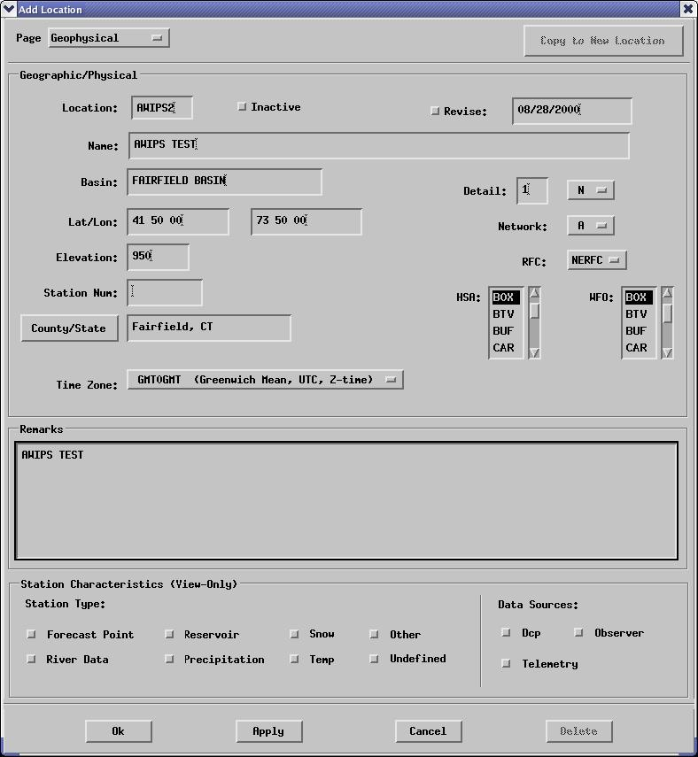
Figure 1

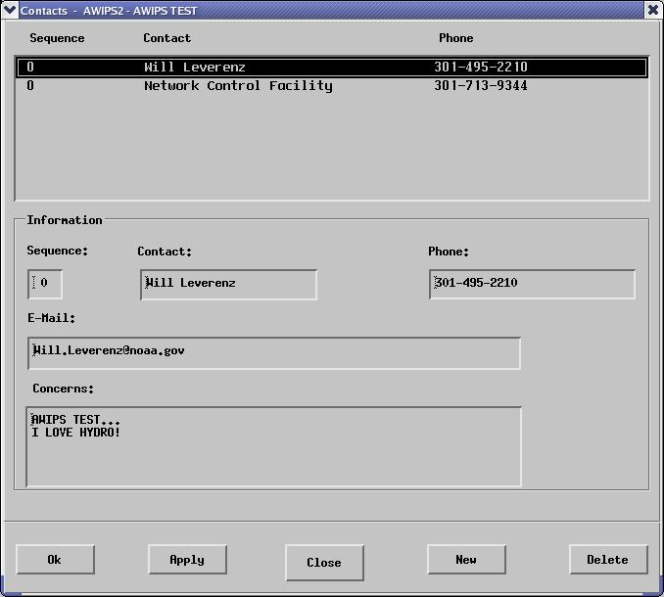
Figure 2

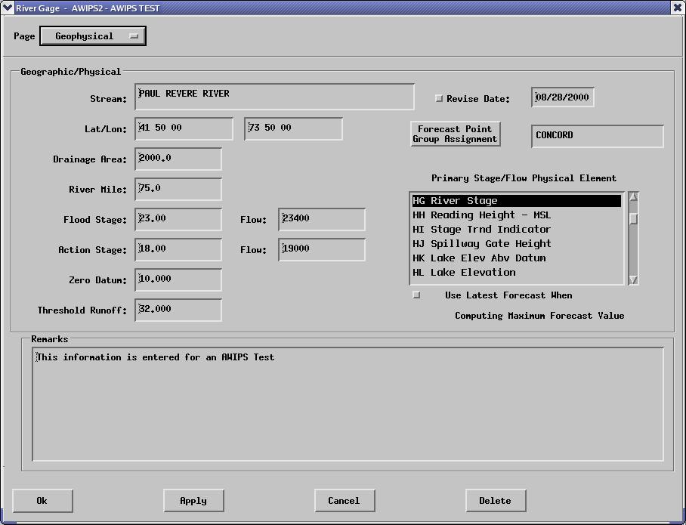
Figure 3

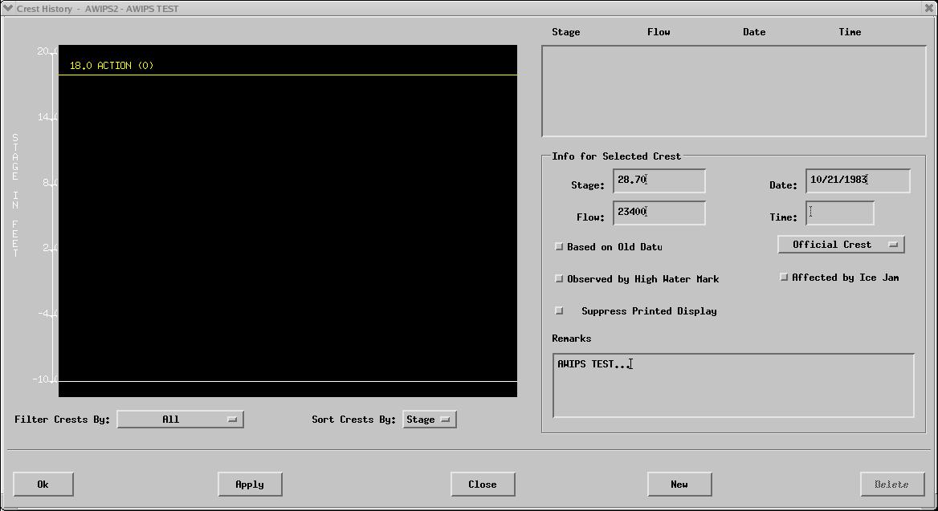
Figure 4

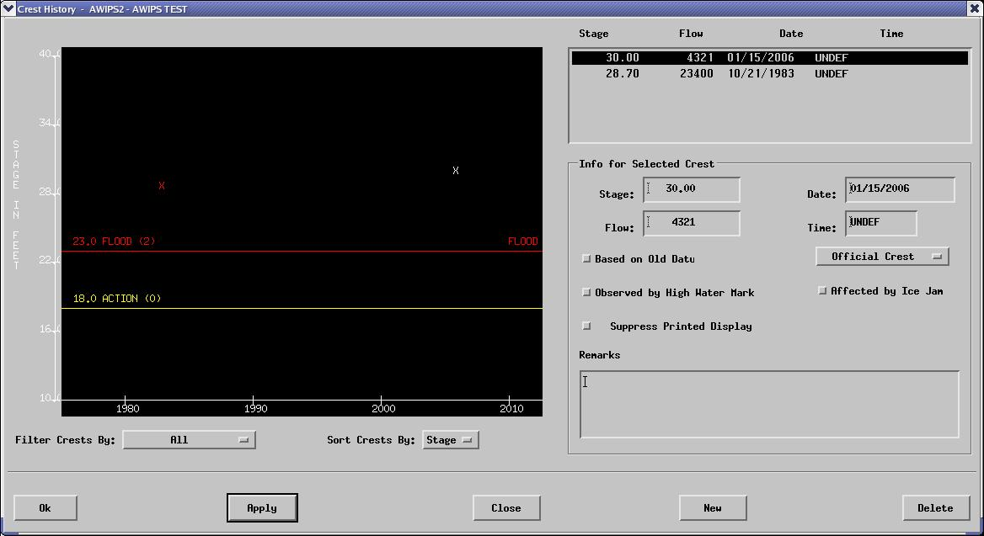
Figure 5

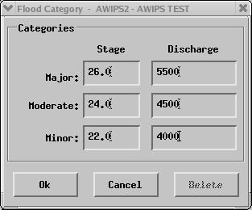
Figure 6

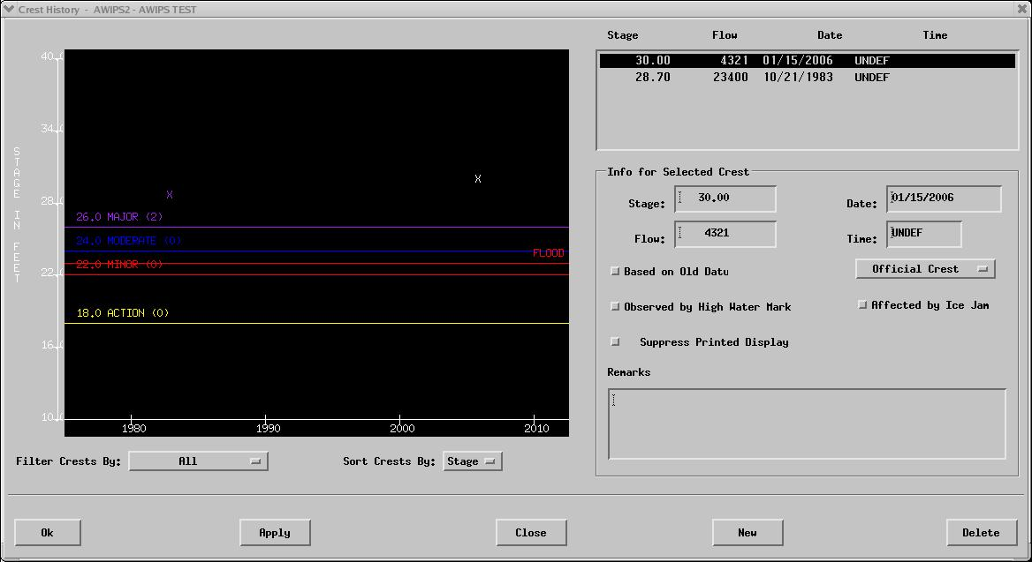
Figure 7

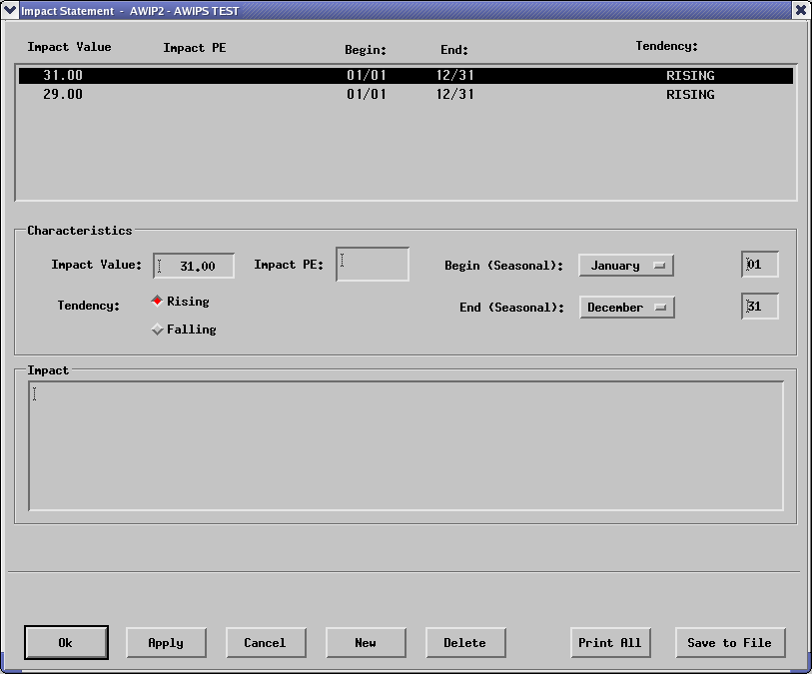
Figure 8

- If requirements are attached to the test cases, then maintain them together. A reference can be made to Table 1.1-1.

Table 1.1-2. Requirements Verification Traceability Matrix (RVTM)
Number | Description | Test Step (s)
1 | The AWIPS system shall implement HydroBase dialogs in the Hydroview perspective. | 1-3
2 | The AWIPS system shall implement the data sources/filters capability for the HydroBase interactive application. | 55-58
3 | The AWIPS system shall implement the river gauge capability for the HydroBase interactive application. | 15-19
4 | The AWIPS system shall implement the flood category/damage capability for the HydroBase interactive application. | 29-32
5 | The AWIPS system shall implement the rating curve/time series groups capability for the HydroBase interactive application. | 43-45
6 | The AWIPS system shall implement the crest and low data history capability for the HydroBase interactive application. | 20-23
7 | The AWIPS system shall implement the QC alert/alarm limits capability for the HydroBase interactive application. | 59-60
8 | The AWIPS system shall implement the reports and impacts capability for the HydroBase interactive application. | 34-37
9 | The AWIPS system shall implement the map features/fields/radars capability for the HydroBase interactive application. | 63-64
10 | The AWIPS system shall implement the reference fields capability for the HydroBase interactive application. | 41-42
11 | The AWIPS system shall implement the RiverPro controls capability for the HydroBase interactive application. | 65-68

