**Solutions and Products to Help Protect People and Facilities**

## Reliable Fire Safety Systems That are Flexible, Innovative, and Scalable

Fire safety is a fundamental mandate for every enterprise, facility, campus, and municipality. Fire safety begins with fire detection, and fire detection means everything from components—sensors, initiating devices, annunciators, and control panels—to integrated systems.

We are leaders in this vital arena because of our depth of expertise in creating reliable and sophisticated fire detection products and technologies. Our worldwide customers rely on our experience to develop and deploy solutions in tandem with our many global partners. We use the latest technology developments to set the bar higher with systems that are more configurable, more scalable, and more automated to help you protect your people and your assets.

## Solutions

### Get complete, integrated fire and life safety solutions from Johnson Controls.

**Control Panels Installation and Services**

**Use an Advanced Fire Safety Solution That is Reliable, Flexible, and Provides Peace of Mind**

**Flexible**

**Solutions, products, and services can be tailored to meet your specific needs.**

**Comprehensive**

**From product features to installation or maintenance, we’ve got you covered.**

**Reliable**

**Rest easy knowing your people and property are better protected.**

**Benefits of Control Panels**

**Our fire alarm control panels are the heart of a robust and scalable fire and life-safety communications system. Intelligent, configurable, and expandable, they can meet a wide range of applications. We also offer cost-effective means to maintain or expand your capabilities—whether that includes product features, system design, training, risk assessments, or ongoing maintenance.**

**Additional Benefits:**

* **Design flexibility, easier installation, lower life-cycle costs, and operational efficiency**
* **Next-generation technology includes internet connectivity, remote service capabilities, and touchscreens to reduce service time**
* **Panels allow you to leverage existing wiring infrastructure and peripheral devices**
* **Revolutionary self-testing capability helps ensure appliances work when needed**
* **Addressable notification offers less disruption of operations**
* **Unique ability to work with systems from almost any manufacturer**
* **24/7 service from NICET-certified technicians**

**Advanced fire safety solutions you can rely on.**

**Feature Rich**

**Next-generation life-safety platforms for added power, with internet connectivity and remote service capabilities.**

**Highly Scalable**

**Systems that can grow and expand as your building’s life-safety needs evolve and change.**

**Ongoing Support**

**Local offices offer consistent maintenance and help uphold standards to keep your premises in compliance.**

**Stay one step ahead with news and insights from our fire detection experts.**

**Notification Solutions and Services**

**Audio and Visual Notification is an Advanced Technology That’s Helping Take Safety in a New Direction**

**Ease of Use**

**From flexible wiring architecture to self-testing capabilities, our solutions are easy to use and cost-effective.**

**Comprehensive**

**Our full suite of technologies can be tailored to meet your needs.**

**Addressable**

**Addressable devices means easier implementation, testing, and maintenance.**

**Benefits of Notification**

**We leverage our full suite of addressable notification technologies to provide benefits through every phase in the life of a building. At the design stage, architects and engineers will enjoy fewer roadblocks, thanks to the industry’s most flexible wiring architecture. Testing and maintenance is far easier and more cost-effective—our revolutionary self-testing capability enables testing to be done through a fire alarm panel, greatly reducing interruptions to building occupants and business operations. Plus, the devices are electronically supervised 24/7, giving facility managers greater control and confidence that the system is ready to perform. When it’s time to expand, TrueAlert ES products are highly scalable, so the system can grow as your needs evolve.**

**Whether you’re looking for notification via texts, horns, strobes, or speakers, our advanced addressable notification solutions can help make protecting your people, property, and business operations more reliable and cost-effective.**

**Additional Benefits:**

* **Global addressability: Intelligent communications between initiating devices, notification appliances, and the control panel**
* **Fewer wires, more appliances per circuit, and fewer installation errors**
* **Appliances can be tested during installation for cost-efficient, on-the-spot problem resolution**
* **Enhanced survivability: Device-level ground faults are identified and isolated automatically**
* **Quick, unobtrusive testing of individual devices or an entire system**
* **Fast diagnostics and maintenance that lowers long-term cost of ownership**
* **Notification appliance circuits synchronized to meet ADA (Americans With Disabilities Act) requirements**

**Stay one step ahead with news and insights from our fire detection experts.**

[**See All Insights**](https://www.johnsoncontrols.com/insights)

**Solution Portfolio**

**[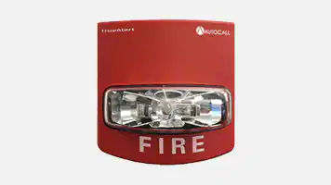](http://autocall.com/products/conventional-notification-appliances)**

[**Conventional Notification Appliances**](http://autocall.com/products/conventional-notification-appliances)

**Basic appliances for fire alarm and emergency communications.**

**[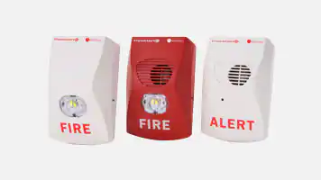](https://simplex-fire.com/en/us/Pages/ProductDetail.aspx?productdetail=TrueAlert+ES+Addressable+Notification+Appliances)**

[**Addressable Notification Appliances**](https://simplex-fire.com/en/us/Pages/ProductDetail.aspx?productdetail=TrueAlert+ES+Addressable+Notification+Appliances)

**Intelligent, fully addressable notification products for virtually any application**

**[](http://autocall.com/products/conventional-speakers)**

[**Conventional Speakers**](http://autocall.com/products/conventional-speakers)

**Horns, strobes, horn-strobes, speakers, speaker-strobes, chimes, and chime-strobes**

**[](http://autocall.com/products/addressable-led-notification-appliances)**

[**Addressable Speakers**](http://autocall.com/products/addressable-led-notification-appliances)

**High-quality audio output for sophisticated emergency message delivery**

**Fire Detection Services**

[**Expert Service Offer**](https://www.johnsoncontrols.com/services-and-support/fire-maintenance-and-support/expert-service-tier)

**All-inclusive personalized service offering a premium level of ongoing support where life-safety and compliance is critical for operation.**

[**Enhanced Service Offer**](https://www.johnsoncontrols.com/services-and-support/fire-maintenance-and-support/enhanced-service-tier)

**A modified service tailored to meet specific or unique requirements for the critical elements of your business.**

[**Advanced Service Offer**](https://www.johnsoncontrols.com/services-and-support/fire-maintenance-and-support/advanced-service-offer)

**A cost-effective and forward-looking service focusing on compliance and incident prevention, along with contingency plans for emergencies.**

[**Essential Service Offer**](https://www.johnsoncontrols.com/services-and-support/fire-maintenance-and-support/essential-service-tier)

**For organizations where staying compliant is critical, our code and compliance experts will help you always stay up-to-date.**

**Brand: Autocall**

**Network Solutions**

**Networked Technology Brings Your Information to One Location for Better Command and Control**

**Advanced**

**Next-generation platforms for added power, connectivity, and centralized control.**

**Comprehensive**

**From product features to installation or maintenance, we offer a full range of options.**

**Flexible**

**Products and services are highly scalable and can be configured to meet your needs.**

**Benefits of Network Solutions**

**Our fire alarm network communicates information among distributed fire alarm control panels, enabling each panel to maintain the status and control of its own points, and monitor and control points physically connected to other network panels. Network solutions are an efficient way to help protect large or complex facilities, allowing, for example, panels to communicate on the evacuation of a specific block of floors versus an entire building.  
  
Networking helps improve survivability; if a single panel loses communication, all remaining panels can still communicate with each other. Our solutions also offer client server capability, creating the ability to monitor activity and remotely view information from a PC with the appropriate software.**

**Additional Benefits:**

* **A single system view can deliver better command and control—ideal for large campuses and facilities**
* **Each panel maintains the status and control of its own points; each can also monitor and control points physically connected to other network panels**
* **Multiple Network Loops are available for campus and other high panel quantity applications**
* **Network-wide initiation of alarm silence, acknowledge, and reset; and investigation of status and details of system points and point lists**
* **Distributed system operation to ensure excellent continuity**
* **Command center that provides centralized network annunciation, historical logging, report generation, and control of fire alarm network points**

**How do Network Solutions help?**

**Safer**

**Respond to life-safety events with speed and efficiency.**

**Smarter**

**Networking allows nodes to operate together or independently.**

**Flexible**

**Networking can help protect simple locations or complex facilities.**

**We make it easier to find the right choices for your applications.**

[**Contact Us**](https://www.johnsoncontrols.com/contact-us)

**Solution Portfolio**

**[](https://www.johnsoncontrols.com/fire-detection/networks)**

[**Integration**](https://www.johnsoncontrols.com/fire-detection/networks)

**Unify multiple systems in your facility to create a true smart building**

**[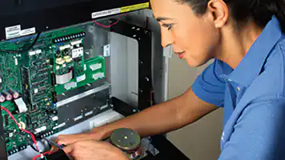](https://www.johnsoncontrols.com/fire-detection/networks)**

[**Networking**](https://www.johnsoncontrols.com/fire-detection/networks)

**Flexible technologies to help you configure and manage your system**

**[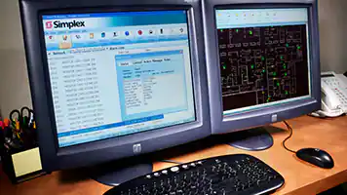](https://www.johnsoncontrols.com/fire-detection/networks)**

[**Workstations**](https://www.johnsoncontrols.com/fire-detection/networks)

**Command and control end points for sharing information and to support centralized control**

**Fire Detection Services**

[**Expert Service Offer**](https://www.johnsoncontrols.com/services-and-support/fire-maintenance-and-support/expert-service-tier)

**All-inclusive personalized service offering a premium level of ongoing support where life-safety and compliance is critical for operation.**

[**Enhanced Service Offer**](https://www.johnsoncontrols.com/services-and-support/fire-maintenance-and-support/enhanced-service-tier)

**A modified service tailored to meet specific or unique requirements for the critical elements of your business.**

[**Advanced Service Offer**](https://www.johnsoncontrols.com/services-and-support/fire-maintenance-and-support/advanced-service-offer)

**A cost-effective and forward-looking service focusing on compliance and incident prevention, along with contingency plans for emergencies.**

[**Essential Service Offer**](https://www.johnsoncontrols.com/services-and-support/fire-maintenance-and-support/essential-service-tier)

**For organizations where staying compliant is critical, our code and compliance experts will help you always stay up-to-date.**

**Smoke and Carbon Monoxide Detection Solutions**

**Protecting Your People and Property Doesn’t Have to Include Frequent Nuisance Disruptions**

**Addressable**

**Our networked devices offer innovative and time-saving benefits.**

**Cost-effective**

**Carbon monoxide sensors are included in our smoke detectors, saving expense and extra wiring needs.**

**Stability**

**Rapid response times with minimal chance of nuisance alarms.**

**Benefits of Smoke and Carbon Monoxide Detection**

**Our innovative software and electronics means we can offer stable smoke and carbon monoxide detectors with the quickest response time and less nuisance. A dirty detector can set off an unwanted alarm—the predictive ability of our remote diagnostics is invaluable by alerting us that the device needs proactive service. Additionally, the addressability of our devices offers time-saving benefits to contractors, facility managers, and owners. Our patented TrueAlarm sensors are one of the industry’s most stable line of detection devices available, and our addressable modules can provide addressability to conventional devices.**

**As an added benefit, carbon monoxide (CO) sensors can be included in our smoke detectors, saving the expense of a separate purchase as well as reducing wiring needs. Our solutions are especially critical for facilities where people sleep: dormitories, hotels, nursing homes, and assisted living facilities.**

**Additional Benefits:**

* **Quick detection of fire, smoke, or heat events, allowing orderly evacuation and mitigation of potential fire damage**
* **Solutions are tailored to your facility and integrated with fire suppression systems where needed**
* **Internet-based diagnostic service offers real-time visibility and automates the detection and notification of abnormal conditions**
* **Alerts when detectors are dirty or almost dirty and more vulnerable to problems**
* **Sensors evaluate environmental data and compensate for contamination to maintain detector sensitivity and decrease the chance of false alarms**
* **CO elements can operate independently or in combination with a smoke or heat sensor, helping reduce unnecessary alarms**

**We make it easier to find the right choices for your applications.**

[**Contact Us**](https://www.johnsoncontrols.com/contact-us)

**Solution Portfolio**

**[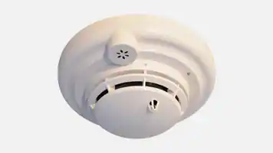](https://www.johnsoncontrols.com/fire-detection/sensors-and-initiating-devices)**

[**Smoke Detectors**](https://www.johnsoncontrols.com/fire-detection/sensors-and-initiating-devices)

**Detects the presence of a fire or life safety event**

**[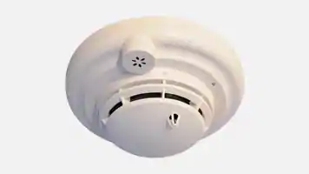](https://www.johnsoncontrols.com/fire-detection/sensors-and-initiating-devices)**

[**Carbon Monoxide Detectors**](https://www.johnsoncontrols.com/fire-detection/sensors-and-initiating-devices)

**Detects the presence of CO in a room or facility**

**[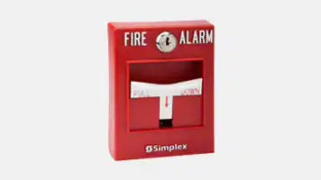](https://www.johnsoncontrols.com/fire-detection/sensors-and-initiating-devices)**

[**Pull Stations and Call Points**](https://www.johnsoncontrols.com/fire-detection/sensors-and-initiating-devices)

**Manual stations that can help warn of a fire or life safety event**

**[](https://www.johnsoncontrols.com/fire-detection/sensors-and-initiating-devices)**

[**Modules**](https://www.johnsoncontrols.com/fire-detection/sensors-and-initiating-devices)

**Addressable modules that provide accessibility to conventional devices like flow switches**

**Fire Detection Services**

[**Enhanced Service Offer**](https://www.johnsoncontrols.com/services-and-support/fire-maintenance-and-support/enhanced-service-tier)

**A modified service tailored to meet specific or unique requirements for the critical elements of your business.**

[**Expert Service Offer**](https://www.johnsoncontrols.com/services-and-support/fire-maintenance-and-support/expert-service-tier)

**All-inclusive personalized service offering a premium level of ongoing support where life-safety and compliance is critical for operation.**

[**Advanced Service Offer**](https://www.johnsoncontrols.com/services-and-support/fire-maintenance-and-support/advanced-service-offer)

**A cost-effective and forward-looking service focusing on compliance and incident prevention, along with contingency plans for emergencies.**

[**Essential Service Offer**](https://www.johnsoncontrols.com/services-and-support/fire-maintenance-and-support/essential-service-tier)

**For organizations where staying compliant is critical, our code and compliance experts will help you always stay up-to-date.**