**AWS DevOps Course Lab-Setup**

|  |
| --- |
| 1. Create Free AWS Account |
| 2. Login to AWS account using Root credentials |
| 3. Create a Linux Virtual Machine in AWS cloud |
| . Access Linux Virtual Machine using SSH tools |
| 5. Create a Windows Virtual Machine |
| 6. Access Windows Virtual Machine using RDP |

# 1. Create a Free AWS account

Pre-requisites:

* Email address
* Mobile number
* Credit/Debit Card
* Visit the following website to create your free AWS account- <https://aws.amazon.com/resources/create-account/>and click on **Sign Up Now** button.

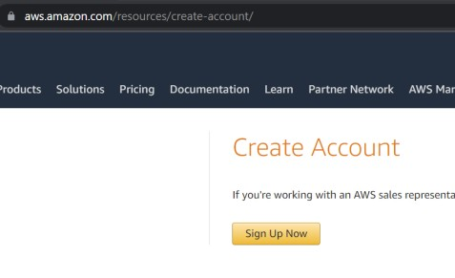

* Provide your email address on the screen. Make sure, you have not used this email address before to create AWS account. For account name, you can put anything like vivekj-cloud.

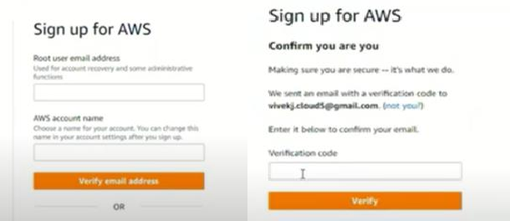

* Once you provide the email address and click on confirm, it will send one verification code on your email address. Provide that code on the screen and click verify.
* Now provide the password for login purpose.

Try to provide a secure password which is not easy to crack( should contain Capital, Small letters, special character and numbers). Remember this password as we will use it later for login purpose.

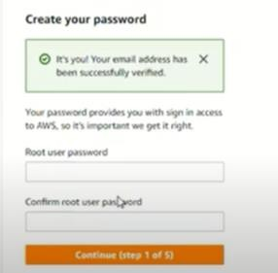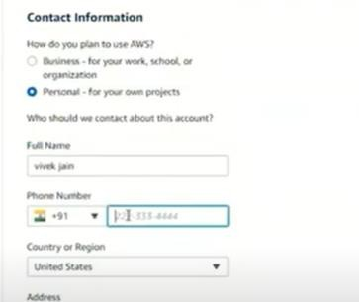

* On next screen, you will be asked to provide some personal details such as the type of account → select personal, then provide your name, address, mobile number and Pincode.
* Next, you will have to provide your credit/debit card details such as card number, expiration month and year, name on card, and CVV. Once you click on confirm, you will be redirected to the payment page.

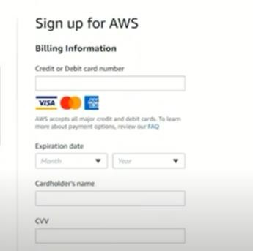

* Based on the credit/debit card provider, you may receive one OTP on your mobile for this transaction of 2Rs. Don’t worry, AWS will

refund this amount after a couple of days.

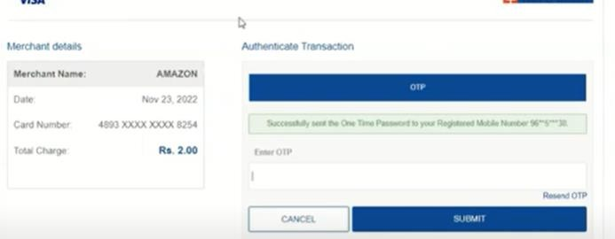

* After successful payment of 2Rs, you will be redirected to the next page to confirm your mobile number. Please provide the correct mobile number as this will be used by AWS to reach out to you in future.

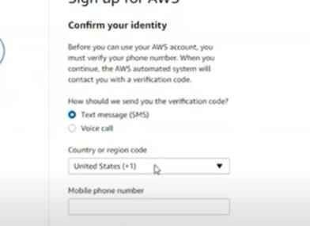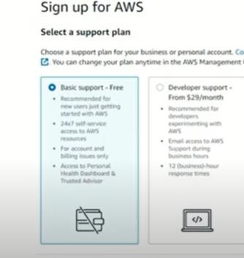

* During this mobile number confirmation, AWS will send you one OTP which you need to provide to validate the mobile number.
* Finally, on the last screen, you maybe asked to select the support plan. Just select Basic Support which is free of cost and click on confirm button.

Congratulations your AWS account is created. Now you can login to this account using your email address and password.

Common issues-

1. If you have got a new debit/credit card and online transactions are not yet activated, then AWS will not be able to confirm your payment of 2 Rs. You need to activate the online transactions either using Net banking or using the SMS service. (Please check this with your bank and follow the official process. DO NOT SHARE ANY SUCH DETAILS WITH ANYONE).
2. If the Debit/Credit card does not have a name on it, you will not be able to use it. Most likely AWS will reject the transaction as it will not be able to authenticate.
3. You can use Credit/Debit card that belongs to any of your friend/colleagues or family members (after their consent 😊). It is not mandatory to use a credit/Debit card that has your name only.

# Login to AWS Account using root credentials

There are two ways to login to AWS account. IAM user and Root user. We will discuss about IAM user login in AWS fundamentals and for now, our focus is on Root user login.

Root User login means, login using the email address and password that we used during the AWS account creation.

* Visit the AWS login/sign in page- <https://aws.amazon.com/console/> and click on “Sign In to the console” option.
* You may get any of the below pages.
  + If you get a screen just like the first image, select Root user, provide the email address, and click on next.
  + If you get the second screen, first click on “Sign in using root user email” at the bottom and then you will get screen like option 1.

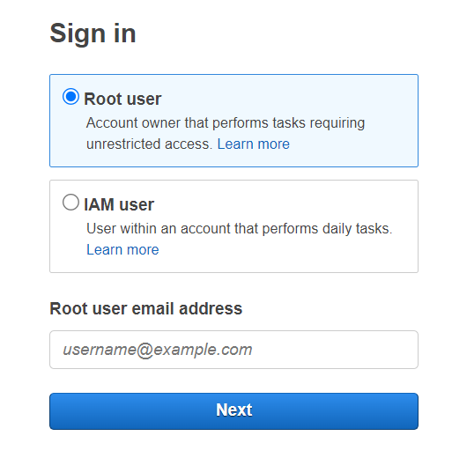

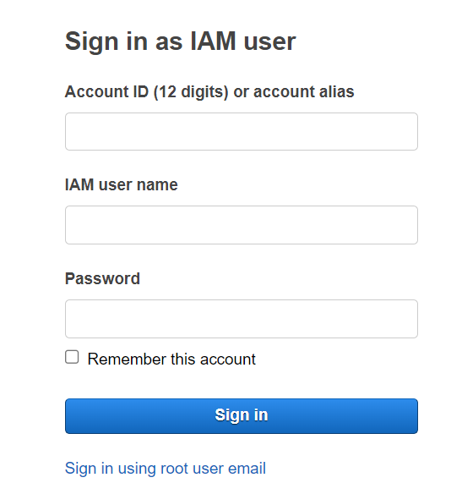

Once you click on Next, you will be asked to provide password. Give the password and then click on Sign In.

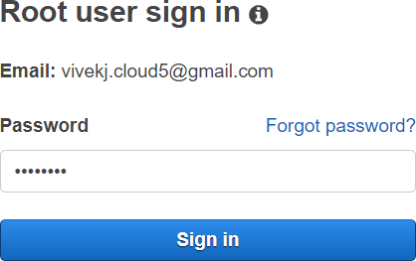That’s it, you are now logged in to your AWS account.

In case you get any error, check your email address and password.

# Create Linux Virtual Machine in AWS cloud

Since we are going to start with Linux fundamentals, it is important to create one Linux virtual machine. In AWS, we can create one Linux VM for free.

Once you are logged in to AWS account following the last task, we can proceed with linux VM creation.

* Search for EC2 in the search bar and select the EC2 service. It will take you to the EC2 dashboard in AWS.

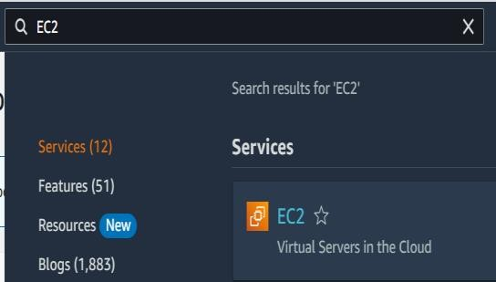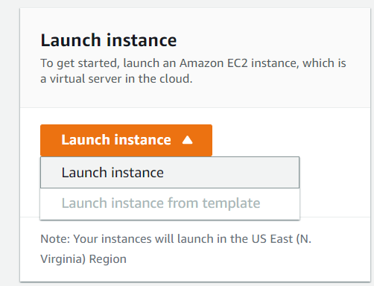

* On the EC2 dashboard, click on Launch Instance (fig 2).
* 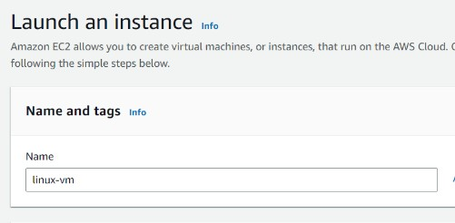On the next screen, you will find all the options to configure Linux Virtual Machine.
  + Set a name for your VM. We have selected “linux-vm” for this example.
  + Next, OS option, keep it default.
  + Next, Instance type , keep it default.
  + 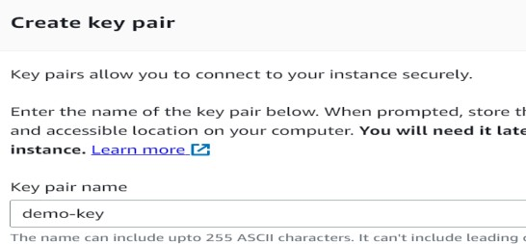Now in Key pair, click on create new key pair and give a name to your key pair. Keep rest of the options as it is and click on create key pair.
  + It will also download the private key in your local machine.
* Keep other options in EC2 creation as it is and finally create on Launch Instance at the right corner of the page.

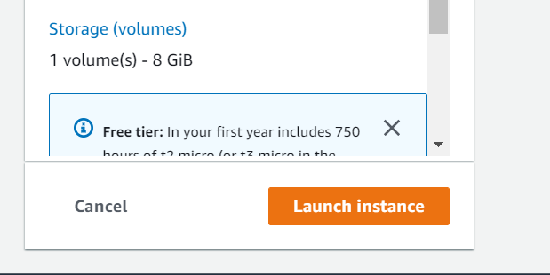

Once the server is created, you can see it in the instance list.

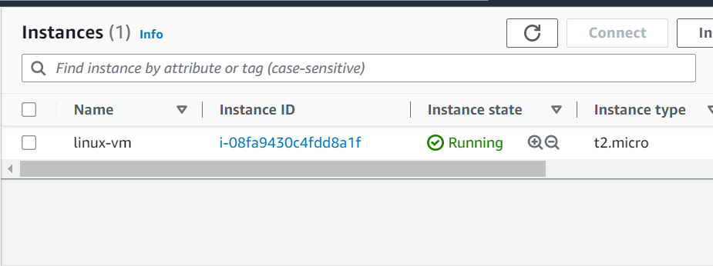

# Access Linux Virtual Machine using SSH tools

We need to use SSH tools to connect to the Linux Virtual Machine. There are several tools available and below are a few of them that we are using for our learning purpose.

* + Mobaxterm
  + gitbash
  + Putty
  + AWS Console connect option

Default username for different OS-

* + Amazon Linux: ec2-user
  + RedHat Linux: ec2-user
  + CentOS: centos
  + Ubuntu: ubuntu
  + Windows: administrator

## Using Mobaxterm:

* Download the mobaxterm package in your laptop using the following URL- <https://mobaxterm.mobatek.net/download.html>
* Download the Home edition as it is free of cost.
* Once downloaded, open the package, and click on Next option.
* Finally click on Install button to install the Mobaxterm package.

Once installed, open it in your laptop.

* Click on User sessions to open the SSH window

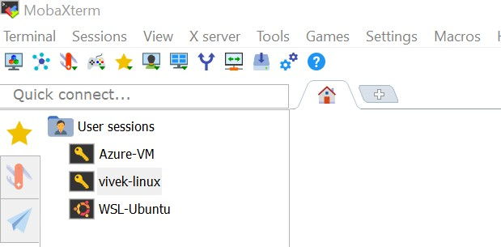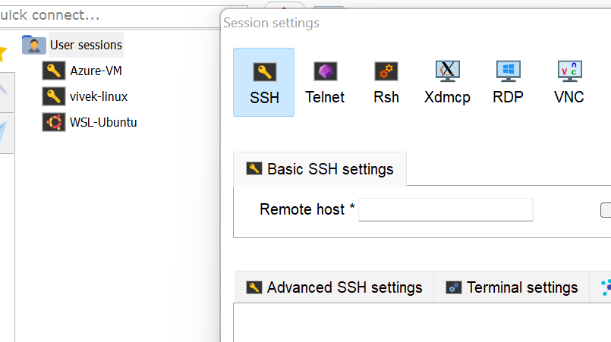

* 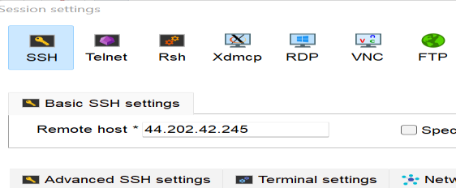Pick up the public IP of the Linux VM from the AWS EC2 console and paste it in Remote host option.
* Next click on Advanced SSH settings on SSH screen and check the “Use private key” box.
* In the same box, click on browse option and select your private key from the downloads folder.

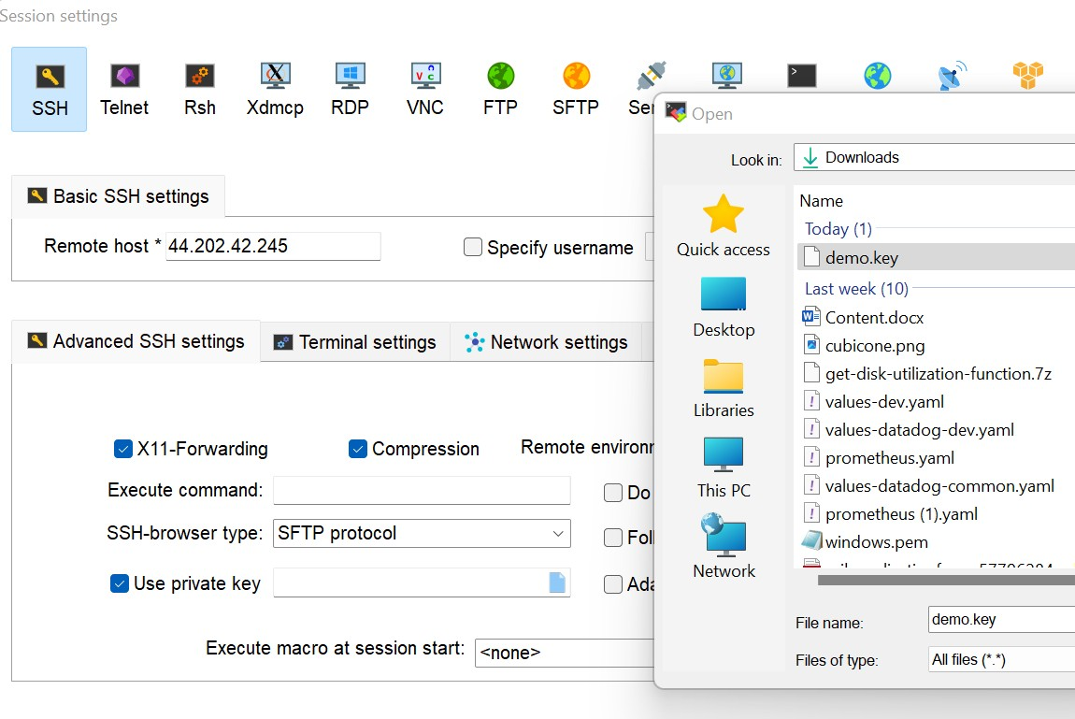

* Once selected, on the next screen, it will ask you for username. Provide “ec2-user” as the username and hit enter.

Congratulations! you are now connected to Linux Virtual Machine.

## Using gitbash:

* Gitbash is another tool that you can use to connect to Linux VM. The same process we can use to connect to the Linux VM from a MacOS terminal.

Download the gitbash from the internet using this link- [https://git-](https://git-scm.com/downloads) [scm.com/downloads](https://git-scm.com/downloads) and click on download for windows.

Once it is downloaded, open the application, and click on next → Install to install the gitbash software.

* Now, open the gitbash in your laptop and run below command to connect to the Linux VM.

Similar command you can use if you are using MacOs.

ssh -i <privatekeyfile> <default-user>@<public-ip-address-of-Linux-VM>

For this example, we can run

ssh -i Downloads/demokey.pem [ec2-user@44.202.42.245](mailto:ec2-user@44.202.42.245)

It will ask for a confirmation, type yes and then you will be connected to the Linux VM.

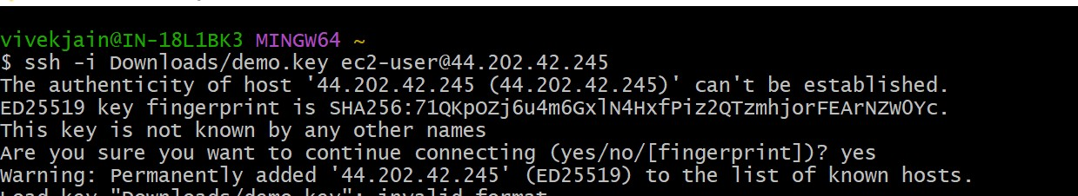

## Using Putty:

* Putty is one of the most common and widely used tool to connect to the Linux Virtual Machine.
* The SSH key that we were using so far is “.pem” key which is not accepted by putty. It only accepts “.ppk” key, hence we will first have to convert pem file to ppk file.

Let’s download the putty software to work with it. Visit the following URL and download the package for our operating system- <https://www.chiark.greenend.org.uk/~sgtatham/putty/latest.html>

* Once the package is downloaded, open it and click on Next → Install.

**Convent pem key file to ppk key file:**

* 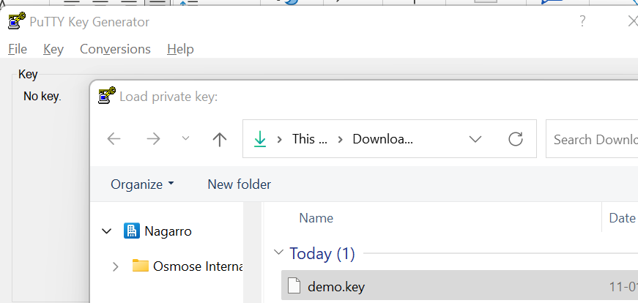As we have downloaded the putty software, it gives us two software called puttygen and putty.
* To convert the pem key into ppk, we need to use puttygen software.
* Open puttygen software and click on Conversions → Import key.
* Select the pem key from the Downloads folder and click on save private key button.
* 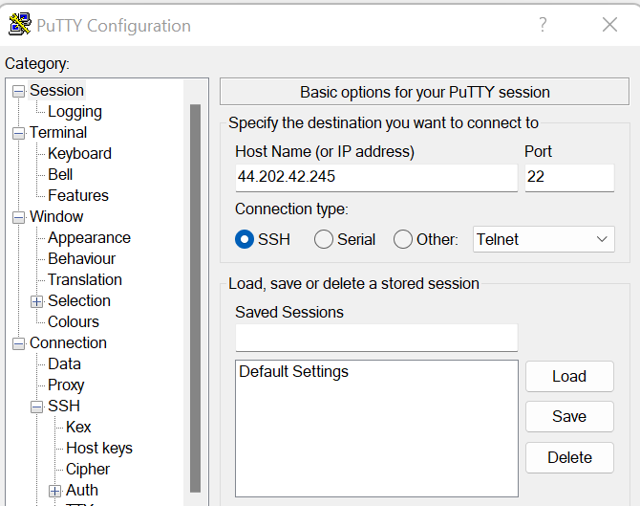This will save another key in our downloads folder but with .ppk extension.
* Now open the putty software and paste your public key in the Host Name section.
* Next, click on Auth option from the left panel → browse → select your ppk key from the list.
* Once selected, click on open button, and provide the username as “ec2- user”. It will ask for a permission, accept it.

Now you are connected to your Linux VM using putty software.

## Using AWS Console Connect:

This is one of the easiest methods but only applicable to AWS Linux virtual machine when they have a public IP address. Also, you must have the AWS console access to use this method.

* Go to AWS Management console and select the virtual Machine →

click on connect button → Ec2 Instance Connect → Connect.

* That’s it, you are now connected to the server from the browser.

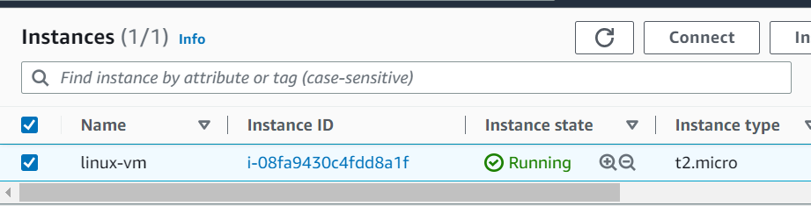

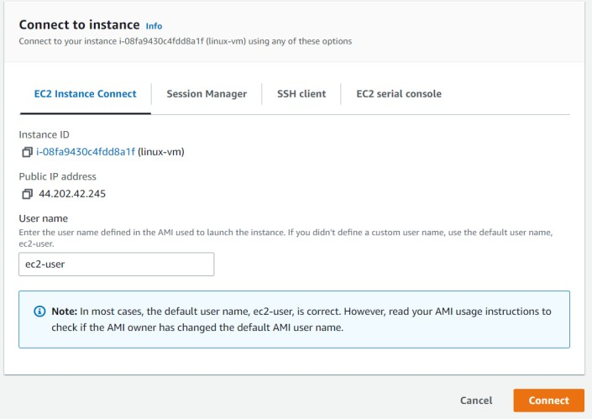

# Create Windows Virtual Machine in AWS cloud

You need to follow the same steps as task no 3, with the only difference of selecting the Windows operating system.

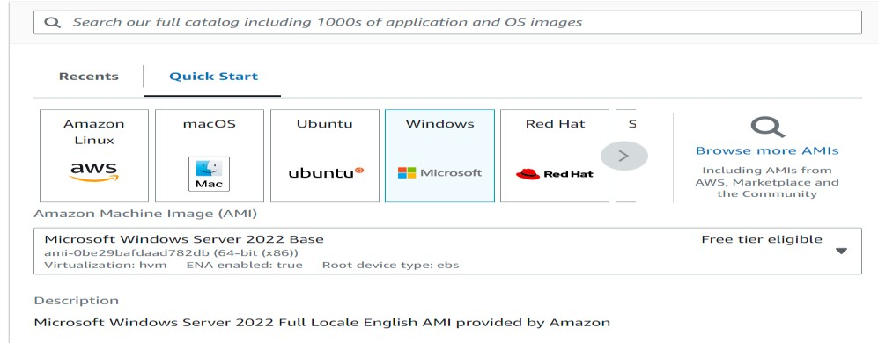

Keep all other settings, as it is and launch it.

# Access windows VM using RDP

Just like we used SSH tools to connect to Linux VM, similarly we can connect to windows VM using RDP tool (Remote desktop protocol.

RDP tool is already available in the windows laptop, and we do not have to download anything.

* First, we need to get the username and password for our windows VM. Windows VM does not use SSH key.
* The default username for windows machine is “administrator”.
* To get the password → Select the Windows VM → click on connect →

RDP → Get Password → Browse and provide your login key → Decrypt.

* Copy the password that you can see on the screen.

Now search for remote desktop connection in your laptop and open the application.

* Provide the public IP of your windows VM in the computer section and click on Show options.

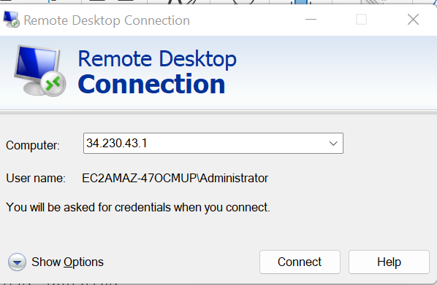

* Provide username as “administrator” on the screen and click on connect button.
* It will ask for the password, provide the same which you copied in last step from AWS console.
* Accept the permission option on the next screen and now you can see your Windows VM.