Ref url : <http://docs.aws.amazon.com/AmazonCloudWatch/latest/monitoring/US_SetupSNS.html>

Create sns topic

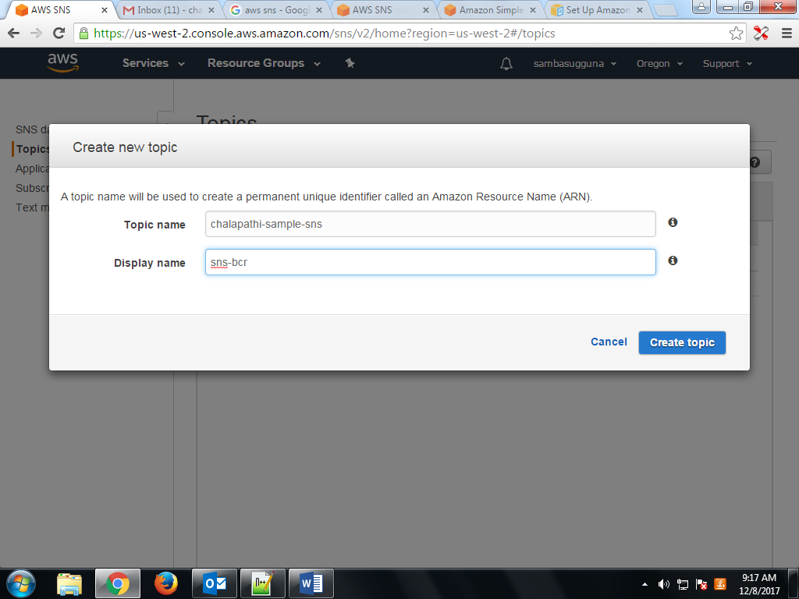

Topic created , then select and click on topic arn url.

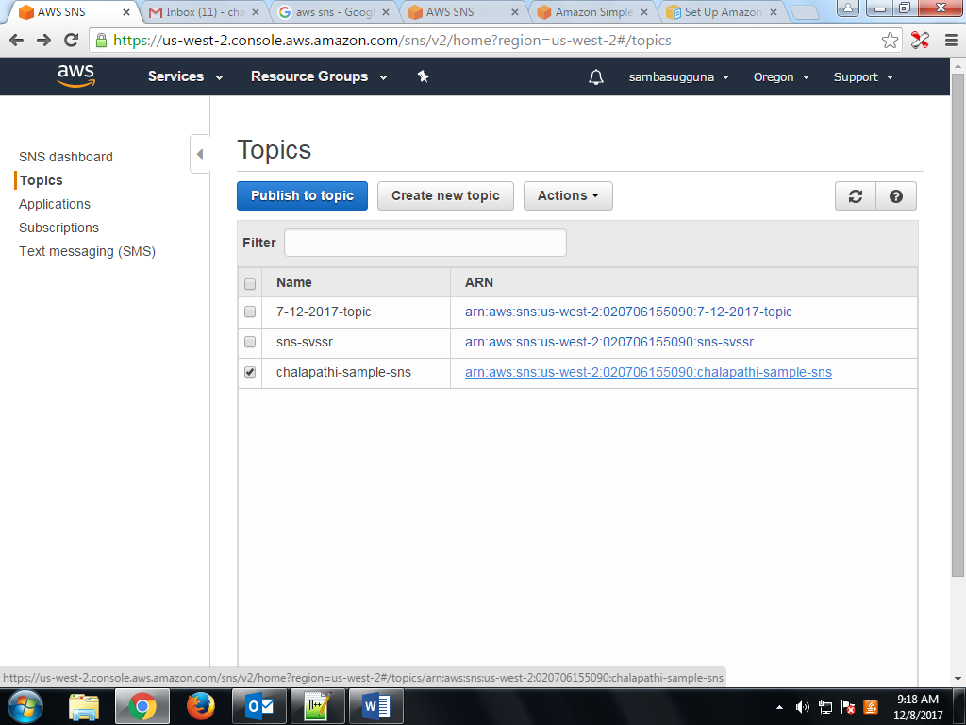

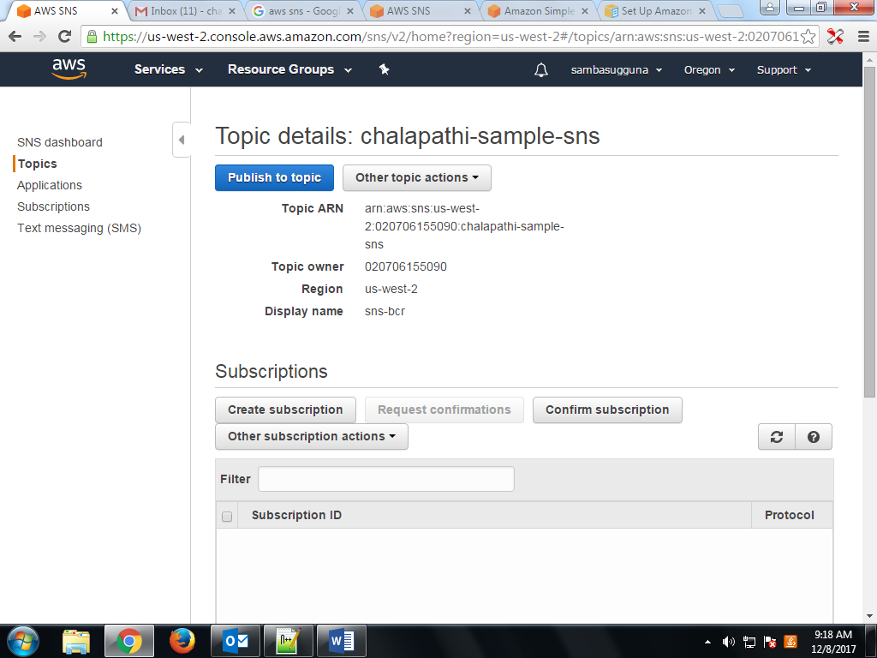

Then click on create subscription button.

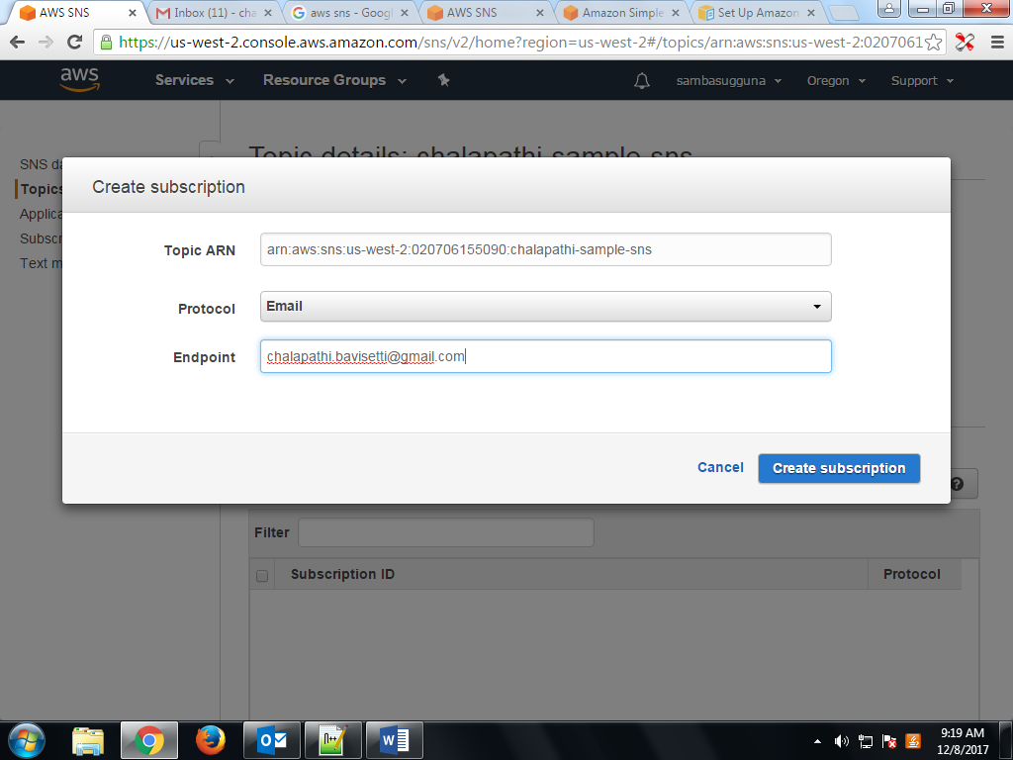

Check given email and click on confirm subscription link.

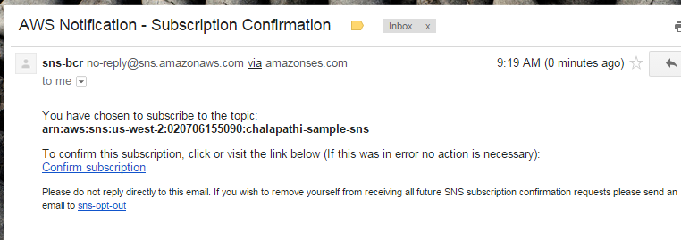

Subscription confirmed.

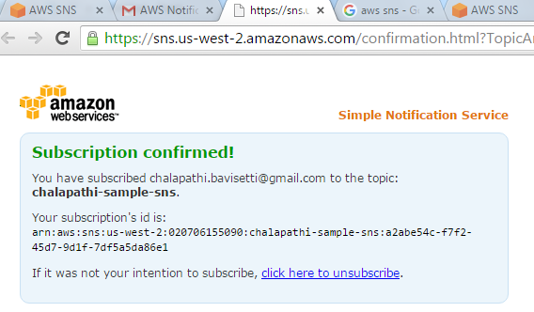

Edit topic polic and provide what all services want to use this sns topic for email notification,

We can integrate this sns topic to any aws service, for now we are integrating with S3 as below.

Take account id from my account link.

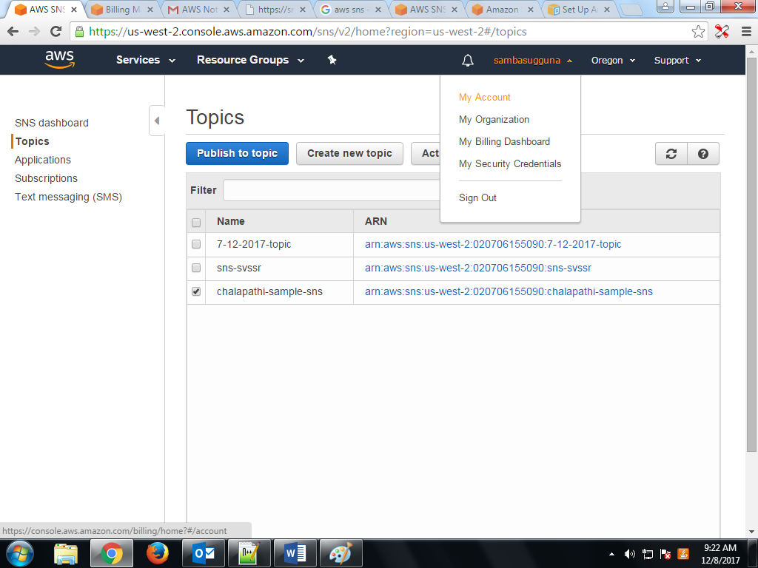

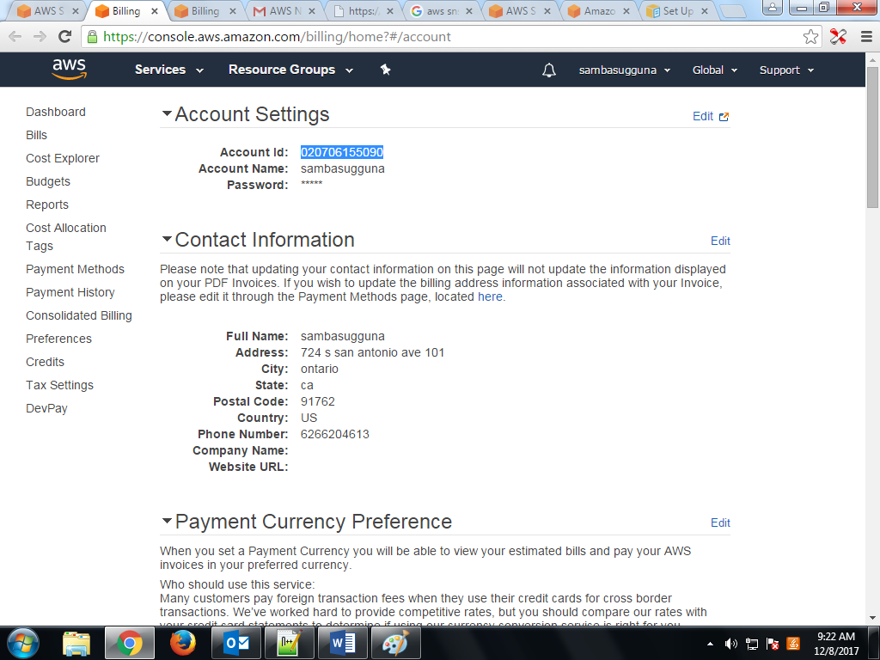

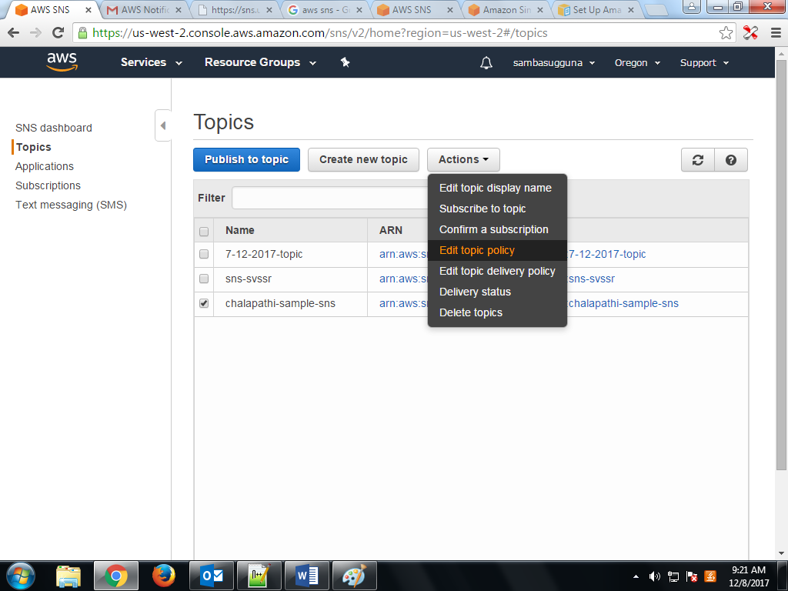

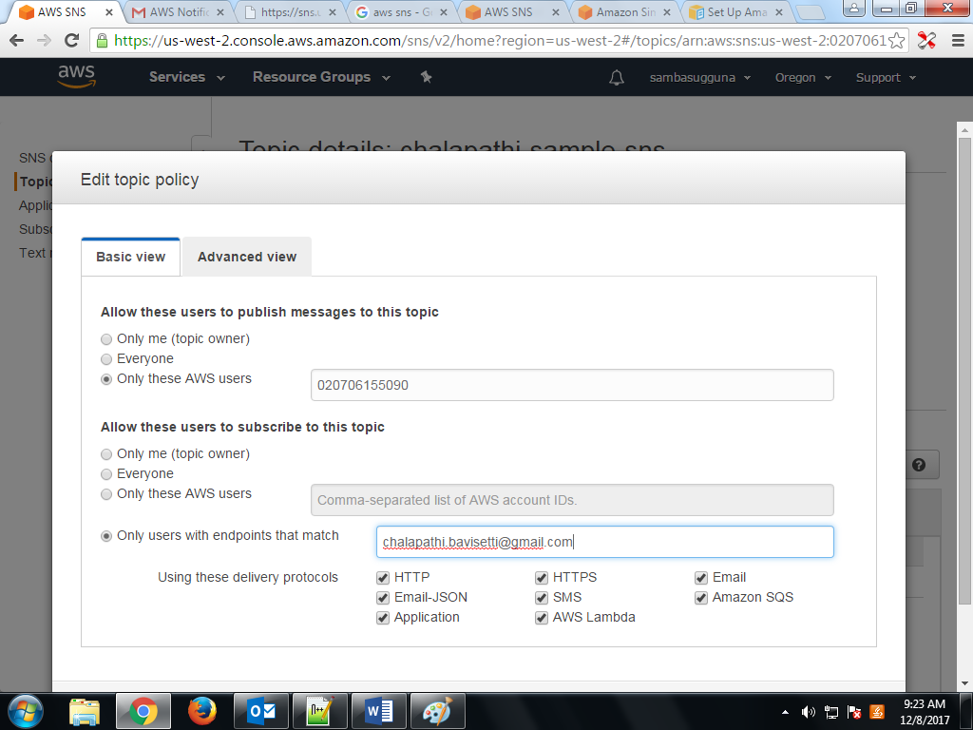

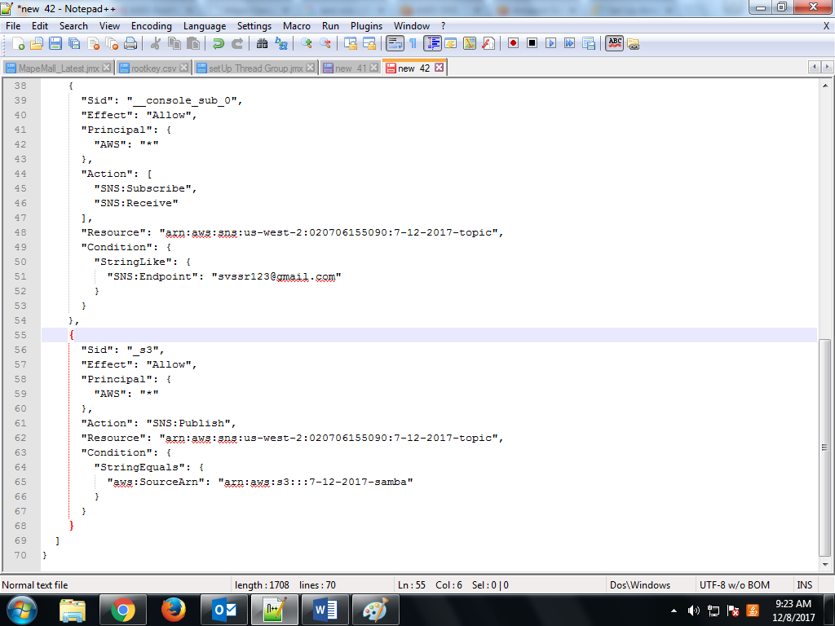

{

"Sid": "_s3",

"Effect": "Allow",

"Principal": {

"AWS": "*"

},

"Action": "SNS:Publish",

"Resource": "arn:aws:sns:us-west-2:020706155090:chalapathi-sample-sns",

"Condition": {

"StringEquals": {

"aws:SourceArn": "arn:aws:s3:::challu-aws-bucket"

}

} }

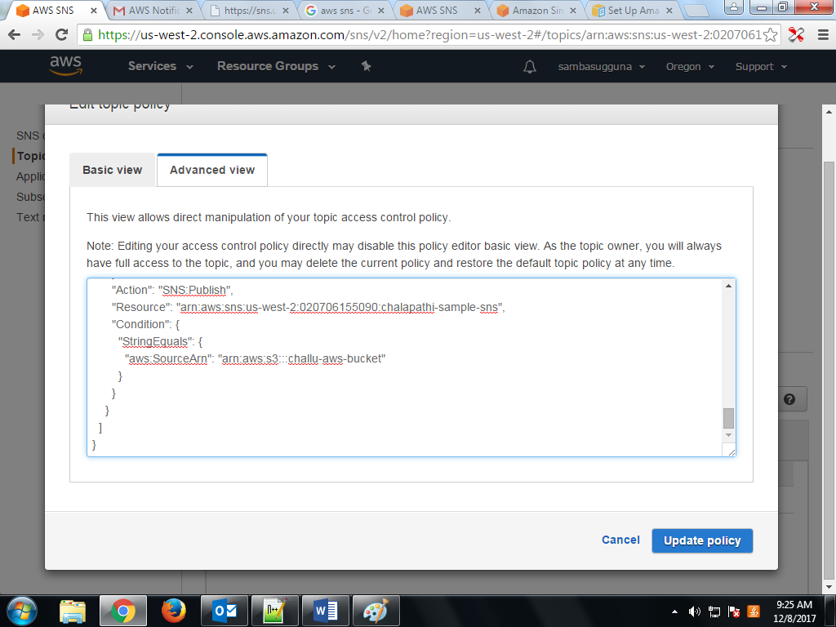

Select S3 bucket that you want to assign sns topic. Then select properties tab , next select Events.

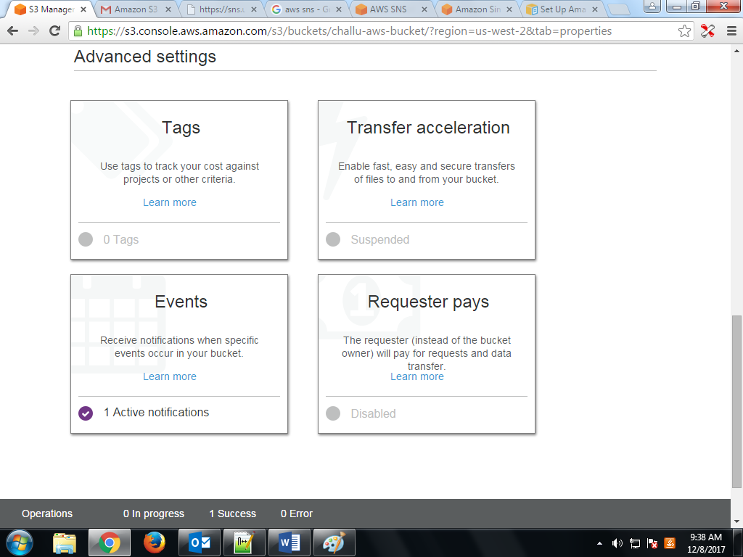

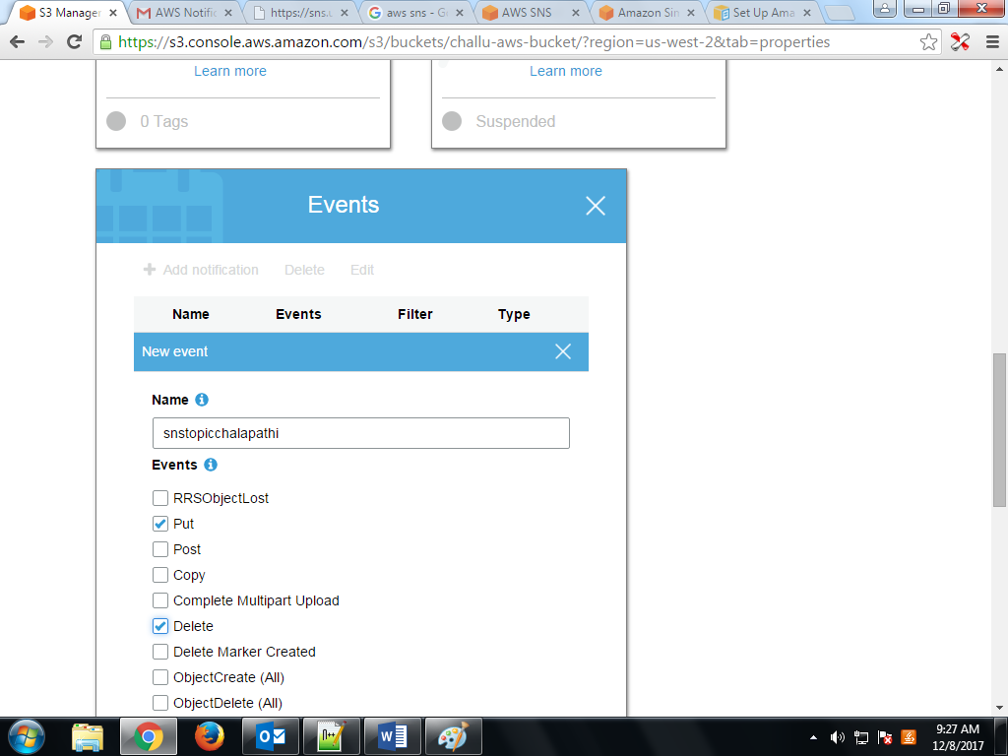

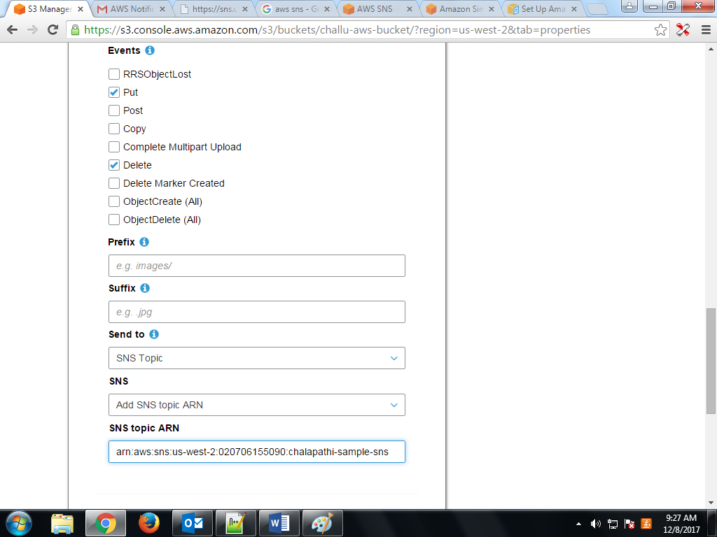

Upload any file to this bucket, then you will get email notification to configured email in the sns topic.

Verify below I have uploaded one file, so I received email notification as below.

