**What is Cloud Computing?**

What is Cloud Computing? Cloud Computing often referred to as “the cloud”, in simple terms means storing or accessing your data and programs over the internet rather than your own hard drive.

Everything nowadays is moved to the cloud, running in the cloud, accessed from the cloud or may be stored in the cloud.

*Where exactly is this cloud?*

So to answer this question in this what is cloud computing blog, it is somewhere at the other end of your internet connection where you store your files and can be accessed from anywhere in the world. This could be a big deal for you, primarily because of three reasons:

* You do not have to maintain or administer any infrastructure for the same.
* It will never run out of capacity, since it is virtually infinite.
* You can access your cloud based applications from anywhere, you just need a device which can connect to the internet.

Let’s go ahead and take a deep dive into “what is cloud computing” and understand its architecture:

Now when you ask what is Cloud Computing the answer would be in a very broad sense therefore, the services it offers has been divided into three different models, let’s discuss each one of them:

* SaaS
* PaaS
* IaaS

## SaaS(Software As a Service)

In this service the Cloud Provider leases applications or softwares which are owned by them to its client. The client can access these softwares on any device which is connected to the Internet using tools such as a web browser, an app etc.

**For Example:** salesforce.com provides the CRM(Customer Relation Manager) on a cloud infrastructure to its client and charges them for it, but the software is owned by the salesforce company only.

## PaaS(Platform as a Service)

In this service the Cloud Provider gives the ability to the customer to deploy customer created application using programming languages, tools etc that are provided by the Cloud Provider. The customer cannot control the underlying architecture including operating  systems, storage, servers etc.

**For Example:**This service would make sense to you only if you are a developer, since this service provides you a platform for developing applications, like Google App Engine.

## IaaS(Infrastructure as a Service)

In this service the Cloud Provider provides the customer with virtual machines and other resources as a service, they abstract the user from the physical machine, location, data partitioning etc. If the user wants a Linux machine, he gets a linux machine, he will not worry about the physical machine or the networking of the system on which the OS is installed, simple.

**For Example**AWS(Amazon Web Services) is IaaS, like AWS EC2.

The diagram below, summarizes the differences b/w IaaS, PaaS and SaaS

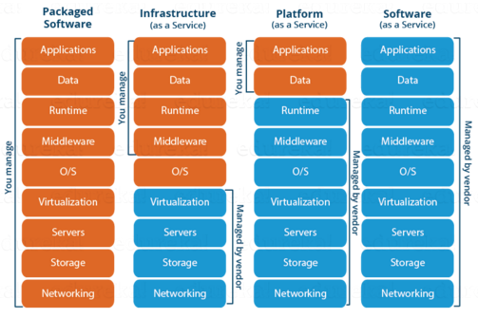

We now know about the service models, once you offer a service next comes deployment, let us now discuss the deployment models:

## Cloud Deployment Models

A cloud deployment model represents a specific type of cloud environment, primarily distinguished by ownership, size, and access.

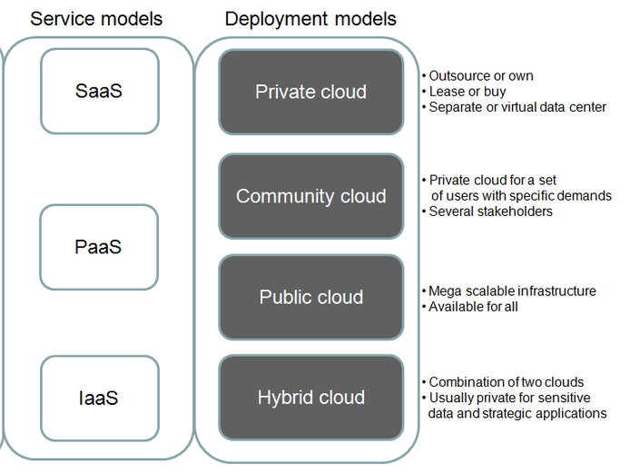

There are four common cloud deployment models:

* Public Cloud
* Community Cloud
* Private Cloud
* Hybrid Cloud

## Public Cloud

In a public cloud deployment mode, the services which are deployed are open for public use and generally public cloud services are free. Technically there may be no difference between a public cloud and a private cloud, but the security parameters are very different, since the public cloud is accessible by anyone there is a more risk factor involved with the same.

A public cloud is a publicly accessible cloud environment owned by a third-party cloud provider. The IT resources on public clouds are usually provisioned via the previously described cloud delivery models and are generally offered to cloud consumers at a cost or are commercialized via other avenues (such as advertisement).

The cloud provider is responsible for the creation and on-going maintenance of the public cloud and its IT resources. Many of the scenarios and architectures explored in upcoming chapters involve public clouds and the relationship between the providers and consumers of IT resources via public clouds.

Figure 1 shows a partial view of the public cloud landscape, highlighting some of the primary vendors in the marketplace.

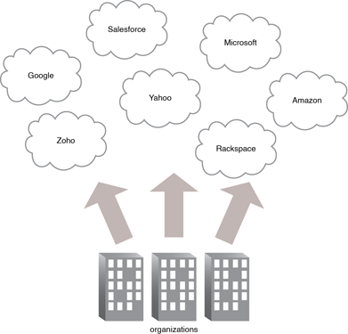

*Figure 1 - Organizations act as cloud consumers when accessing cloud services and IT resources made available by different cloud providers.*

Community Clouds

A community cloud is similar to a public cloud except that its access is limited to a specific community of cloud consumers. The community cloud may be jointly owned by the community members or by a third-party cloud provider that provisions a public cloud with limited access. The member cloud consumers of the community typically share the responsibility for defining and evolving the community cloud (Figure 1).

Membership in the community does not necessarily guarantee access to or control of all the cloud's IT resources. Parties outside the community are generally not granted access unless allowed by the community.

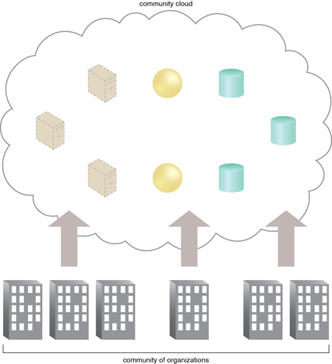

*Figure 1 - An example of a "community" of organizations accessing IT resources from a community cloud.*

Private Clouds

A private cloud is operated solely for a single organization, it can be done by the same organization or a third-party organization. But usually the costs are high when you are using your own cloud since the hardware would be updated periodically, security also has to be kept in check since new threats come up every day.

A private cloud is owned by a single organization. Private clouds enable an organization to use cloud computing technology as a means of centralizing access to IT resources by different parts, locations, or departments of the organization. When a private cloud exists as a controlled environment, the problems described in the Risks and Challenges section do not tend to apply.

The use of a private cloud can change how organizational and trust boundaries are defined and applied. The actual administration of a private cloud environment may be carried out by internal or outsourced staff.

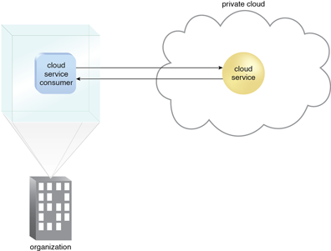

*Figure 1 - A cloud service consumer in the organization's on-premise environment accesses a cloud service hosted on the same organization's private cloud via a virtual private network.*

## Hybrid Cloud

A hybrid cloud consists the functionalities of both private and public cloud. How?

Hybrid Clouds

A hybrid cloud is a cloud environment comprised of two or more different cloud deployment models. For example, a cloud consumer may choose to deploy cloud services processing sensitive data to a private cloud and other, less sensitive cloud services to a public cloud. The result of this combination is a hybrid deployment model (Figure 1).

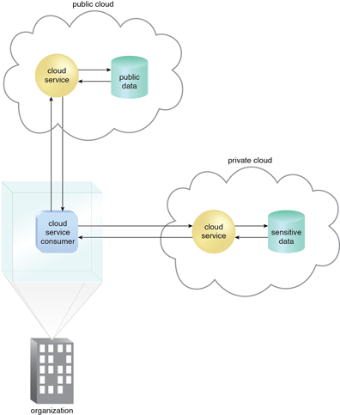

*Figure 1 - An organization using a hybrid cloud architecture that utilizes both a private and public cloud.*

Hybrid deployment architectures can be complex and challenging to create and maintain due to the potential disparity in cloud environments and the fact that management responsibilities are typically split between the private cloud provider organization and the public cloud provider.