Milestone 1: Debug a Silently Failing Training Run
Problem:
A binary classifier on tabular data (10,000 rows) shows training loss that keeps falling, but validation accuracy sits near 55% and bounces around from epoch to epoch.
Provided training code:
X = StandardScaler().fit_transform(X)
X_tr, X_val = X[:8000], X[8000:]
y_tr, y_val = y[:8000], y[8000:]
np.random.shuffle(X_tr)

model = nn.Sequential(nn.Linear(40, 128), nn.ReLU(), nn.Dropout(0.5),
nn.BatchNorm1d(128), nn.Linear(128, 2))
opt = torch.optim.Adam(model.parameters(), lr=1e-3)
scheduler = torch.optim.lr_scheduler.StepLR(opt, step_size=1, gamma=0.9)

for epoch in range(50):
model.train()
for xb, yb in train_loader:
loss = loss_fn(model(xb), yb)
opt.zero_grad(); loss.backward(); opt.step()
scheduler.step()
val_logits = model(torch.tensor(X_val))
print(epoch, accuracy(val_logits, y_val))
Required analysis:

Identify every bug you can find.
- scheduler.step() is called inside the inner batch loop instead of once per epoch.
- StandardScaler() is fit on all the data before the train/validation split.
- np.random.shuffle(X_tr) shuffles the features but not y_tr, so rows and labels no longer match.
- nn.Dropout(0.5) comes before BatchNorm1d(128). Dropout randomly switches off 50% of the activations, so BatchNorm ends up normalizing a distorted signal.
- Validation runs without model.eval(), so the validation accuracy is wrong.
- The class balance is never checked before training.
- No proper evaluation metrics are used to judge the results.

Explain which symptom each bug causes.
- scheduler.step() in the inner loop shrinks the learning rate by a factor of 0.9 after every batch instead of every epoch. It gets close to zero almost right away, and learning stalls.
- Fitting the scaler before the split lets information from the validation rows leak into training, which makes the validation accuracy biased. Split first, fit the scaler on the training rows only, then use it to transform the validation rows.
- When features and labels do not line up, the data is basically noise. Training loss and validation accuracy get stuck at a plateau.
- Dropout zeroes out 50% of the activations, and BatchNorm then has to normalize this distorted signal.
- Without model.eval(), dropout keeps switching off 50% of the neurons during validation, and BatchNorm keeps updating its running statistics. That causes the wild swings in validation accuracy around 55%.
- Validation accuracy may not represent the whole population. Use a stratified random split for i.i.d. data, or a time-based split when the model will be deployed on data that changes over time.
- A model can look fine while failing on the class that matters. Check the class balance, the confusion matrix, precision and recall, and the baseline accuracy.

Provide corrected code or a description of each fix.
import numpy as np
import torch
import torch.nn as nn
from sklearn.preprocessing import StandardScaler

# 1. Split BEFORE scaling to prevent data leakage
X_tr, X_val = X[:8000], X[8000:]
y_tr, y_val = y[:8000], y[8000:]

scaler = StandardScaler()
X_tr = scaler.fit_transform(X_tr)
X_val = scaler.transform(X_val)

# 2. Correct Layer Ordering: Linear -> BatchNorm -> ReLU -> Dropout
model = nn.Sequential(
nn.Linear(40, 128),
nn.BatchNorm1d(128),
nn.ReLU(),
nn.Dropout(0.5),
nn.Linear(128, 2),
)

opt = torch.optim.Adam(model.parameters(), lr=1e-3)
scheduler = torch.optim.lr_scheduler.StepLR(
opt, step_size=1, gamma=0.9
) # Step every epoch

for epoch in range(50):
model.train()
for xb, yb in train_loader: # Ensure train_loader uses aligned (X_tr, y_tr) Dataset
loss = loss_fn(model(xb), yb)
opt.zero_grad()
loss.backward()
opt.step()

# Fix 1: Step scheduler per epoch, not per batch
scheduler.step()

# Fix 3: Proper validation mode & no_grad
model.eval()
with torch.no_grad():
val_logits = model(torch.tensor(X_val, dtype=torch.float32))
print(f"Epoch {epoch}: Accuracy = {accuracy(val_logits, y_val):.4f}")

Describe quick experiments that would reveal pipeline problems without access to the code.
- Compare this approach to always guessing the most frequent class. Since 55% of the labels are for one class, a model that always makes that prediction would achieve a score of 55%; therefore, if your model's score is near that figure, it has not actually picked up any knowledge.
- Use a small dataset (100 to 500 examples). The model should memorise this set almost entirely; if it doesn't, then something fundamental is at fault, for example the labels not matching the rows, an incorrect loss function, or an inappropriate learning rate.
- Randomise the training labels and then retrain the model; it should now be performing no better than by random chance. However, if it still achieves a good score, then information must be leaking from the validation data or the initial split was incorrect.
- Run the process using five different random seeds. If the results vary significantly, then the validation set might be too small or too unbalanced, the training could be unstable, or there could be leakage.
- Look at the raw data, count the number of classes and check for any missing values or duplicate rows; ensure that the labels are encoded as you expect (with 0/1 not reversed) and that each row still has its own label.
- It is important to plot both the training loss and the validation loss, not merely the accuracy. If the training loss continues to decrease while the validation loss remains unchanged, the model might be memorising the training data, the validation data could be different from the training data, the features may be of low quality, or there could be a bug in the evaluation code.
7. Make sure that the preprocessing was carried out correctly. The scalers and encoders should have been trained only on the training data and then applied without any changes to the validation and test data. If they are fitted on all the data first, information is leaked.

Milestone 2: Derive and Implement a Gradient
Problem:
Consider single-head attention:
S = QKᵀ / √d
P = softmax(S) (row-wise)
O = PV
Required analysis and implementation:

Derive dV, dP, dS, dQ, and dK given upstream gradient dO.
Given upstream gradient $dO$ and dimensions: $Q,K∈R^{n×d_{k}}$, $V∈R^{n×d_{v}}$.
- $dV$ (Value Gradient): Since $O=PV$, differentiating gives:
- $dV=P^{T}dO$
- $dP$ (Attention Probability Gradient): Since $O=PV$, differentiating gives:
- $dP=dOV^{T}$
- $dS$ (Attention Score Gradient): Let $P=softmax(S)$. The softmax Jacobian-vector product gives:
- $dS=P⊙\left(dP−sum(dP⊙P,axis=−1,keepdims=True)\right)$

- $dQ$ & $dK$ (Query & Key Gradients): Since $S=\frac{QK^{T}}{\sqrt{d_{k}}}$, differentiating gives:
- $dQ=\frac{1}{\sqrt{d_{k}}}dSK$

- $dK=\frac{1}{\sqrt{d_{k}}}dS^{T}Q$

Implement forward and backward passes in NumPy; verify using numerical gradient checking. State the step size, precision, and acceptance threshold.
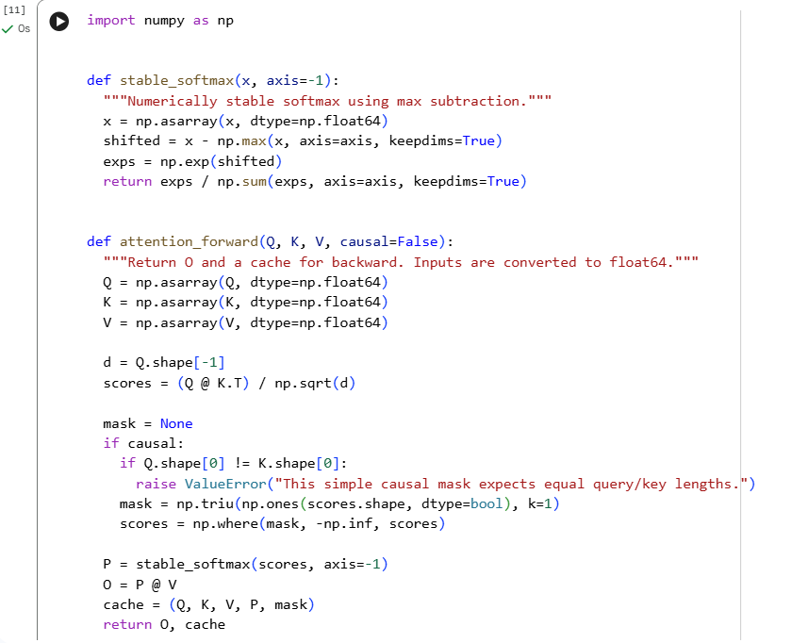
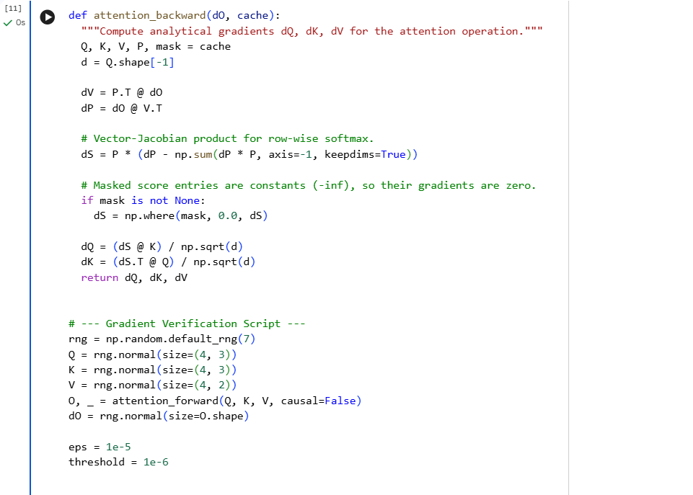
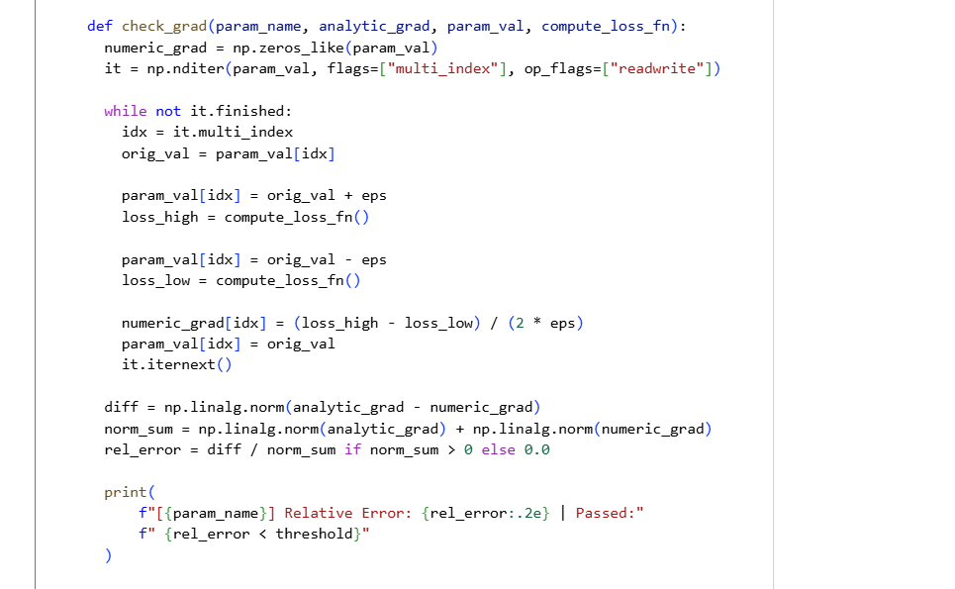
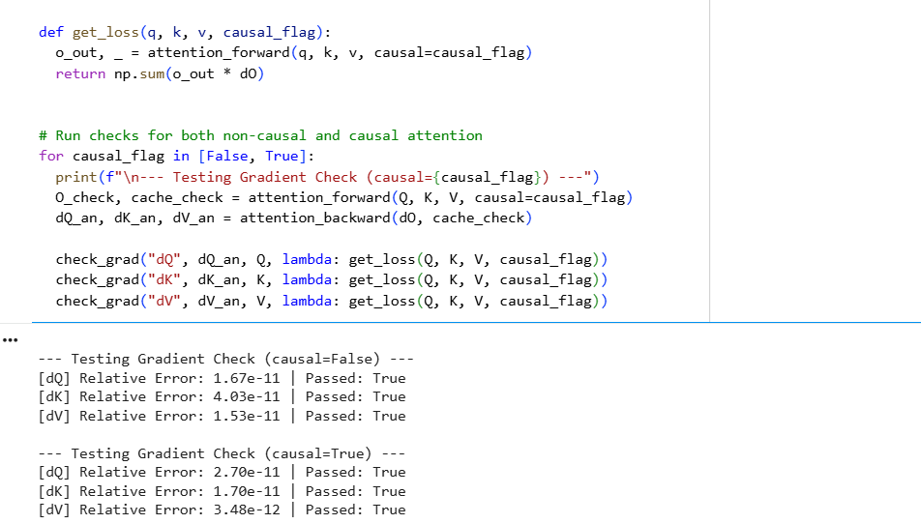

Verification Parameters & Result
- Step Size ($ϵ$): 1e-5
- Data Precision: np.float64 (Double precision)
- Acceptance Threshold: Relative error $<10^{−6}$
- Result: All relative errors are on the order of $≈10^{−10}$, so the check passes for both non-causal and causal attention.

Identify the forward-pass numerical stability issue and explain its fix.
Issue: Calculating $exp(S)$ on large raw dot-product values can overflow and give inf or NaN.
Fix: Shifted Softmax. Subtracting $\max_{}(S)$ row-wise before taking the exponential keeps all the inputs $≤0$:
$$softmax(S)=\frac{exp(S−\max_{}(S))}{\sum{}exp(S−\max_{}(S))}$$

Explain why attention uses the scaling factor 1/√d.
The scaling factor (or similar) prevents the dot products of the query and key from becoming too large in high dimensions; otherwise the softmax would end up in regions where the gradients vanish and training would come to a halt. When the dimensions are large, the scores become large and cause the softmax to enter saturated areas where the gradients are almost zero (this is the vanishing gradient problem). Dividing by brings the score variance back to , thereby keeping the gradients from vanishing.

Explain how the backward pass changes with a causal mask.
During the backward pass, the masked (future) positions have an attention probability of 0 and therefore the corresponding values in dS are also 0; as a result, no error signal can pass from a token to a position which it was never permitted to attend to.

Analyze memory cost as sequence length n grows and explain how FlashAttention avoids it.
In standard attention, each token is compared with all the other tokens, which causes an n × n matrix of scores to be created and stored in the GPU's main memory (HBM); when the sequence length is doubled, the matrix becomes four times larger, which is the reason why long sequences exceed the memory capacity. FlashAttention solves this by not keeping the entire matrix in memory; instead, it divides the inputs into small blocks, loads one block at a time into SRAM (which is small but much faster than HBM), and carries out the calculation there. The difficulty lies with the softmax, since it usually requires all the scores in a row before it can proceed. FlashAttention overcomes this by maintaining a running maximum and a running sum, and it adjusts its partial result each time a new block is brought in. The final output is identical to that of standard attention, not an approximation. When a block has been processed, the scores are discarded.
In HBM only the inputs, the output and a small number of values for each row are retained, which means that the memory usage increases linearly with n.

Milestone 3

Identify which model comparison metrics to use and avoid, with justification.
Given the fact that Fraud accounts for 0.1% of transactions which means if the model is trained on such significantly high imbalance dataset it will give 99.9% accuracy since it’ll just given negative on each case. Metrics suitable for working in such cases are:
Recall (Sensitivity / True Positive Rate) : Measures the fraction of real positive cases that the model correctly finds (TP / (TP + FN)). Use this when missing a positive case is dangerous or costly (e.g., disease screening)
Precision (Positive Predictive Value): this measures how many positive flagged values are actually flagged (TP / (TP + FP)).
F1 Score: The harmonic mean of precision and recall (2 ⋅ (Precision ⋅ Recall) / (Precision + Recall)). Use this when you have imbalanced data and need a single score for both errors. [1, 2, 3]
Precision-Recall Curve (AUC-PR): Focuses heavily on the positive class performance. This is better than ROC

2. Design the train/validation/test split.

We would opt for out of time split. The order of time for transaction matters that’s why we chose this method. Order transactions by timestamp and split chronologically, so the model is always evaluated on data later than what it trained on.
Since we have 30-60 day charge back, so we leave this gap to avoid training on rows whose labels are incomplete. Otherwise recent fraud looks like legit transactions and the model learns a wrong picture.

3. Explain how to evaluate despite label delays.

Following are the few techniques that can be used in this case:

Label maturity window (the baseline): plot the cumulative fraction of fraud labels received vs. days since transaction. Set the window where that curve flattens (e.g., 90% of chargebacks arrive by day 45, 98% by day 60). We are going to evaluate on the data older than the cutoff. But this only tell us how our model was performing 1 or 2 months before.

For data that is only partly matured, Use the historical delay distribution to scale up observed fraud counts. If only 60% of chargebacks typically arrive by day 20, divide the observed fraud count at day 20 by 0.6. This gives a rough early estimate of recall, fraud rate, and dollar loss, with wider uncertainty than matured data.

Data which is still immature will be excluded and cannot be treated as negative until proper chargeback periods is completed.

4. Choose a cost-based decision threshold where a false negative costs $200 on average and a false positive costs $5. Explain how to assess score calibration.

In this case, a false negativecosts $200 and a false positive costs $5.

Decision | When it’s wrong | Expected cost
Let it through | It was fraud (probability p) | p × $200
Block it | It was legit (probability 1 − p) | (1 − p) × $5
p × 200 > (1 − p) × 5 200p > 5 − 5p 205p > 5 p > 5/205 ≈ 0.0244

So if a case has 0.002% likelihood of being fraud it’ll get flagged by the model.

5. Explain how to detect production drift and determine when to retrain.
Potential things that can drift is input data, final label and pattern. Concept drift is the most damaging and the hardest to see, because it needs labels.
Score distribution: compare today’s fraud scores to a past period using PSI or the KS test.
Alert rate: the share of transactions flagged. A sudden jump or drop in the flagged cases is a warning.
PSI rule: below 0.1 is fine, 0.1-0.25 means investigate, above 0.25 means act.
When to train?
Every 1-3 months, as a safety net
PSI above 0.25, or the alert rate moves outside its normal range
Cost or missed fraud gets noticeably worse (e.g., 10% above baseline)

Milestone 4: Diagnose Learning Curves

1. Diagnosis of Cases A, B, and C

Case A (Train: 62%, Val: 60%, flat as data grows)
- Diagnosis: Severe Underfitting (High Bias).
  - The reason is that both the training and validation accuracies are low and do not improve as the amount of training data increases; the model lacks sufficient capacity to capture the patterns present in the data, so adding more data will not make any difference and it has already reached its limit..
- Proposed Interventions:
  - Increase the model's capacity by expanding the architecture, for instance, by adding layers or hidden units, or by switching to a more expressive model family..
  - Decrease the amount of regularization: reduce the weight decay, eliminate the dropout layers, or relax any of the feature constraints if the model is being hindered too much.
- Justification: The reason is that increasing the number of parameters and at the same time reducing the constraints allows the model to fit the training data more closely; concerns regarding generalization will be addressed later.

Case B (Train: 99%, Val: 78%, validation rises slowly and the gap shrinks slowly)
- Diagnosis: Overfitting (High Variance) with Slow Data Scaling.
  - Why: The reason is that the difference between the near-perfect training accuracy (99%) and the moderate validation accuracy (78%) indicates the model is memorizing the training data. However, validation accuracy does improve and the gap between the two decreases as more data is available, which shows that increasing the amount of data is of some help, although the effect is slow.
- Proposed Interventions:
1. ScaleAggressively scale up the data: keep gathering more training data since the curve indicates that this is having the desired effect.
2. Add stronger regularization. Use dropout, weight decay, or strong data augmentation to help prevent memorization.
3. Introduce early stopping by terminating the training process before the model overfits the training dataset. Justification: Regularization stops the model from making decision boundaries that are too complex. More data helps the model learn general patterns instead of noise.
- Justification: Regularization penalizes overly complex decision boundaries, and more data helps the model pick up general patterns instead of noise.

Case C (Train: 85%, Val: 91%, both rise slightly as data grows)
- Diagnosis: Healthy Generalization with Training-Time Regularization.
  - Why: Validation accuracy is consistently higher than training accuracy. This is a classic pattern when strong regularizers (such as dropout, stochastic depth, or heavy data augmentation) are active during training. They make the training task harder than evaluation, while the validation set is clean and unregularized.
- Proposed Interventions:
  - No critical intervention needed: The model generalizes well, and more data gives steady but small improvements.
  - Optional tuning: If you want, reduce the training-time augmentation a little to bring training accuracy closer to validation accuracy. The current state is healthy as it is.
- Justification: Validation accuracy that beats regularized training accuracy is a good sign that the model has learned robust features that generalize.

2. Analysis of Case D

Case D (Train: 88%, Val: 70%, gap does not close even with $4×$ data)
When a large generalization gap stays put even after a huge increase in training data ($4×$), the problem is no longer a lack of data.

Two Plausible Explanations:
- Data Distribution Mismatch (Domain Shift): The training and validation sets come from different distributions (non-IID). For example, the training data may be clean and curated while the validation data has real-world noise or different lighting or demographics. Adding more training data from the wrong distribution does nothing to close the gap.
- Validation Set Quality / Label Noise: The validation set has a lot of label noise, mislabeled examples, or labels that are inherently ambiguous (high irreducible error, or Bayes error, for the validation split). In that case the 70% ceiling comes from poor data quality, not from a model failure.

Distinguishing Experiment:
- The Random Shuffle and Re-Split Test:
  - Combine the training and validation data into a single pool.
  - Shuffle the pool randomly and re-split it into new training and validation sets, using the same ratio as before.
  - Retrain the model from scratch on the new training split and evaluate it on the new validation split.
- How it distinguishes the causes:
  - If the validation accuracy jumps up to match or come close to the training accuracy (the gap closes), that points to Distribution Mismatch / Non-IID splitting as the cause, since the original validation set was harder or systematically different.
  - If the 18% gap persists unchanged, the bottleneck is Label Noise / Inherent Ambiguity in the validation labels. Reshuffling the split spreads the noise around evenly but does not fix the underlying quality problem.

