Label Noise in HelpDeskNet-50K
Diagnosis, Characterisation and Remediation of the 82% Accuracy Plateau
Hackathon Issue #9 · AI/ML
Prepared by: ClaudeBuster

Answers at a Glance
Milestone | Question | Our answer
1 | How noisy are the crowd labels? | 15.0% (60 of 400 audited), 95% CI 11.5% – 18.5%
1 | Is Tier B really worse than Tier A? | Yes. 21.8% vs 6.7% (3.3× the error rate), z = 4.22, p = 2.4 × 10⁻⁵. Tier B makes 80% of errors from 55% of tickets
2 | Random or systematic? | Systematic. 52 of 60 errors (86.7%) fall in three look-alike pairs; 20% expected by chance
2 | Root cause? | Hypothesis: unclear boundaries between adjacent classes plus weak onboarding and quality control for newer workers (checks listed)
3 | True accuracy if 15% uniform noise? | ≈ 96.3%, but unreliable. Realistic range ≈ 91 – 96%
4 | Which 2,000 tickets to review? | 1,600 ranked by suspicion + 400 stratified random control. Judged by precision, lift and recall
5 | Robust training | Forward loss correction with a noise matrix; co-teaching with small-loss selection
5 | Why is the test set a problem? | A perfect model scores only ≈ 85% on it, and it rewards copying the crowd’s mistakes
One-line conclusion. The 82% plateau is mostly a measurement problem, not a model problem. The test labels cap the score near 85%, and the model is probably already in the low-to-mid 90s on true accuracy. The first job is a clean, expert-labelled test set.

1. Problem Setup
A fine-tuned classifier on HelpDeskNet-50K (50,000 tickets, six classes) stays at 82% on its held-out test set, regardless of epochs or model size. We ask whether the limit is the model or the labels.
Input | Content | Why it matters
Classes | Billing 30%, Technical 25%, Refund 15%, Account Access 15%, Shipping 10%, Other 5% | Three natural families: Billing + Refund (45%), Technical + Account Access (40%), Shipping + Other (15%)
Labelling | 5,000 expert tickets; 45,000 crowd tickets. Tier A: 10 experienced workers, 20,000 tickets. Tier B: 30 newer workers, 25,000 tickets | Most labels come from the crowd, and over half from the less experienced tier
Test set | Labelled by the same crowd process as training | Test errors are correlated with training errors
Audit | 400 random crowd tickets (180 Tier A, 220 Tier B), 60 disagreements | The audit mix (45% / 55%) matches the full crowd mix (44.4% / 55.6%), so it is representative
Assumptions. (1) Expert labels are ground truth, so “noise” means disagreement with experts. (2) The audit is a random sample. (3) Test-set noise follows the same process as training noise. (4) The 5,000 expert tickets are clean.

2. Milestone 1: Quantify Label Noise

2.1 Overall noise rate
p-hat = 60/400 = 0.150. Standard error SE = √( p-hat × (1 − p-hat) / n ) = √( 0.15 × 0.85 / 400 ) = 0.0179. Margin of error = 1.96 × 0.0179 = 0.035.
95% CI: 15.0% ± 3.5% = 11.5% to 18.5%.
Estimate | Value | 95% interval
Overall, normal approximation | 15.00% | 11.50% – 18.50%
Overall, Wilson interval | 15.00% | 11.83% – 18.83%
Overall, weighted by tier workload (0.444 / 0.556) | 15.08% | 11.65% – 18.52%
Tier A (12 / 180), Wilson | 6.67% | 3.9% – 11.3%
Tier B (48 / 220), Wilson | 21.82% | 16.9% – 27.7%
Whole dataset, if expert tickets are clean (0.9 × 15.08%) | ≈ 13.6% | point estimate
Three methods agree within 0.3 points, so the conclusion does not depend on the method. The lower bound is above 11%, so material noise exists under any reasonable reading.
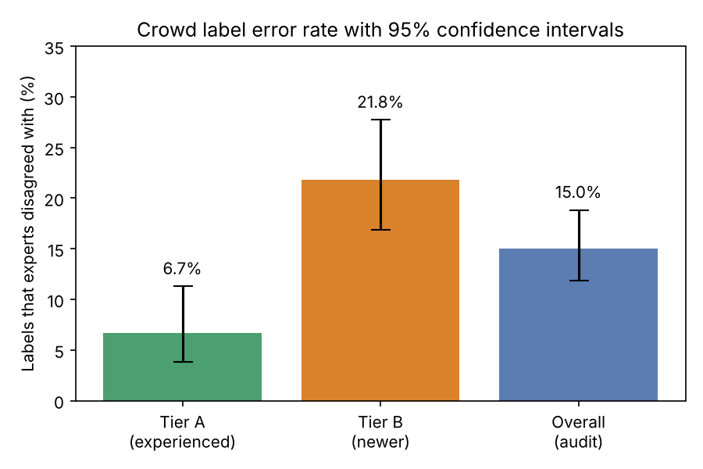
Crowd label error rate with 95% confidence intervals

2.2 Tier A vs Tier B
Null hypothesis: both tiers share one error rate. Pooled rate = (12 + 48) / (180 + 220) = 0.150.
SE = √( 0.15 × 0.85 × (1/180 + 1/220) ) = 0.0359, and z = (0.2182 − 0.0667) / 0.0359 = 4.22.
Statistic | Value
Difference (Tier B − Tier A) | 15.15 points (95% CI 8.6 to 21.7)
Risk ratio | 3.27
z / two-sided p | 4.22 / 2.4 × 10⁻⁵
Chi-square (1 d.f.) / Fisher exact p | 17.83 / 1.8 × 10⁻⁵
Smallest expected cell count | 27 (validity condition needs ≥ 5)
The gap is not chance. It would appear about twice in 100,000 samples if the tiers were equally accurate. Tier B produced 80% of disagreements (48 of 60) from 55% of audited tickets. If Tier B matched Tier A, overall noise would fall from about 15% to about 7%.

2.3 What this does and does not show
- Tier is not worker. The audit shows Tier B labels are less accurate. It cannot judge individuals: with 220 audited tickets over 30 workers, each Tier B worker has only about 7 audited tickets. One worker with 2 errors in 7 has a 95% interval of 8% to 64%. Judging a worker to within ±10 points needs about 66 gold tickets, and ±5 points needs about 263. This is why we recommend hidden gold tickets, not worker-level conclusions from the current audit.
- Possible confounding. If Tier B was given harder or different tickets, part of the gap comes from ticket mix, not skill. The data do not say how tickets were assigned. Check: compare class mix across tiers, then repeat the tier comparison within each class (a stratified test). Even if difficulty explains part of the gap, the noise rate and the structure in Section 3 are unchanged.

3. Milestone 2: Characterise the Noise

3.1 The disagreement table
Crowd → Expert | Count | Share of 60
Billing → Refund | 14 | 23.3%
Refund → Billing | 12 | 20.0%
Technical → Account Access | 9 | 15.0%
Shipping → Other | 8 | 13.3%
Account Access → Technical | 6 | 10.0%
Technical → Other | 5 | 8.3%
Other → Shipping | 3 | 5.0%
Billing → Other | 3 | 5.0%

Class pair (both directions) | Count | Share of errors
Billing ↔ Refund | 26 | 43.3%
Technical ↔ Account Access | 15 | 25.0%
Shipping ↔ Other | 11 | 18.3%
Three pairs together | 52 | 86.7%
Technical → Other, Billing → Other | 8 | 13.3%
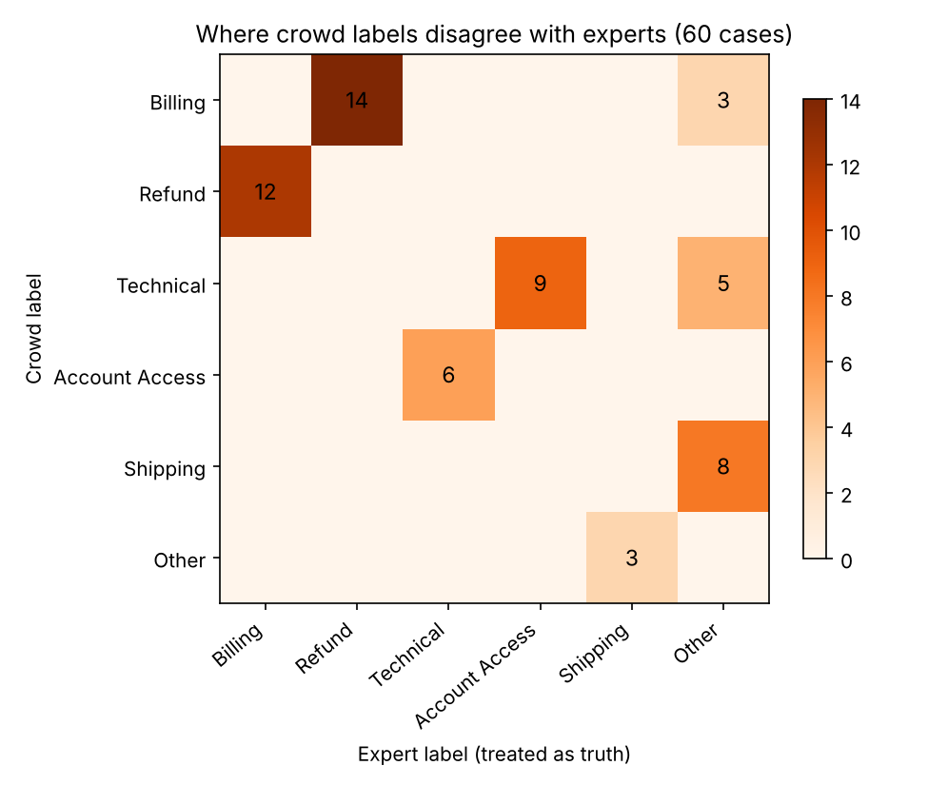
Crowd vs expert disagreements

3.2 Test against random noise
If errors were random, each wrong label would land on any of the five other classes with probability 20%. Each class has exactly one partner in the three pairs, so we expect 60 × 0.20 = 12 errors inside them. We observe 52, about 12.9 standard deviations above expectation. In a 100,000-trial Monte Carlo simulation, no trial reached 52. Only 8 of the 30 possible error types occur at all.
The three pairs follow the class families from the dataset description, so they were defined by meaning before looking at the audit, not fitted to it.

3.3 Further structure
- Symmetry. Billing → Refund (14) and Refund → Billing (12) are nearly equal, as are the two Technical / Account Access directions (9 and 6). Workers are not biased toward one label; the boundary between the classes is ambiguous.
- “Other” is treated differently. All 16 errors where experts said “Other” were labelled Shipping (8), Technical (5) or Billing (3). Only 3 errors went the other way. Crowdworkers seem to force borderline tickets into a specific class. Counts are small, so this is a hypothesis to verify.
- Errors match the class structure. Unclear definitions, not random slips, are the likely driver.

3.4 Root cause (working hypothesis)
The most likely cause is insufficiently separated class definitions in the guidelines, combined with limited training and quality control for newer workers. The evidence fits: errors cluster in adjacent classes; experienced Tier A workers make about one-third as many errors on the same task, so the task is learnable once the conventions are known; and the pattern for “Other” suggests no explicit criterion exists. Other factors to confirm or exclude: genuinely ambiguous tickets, speed-based pay, a few very weak workers in Tier B, and interface effects such as option order and defaults.

3.5 What to change in the annotation process
- Rewrite the guidelines with explicit decision rules and worked examples for each pair. Example: a request for money back is Refund; a question about a charge, invoice or plan is Billing; inability to sign in is Account Access; a crash or broken feature is Technical. Add a tie-break rule for tickets that fit both.
- Define “Other” by explicit criteria and add an “Unsure / multiple topics” option.
- Qualification test on hard examples before new workers start, with periodic feedback.
- Hidden gold tickets to track per-worker accuracy continuously; retrain or remove persistent low performers.
- Redundant labelling (2 to 3 workers) on high-risk tickets, majority vote, ties escalated to experts.
- Reassess the taxonomy. If Billing and Refund cannot be separated reliably, merge them or use a hierarchy (“Money → billing query / refund request”).
Diagnostic checks to confirm the root cause (per-worker error rates, inter-annotator kappa, review of disputed tickets, pay structure, interface) are in Appendix A.

4. Milestone 3: The Accuracy Ceiling

4.1 Estimate under uniform noise
Assume 15% of labels are flipped uniformly to one of the other five classes, and the model scores 82% on the noisy test set. Let T be its true accuracy.
- When the model is right (probability T), it matches the noisy label only if the label was not flipped: 0.85.
- When it is wrong (probability 1 − T), it predicts one specific wrong class. The noisy label matches only if the label was flipped (0.15) to that exact class (1 in 5): 0.15 / 5 = 0.03.
Observed accuracy = 0.85 × T + 0.03 × (1 − T), so 0.82 = 0.03 + 0.82 × T, and T = (0.82 − 0.03) / 0.82 = 0.963.
Estimated true accuracy ≈ 96.3%. The shortcut 0.82 / 0.85 = 96.5% skips the chance-agreement term and slightly overstates it.
Component | Effect | Running value
Perfect model, error-free labels | n/a | 100%
Label noise (15%) | −15.0 points | 85.0% (ceiling)
Genuine model errors (≈ 3.7% of tickets × 0.82) | −3.0 points | 82.0% (observed)
A perfect classifier scores only 85% on this test set, and the observed 82% is within three points of that. Because the ceiling is 1 − η (η is the noise rate), it ranges from 81.5% to 88.5% across the audit interval. Noise also shrinks measured gains: a real improvement of 1.0 point shows up as about 0.82 points, which sampling variation easily hides. This explains the plateau.

4.2 Why the estimate may be unreliable
- Noise is not uniform. The formula assumes a wrong prediction matches the noisy label 3% of the time. Because crowd errors cluster in look-alike pairs, a model that confuses Billing with Refund is far more likely to agree with a label containing the same confusion.
- Errors are shared. The model trained on crowd labels can learn the crowd’s systematic mistakes and get credit for repeating them. The formula needs model errors and label errors to be independent.
- The noise rate is uncertain. The audit gives a range, and the rate differs by tier and class.
- Reference labels and audit size. Experts may disagree with each other, and 400 tickets is small.
Assumed noise rate | Implied true accuracy |  | Match rate of wrong predictions with noisy label | Implied true accuracy
11.5% | 92.5% |  | 3% (uniform assumption) | 96.3%
13.0% | 94.1% |  | 20% | 95.4%
15.0% | 96.3% |  | 50% | 91.4%
17.0% | 98.7%
18.0% | 100.0%
18.5% | 100.6% (impossible)
At the top of the audit interval the formula gives an impossible value, so the simple model does not fit this data. The right-hand column shows that the more the model’s errors coincide with the crowd’s, the lower the true accuracy. Defensible conclusion: true accuracy is probably about 91 – 96% (the range of the right-hand column), and cannot be pinned down until we have a clean, expert-labelled test set.

5. Milestone 4: Find the Bad Labels

5.1 Selection strategy
Random review of 2,000 tickets (4.4% of the crowd data) would find about 300 errors at a 15% noise rate. We aim to do much better, while keeping an unbiased sample.
Part | Tickets | Purpose
Targeted, ranked by suspicion | ≈ 1,600 | Maximise corrections
Random, stratified by class and tier | ≈ 400 | Unbiased noise matrix, unbiased benchmark for lift
Suspicion signals
- Cross-validated model disagreement. Predict each of 5 folds with a model trained on the other 4, so no prediction comes from a model that saw that ticket’s label. Flag tickets where the crowd label gets low probability and another class gets high probability, using per-class thresholds (confident learning).
- Class-pair prior. Boost tickets where the crowd label and the model’s top class form one of the three look-alike pairs (86.7% of observed errors).
- Source quality. Boost Tier B tickets (1.45× the overall error rate; Tier A is 0.44×), and weak workers once identified.
- Supplementary. High early-training loss; disagreement between independently trained models.
- Diversity. Remove near-duplicates; spread selections across pairs roughly in line with error shares (about 43% Billing/Refund, 25% Technical/Account Access, 18% Shipping/Other).
Review runs in batches of 400 in descending suspicion. After each batch, retrain, re-rank, and stop targeting when a batch’s hit rate falls to the 15% random baseline.

5.2 How to tell whether selection works
Metric | Definition | Target
Precision (hit rate) | Share of reviewed tickets where experts changed the label | Well above 15%
Lift | Precision ÷ precision of the random control | 2× or higher
Recall | Corrections found ÷ estimated total errors (≈ 6,800) | Reported to show what remains
Precision by suspicion band | Hit rate vs rank | Declines steadily; a flat curve means the ranking failed
Method comparison | Pilot 2–3 ranking methods on ≈ 200 tickets each | Pick the winner with a two-proportion test
Downstream effect | Accuracy on the clean expert test set, with and without corrections | Measurable gain, especially on the three pairs
A second expert should independently review about 100 of the random-control tickets to measure expert disagreement.
Planning scenarios (targets, not results):
Targeted precision | Fixed from 1,600 targeted | + ≈ 60 from random control | Share of the ≈ 6,800 total errors
30% | 480 | ≈ 540 | 8.0%
40% | 640 | ≈ 700 | 10.3%
50% | 800 | ≈ 860 | 12.7%
Direct review reaches only about 8–13% of all errors. That is why the corrected tickets are used to teach a cleaner (below) and why Milestone 5 adds noise-tolerant training.

5.3 Using the corrected labels
- Replace wrong labels with expert labels. Together with the expert tickets not reserved for testing (Section 6.2), this forms a clean core of about 5,400 tickets (3,000 + 2,000 + the 400 audited).
- Estimate a 6 × 6 noise matrix T (probability of each crowd label given the true class) from the random tickets only: the 400 audited plus the 400 random control, about 800. The targeted tickets are a biased sample and must not be used for this, or for noise-rate estimates.
- Train a label-cleaning model on the clean core and rescore the remaining ≈ 42,600 crowd tickets: auto-correct high-confidence disagreements, down-weight uncertain labels, queue the rest.
- Weight by source reliability: expert > Tier A > Tier B.
- Feed error patterns back into the guidelines (Section 3.5).
- Exclude every reviewed ticket from the test set.
Selection bias warning. Because reviewed tickets were chosen for looking wrong, fixing only those shifts the label distribution toward the confusable classes. The random control and the transition matrix are how we correct for that.

6. Milestone 5: Mitigate Noise and Evaluate Reliably

6.1 Two training-time methods that tolerate noise
Forward loss correction with a noise matrix. Let T[i][j] be the probability that a ticket of true class i gets crowd label j (estimated in Section 5.3). The model’s beliefs are passed through T before computing the loss:
P(noisy label = j | ticket) = Σᵢ P(true class = i | ticket) × T[i][j]
The model is then penalised for the noisy label it would receive, so it learns the true classes while allowing for known annotator behaviour. Our matrix is sparse (mass on the diagonal, leakage in three pairs), so a few hundred audited tickets can estimate it reliably.
Co-teaching with small-loss selection. Two networks train together. Each round, each network picks its small-loss tickets and hands them to the other for the update. Deep networks learn clean patterns before they memorise wrong labels, so small-loss tickets are mostly correct. Add early stopping to halt before memorisation.
Supporting options: label smoothing, noise-robust losses (symmetric or generalised cross-entropy), lower weights for Tier B, confident-learning pruning, and a final fine-tune on the clean core.

6.2 A trustworthy evaluation set
- Expert labels only, ideally two experts per ticket with disagreements adjudicated. Report inter-expert kappa.
- Representative random sample, stratified by class and tier. Never use the targeted tickets from Section 5, which over-represent hard cases.
- Source. Check that the 5,000 expert tickets are representative and were not used in training. If so, reserve a stratified 2,000 of them as the test set (±0.96 points at 95% accuracy; 5,000 would give ±0.6). The other 3,000 join the clean training core. If they were used in training, re-label a stratified random sample of the current test set instead.
- Size. n = 1.96² × p(1 − p) / m², where m is the margin. At 95% accuracy, about 460 tickets give ±2 points and about 1,830 give ±1 point.
- Isolation. Never used for training, label cleaning, tuning or selection. A separate small clean validation set handles tuning. Remove near-duplicates across splits.
- Reporting. Accuracy with a 95% interval; per-class precision and recall, especially for the three pairs; results against expert labels and crowd labels.
- Maintenance. Refresh periodically as ticket distribution changes.

6.3 Why the existing crowd-labelled test set is problematic
Deficiency | Consequence
About 15% of labels are wrong | A flawless model cannot exceed about 85%
Noise compresses differences (factor 0.82) | Real gains look smaller and are masked by sampling variation
Noise is systematic, not random | A model that copies the crowd’s confusion is rewarded; one that corrects it is penalised
Training and test labels share workers and guidelines | Errors are correlated, so the score measures agreement with the crowd, not correctness
Tier A labels about 93% correct, Tier B about 78% | The score blends two quality levels
One score fits models of very different true quality | Model selection rests on an unreliable number

7. Conclusion and Recommended Sequence
The 82% plateau is best explained by the evaluation labels. The score is capped near 85% by about 15% label noise; the noise is systematic, driven by unclear class boundaries and uneven worker quality; and true model accuracy is very likely well above the test score. Improvement should start with measurement and data quality, not model capacity. We cannot correct every label within the expert budget, and we do not need to. We first need a reliable yardstick.
Step | Action | Rationale
1 | Build the clean expert test set (Section 6.2) | All later conclusions depend on honest measurement
2 | Score the current model on it, with a 95% interval | Replaces the estimated 96% with a measured value
3 | Interpret (below) | Shows whether data or model is the limit
4 | Run the 2,000-ticket targeted review; revise guidelines | Fixes the confusing pairs and improves future labels
5 | Train with loss correction and co-teaching | Absorbs residual noise
6 | Improve the model: error analysis on the clean set, more clean examples for weak classes, then capacity and hyperparameters | Gains become measurable only after steps 1–5
7 | Re-evaluate on the same locked test set after every change | Confirms each change is a real improvement
Interpreting step 3. If clean-set accuracy is in the low-to-mid 90s or higher, the model was not the limit and effort should go to labelling. If it is materially lower, the model is the limit, and step 6 can be pursued with trustworthy evidence.
Limitations. All findings rest on a 400-ticket audit, and some confusion cells hold as few as 3 tickets, so class-level statements are indicative. No worker IDs or per-tier confusion tables were provided, so worker-level diagnosis is a recommendation. Ticket assignment to tiers is unknown (possible confounding, Section 2.3). Experts are treated as ground truth but may disagree. The dataset is fictional, and the precision scenarios in Section 5.2 are planning targets.

Appendix A: Diagnostic Checks for the Root Cause
Check | Purpose
Error rate by individual worker (with gold tickets) | Are Tier B errors widespread or concentrated in a few workers?
Class mix of Tier A vs Tier B; tier comparison within each class | Rule out the tier gap being caused by different ticket difficulty
Inter-annotator agreement (Cohen’s or Fleiss’ kappa) on the three pairs | Measure reproducibility independently of expert judgement
Manual review of disputed tickets | Separate truly ambiguous tickets from guideline failures
Pay structure and time per ticket | Detect incentives that favour speed over accuracy
Labelling interface (option order, defaults, wording) | Detect design effects that induce errors

Appendix B: Reproducibility
Every number in this report is reproduced by verify_calculations.py, which should sit in the same folder as this file.
python verify_calculations.py
Script section | Computes | Used in
Milestone 1 | Noise rate, standard error, normal and Wilson intervals, tier rates, tier-weighted rate; two-proportion z-test, chi-square, Fisher exact, risk ratio | Section 2
Milestone 2 | Pair totals, expected count under random noise, 100,000-trial simulation | Section 3
Milestone 3 | True-accuracy estimate, sensitivity to noise rate and to match rate | Section 4
Milestone 4 / 5 | Review-yield scenarios, test-set sample sizes, margin for expert tickets | Sections 5 and 6
Extras A, B | Per-worker audit power; review-plan yields (1,600 targeted + 400 control) | Sections 2.3 and 5.2
Charts | Tier error-rate chart and disagreement matrix | Sections 2 and 3
Needs Python 3.8+. matplotlib and numpy are only needed for the charts, and scipy only for the optional Fisher exact test.

