**ISS Technologies**

**Document Name: Wazuh Cluster Setup on VMs**

**Version No: 1.0**

**Created by: Ram Moahan**

**Reviewed & Approved by: Sasidhar.**

**Version Control:**

|  |  |  |  |  |
| --- | --- | --- | --- | --- |
| **Date** | **Version** | **Description of change** | **Prepared by** | **Reviewed and Approved by** |
| **27/03/2025** | **1.0** | **Original – created** | **Ram Mohan** | **Sasidhar B** |

**Pre-requsites:**

**1.**AWS account

2.OpenVPN AMI

### **Introduction to OpenVPN**

OpenVPN is an open-source VPN (Virtual Private Network) solution that provides secure, encrypted communication over the internet or private networks. It uses SSL/TLS for encryption and authentication, ensuring data confidentiality and integrity. OpenVPN is highly flexible and can be used for remote access, site-to-site connections, and securing online activities.

### **Features of OpenVPN**

* **Strong Encryption:** Uses AES-256 encryption for secure data transmission.
* **Cross-Platform:** Available for Windows, Linux, macOS, Android, and iOS.
* **Authentication:** Supports certificate-based authentication and username/password authentication.
* **Tunneling Protocols:** Works over TCP and UDP for better performance and reliability.
* **Firewall Compatibility:** Can bypass firewalls by running on common ports like 443.
* **Scalability:** Supports both small business and enterprise-level deployments.

**OpenVPN configuration procedure:**

1. **Go to AWS EC2 dashboard**

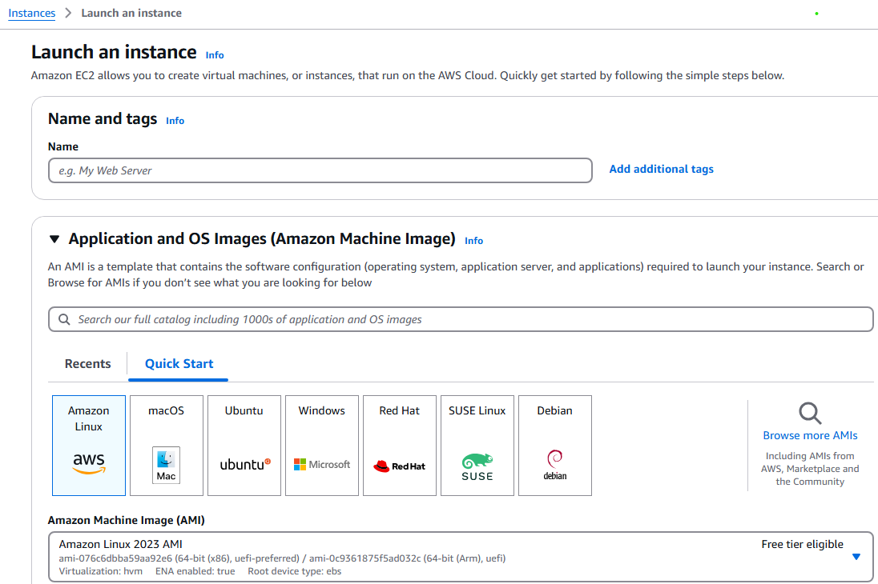

**2.select ythe browse more AMI’s**

**3.click on “AWS Marketplace AMIs” and search for openVPN then select the openVPN server AMI.**

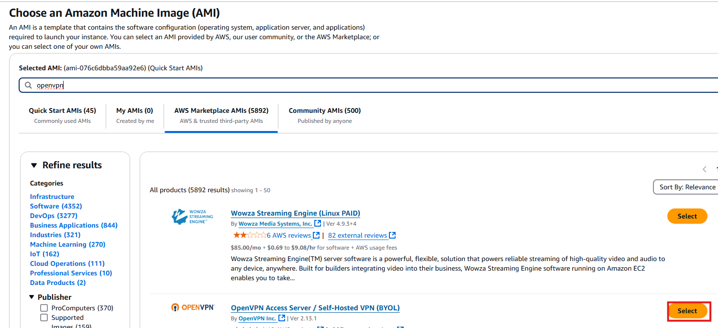

**4.If you select the OpenVPN AMI it will ask for subscription**

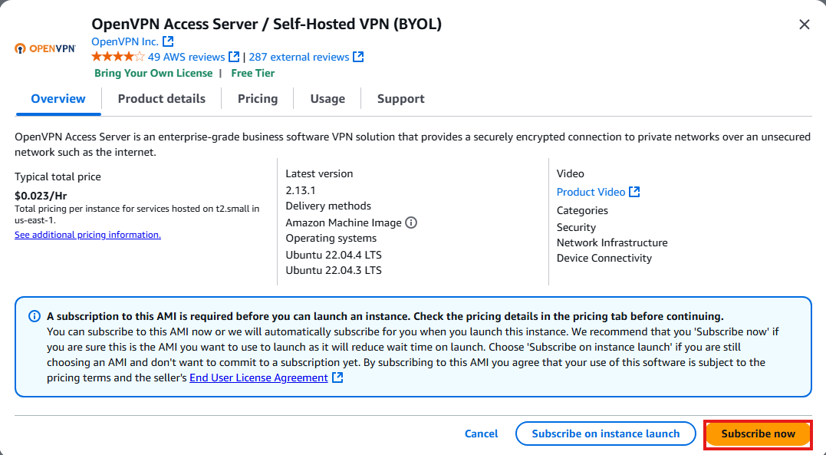

**5.aftre subscription it will come into AWS EC2 Dashboard, using this AMI we need to launch EC2 instance.**

**6.We login to the EC2 instance with SSH connect using Mobaxterm or putty or Gitbash or EC2 connect with username is openvpnas.**

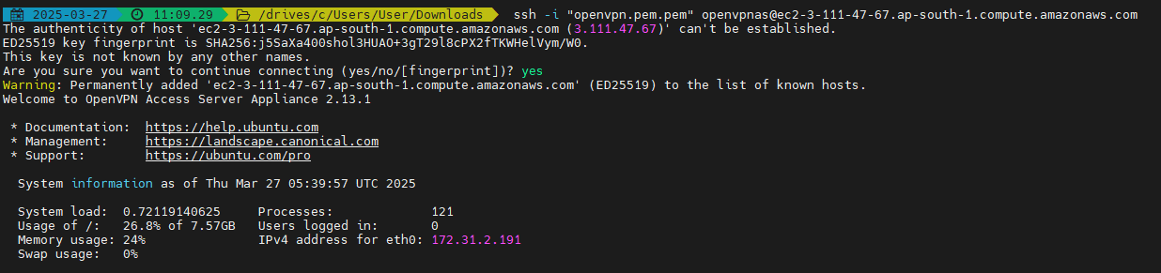

**It will give to us in CLI is**

**Ssh -i "openvpn.pem.pem"** [**openvpnas@ec2-3-111-47-67.ap-south-1.compute.amazonaws.com**](mailto:openvpnas@ec2-3-111-47-67.ap-south-1.compute.amazonaws.com)

**After enter the above command it will ask the permissions we need to accecpt them. For that permissions, press the ENTER for default and we need to assign password here.**

The authenticity of host 'ec2-3-111-47-67.ap-south-1.compute.amazonaws.com (3.111.47.67)' can't be established.

ED25519 key fingerprint is SHA256:j5SaXa400shol3HUAO+3gT29l8cPX2fTKWHelVym/W0.

This key is not known by any other names.

Are you sure you want to continue connecting (yes/no/[fingerprint])? yes

Warning: Permanently added 'ec2-3-111-47-67.ap-south-1.compute.amazonaws.com' (ED25519) to the list of known hosts.

Welcome to OpenVPN Access Server Appliance 2.13.1

* Documentation: https://help.ubuntu.com

* Management: https://landscape.canonical.com

* Support: https://ubuntu.com/pro

System information as of Thu Mar 27 05:39:57 UTC 2025

System load: 0.72119140625 Processes: 121

Usage of /: 26.8% of 7.57GB Users logged in: 0

Memory usage: 24% IPv4 address for eth0: 172.31.2.191

Swap usage: 0%

Expanded Security Maintenance for Applications is not enabled.

1 update can be applied immediately.

1 of these updates is a standard security update.

To see these additional updates run: apt list --upgradable

Enable ESM Apps to receive additional future security updates.

See https://ubuntu.com/esm or run: sudo pro status

The list of available updates is more than a week old.

To check for new updates run: sudo apt update

/usr/bin/xauth: timeout in locking authority file /home/openvpnas/.Xauthority

To run a command as administrator (user "root"), use "sudo <command>".

See "man sudo_root" for details.

OpenVPN Access Server

Initial Configuration Tool

------------------------------------------------------

OpenVPN Access Server End User License Agreement (OpenVPN-AS EULA)

1. Copyright Notice: OpenVPN Access Server License;

Copyright (c) 2009-2024 OpenVPN Inc. All rights reserved.

"OpenVPN" is a trademark of OpenVPN Inc.

2. Redistribution of OpenVPN Access Server binary forms and related documents,

are permitted provided that redistributions of OpenVPN Access Server binary

forms and related documents reproduce the above copyright notice as well as

a complete copy of this EULA.

3. You agree not to reverse engineer, decompile, disassemble, modify,

translate, make any attempt to discover the source code of this software,

or create derivative works from this software.

4. The OpenVPN Access Server is bundled with other open source software

components, some of which fall under different licenses. By using OpenVPN

or any of the bundled components, you agree to be bound by the conditions

of the license for each respective component. For more information, you can

find our complete EULA (End-User License Agreement) on our website

(http://openvpn.net), and a copy of the EULA is also distributed with the

Access Server in the file /usr/local/openvpn_as/license.txt.

5. This software is provided "as is" and any expressed or implied warranties,

including, but not limited to, the implied warranties of merchantability

and fitness for a particular purpose are disclaimed. In no event shall

OpenVPN Inc. be liable for any direct, indirect, incidental,

special, exemplary, or consequential damages (including, but not limited

to, procurement of substitute goods or services; loss of use, data, or

profits; or business interruption) however caused and on any theory of

liability, whether in contract, strict liability, or tort (including

negligence or otherwise) arising in any way out of the use of this

software, even if advised of the possibility of such damage.

6. OpenVPN Inc. is the sole distributor of OpenVPN Access Server

licenses. This agreement and licenses granted by it may not be assigned,

sublicensed, or otherwise transferred by licensee without prior written

consent of OpenVPN Inc. Any licenses violating this provision

will be subject to revocation and deactivation, and will not be eligible

for refunds.

7. Subscription License Key: Entitles you to use this software for the

duration of term of your subscription up to the concurrent user limit

specified by your subscription. This license permits you to use the

software on one or more servers, provided that in no event will the number

of concurrent VPN connections that all servers may allow exceed the

concurrent user limit. Upon activation of the first purchased activation

key for this software, you agree to forego any free licenses or keys that

were given to you for demonstration purposes, and as such, the free

licenses will not appear after the activation of a purchased key. You are

responsible for the timely activation of these licenses on the server or

servers of your choice.

Refunds on purchased activation keys are only possible within 30 days of

purchase of activation key, and then only if the activation key has not

already been activated on a system. To request a refund, contact us through

our support ticket system using the account you have used to purchase the

activation key. Activated subscriptions are nontransferable. Access Server

Subscription entitles the use of (1) subscription license key on a single

server or across multiple servers. Once an activated key expires or becomes

invalid, the concurrency limit on our software product will revert to

demonstration mode, which allows a maximum of two (2) concurrent users to

be connected to your server. Prior to your subscription license expiration,

OpenVPN Inc. will, depending on your purchase selection, either auto-renew

your subscription, or attempt to remind you to renew your subscription by

sending periodic email messages to the licensee email address on record.

You are solely responsible for the timely renewal of your activation key(s)

prior to their expiration if continued operation is expected after the

subscription term ends. OpenVPN Inc. will not be responsible for any

misdirected and/or undeliverable email messages, nor does it have an

obligation to contact you regarding your subscription term's expiry.

8. Standard Non-Subscription License Key(s) also called Fixed License Key(s):

A Purchased Standard Non-Subscription license entitles you to use this

software for the duration of time denoted on your activation key on any one

(1) particular device, up to the concurrent user limit specified by your

license. Multiple activation keys may be activated to achieve a desired

concurrency limit on this given device. Unless otherwise prearranged with

OpenVPN Inc., concurrency counts on activation keys are not to be divided

for use amongst multiple devices. Upon activation of the first purchased

activation key in this software, you agree to forego any free licenses or

keys that were given to you for demonstration purposes, and as such, the

free licenses will not appear after the activation of a purchased key. You

are responsible for the timely activation of these licenses on your desired

server of choice. Refunds on purchased activation keys are only possible

within 30 days of purchase of activation key, and then only if the

activation key has not already been activated on a system. To request a

refund, contact us through our support ticket system using the account you

have used to purchase the activation key.

Activating a standard Non-Subscription key ties it to the specific

hardware/software combination that it was activated on, and activated

activation keys are nontransferable. Substantial software and/or hardware

changes may invalidate an activated license. In case of substantial

software and/or hardware changes, caused by for example, but not limited to

failure and subsequent repair or alterations of (virtualized)

hardware/software, our software product will automatically attempt to

contact our online licensing systems to renegotiate the licensing state. On

any given activation key, you are limited to three (3) automatic

renegotiations within the activation key lifetime. After these

renegotiations are exhausted, the activation key is considered invalid, and

the activation state will be locked to the last valid system configuration

it was activated on. OpenVPN Inc. reserves the right to grant exceptions to

this policy for license holders under extenuating circumstances, and such

exceptions can be requested through a ticket via the OpenVPN Access Server

ticketing system.

Once an activated activation key expires or becomes invalid, the

concurrency limit on our software product will decrease by the number of

concurrent connections previously granted by the activation key. If all

purchased activation key(s) have expired, the product will revert to

demonstration mode, which allows a maximum of two (2) concurrent users to

be connected to your server. Prior to your license expiration date(s),

OpenVPN Inc. will attempt to remind you to renew your license(s) by sending

periodic email messages to the licensee email address on record. You are

solely responsible for the timely renewal of your activation key(s) prior

to their expiration if continued operation is expected after the license

expiration date(s). OpenVPN Inc. will not be responsible for any

misdirected and/or undeliverable email messages, nor does it have an

obligation to contact you regarding your expiring activation keys.

9. Once an activated activation key expires or becomes invalid, the

concurrency limit on our software product will decrease by the amount of

concurrent connections previously granted by the activation key. If all of

your purchased activation key(s) have expired, the product will revert to

demonstration mode, which allows a maximum of two (2) concurrent users to

be connected to your server. Prior to your license expiration date(s),

OpenVPN Inc. will attempt to remind you to renew your license(s) by sending

periodic email messages to the licensee email address on record. You are

solely responsible for the timely renewal of your activation key(s) prior

to their expiration if continued operation is expected after the license

expiration date(s). OpenVPN Inc. will not be responsible for any

misdirected and/or undeliverable email messages, nor does it have an

obligation to contact you regarding your expiring activation keys.

10. Any valid activation key holder is entitled to use our ticketing system for

support questions or issues specifically related to the OpenVPN Access

Server product. To file a ticket, go to our website at https://openvpn.net/

and sign in using the account that was registered and used to purchase the

activation key(s). You can then access the support ticket system through

our website and submit a support ticket. Tickets filed in the ticketing

system are answered on a best-effort basis. OpenVPN Inc. staff reserve the

right to limit responses to users of our demo / expired licenses, as well

as requests that substantively deviate from the OpenVPN Access Server

product line. Tickets related to the open source version of OpenVPN may

not be handled here.

11. Purchasing an activation key does not entitle you to any special rights or

privileges, except the ones explicitly outlined in this user agreement.

Unless otherwise arranged prior to your purchase with OpenVPN Inc.,

software maintenance costs and terms are subject to change after your

initial purchase without notice. In case of price decreases or special

promotions, OpenVPN Inc. will not retrospectively apply credits or price

adjustments toward any licenses that have already been issued. Furthermore,

no discounts will be given for license maintenance renewals unless this is

specified in your contract with OpenVPN Inc.

Please enter 'yes' to indicate your agreement [no]: yes

Once you provide a few initial configuration settings,

OpenVPN Access Server can be configured by accessing

its Admin Web UI using your Web browser.

Will this be the primary Access Server node?

(enter 'no' to configure as a backup or standby node)

> Press ENTER for default [yes]:

Please specify the network interface and IP address to be

used by the Admin Web UI:

(1) all interfaces: 0.0.0.0

(2) eth0: 172.31.2.191

Please enter the option number from the list above (1- 2).

> Press Enter for default [1]:

What public/private type/algorithms do you want to use for the OpenVPN CA?

Recommended choices:

rsa - maximum compatibility

secp384r1 - elliptic curve, higher security than rsa, allows faster connection setup and smaller user profile files

showall - shows all options including non-recommended algorithms.

> Press ENTER for default [secp384r1]:

What public/private type/algorithms do you want to use for the self-signed web certificate?

Recommended choices:

rsa - maximum compatibility

secp384r1 - elliptic curve, higher security than rsa, allows faster connection setup and smaller user profile files

showall - shows all options including non-recommended algorithms.

> Press ENTER for default [secp384r1]:

Please specify the port number for the Admin Web UI.

> Press ENTER for default [943]:

Please specify the TCP port number for the OpenVPN Daemon

> Press ENTER for default [443]:

Should client traffic be routed by default through the VPN?

> Press ENTER for default [no]:

Should client DNS traffic be routed by default through the VPN?

> Press ENTER for default [no]:

Admin user authentication will be local

Private subnets detected: ['172.31.0.0/16']

Should private subnets be accessible to clients by default?

> Press ENTER for EC2 default [yes]:

To initially login to the Admin Web UI, you must use a

username and password that successfully authenticates you

with the host UNIX system (you can later modify the settings

so that RADIUS or LDAP is used for authentication instead).

You can login to the Admin Web UI as "openvpn" or specify

a different user account to use for this purpose.

Do you wish to login to the Admin UI as "openvpn"?

> Press ENTER for default [yes]:

Type a password for the 'openvpn' account (if left blank, a random password will be generated):

Confirm the password for the 'openvpn' account:

> Please specify your Activation key (or leave blank to specify later):

Initializing OpenVPN...

Removing Cluster Admin user login...

userdel: user 'admin_c' does not exist

Writing as configuration file...

Perform sa init...

Wiping any previous userdb...

Creating default profile...

Modifying default profile...

Adding new user to userdb...

Modifying new user as superuser in userdb...

Setting password in db...

Getting hostname...

Hostname: 3.111.47.67

Preparing web certificates...

Getting web user account...

Adding web group account...

Adding web group...

groupadd: group 'openvpn_as' already exists

Adjusting license directory ownership...

Initializing confdb...

Initial version is not set. Setting it to 2.13.1...

Generating PAM config for openvpnas ...

Enabling service

Created symlink /etc/systemd/system/multi-user.target.wants/openvpnas.service → /lib/systemd/system/openvpnas.service.

Starting openvpnas...

NOTE: Your system clock must be correct for OpenVPN Access Server

to perform correctly. Please ensure that your time and date

are correct on this system.

Initial Configuration Complete!

You can now continue configuring OpenVPN Access Server by

directing your Web browser to this URL:

https://3.111.47.67:943/admin

During normal operation, OpenVPN AS can be accessed via these URLs:

Admin UI: https://3.111.47.67:943/admin

Client UI: https://3.111.47.67:943/

To login please use the "openvpn" account with the password you specified during the setup.

See the Release Notes for this release at:

https://openvpn.net/vpn-server-resources/release-notes/

**7.** <https://3.111.47.67:943/admin> go through this URL in the Browser we need give enable in the VPN settings and for details go through the image

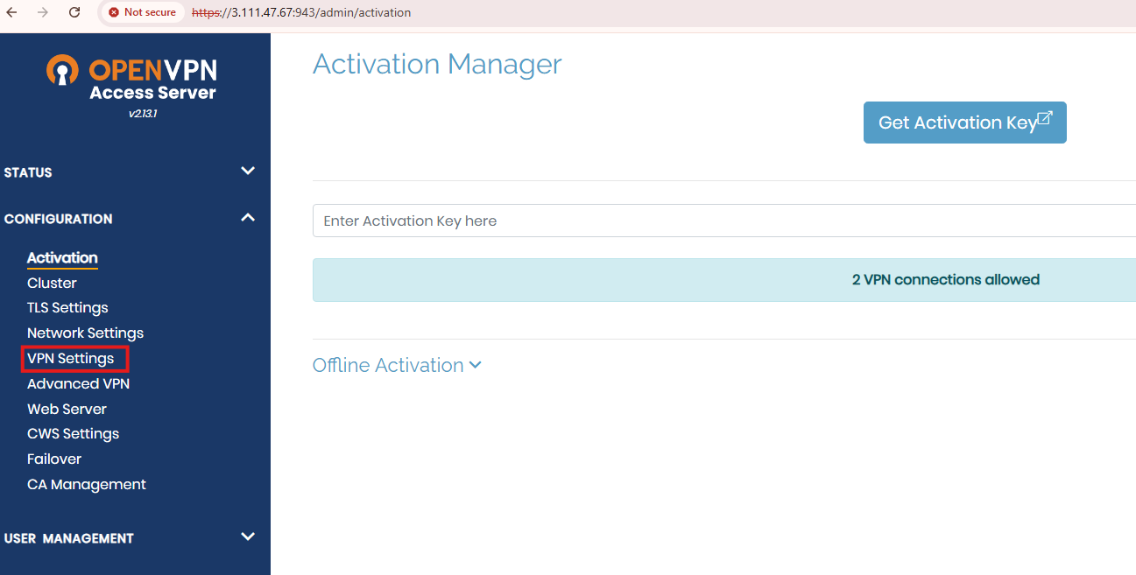

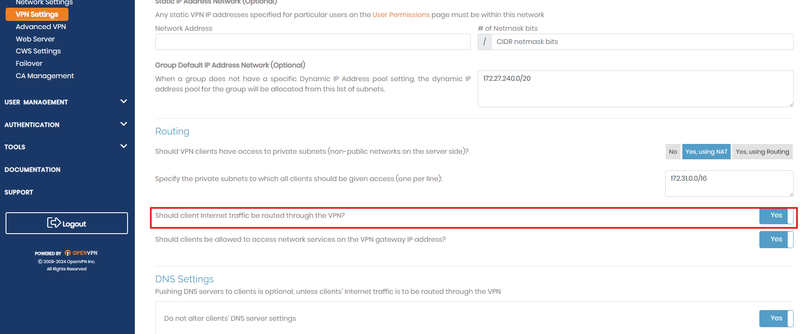

**Then save the settings and and select update running server**

**8.** <https://3.111.47.67:943> go through this URL ,it will gives the configuration download file.

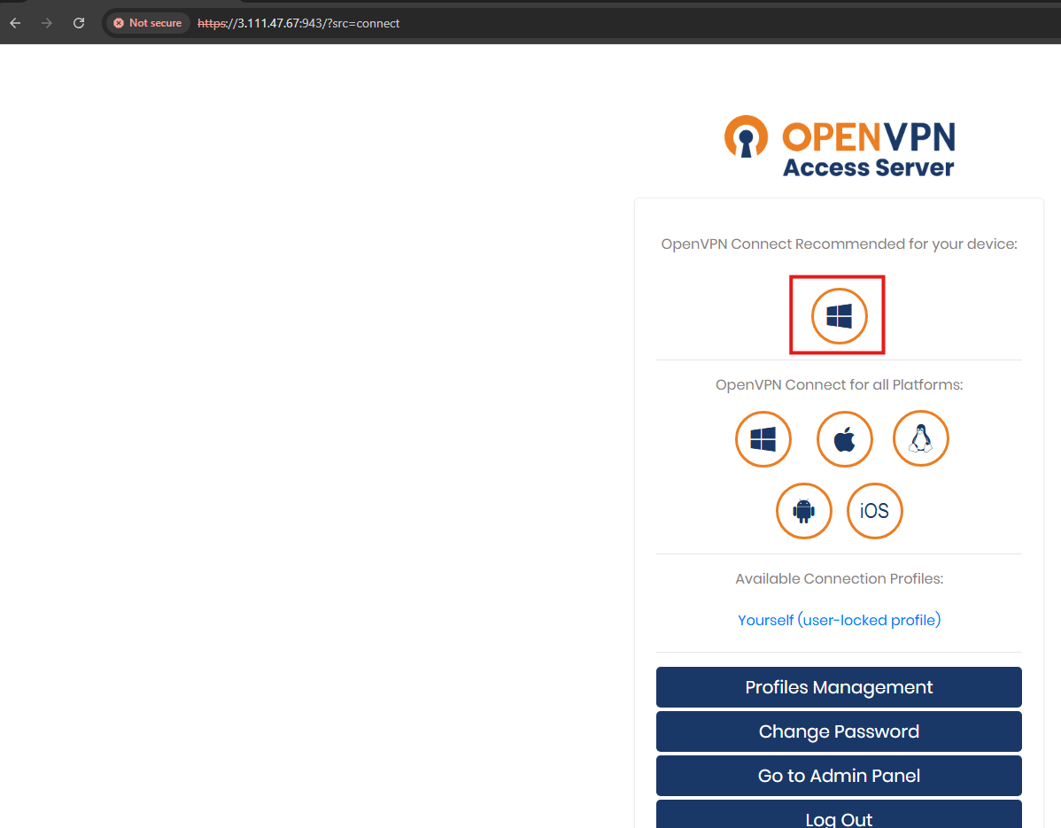

**9.select the windows device ,it will download into our local machine,then we need to install on our local machine.**



**10.Before installing VPN config file**

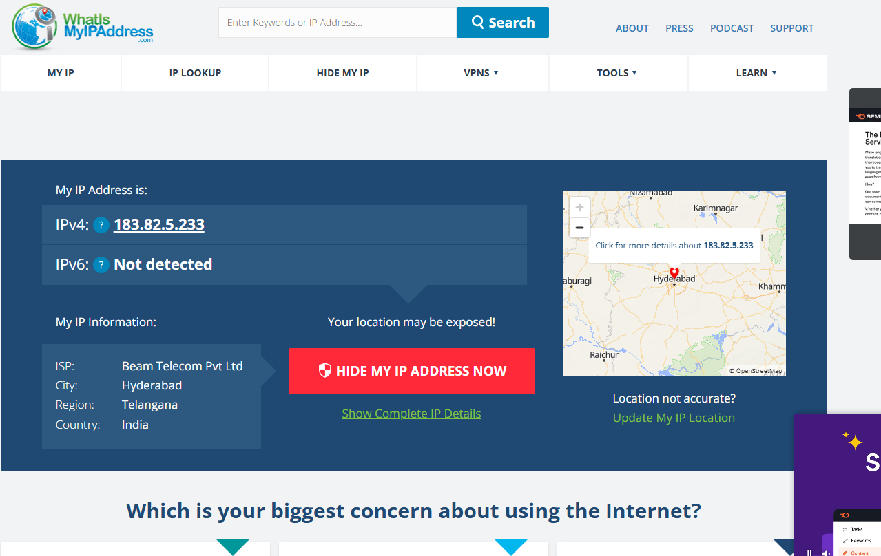

**11.After installing the config file of OpenVPN it**

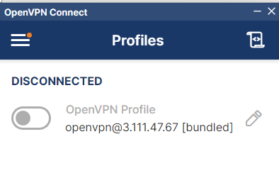

**12.Then we need to enable the openVPN ,it will ask the password,then enter the openVPN password**

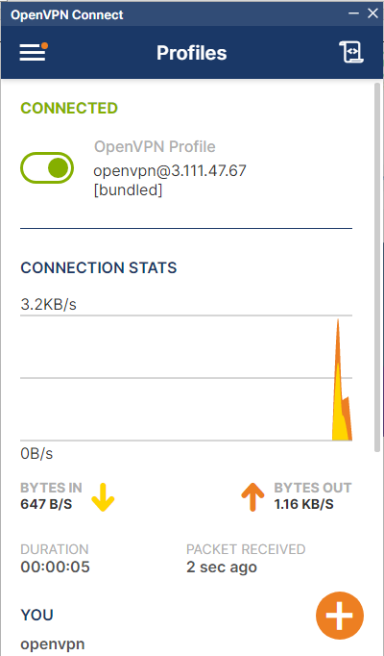

**13.Then go to browser search for what is myip, it will gives**

