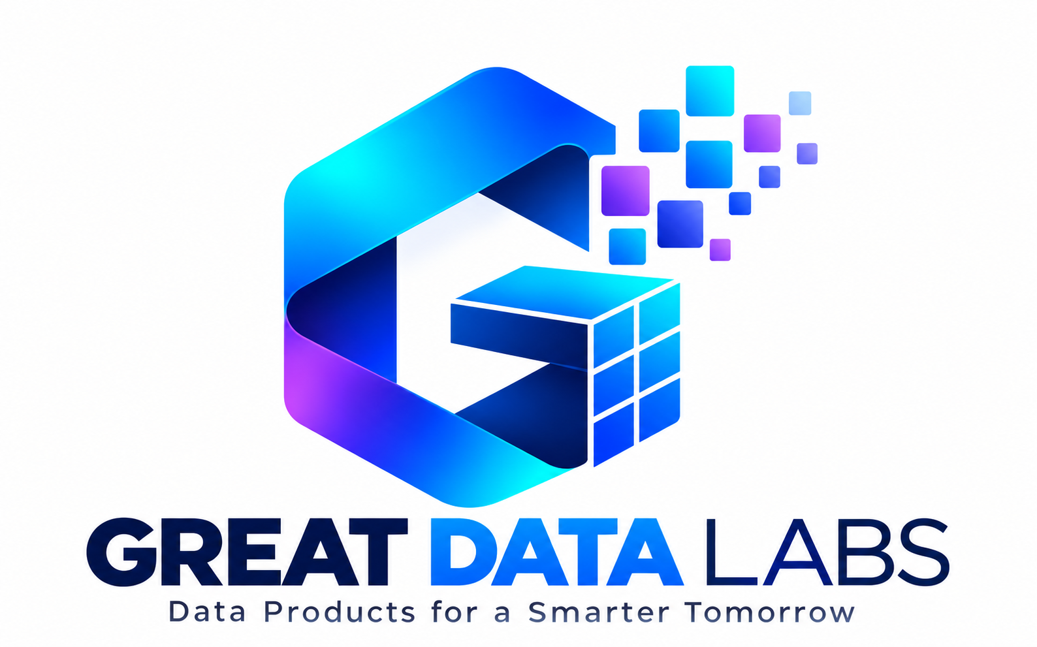

Organization Overview
Great Data Labs is a technology-focused initiative centered on practical data engineering, artificial intelligence, and open-source innovation. Its work aims to help learners and practitioners build reliable, realistic, and scalable data-driven solutions.

Our mission
Make modern data and AI engineering more accessible through practical tools, reusable engineering patterns, hands-on learning, and community collaboration.

What we focus on
- Data engineering & analytics: Modern pipelines, data quality, scalable processing, and analytics-ready datasets.
- AI-ready data systems: Synthetic and test data that support prototyping, experimentation, and responsible development.
- Open-source engineering: Reusable libraries, developer-friendly interfaces, documentation, and practical examples.
- Student development: Project-based learning, technical exploration, and opportunities to contribute to real software.

Flagship open-source project: great-generator
great-generator is a Python-based synthetic data generation project designed for realistic engineering workflows. It helps developers create sample datasets for prototyping, testing, demonstrations, and data pipeline development without depending on real production records.
- Schema-driven synthetic data generation
- Relational and domain-oriented dataset generation
- Pandas and Apache Spark workflow support
- CSV, Parquet, and Delta-oriented output workflows
Project repository: https://github.com/ravikiranpagidi/great-generator

For Students & Early-Career Engineers
Great Data Labs encourages students to connect foundational concepts with real engineering practice. The great-generator project provides a concrete starting point for learning how data tools are designed, tested, documented, and used.

Areas students can explore
- Python & software engineering — Modular code, testing, packaging, version control, and documentation.
- Data engineering — Schemas, relationships, data formats, data quality, and scalable processing.
- AI and synthetic data — How representative test data supports experiments, model development, and evaluation.
- Open-source contribution — Issue triage, examples, documentation, feature proposals, and pull requests.

Founder
Ravi Kiran Pagidi | Founder & CEO, Great Data Labs
Ravi is a senior data and AI engineering professional with 11+ years of experience across enterprise data platforms, cloud analytics, and AI-enabled systems. His interests include scalable data architecture, synthetic data, generative AI, research, mentoring, and developer tools.

GREAT DATA LABS
Building practical tools for modern data and AI engineering
Great Data Labs is a technology-focused initiative advancing accessible, hands-on data engineering and AI innovation. Its flagship open-source project, great-generator, enables schema-driven synthetic data generation for realistic development and testing workflows. Through open-source tools and practical learning, Great Data Labs aims to help students and engineers turn ideas into working solutions.
Founder & CEO: Ravi Kiran Pagidi
Explore: github.com/ravikiranpagidi/great-generator

Suggested introduction for event hosts
“We are pleased to introduce Great Data Labs, a technology-focused initiative founded by Ravi Kiran Pagidi. Through its open-source great-generator project, Great Data Labs supports hands-on exploration of synthetic data, modern data engineering, and AI-ready workflows. We welcome students to explore the project and learn through practical engineering.”

Connect
Open-source project: https://github.com/ravikiranpagidi/great-generator
Email: greatdatalabs@proton.me

