— Verify
sql
SELECT COUNT(*) FROM online_retail_clean;
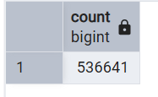

1. KPI Summary
sql
SELECT COUNT(DISTINCT invoice_no) AS total_orders,
COUNT(DISTINCT customer_id) AS total_customers,
ROUND(SUM(revenue), 2) AS total_revenue,
ROUND(SUM(revenue) / COUNT(DISTINCT invoice_no), 2) AS avg_order_value
FROM online_retail_clean
WHERE is_valid_sale = TRUE;
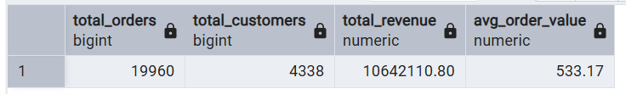
2. Top 10 Products by Revenue
sql
SELECT stock_code,
MAX(description) AS description,
ROUND(SUM(revenue), 2) AS revenue,
SUM(quantity) AS quantity_sold
FROM online_retail_clean
WHERE is_valid_sale = TRUE
GROUP BY stock_code
ORDER BY revenue DESC
LIMIT 10;
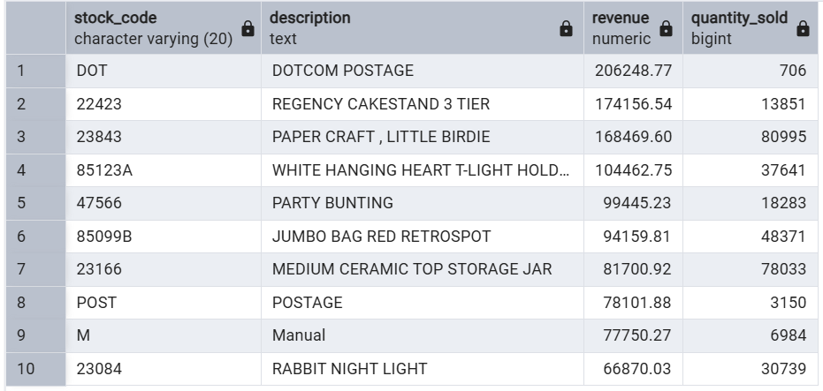

3. Top 10 Countries by Revenue
sql

SELECT country,
ROUND(SUM(revenue), 2) AS revenue,
COUNT(DISTINCT invoice_no) AS orders,
COUNT(DISTINCT customer_id) AS customers
FROM online_retail_clean
WHERE is_valid_sale = TRUE
GROUP BY country
ORDER BY revenue DESC
LIMIT 10;
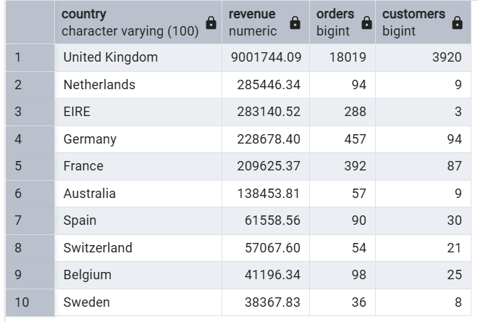

4. Monthly Revenue Trend
sql

SELECT year_month,
ROUND(SUM(revenue), 2) AS revenue,
COUNT(DISTINCT invoice_no) AS orders
FROM online_retail_clean
WHERE is_valid_sale = TRUE
GROUP BY year_month
ORDER BY year_month;
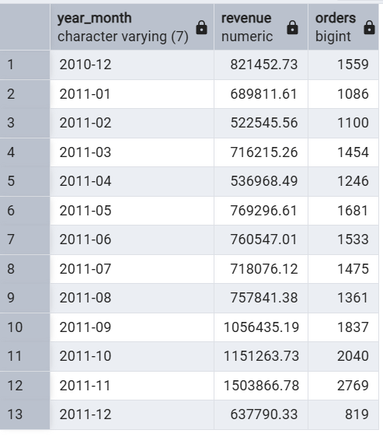

5. Top 10 Customers by Revenue
sql

SELECT customer_id,
ROUND(SUM(revenue), 2) AS revenue,
COUNT(DISTINCT invoice_no) AS orders
FROM online_retail_clean
WHERE is_valid_sale = TRUE AND customer_id IS NOT NULL
GROUP BY customer_id
ORDER BY revenue DESC
LIMIT 10;
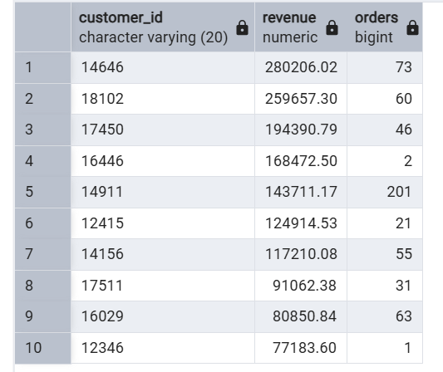

6. Revenue by Weekday
sql

SELECT weekday,
ROUND(SUM(revenue), 2) AS revenue
FROM online_retail_clean
WHERE is_valid_sale = TRUE
GROUP BY weekday
ORDER BY revenue DESC;
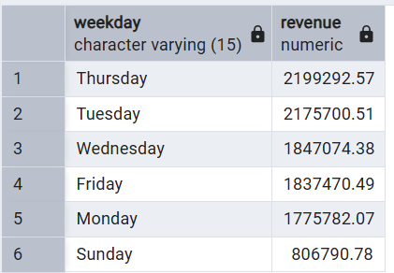
7. Revenue by Hour
sql
SELECT hour,
ROUND(SUM(revenue), 2) AS revenue
FROM online_retail_clean
WHERE is_valid_sale = TRUE
GROUP BY hour
ORDER BY hour;
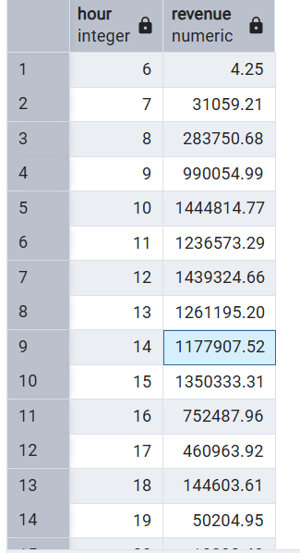

8. Returns vs Normal vs Cancelled
sql

SELECT CASE
WHEN is_cancelled = TRUE THEN 'Cancelled'
WHEN is_return = TRUE THEN 'Return'
ELSE 'Normal'
END AS type,
COUNT(*) AS rows_count,
ROUND(SUM(revenue), 2) AS revenue
FROM online_retail_clean
GROUP BY type
ORDER BY rows_count DESC;
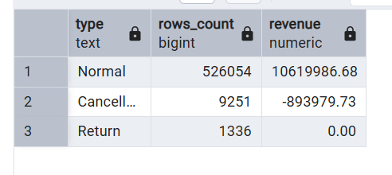

9. RFM Base Table
sql

WITH snapshot AS (
SELECT MAX(invoice_date) + INTERVAL '1 day' AS snap
FROM online_retail_clean
WHERE is_valid_sale = TRUE
)
SELECT customer_id,
EXTRACT(DAY FROM (SELECT snap FROM snapshot) - MAX(invoice_date))::INT AS recency,
COUNT(DISTINCT invoice_no) AS frequency,
ROUND(SUM(revenue), 2) AS monetary
FROM online_retail_clean
WHERE is_valid_sale = TRUE AND customer_id IS NOT NULL
GROUP BY customer_id
ORDER BY monetary DESC
LIMIT 50;
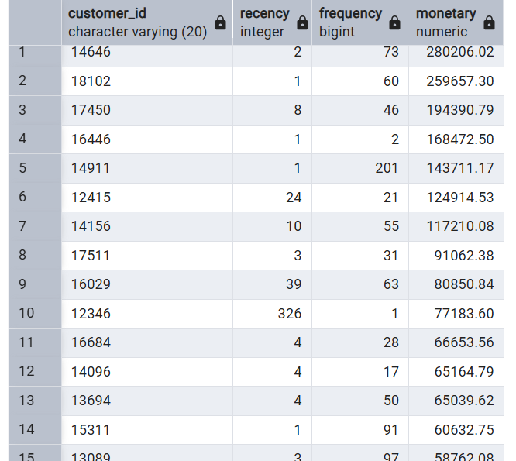
10. Customer Segments (RFM)
sql

WITH snapshot AS (
SELECT MAX(invoice_date) + INTERVAL '1 day' AS snap
FROM online_retail_clean
WHERE is_valid_sale = TRUE
),
rfm AS (
SELECT customer_id,
EXTRACT(DAY FROM (SELECT snap FROM snapshot) - MAX(invoice_date))::INT AS recency,
COUNT(DISTINCT invoice_no) AS frequency,
ROUND(SUM(revenue), 2) AS monetary
FROM online_retail_clean
WHERE is_valid_sale = TRUE AND customer_id IS NOT NULL
GROUP BY customer_id
),
scored AS (
SELECT customer_id,
NTILE(4) OVER (ORDER BY recency ASC) AS r_score,
NTILE(4) OVER (ORDER BY frequency ASC) AS f_score,
NTILE(4) OVER (ORDER BY monetary ASC) AS m_score
FROM rfm
)
SELECT CASE
WHEN r_score = 4 AND f_score = 4 AND m_score = 4 THEN 'Champion'
WHEN r_score >= 3 AND f_score >= 3 THEN 'Loyal'
WHEN r_score = 4 AND f_score <= 2 THEN 'New Customer'
WHEN r_score <= 2 AND f_score >= 3 THEN 'At Risk'
WHEN r_score <= 2 AND f_score <= 2 THEN 'Lost'
ELSE 'Regular'
END AS customer_segment,
COUNT(*) AS customer_count
FROM scored
GROUP BY customer_segment
ORDER BY customer_count DESC;
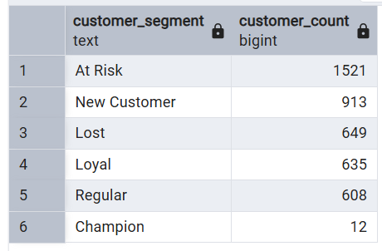
11. Month-over-Month Growth
sql
WITH monthly AS (
SELECT year_month,
ROUND(SUM(revenue), 2) AS revenue
FROM online_retail_clean
WHERE is_valid_sale = TRUE
GROUP BY year_month
)
SELECT year_month,
revenue,
LAG(revenue) OVER (ORDER BY year_month) AS previous_revenue,
ROUND(
(revenue - LAG(revenue) OVER (ORDER BY year_month))
/ LAG(revenue) OVER (ORDER BY year_month) * 100,
2
) AS mom_growth_percent
FROM monthly
ORDER BY year_month; 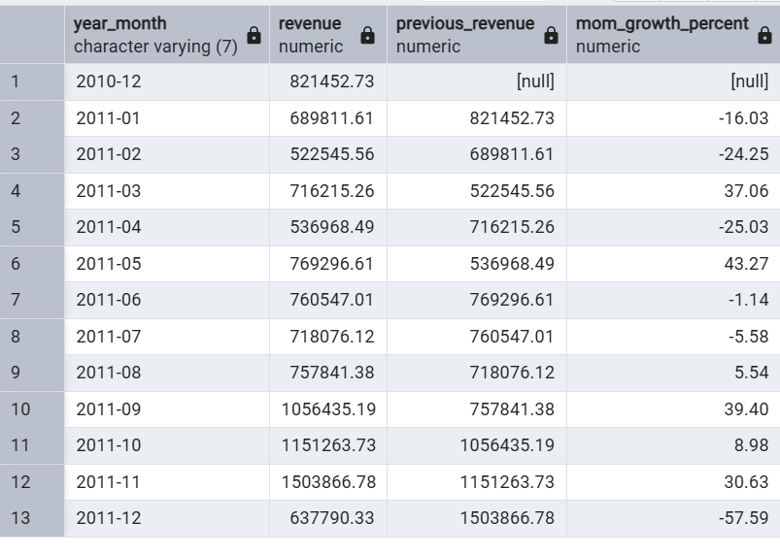

12. Customer Lifetime Value (CLV)
sql

SELECT customer_id,
ROUND(SUM(revenue), 2) AS lifetime_value,
COUNT(DISTINCT invoice_no) AS total_orders,
MIN(invoice_date)::DATE AS first_purchase,
MAX(invoice_date)::DATE AS last_purchase
FROM online_retail_clean
WHERE is_valid_sale = TRUE AND customer_id IS NOT NULL
GROUP BY customer_id
ORDER BY lifetime_value DESC
LIMIT 20;
