Project Overview

As the advanced technology, there are more and more potential risk involved in human’s daily life. Short circuit, leaking pipes, and other equipment failures may result serious consequences. However, in modern life, people cannot wake for 24 hours to watch every corner to ensure the equipment working properly. In this project, we are design a alarm system to info the administrator whenever there is a failure occurred.

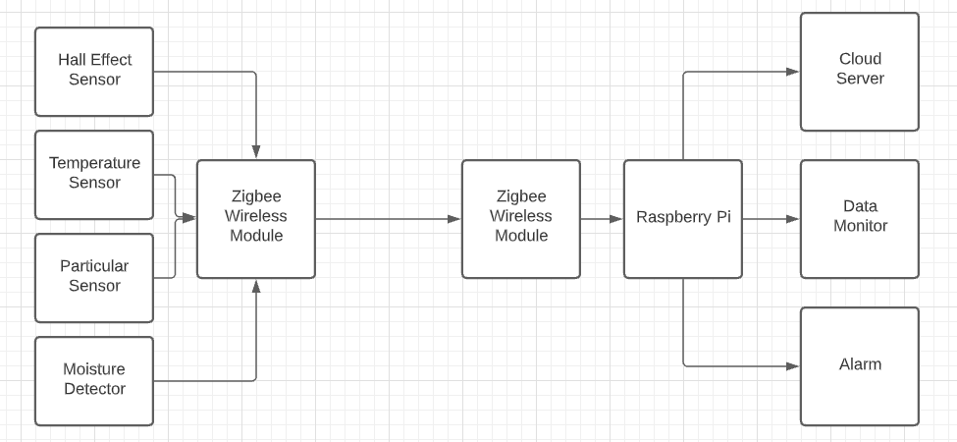

Procedure/Methodology

In the first stage, we are going to design the whole hardware for the system. As the graph shows above, we need to integrate four sensors with Zigbee modules to communicate each other. By using oscilloscope to ensure there are data flows.

The next stage, we need to set up software on the Raspberry Pi that can process data from sensors. Then Raspberry Pi will monitor the data itself and upload to cloud, and send notify top administrator.

In the last stage, we will made a fancy enclosure and a self-checking circuit to make sure there are no internal failure occurred while operating.

Costs

|  |  |  |  |
| --- | --- | --- | --- |
| Name | Cost per Unit | Quantity | Resource |
| Raspberry Pi 3B | $46.95 | 1 | https://www.raspberrypi.com/products/raspberry-pi-3-model-b/ |
| XBEE ZIGBEE MESH KIT | $131.60 | 1 | https://www.digikey.ca/en/products/detail/digi/XKB2-Z7T-WZM/5764681 |
| BATT HOLDER AA 4 CELL 6" LEADS | $2.61 | 1 | https://www.digikey.ca/en/products/detail/keystone-electronics/2478/303823 |
| Arduino Nano | $47.10 | 2 | https://www.robotshop.com/ca/en/arduino-nan-v-3.html |

Schedule

|  |  |
| --- | --- |
| Due Date | Description |
| Jan 28, 2022 | Get parts ready |
| Feb 4, 2022 | Install hardware |
| Feb 18, 2022 | Program software |
| Mar 13, 2022 | Program testing |
|  |  |
|  |  |
|  |  |
|  |  |
|  |  |
|  |  |

Team Coordination

For team cooperating, we are use discord for real time communication, and GitHub to share and program code and corresponding file. By using GitHub, we can easily tracking the progress of project and what stage we are currently working on. Also, we can make several branch of our brainstorm.