Running the docker build command in terminal succesfully:

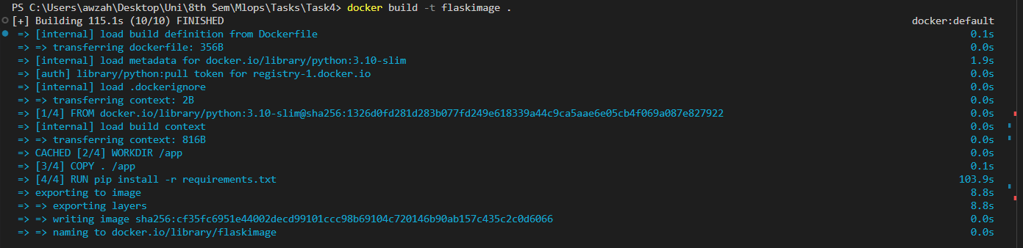

Running the docker run command in terminal succesfully:

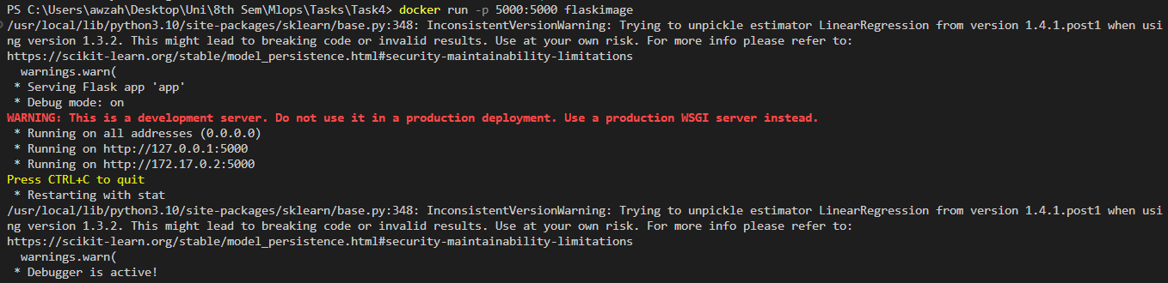

Using the model to predict a value through CURL:

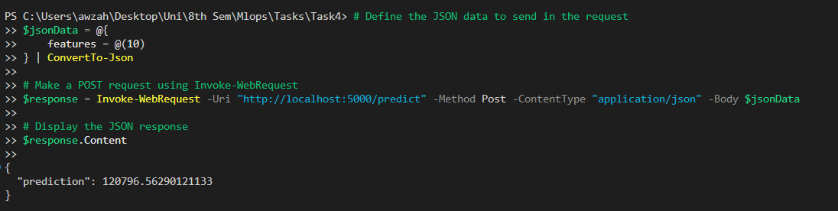

Display of the Flask Application:

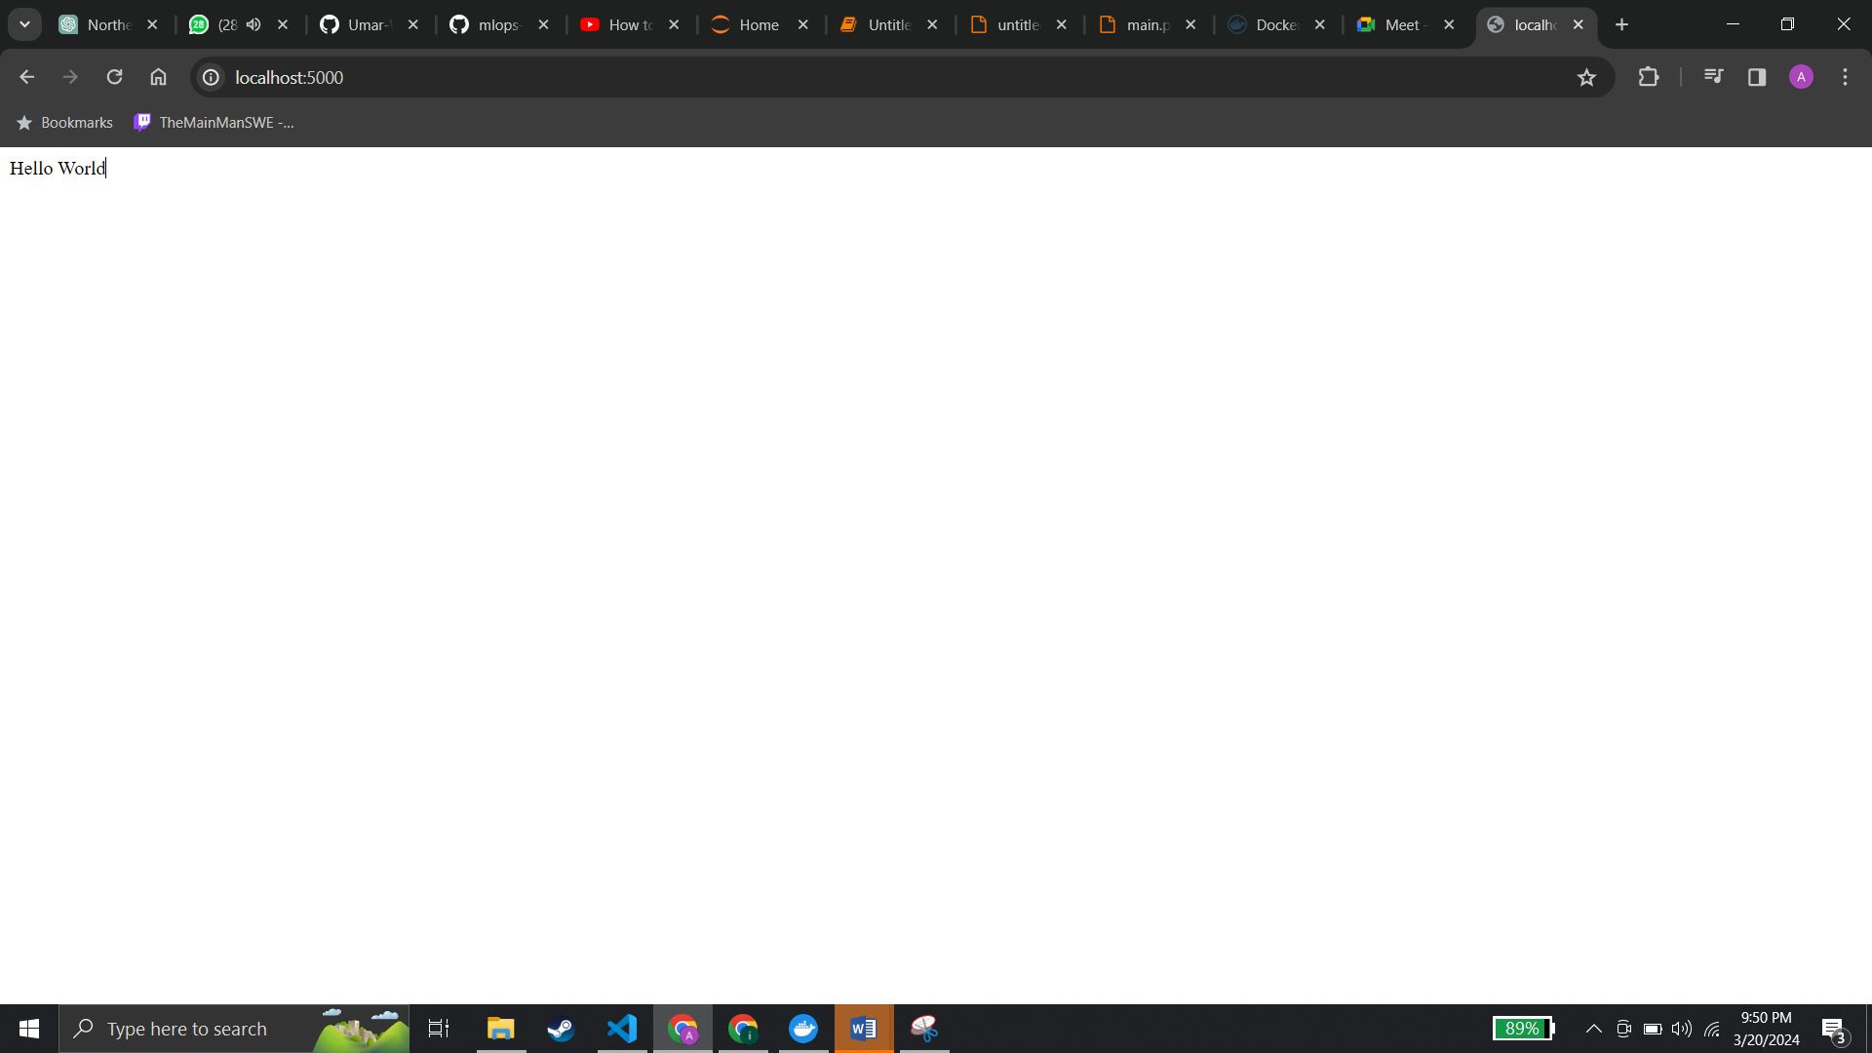

Image in Docker Desktop:

