Dexter Watkins Propulsion - Homework 2
1. Problem Definition 1
2. Specified Properties and Assumptions 1
3. Rocket has a dry mass of 14.34 kg 1
4. Governing Equations 1
5. Define rocket and wind properties 2
6. Execute Simulation 2
7. Case 6 Analysis 2
8. Case 7 Analysis 5
9. Case 8 Analysis 8
10. Case 9 Analysis 10

Problem Definition
Calculate apogee and drift at apogee as a function of side wind speed for a rocket from launch until apogee. Use a numerical method to solve this problem. Examine the following four cases.
- Side winds of (5,15,25 m/s) start after main engine cutoff and are constant
- Same as above but the sidewinds are now amplified via the Atm BL
- Same as above, but the side winds now start at rail exit (V_r = 30 m/s)
- Same as above but the rocket now launches 5 degress into the wind

Specified Properties and Assumptions

Rocket has a dry mass of 14.34 kg
The rocket has a cross-sectional area of 0.015327 square meters
The rocket has a drag coefficient of 0.45
The main motor follows the properties of the Cesaroni L1720
The Mono-Props are 0.08 kg each, with a mass flux of 0.01 kg/s each
The Mono-Props produce no thrust

Governing Equations
The equation of motion for the flight vehicle is determined by the following system of equations:
For easier use, the system of equations is rewritten as a system of purely first order equations, as follows:

Define rocket and wind properties
cd = 0.45;
area = 0.015327; %m2
dryMass = 14.84; %kg
rho = @(z) stdAtmD(z);
% ws = @(w0,z0,z) stdAtmWind(w0,z0,z);

Execute Simulation
tspan = [0 25];
time = tspan(1):0.05:tspan(2);
windspeed = [5,15,25]*0.44704; %mph to m/s
y0 = [0 0 0 0]';
cases = [6,7,8,9];
y6 = cell(length(cases),length(windspeed));
yp6 = y6;
x = cell(1,length(cases));
for j = 1:1:length(cases)
for i = 1:1:length(windspeed)
sol = ode45(@(t,y) func6(t,y,windspeed(i),cd,area,dryMass,cases(j)),...
tspan,y0);
[y6{j,i}, yp6{j,i}] = deval(sol,time);
end
x{i} = time(y6{j,i}(4,:)>=0);
end

Case 6 Analysis
Introducing wind after MECO has very little effect. Apogee is nearly completely the same. A small amount of drift <50 meters is seen at higher wind speeds.
curcase = 1;
titles = cell(1,length(cases));
for i = 1:length(cases)
titles{i} = ['Case ' num2str(i+5)];
end
figure()
figlegend = cell(1,length(windspeed));
data = cell(1,2*length(windspeed));
for i = 1:length(windspeed)
data{2*i-1} = time(y6{curcase,i}(4,:)>=0);
data{2*i} = y6{curcase,i}(2,y6{curcase,i}(4,:)>=0);
figlegend{i} = ['Windspeed = ' num2str(windspeed(i)) ' mph'];
end
plot(data{:});
xlabel('Time (s)');
ylabel('Vertical Position (m)');
legend(figlegend,'Location', 'SouthEast');
title(titles{curcase});
figure()
figlegend = cell(1,length(windspeed));
data = cell(1,2*length(windspeed));
for i = 1:length(windspeed)
data{2*i-1} = time(y6{curcase,i}(4,:)>=0);
data{2*i} = y6{curcase,i}(1,y6{curcase,i}(4,:)>=0);
figlegend{i} = ['Windspeed = ' num2str(windspeed(i)) ' mph'];
end
plot(data{:});
xlabel('Time (s)');
ylabel('Horizontal Position (m)');
legend(figlegend,'Location', 'NorthWest');
title(titles{curcase});
figure()
figlegend = cell(1,length(windspeed));
data = cell(1,2*length(windspeed));
for i = 1:length(windspeed)
data{2*i-1} = y6{curcase,i}(1,y6{curcase,i}(4,:)>=0);
data{2*i} = y6{curcase,i}(2,y6{curcase,i}(4,:)>=0);
figlegend{i} = ['Windspeed = ' num2str(windspeed(i)) ' mph'];
end
plot(data{:});
xlabel('Horizontal Position (m)');
ylabel('Vertical Position (m)');
legend(figlegend,'Location', 'SouthEast');
title(titles{curcase});
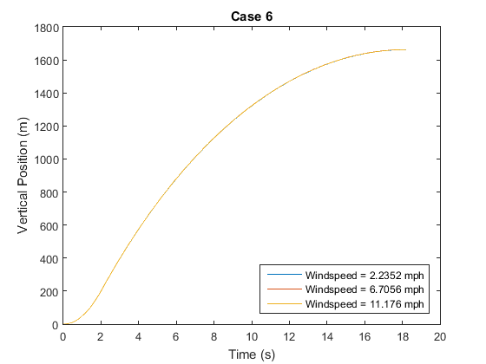
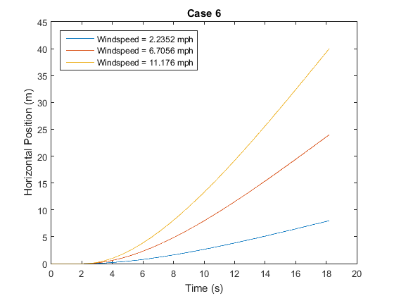
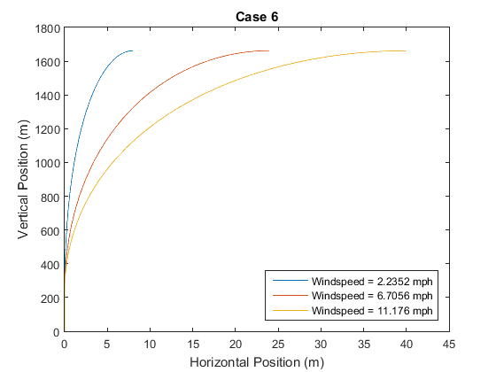

Case 7 Analysis
Adding in wind amplification via the atmospheric boundary layer still did not affect apogee, but did increase drift up to 80m depending on the base wind speed that was set.
curcase = 2;
figure()
figlegend = cell(1,length(windspeed));
data = cell(1,2*length(windspeed));
for i = 1:length(windspeed)
data{2*i-1} = time(y6{curcase,i}(4,:)>=0);
data{2*i} = y6{curcase,i}(2,y6{curcase,i}(4,:)>=0);
figlegend{i} = ['Windspeed = ' num2str(windspeed(i)) ' mph'];
end
plot(data{:});
xlabel('Time (s)');
ylabel('Vertical Position (m)');
legend(figlegend,'Location', 'SouthEast');
title(titles{curcase});
figure()
figlegend = cell(1,length(windspeed));
data = cell(1,2*length(windspeed));
for i = 1:length(windspeed)
data{2*i-1} = time(y6{curcase,i}(4,:)>=0);
data{2*i} = y6{curcase,i}(1,y6{curcase,i}(4,:)>=0);
figlegend{i} = ['Windspeed = ' num2str(windspeed(i)) ' mph'];
end
plot(data{:});
xlabel('Time (s)');
ylabel('Horizontal Position (m)');
legend(figlegend,'Location', 'NorthWest');
title(titles{curcase});
figure()
figlegend = cell(1,length(windspeed));
data = cell(1,2*length(windspeed));
for i = 1:length(windspeed)
data{2*i-1} = y6{curcase,i}(1,y6{curcase,i}(4,:)>=0);
data{2*i} = y6{curcase,i}(2,y6{curcase,i}(4,:)>=0);
figlegend{i} = ['Windspeed = ' num2str(windspeed(i)) ' mph'];
end
plot(data{:});
xlabel('Horizontal Position (m)');
ylabel('Vertical Position (m)');
legend(figlegend,'Location', 'SouthEast');
title(titles{curcase});
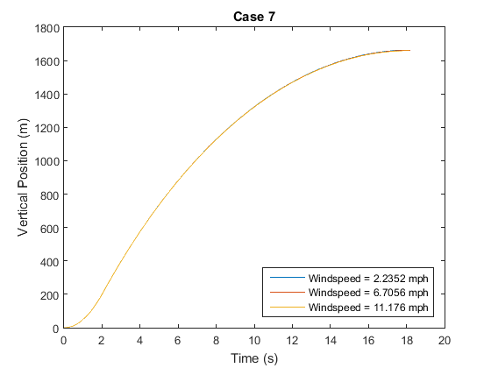
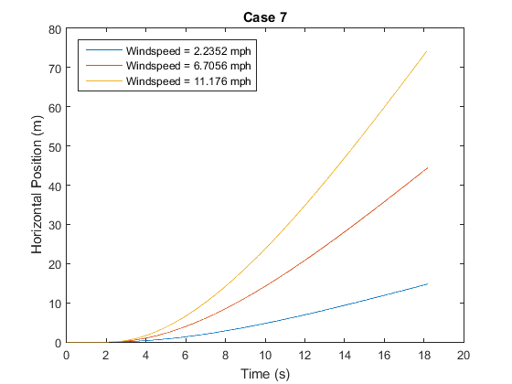
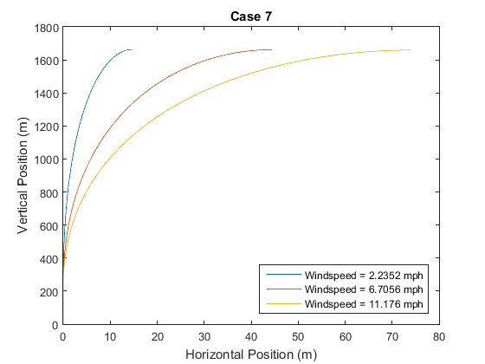

Case 8 Analysis
Introducing side winds at the launch rail instead of after MECO resulted in a drastic change in behavior. Instead of drifting WITH the wind as the rockets do in the earlier cases, the rocket now drifts INTO the wind. Additionally, since the rocket is going at a slower speed and is still thrusting when it turns into the wind, the drift is drastically higher, and the apogee lower. Apogee peaks at 1639 m, with a corresponding drift of 218 m, while drift peaks at 903 m with a corresponding apogee of 1399.
curcase = 3;
figure()
figlegend = cell(1,length(windspeed));
data = cell(1,2*length(windspeed));
for i = 1:length(windspeed)
data{2*i-1} = time(y6{curcase,i}(4,:)>=0);
data{2*i} = y6{curcase,i}(2,y6{curcase,i}(4,:)>=0);
figlegend{i} = ['Windspeed = ' num2str(windspeed(i)) ' mph'];
end
plot(data{:});
xlabel('Time (s)');
ylabel('Vertical Position (m)');
legend(figlegend,'Location', 'SouthEast');
title(titles{curcase});
figure()
figlegend = cell(1,length(windspeed));
data = cell(1,2*length(windspeed));
for i = 1:length(windspeed)
data{2*i-1} = time(y6{curcase,i}(4,:)>=0);
data{2*i} = y6{curcase,i}(1,y6{curcase,i}(4,:)>=0);
figlegend{i} = ['Windspeed = ' num2str(windspeed(i)) ' mph'];
end
plot(data{:});
xlabel('Time (s)');
ylabel('Horizontal Position (m)');
legend(figlegend,'Location', 'SouthWest');
title(titles{curcase});
figure()
figlegend = cell(1,length(windspeed));
data = cell(1,2*length(windspeed));
for i = 1:length(windspeed)
data{2*i-1} = y6{curcase,i}(1,y6{curcase,i}(4,:)>=0);
data{2*i} = y6{curcase,i}(2,y6{curcase,i}(4,:)>=0);
figlegend{i} = ['Windspeed = ' num2str(windspeed(i)) ' mph'];
end
plot(data{:});
xlabel('Horizontal Position (m)');
ylabel('Vertical Position (m)');
legend(figlegend,'Location', 'SouthWest');
title(titles{curcase});
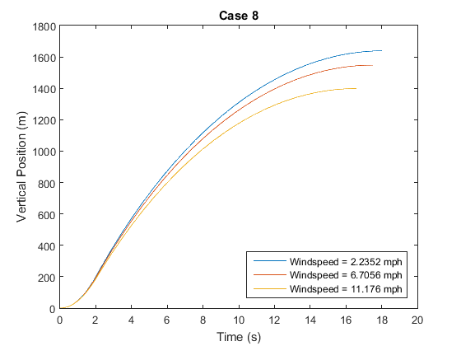
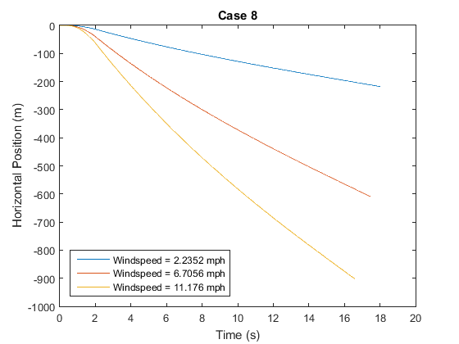
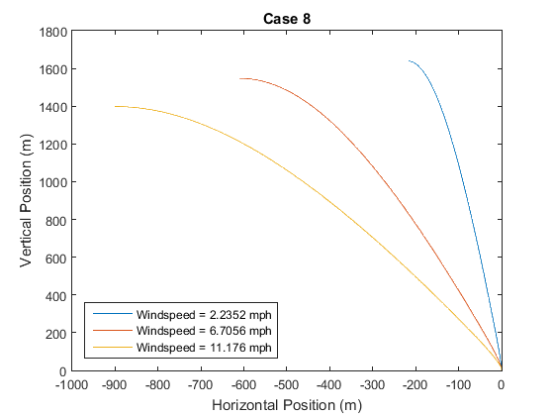

Case 9 Analysis
Launching with a launch rail located 5 degrees into the wind further decreased apogee and increased apogee drift, with a new peak apogee of 1606 m and a peak drift of 1076 m.
curcase = 4;
figure()
figlegend = cell(1,length(windspeed));
data = cell(1,2*length(windspeed));
for i = 1:length(windspeed)
data{2*i-1} = time(y6{curcase,i}(4,:)>=0);
data{2*i} = y6{curcase,i}(2,y6{curcase,i}(4,:)>=0);
figlegend{i} = ['Windspeed = ' num2str(windspeed(i)) ' mph'];
end
plot(data{:});
xlabel('Time (s)');
ylabel('Vertical Position (m)');
legend(figlegend,'Location', 'SouthEast');
title(titles{curcase});
figure()
figlegend = cell(1,length(windspeed));
data = cell(1,2*length(windspeed));
for i = 1:length(windspeed)
data{2*i-1} = time(y6{curcase,i}(4,:)>=0);
data{2*i} = y6{curcase,i}(1,y6{curcase,i}(4,:)>=0);
figlegend{i} = ['Windspeed = ' num2str(windspeed(i)) ' mph'];
end
plot(data{:});
xlabel('Time (s)');
ylabel('Horizontal Position (m)');
legend(figlegend,'Location', 'SouthWest');
title(titles{curcase});
figure()
figlegend = cell(1,length(windspeed));
data = cell(1,2*length(windspeed));
for i = 1:length(windspeed)
data{2*i-1} = y6{curcase,i}(1,y6{curcase,i}(4,:)>=0);
data{2*i} = y6{curcase,i}(2,y6{curcase,i}(4,:)>=0);
figlegend{i} = ['Windspeed = ' num2str(windspeed(i)) ' mph'];
end
plot(data{:});
xlabel('Horizontal Position (m)');
ylabel('Vertical Position (m)');
legend(figlegend,'Location', 'SouthWest');
title(titles{curcase});

function dy = func6(t,y,ws,cd,a,m,scenario)
% y = [px py vx vy]
dy = zeros(4,1);
rho = stdAtmD(y(2));
mstate1 = L1720_Profile(t);
mstate2 = H202_Profile(t);
m = m + mstate1(2) + mstate2(2);
T = mstate1(3) + mstate2(3);
switch scenario
case 6
if t < 2.13
ws = [0; 0];
else
ws = [ws; 0];
end
case 7
if t < 2.13
ws = [0;0];
else
ws = [stdAtmWind(ws,10,y(2));0];
end
case 8
if y(4) < 30
ws = [0;0];
else
ws = [stdAtmWind(ws,10,y(2));0];
end
case 9
if y(4) < 30
ws = [0;0];
else
ws = [stdAtmWind(ws,10,y(2));0];
end
end
V = [y(3); y(4)]; %rocket velocity vector, what we actually care about
switch scenario
case 9
if y(4) < 30 && t < 2
tmp = norm(V);
V(1) = -sind(5)*tmp;
V(2) = cosd(5)*tmp;
end
end
Vapp = V - ws; % Apparent velocity vector
Vapp_unit = Vapp/norm(Vapp); % unit vector for apparent velocity
if isnan(Vapp_unit)
Vapp_unit = [0;1];
end
Vnorm = norm(Vapp);
up = [0;1]; % vertical unit vector
dy(1) = y(3);
dy(2) = y(4);
dvdt = Vapp_unit*(T - 0.5*cd*rho*a*Vnorm^2)/m - up*g(R0+y(2));
dy(3) = dvdt(1);
dy(4) = dvdt(2);
end
Published with MATLAB® R2015a

