Dexter Watkins Propulsion - Homework 2
Problem Definition 1
Specified Properties and Assumptions 1
Governing Equations 2
Problem Setup 2
Rocket Construction 3
Simulation Setup and Execution 4
Case 1-3 Analysis 6
Case 4 Analysis 9
Case 5 Analysis 11

Problem Definition
Calculate position, velocity, and acceleration as a function of time for a rocket from launch until apogee. Use a numerical method to solve this problem. Examine the following five cases.
- A single rocket motor and constant air density (1.2 kg/m3)
- A single rocket motor and density as a function of height
- Same as case two, with the addition of two monopropellant thrusters
- Same as case three, but varying Cd from 0.4-0.6 in steps of 0.05
- Same as case three, but varying dry mass from 14-16 in steps of 0.25

Specified Properties and Assumptions
- Rocket has a dry mass of 14.34 kg
- The rocket has a cross-sectional area of 0.015327 square meters
- The rocket has a drag coefficient of 0.5,cases 1-4 and 0.45 for case 5
- The main motor has a mass of 1.755 kg and mass flow rate of 0.8357 kg/s
- The main motor will fire from t0 to t+2.1 seconds
- The main motor produces a thrust of 1760 N;
- The Mono-Props are 0.08 kg each, with a mass flux of 0.01 kg/s each
- The Mono-Props will fire from t+1 to t+9 seconds
- Each Mono-Prop produces a thust of 10 N;

Governing Equations
The equation of motion for the flight vehicle is determined by the following system of equations:
For easier use, the system of equations is rewritten as a system of purely first order equations, as follows:
Where is position, is velocity, and is mass

Problem Setup
A custom matlab class named "Vehicle" is used to encapsulate vehicle properties such as its state vector, cross-sectional area, and drag coefficient. Additionally, the Vehicle class will contain system components such as thrusters and structures. Each of these components will contain properties such as current mass, fuel mass, thrust produced, fuel flow rate, etc.
The system of differential equations will be solved using matlab's built in ode45 solver. The ode45 solver gets it name from the 4th and 5th order runge kutta numerical techniques it uses. Ode45 first estimates a time step and approximates a solution using the 4th order method. The 5th order method is then evaluated and the difference between the two is taken to be the method's error. This error is compared to the user-specified error tolerance (default 0.1%). If the error is too large, a smaller time step is chosen and the solution re-evaluated.
In order to use ode45, a function must be defined that calculates the system of equations in the following way:
As a system of equations that satisfies this criterion has already been developed, all that is needed are initial conditions and the start and end times.

Rocket Construction
% Define rocket vehicle
rocket_name = 'Rocket';
% Define earth's mean radius
R0 = 6.371e6; % m
sv = zeros(1,9); % state vector: [x y z vx vy vz ax ay az]
sv(1) = R0; %initially at earth's surface
area = 0.015327;
cd = 0.5;
CS = 'Cartesian';
Units = 'Metric';
r = Vehicle(rocket_name,sv,area,cd,CS,Units);
% Define rocket body
bname = 'Body';
bmass = 14.34;
b = Structure(bname, bmass, CS, Units);
% Define main thruster
mname = 'Main';
mmass = 0;
mmass_fuel = 1.755;
mmass_flowrate = 1.755/2.1;
mthrust = 1760;
main = Thruster(mname,mmass,CS,Units,mmass_fuel, mmass_flowrate,mthrust);
% Define monoprop1
mp1name = 'Mono1';
mpmass = 0;
mpmass_fuel = 0.08;
mpmass_flowrate = 0.01;
mpthrust = 10;
mp1 = Thruster(mp1name,mpmass,CS,Units,mpmass_fuel,mpmass_flowrate,mpthrust);
% Define monoprop2
mp2name = 'Mono2';
mp2 = Thruster(mp2name,mpmass,CS,Units,mpmass_fuel,mpmass_flowrate,mpthrust);
% Attach components to rocket
r.attach(b);
r.attach(main);
r.attach(mp1);
r.attach(mp2);

Simulation Setup and Execution
% Case 1 Setup
xintmain = 0:0.1:2.0; %setup time interval to be used
xintcoast = 2.1:0.1:22; %setup time interval to be used
xint = [xintmain xintcoast];
rho = 1.2; % constant density kg/m3
tspanmain = [0 2.1];
tspancoast = [2.1 22];
r.toggleThruster(mname); % fire main thruster
% Execute Case 1
[y1_1, yp1_1] = deval(r.propagate(tspanmain,rho),xintmain);
[y1_2, yp1_2] = deval(r.propagate(tspancoast,rho),xintcoast);
y1 = {[y1_1 y1_2]};
yp1 = {[yp1_1 yp1_2]};
% Case 2 Setup
r.attach(main); % reset main thruster
r.sv = sv; % reset state vector
r.toggleThruster(mname);
% Execute Case 2
[y2_1, yp2_1] = deval(r.propagate(tspanmain),xintmain);
[y2_2, yp2_2] = deval(r.propagate(tspancoast),xintcoast);
y2 = {[y2_1 y2_2]};
yp2 = {[yp2_1 yp2_2]};
% Case 3 Setup
r.attach(main); % reset main thruster
r.toggleThruster(mname);
r.sv = sv; % reset state vector
tspanMain = [0 1];
tspanMixed = [1 2.1];
tspanMono = [2.1 9];
tspanCoast = [9 22];
% Execute Case 3
[y3_1, yp3_1] = deval(r.propagate(tspanMain),0:0.1:.9);
r.toggleThruster(mp1name);
r.toggleThruster(mp2name);
[y3_2, yp3_2] = deval(r.propagate(tspanMixed),1:0.1:2);
[y3_3, yp3_3] = deval(r.propagate(tspanMono), 2.1:0.1:8.9);
[y3_4, yp3_4] = deval(r.propagate(tspanCoast), 9:0.1:22);
y3 = {[y3_1 y3_2 y3_3 y3_4]}; % combine the time span results
yp3 = {[yp3_1 yp3_2 yp3_3 yp3_4]}; % combine the time span results
% Case 4 Setup
cd = 0.4:0.05:0.6; % vary cd
% Execute Case 4
i = 1;
y4 = {};
yp4 = y4;
for c = cd
r.attach(main); % reset main thruster
r.attach(mp1); % reset monoprops
r.attach(mp2); % reset monoprops
r.toggleThruster(mname);
r.sv = sv; % reset state vector
r.cd = c;
[y4_1, yp4_1] = deval(r.propagate(tspanMain),0:0.1:.9);
r.toggleThruster(mp1name);
r.toggleThruster(mp2name);
[y4_2, yp4_2] = deval(r.propagate(tspanMixed),1:0.1:2);
[y4_3, yp4_3] = deval(r.propagate(tspanMono), 2.1:0.1:8.9);
[y4_4, yp4_4] = deval(r.propagate(tspanCoast), 9:0.1:22);
y4{i} = [y4_1 y4_2 y4_3 y4_4]; % combine the time span results
yp4{i} = [yp4_1 yp4_2 yp4_3 yp4_4]; % combine the time span results
i = i+1;
end
% Case 5 Setup
m = (bmass-0.5):0.25:(bmass+1.5); % vary mass
r.cd = 0.5;
% Execute Case 5
i = 1;
y5 = {};
yp5 = y5;
for c = m(1:4)
r.attach(main); % reset main thruster
r.attach(mp1); % reset monoprops
r.attach(mp2); % reset monoprops
r.toggleThruster(mname);
r.sv = sv; % reset state vector
r.Structures(bname) = Structure(bname, c, CS, Units);
[y5_1, yp5_1] = deval(r.propagate(tspanMain),0:0.1:.9);
r.toggleThruster(mp1name);
r.toggleThruster(mp2name);
[y5_2, yp5_2] = deval(r.propagate(tspanMixed),1:0.1:2);
[y5_3, yp5_3] = deval(r.propagate(tspanMono), 2.1:0.1:8.9);
[y5_4, yp5_4] = deval(r.propagate(tspanCoast), 9:0.1:22);
y5{i} = [y5_1 y5_2 y5_3 y5_4]; % combine the time span results
yp5{i} = [yp5_1 yp5_2 yp5_3 yp5_4]; % combine the time span results
i = i+1;
end
tspanCoastFat = [9 22]; %this is a useless variable,same as tspancoast
for c = m(5:end)
r.attach(main); % reset main thruster
r.attach(mp1); % reset monoprops
r.attach(mp2); % reset monoprops
r.toggleThruster(mname);
r.sv = sv; % reset state vector
r.Structures(bname) = Structure(bname, c, CS, Units);
[y5_1, yp5_1] = deval(r.propagate(tspanMain),0:0.1:.9);
r.toggleThruster(mp1name);
r.toggleThruster(mp2name);
[y5_2, yp5_2] = deval(r.propagate(tspanMixed),1:0.1:2);
[y5_3, yp5_3] = deval(r.propagate(tspanMono), 2.1:0.1:8.9);
[y5_4, yp5_4] = deval(r.propagate(tspanCoastFat), 9:0.1:22);
y5{i} = [y5_1 y5_2 y5_3 y5_4]; % combine the time span results
yp5{i} = [yp5_1 yp5_2 yp5_3 yp5_4]; % combine the time span results
i = i+1;
end

Case 1-3 Analysis
Case 1, with a constant value for density (1.2 kg/m3) slightly underperformed Case 2, which had density as a function of height. This is due to density quickly diverging from Case 1's constant value as the rocket ascended to apogee. This shows up again in the velocity graph, as case 2 maintains a slightly higher velocity over time. Case 3 stands out, as the addition of monopropellant boosters give a clear boost in altitude. A small (but noticeable) increase in acceleration can be observed at t+1, when the monoprops fire, as well as a correspondign drop in accleration at t+9 when they stop.
% plot position
figure(1)
x1 = xint(y1{1}(2,:)>=0);
pos1 = y1{1}(1,y1{1}(2,:)>=0)-R0;
x2 = xint(y2{1}(2,:)>=0);
pos2 = y2{1}(1,y2{1}(2,:)>=0)-R0;
x3 = xint(y3{1}(2,:)>=0);
pos3 = y3{1}(1,y3{1}(2,:)>=0)-R0;
plot(x1,pos1,x2,pos2,x3,pos3);
ylabel('Position (m)');
xlabel('Time (s)');
legend('Case 1', 'Case 2', 'Case 3', 'Location', 'SouthEast');
% plot velocity
figure(2)
vel1 = y1{1}(2,y1{1}(2,:)>=0);
vel2 = y2{1}(2,y2{1}(2,:)>=0);
vel3 = y3{1}(2,y3{1}(2,:)>=0);
plot(x1,vel1,x2,vel2,x3,vel3);
ylabel('Velocity (m/s)');
xlabel('Time (s)');
legend('Case 1', 'Case 2', 'Case 3');
%plot acceleration
figure(3)
acc1 = yp1{1}(2,y1{1}(2,:)>=0);
acc2 = yp2{1}(2,y2{1}(2,:)>=0);
acc3 = yp3{1}(2,y3{1}(2,:)>=0);
plot(x1,acc1,x2,acc2,x3,acc3);
ylabel('Acceleration (m/s2)');
xlabel('Time (s)');
legend('Case 1', 'Case 2', 'Case 3');
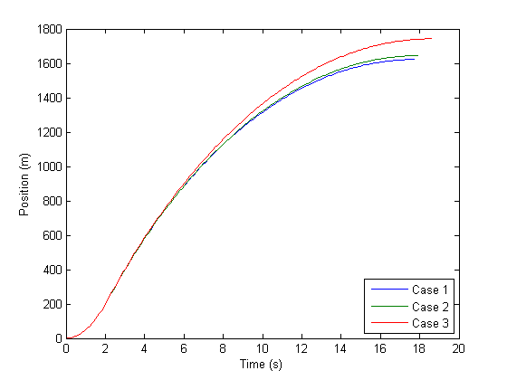
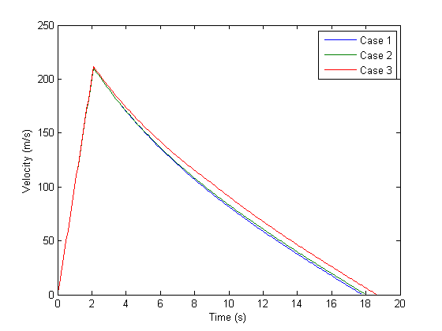
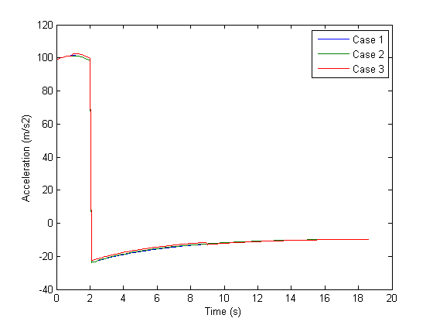

Case 4 Analysis
Case 4 looks at the effect of varying the drag coefficient. As can be seen in the altitude plot, a change of nearly 250 meters is evident between the minimum cd (0.4) and the maximum cd (0.6).
% plot position
figure(4);
hold on;
legendval = cell(1,length(cd)+2);
cm = jet(length(cd));
for i=1:1:length(cd)
plot(xint(y4{i}(2,:)>=0), y4{i}(1,y4{i}(2,:)>=0)-R0, 'color', cm(i,:));
legendval{i} = ['Cd = ' num2str(cd(i))];
end
legendval{end-1} = 'Location';
legendval{end} = 'SouthEast';
ylabel('Position (m)');
xlabel('Time (s)');
legend(legendval{:});
% plot velocity
figure(5);
hold on;
legendval = legendval(1:end-2);
for i=1:1:length(cd)
plot(xint(y4{i}(2,:)>=0), y4{i}(2,y4{i}(2,:)>=0), 'color', cm(i,:));
legendval{i} = ['Cd = ' num2str(cd(i))];
end
ylabel('Velocity (m/s)');
xlabel('Time (s)');
legend(legendval{:});
% plot acceleration
figure(6);
hold on;
for i=1:1:length(cd)
plot(xint(y4{i}(2,:)>=0), yp4{i}(2,y4{i}(2,:)>=0), 'color', cm(i,:));
legendval{i} = ['Cd = ' num2str(cd(i))];
end
ylabel('Acceleration');
xlabel('Time (s)');
legend(legendval{:});
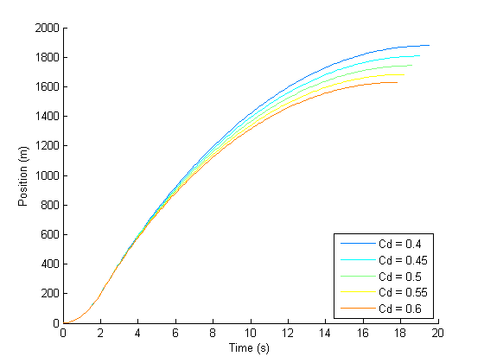
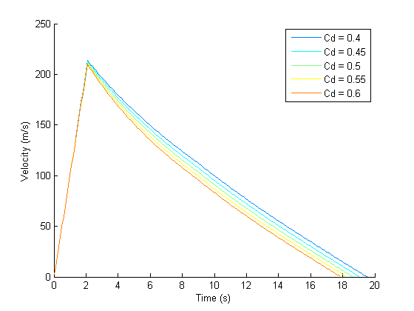
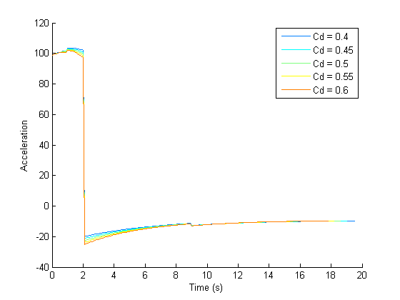

Case 5 Analysis
Case 5 looks at the effect of varying the rocket's dry mass. Please note that the dry mass does not include the mass of the monoprops fuel, hence the values that are 0.16kg less than the specified range of 14:0.25:16. A change of apogee of ~225 meters is evident between the maximum and minimum mass.
% plot position
figure(7);
hold on;
legendval = cell(1,length(m)+2);
cm = jet(length(m));
for i=1:1:length(m)
plot(xint(y5{i}(2,:)>=0), y5{i}(1,y5{i}(2,:)>=0)-R0, 'color', cm(i,:));
legendval{i} = ['Mass = ' num2str(m(i))];
end
legendval{end-1} = 'Location';
legendval{end} = 'SouthEast';
ylabel('Position (m)');
xlabel('Time (s)');
legend(legendval{:});
% plot velocity
figure(8);
hold on;
legendval = legendval(1:end-2);
for i=1:1:length(m)
plot(xint(y5{i}(2,:)>=0), y5{i}(2,y5{i}(2,:)>=0), 'color', cm(i,:));
legendval{i} = ['Mass = ' num2str(m(i))];
end
ylabel('Velocity (m/s)');
xlabel('Time (s)');
legend(legendval{:});
% plot acceleration
figure(9);
hold on;
for i=1:1:length(m)
plot(xint(y5{i}(2,:)>=0), yp5{i}(2,y5{i}(2,:)>=0), 'color', cm(i,:));
legendval{i} = ['Mass = ' num2str(m(i))];
end
ylabel('Acceleration');
xlabel('Time (s)');
legend(legendval{:});
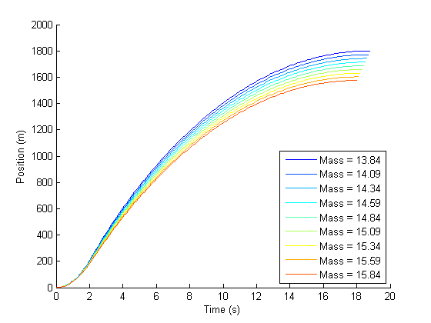
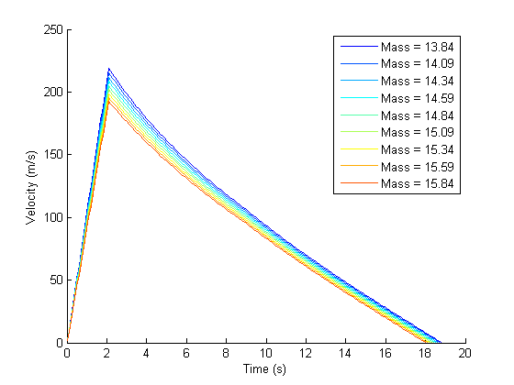
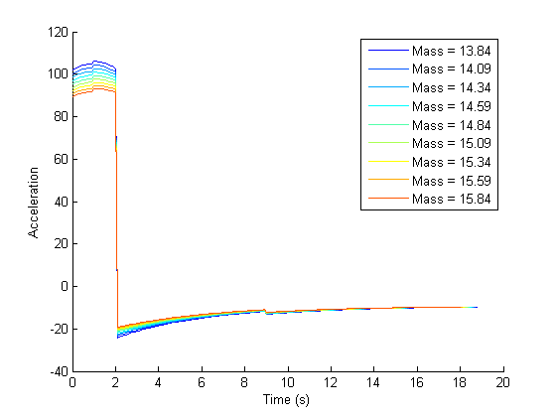
Published with MATLAB® R2014a

