## About the Project/Project Title

This project is an interactive dashboard for Grazioso Salvare which makes it easy and convenient to identify dogs that can be used for various rescue purposes from the Austin Animal Center database.

## Motivation

This project exists to ensure that Grazioso Salvare is able to find dogs quickly and accurately that meet their training needs so they can perform vital search and rescue roles.

## Getting Started

MongoDB was chosen for this project’s database due to its easy of use and powerful interface with python through the PyMongo library. This enables us to use MongoDB as the model layer without a lot of tinkering to get the program to work correctly.

To get a local copy up and running set up a local MongoDB instance and import the AAC.csv file using the mongoimport tool.



You also must set a user in the correct database with credentials for the program to use.

You should test in the mongo shell to ensure that your credentials are valid and allow you access to the database before proceeding to the python program.

## Installation

To run this project, you need Python 3 which can be downloaded from <https://www.python.org/downloads/> and a MongoDB server which can be downloaded from <https://www.mongodb.com/try/download/community>.

## Usage

### Dash Framework

This project makes great use of the Dash framework to allow us to rapidly prototype and complete our information dashboard. This allows us to make changes concisely and quickly as well as make interactive charts to show the locations of the animals and the break downs of breeds and update it programmatically based on user selections.

### Steps Taken

The first step of this project was to create the basic layout of the dashboard and import the whole data set into the dash table. The next step was to create database queries based on our client’s criteria for each type of rescue dog and implement them into the dash table through a drop-down selection menu. The final step was to create an interactive pie chart and geolocation chart to give the users more information about the selected query and animal.

### Screenshots Dashboard with all selected

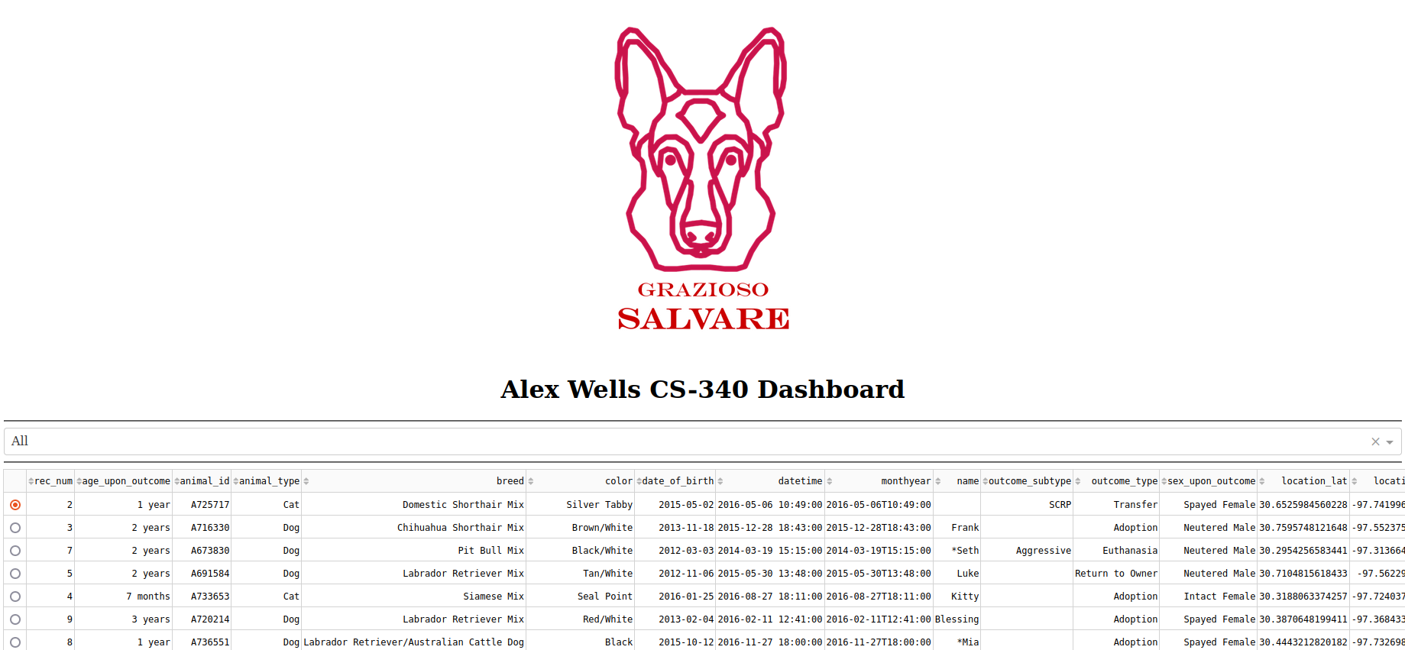

Dashboard with disaster rescue selected

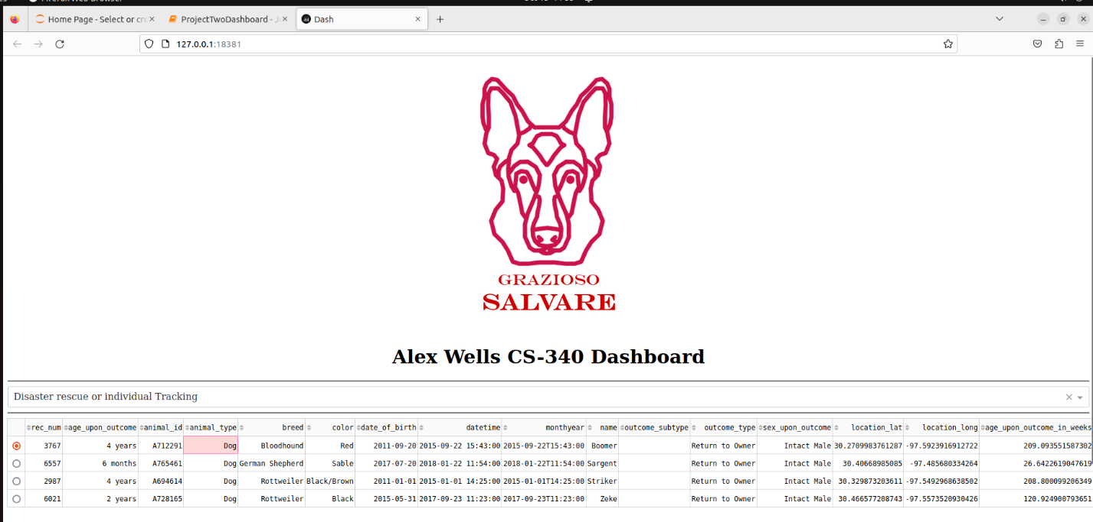

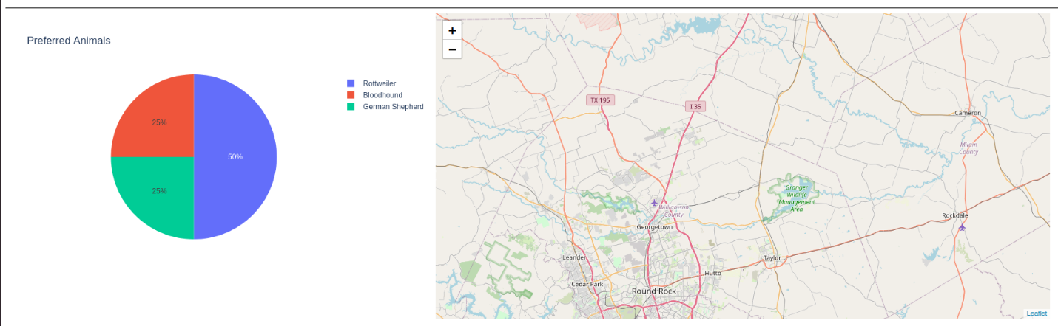

Dashboard with mountain/wilderness selected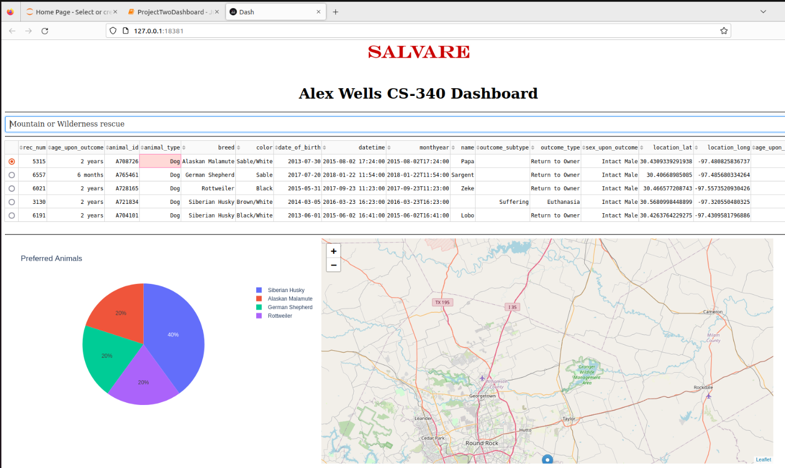

Dashboard with water rescue selected

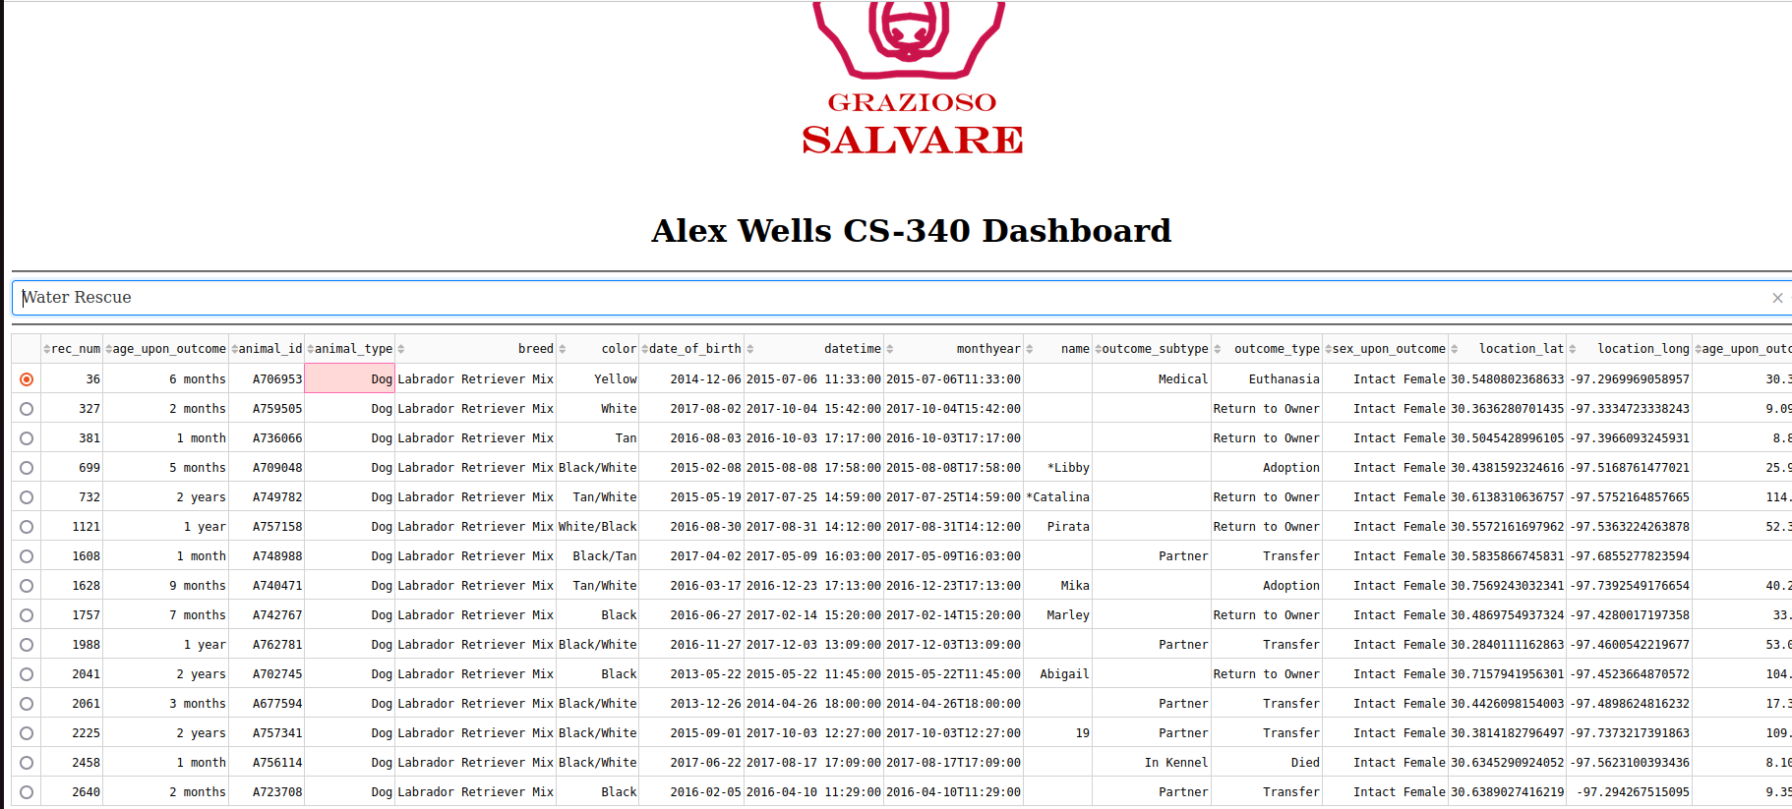

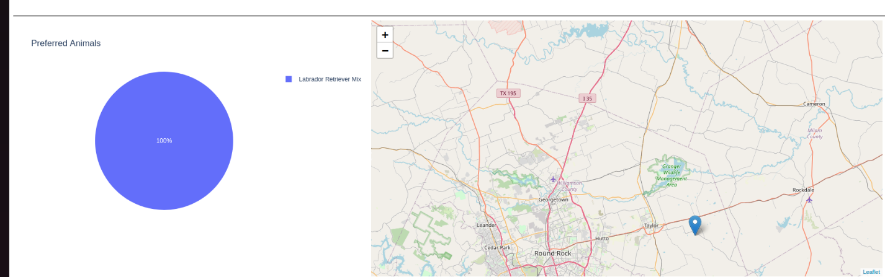

## Contact

Your name: Alex Wells