**Entity Relationship Diagram Implemented**

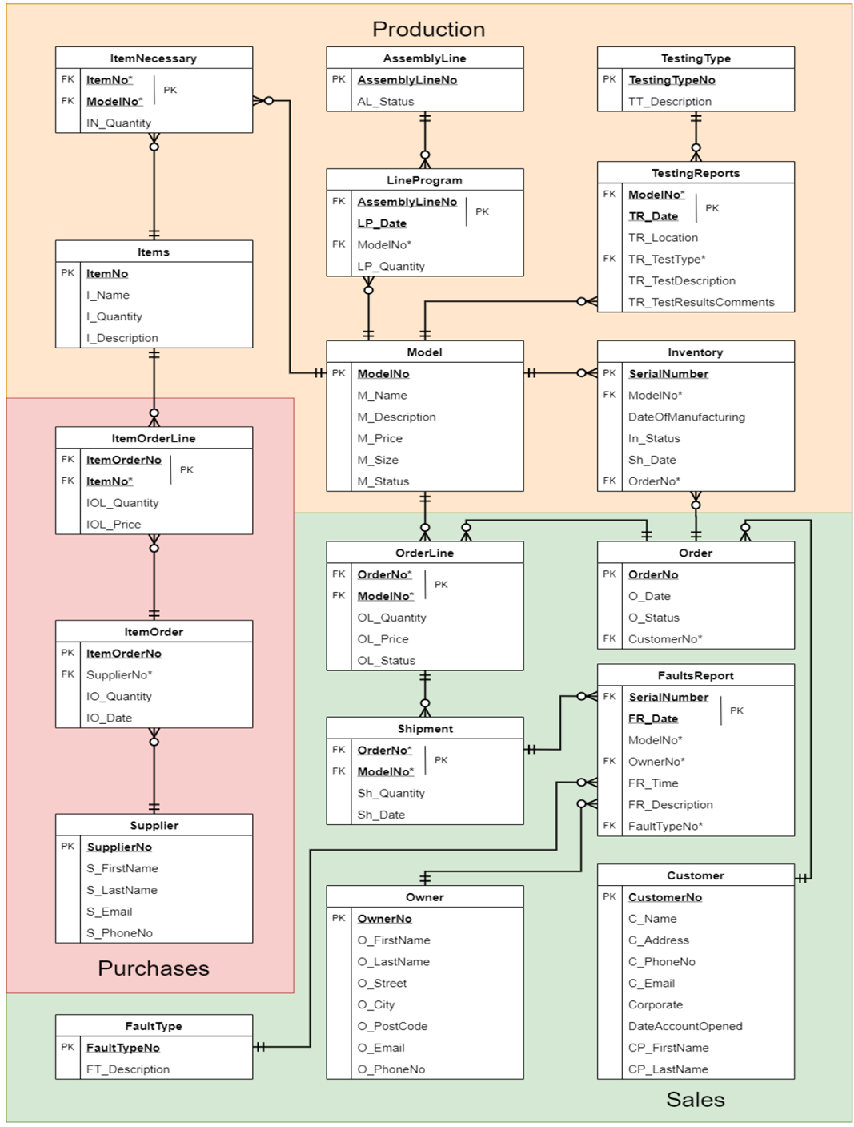

**Table Creation Statements**

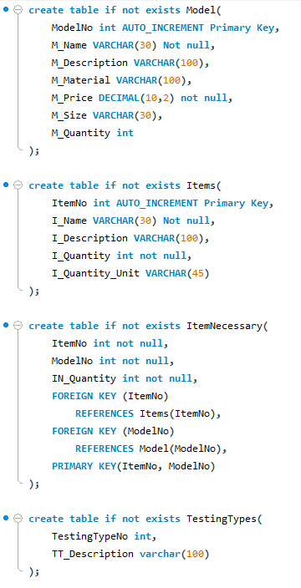

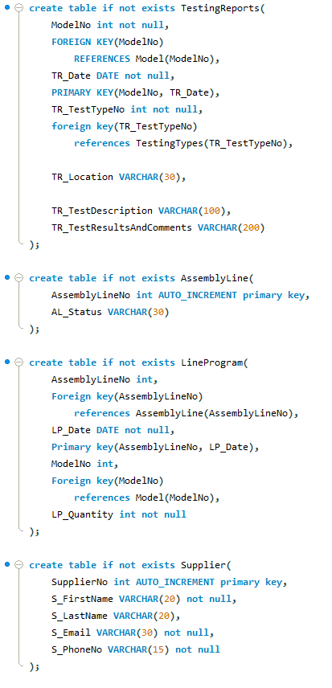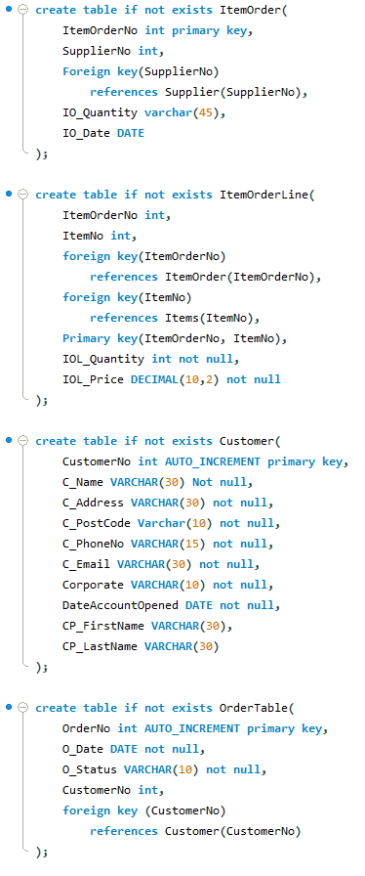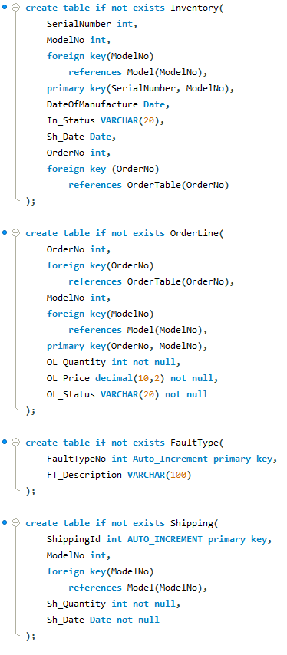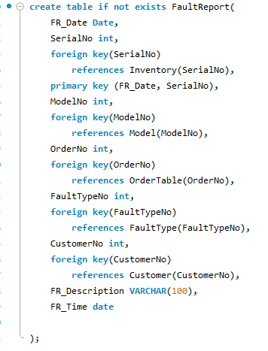

**Data Dictionary**

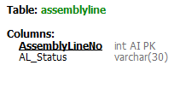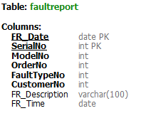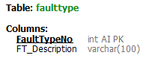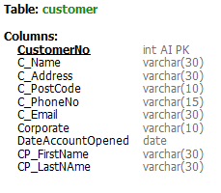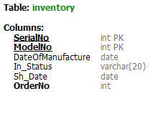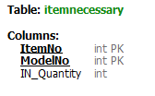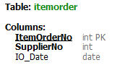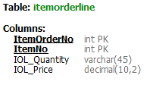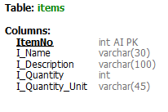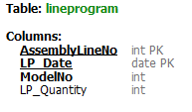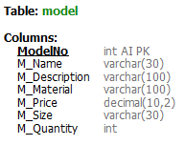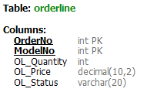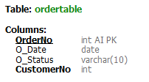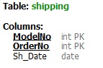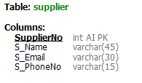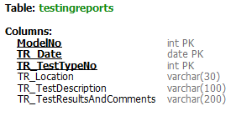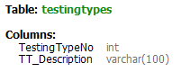

**Demonstration**

|  | **Code** | **Results** |
| --- | --- | --- |
| 1. List of tools produced by the company. |  |  |
| 1. List of suppliers. |  |  |
| 1. List of customers. |  |  |
| 1. Current inventory levels of finished tools. |  |  |
| 1. Current inventory levels of raw materials. |  |  |
| 1. List all the tests conducted on a given tool in the current catalogue. |  |  |
| 1. List of raw materials required to produce a given tool. |  |  |
| 1. Create a new order for an existing Customer. |  |  |
| 1. Add 4 different items to the order created in question 8. -two of them must NOT be in existence, i.e. not part of current inventory of finished tools. |  |  |
| 1. Calculate and show the cost of each line in the order updated in question 9. |  |  |
| 1. Calculate and show the total cost of the order updated in question 9. |  |  |
| 1. Schedule the production line for the tools requested in the order updated in question 9 that are currently out of stock. |  |  |
| 1. For one of the tools scheduled in question 12, show the list of raw materials and quantities required for its manufacturing. |  |  |
| 1. Assume raw materials are being delivered by one of the company’s suppliers, create a new Delivery of raw materials order/note. |  |  |
| 1. Update the inventory of raw materials by adding the raw materials delivered in question 14. |  |  |
| 1. Assume that the manufacturing of the tools scheduled in question 12 has finished. Add these tools to the inventory of finished tools. |  |  |
| 1. Using the serial number assigned to one of the tools added to the inventory of finished tools (question 16), create a shipment for the order created in question 8. |  |  |
| 1. Assume one the tools added to the inventory of finished tools (question 16), has been purchased and is now returned due to a fault. Create a new Problem Report for it. |  |  |