置换特征重要性-python-sklearn
预测葡萄牙的两所高中的学生的成绩
395个样本+15个特征
import pandas as pd
df = pd.read_csv('student-mat.csv', delimiter=';')
# drop columns that are less related to the target based on my judgement
cols_to_drop = ['school', 'age', 'address', 'Medu', 'Fedu', 'Mjob', 'Fjob', 'reason', 'guardian', 'famsup',
'romantic', 'goout', 'Dalc', 'Walc', 'health', 'G1', 'G2']
# at the same time, rename the columns so that they are understandable
df = df.drop(columns=cols_to_drop).rename(columns={'famsize': 'family_size', 'Pstatus': 'parent_cohab_status',
'traveltime': 'travel_time_school', 'studytime': 'study_time',
'failures': 'past_failures', 'schoolsup': 'extra_support',
'paid': 'extra_paid_classes', 'activities': 'extra_curricular',
'nursery': 'nursery_school', 'higher': 'want_higher_edu',
'internet': 'internet_access', 'famrel': 'family_relationships',
'freetime': 'free_time', 'absences': 'number_absences',
'G3': 'score'})
# convert categorical variables into dummy variables
df = pd.get_dummies(df, drop_first=True)
df_features = df.drop(columns='score')
df_features.info()

travel_time_school：从学校到家的时间；study_time：每周学习时间；past_failures：过去课程不及格次数；family_relationships：家庭关系质量；free_time：放学后的休息时间；number_absences：翘课的次数；sex_M：性别为男性（1是男性，0是女性）等等，其余的解释可以直接去UCI官网查看。

# machine learning model
import xgboost as xgb
model = xgb.XGBRegressor(n_estimators=500, max_depth=20, learning_rate=0.1, subsample=0.8, random_state=33)
model.fit(df_features, df['score'])

# using permutation_importance
from sklearn.inspection import permutation_importance
scoring = ['r2', 'neg_mean_squared_error']
perm_importance = permutation_importance(model, df_features, df['score'], scoring=scoring, n_repeats=5, random_state=33)

# plot a figure
%matplotlib inline
%config InlineBackend.figure_format = 'svg'
perm_importance_r2 = pd.DataFrame(
data={'importance': perm_importance['r2']['importances_mean']}, index=df_features.columns
)
perm_importance_r2.sort_values(by='importance', ascending=False).plot(kind='barh', figsize=(5, 3.75))
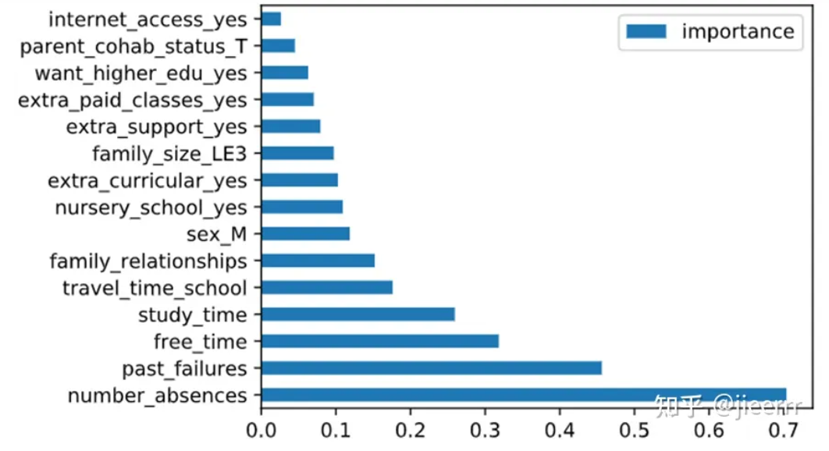

随机森林-特征重要性
数据集：

cwd = './Machine_Learning/'
data_dir = cwd+'RandomForest随机森林/data/'

# Wine dataset and rank the 13 features by their respective importance measures
df_wine = pd.read_csv(data_dir+'wine.data',
header=None,
names=['Class label', 'Alcohol', 'Malic acid', 'Ash', 'Alcalinity of ash', 'Magnesium','Total phenols', 'Flavanoids', 'Nonflavanoid phenols', 'Proanthocyanins', 'Color intensity', 'Hue', 'OD280/OD315 of diluted wines', 'Proline'])
print('Class labels', np.unique(df_wine['Class label']))
print('numbers of features:', len(df_wine.keys())-1)
df_wine.head()

部分结果：
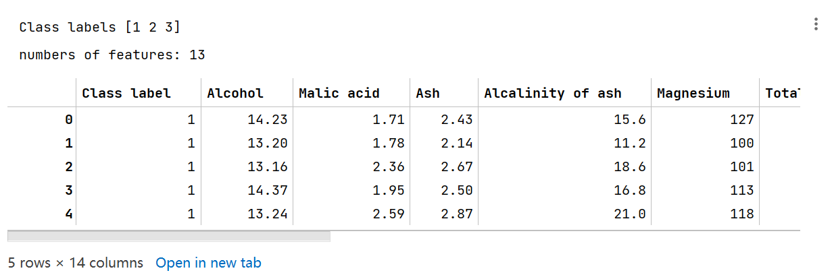

划分训练集和测试集：

X, y = df_wine.iloc[:, 1:].values, df_wine.iloc[:, 0].values
X_train, X_test, y_train, y_test = train_test_split(X, y, test_size=0.3, random_state=0, stratify=y)
X_train.shape

(124, 13)

使用RandomForestClassifier训练，然后调用feature_importances_属性获得特征重要性：

feat_labels = df_wine.columns[1:]
forest = RandomForestClassifier(n_estimators=200, random_state=1)
forest.fit(X_train, y_train)
importances = forest.feature_importances_
print(len(importances))
importances

#通过模型的feature_importances_方法获取特征贡献度。使用sklearn的算法都有这个方法。

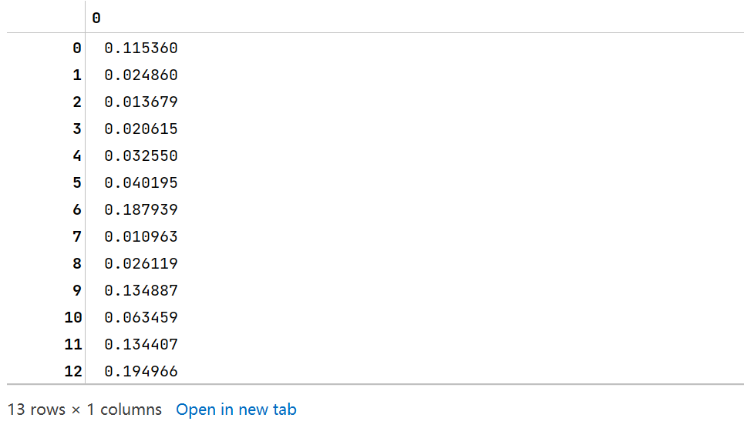
排一下顺序：

indices = np.argsort(importances)[::-1] # 取反后是从大到小
indices

#使用argsort对其进行排序，由于argsort排序是从小到大的，因此要用[::-1]进行倒序
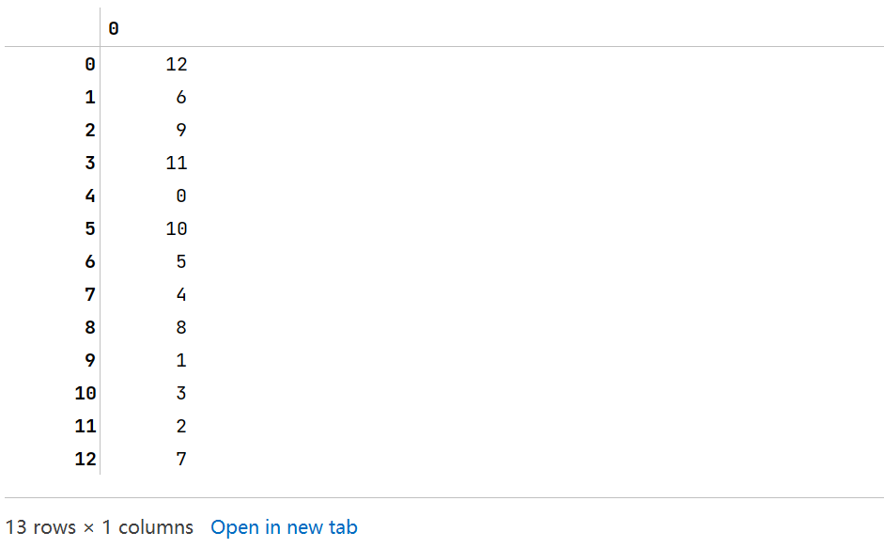

for i in range(X_train.shape[1]):
print("%2d) %-*s %f" % (i + 1, 30, feat_labels[indices[i]], importances[indices[i]]))

最终的结果为：

1) Proline 0.194966
2) Flavanoids 0.187939
3) Color intensity 0.134887
4) OD280/OD315 of diluted wines 0.134407
5) Alcohol 0.115360
6) Hue 0.063459
7) Total phenols 0.040195
8) Magnesium 0.032550
9) Proanthocyanins 0.026119
10) Malic acid 0.024860
11) Alcalinity of ash 0.020615
12) Ash 0.013679
13) Nonflavanoid phenols 0.010963

可视化一下结果：

plt.title('Feature Importance')
plt.bar(range(X_train.shape[1]), importances[indices], align='center')
plt.xticks(range(X_train.shape[1]), feat_labels[indices], rotation=90)
plt.xlim([-1, X_train.shape[1]])
plt.tight_layout()
plt.show()

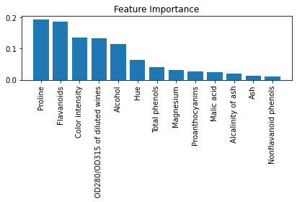

随机森林-回归任务
展示一下数据集：

from sklearn.ensemble import RandomForestRegressor
from sklearn.metrics import mean_squared_error

df = pd.read_csv(data_dir+'housing.data.txt',
header=None,
sep='\s+',
names= ['CRIM', 'ZN', 'INDUS', 'CHAS', 'NOX', 'RM', 'AGE', 'DIS', 'RAD', 'TAX', 'PTRATIO', 'B', 'LSTAT', 'MEDV'])
df.head()
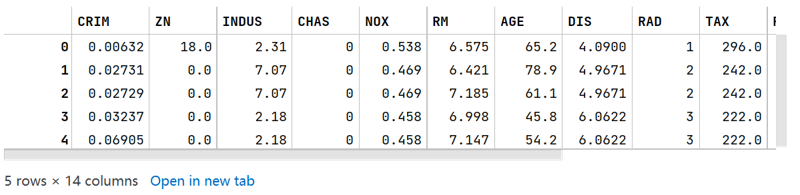

# 划分数据集
X = df.iloc[:, :-1].values
y = df['MEDV'].values
X_train, X_test, y_train, y_test =train_test_split(X, y, test_size=0.2, random_state=1)
print(X_train.shape, y_train.shape)

(404, 13) (404,)

forest = RandomForestRegressor(n_estimators=100, criterion='mse', random_state=1, n_jobs=-1)
forest.fit(X_train, y_train) # 训练

y_train_pred = forest.predict(X_train)
y_test_pred = forest.predict(X_test)
print('MSE train: %.3f, test: %.3f' % (mean_squared_error(y_train, y_train_pred), mean_squared_error(y_test, y_test_pred)))

最终结果为：

MSE train: 1.237, test: 8.916

源代码
from sklearn import datasets
from sklearn.model_selection import train_test_split
from sklearn.ensemble import RandomForestClassifier
import numpy as np

from matplotlib.colors import ListedColormap
import matplotlib.pyplot as plt

iris = datasets.load_iris()
print(iris['data'].shape, iris['target'].shape) # (150, 4) (150,)
X = iris.data[:,[2,3]]
y = iris.target
print('Class labels:', np.unique(y))
X_train, X_test, y_train, y_test = train_test_split(X, y, test_size=0.3, random_state=1, stratify=y)
print(X_train.shape, y_train.shape)
def plot_decision_regions(X, y, classifier, test_idx=None, resolution=0.02):
# setup marker generator and color map
markers = ('s', 'x', 'o', '^', 'v')
colors = ('red', 'blue', 'lightgreen', 'gray', 'cyan')
cmap = ListedColormap(colors[:len(np.unique(y))])

# plot the decision surface
x1_min, x1_max = X[:, 0].min() - 1, X[:, 0].max() + 1
x2_min, x2_max = X[:, 1].min() - 1, X[:, 1].max() + 1
xx1, xx2 = np.meshgrid(np.arange(x1_min, x1_max, resolution),
np.arange(x2_min, x2_max, resolution))
Z = classifier.predict(np.array([xx1.ravel(), xx2.ravel()]).T)
Z = Z.reshape(xx1.shape)
plt.contourf(xx1, xx2, Z, alpha=0.3, cmap=cmap)
plt.xlim(xx1.min(), xx1.max())
plt.ylim(xx2.min(), xx2.max())

for idx, cl in enumerate(np.unique(y)):
plt.scatter(x=X[y == cl, 0], y=X[y == cl, 1],
alpha=0.8, c=colors[idx],
marker=markers[idx], label=cl,
edgecolor='black')
# highlight test samples
if test_idx:
# plot all samples
X_test, y_test = X[test_idx, :], y[test_idx]
plt.scatter(X_test[:, 0], X_test[:, 1],
c='', edgecolor='black', alpha=1.0,
linewidth=1, marker='o',
s=100, label='test set')
forest = RandomForestClassifier(criterion='gini', # 划分准则
n_estimators=25, # 25个基学习器（决策树）
random_state=1,
n_jobs=2) # 并行执行
forest.fit(X_train, y_train)
X_combined = np.vstack((X_train, X_test))
y_combined = np.hstack((y_train, y_test))
plot_decision_regions(X_combined, y_combined, classifier=forest, test_idx=range(105,150))
plt.xlabel('petal length')
plt.ylabel('petal width')
plt.legend(loc='upper left')
plt.show()

import pandas as pd
import numpy as np
from sklearn.ensemble import RandomForestClassifier
from sklearn.model_selection import train_test_split

import matplotlib.pyplot as plt

cwd = './MachineLearning/'
data_dir = cwd+'RandomForest随机森林/data/'

# Wine dataset and rank the 13 features by their respective importance measures
df_wine = pd.read_csv(data_dir+'wine.data',
header=None,
names=['Class label', 'Alcohol', 'Malic acid', 'Ash', 'Alcalinity of ash', 'Magnesium',
'Total phenols', 'Flavanoids', 'Nonflavanoid phenols', 'Proanthocyanins', 'Color intensity',
'Hue', 'OD280/OD315 of diluted wines', 'Proline'])
print('Class labels', np.unique(df_wine['Class label']))
print('numbers of features:', len(df_wine.keys())-1)
df_wine.head()

# 划分训练集测试集
X, y = df_wine.iloc[:, 1:].values, df_wine.iloc[:, 0].values
X_train, X_test, y_train, y_test = train_test_split(X, y, test_size=0.3, random_state=0, stratify=y)
X_train.shape

feat_labels = df_wine.columns[1:]
forest = RandomForestClassifier(n_estimators=200, random_state=1)
forest.fit(X_train, y_train)
importances = forest.feature_importances_
print(len(importances))
importances

indices = np.argsort(importances)[::-1] # 取反后是从大到小
indices

for i in range(X_train.shape[1]):
print("%2d) %-*s %f" % (i + 1, 30, feat_labels[indices[i]], importances[indices[i]]))

plt.title('Feature Importance')
plt.bar(range(X_train.shape[1]), importances[indices], align='center')
plt.xticks(range(X_train.shape[1]), feat_labels[indices], rotation=90)
plt.xlim([-1, X_train.shape[1]])
plt.tight_layout()
plt.show()

from sklearn.ensemble import RandomForestRegressor
from sklearn.metrics import mean_squared_error

df = pd.read_csv(data_dir+'housing.data.txt',
header=None,
sep='\s+',
names= ['CRIM', 'ZN', 'INDUS', 'CHAS', 'NOX', 'RM', 'AGE', 'DIS', 'RAD', 'TAX', 'PTRATIO', 'B', 'LSTAT', 'MEDV'])
df.head()

# 划分数据集
X = df.iloc[:, :-1].values
y = df['MEDV'].values
X_train, X_test, y_train, y_test =train_test_split(X, y, test_size=0.2, random_state=1)
print(X_train.shape, y_train.shape)

forest = RandomForestRegressor(n_estimators=100, criterion='mse', random_state=1, n_jobs=-1)
forest.fit(X_train, y_train) # 训练

y_train_pred = forest.predict(X_train)
y_test_pred = forest.predict(X_test)
print('MSE train: %.3f, test: %.3f' % (mean_squared_error(y_train, y_train_pred), mean_squared_error(y_test, y_test_pr

# -*- coding: utf-8 -*-
"""
Created on Sun Sep 26 15:51:26 2021

@author: chenguimei
"""

# 引入数据
from sklearn import datasets
import pandas as pd
import numpy as np

iris = datasets.load_iris()
X = pd.DataFrame(iris.data)
X.columns = iris.feature_names
y = iris.target
print("Class labels:",np.unique(y)) #打印分类类别的种类

# 切分训练数据和测试数据
from sklearn.model_selection import train_test_split
## 30%测试数据，70%训练数据，stratify=y表示训练数据和测试数据具有相同的类别比例
X_train,X_test,y_train,y_test = train_test_split(X,y,test_size=0.3,random_state=1,stratify=y)

#决策树模型
from sklearn.tree import DecisionTreeClassifier
tree = DecisionTreeClassifier(criterion='gini',max_depth=4,random_state=1)
tree.fit(X_train,y_train)
print(X.columns,tree.feature_importances_)

from sklearn.metrics import roc_curve, auc
resu = tree.predict(X_test)
print(resu)
print(y_test)

import eli5
from eli5.sklearn import PermutationImportance

perm = PermutationImportance(lr, random_state=1).fit(X_test, y_test)
eli5.show_weights(perm, feature_names = X_test.columns.tolist())

from sklearn.inspection._permutation_importance import permutation_importance
from sklearn.datasets import load_iris
from sklearn.metrics import get_scorer
from sklearn.linear_model import LogisticRegression

permutation_importance(tree, X_test, y_test, get_scorer('accuracy'))

