部分依赖图-melb地区房屋的数据

import pandas as pd
from sklearn.ensemble import GradientBoostingRegressor, GradientBoostingClassifier
from sklearn.ensemble.partial_dependence import partial_dependence, plot_partial_dependence
from sklearn.impute import SimpleImputer
import matplotlib.pyplot as plt

cols_to_use = ['Distance', 'Landsize', 'BuildingArea']

def get_some_data():
data = pd.read_csv('melb_data.csv')
y = data.Price
X = data[cols_to_use]
my_imputer = SimpleImputer()#填补缺失值
imputed_X = my_imputer.fit_transform(X)
return imputed_X, y

X, y = get_some_data()
my_model = GradientBoostingRegressor()
my_model.fit(X, y)
myplots = plot_partial_dependence(my_model,
features=[0, 2],
X=X,
feature_names=cols_to_use,
grid_resolution=10)

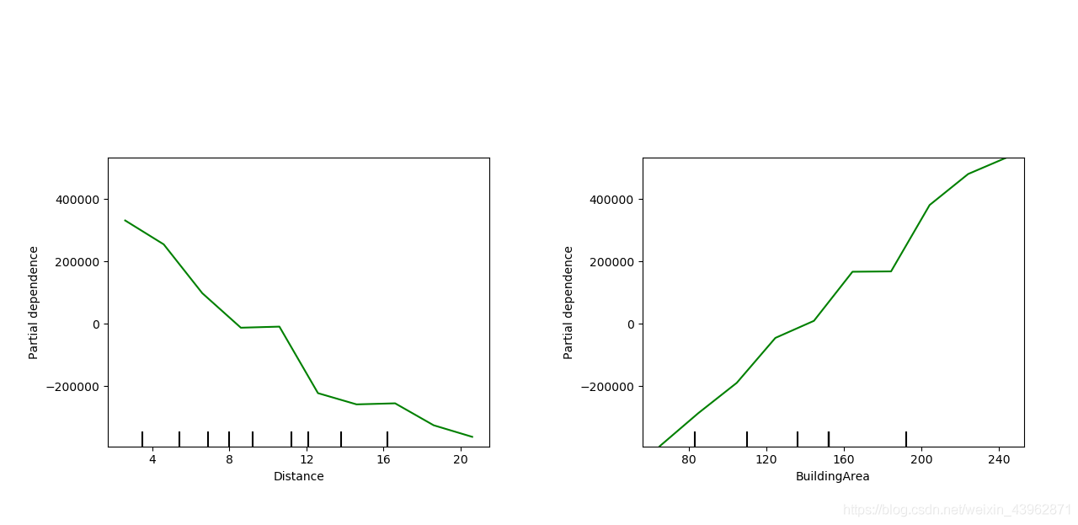
返回结果如下：
左图显示了价格和距离变量之间的部分依赖关系，右图是价格和建筑面积变量之间的部分依赖关系。
从上图可以看出，随着距离（距离中央商务区的距离）的增长价格下降，在中间9-10以及15-16左右可能是有不错地段的郊区/地段，导致即使距离有增长，价格甚至会更高。

通过PDP的使用，能使我们更清楚的看到一个变量是怎样影响Y值，不过它也有自己的不足之处。

实际分析PDP时的最大特征数为2个
看PDP图时，最好结合特征分布图，不然容易对数据量少的地方过度解读
PDP的假设前提是需要计算特征与其他特征之间不相关
PDP最终的返回结果是平均值多种类的影响可能会被隐藏

部分依赖图-一个特征
print('Computing partial dependence plots...')
tic = time()
features = ['MedInc', 'AveOccup', 'HouseAge', 'AveRooms']
display = plot_partial_dependence(
est, X_train, features, kind="average", subsample=50,
n_jobs=3, grid_resolution=20, random_state=0
)
# average / individual

print(f"done in time() - tic:.3fs")
display.figure_.suptitle(
'Partial Dependence Plot\\n'
)
display.figure_.subplots_adjust(hspace=0.3)
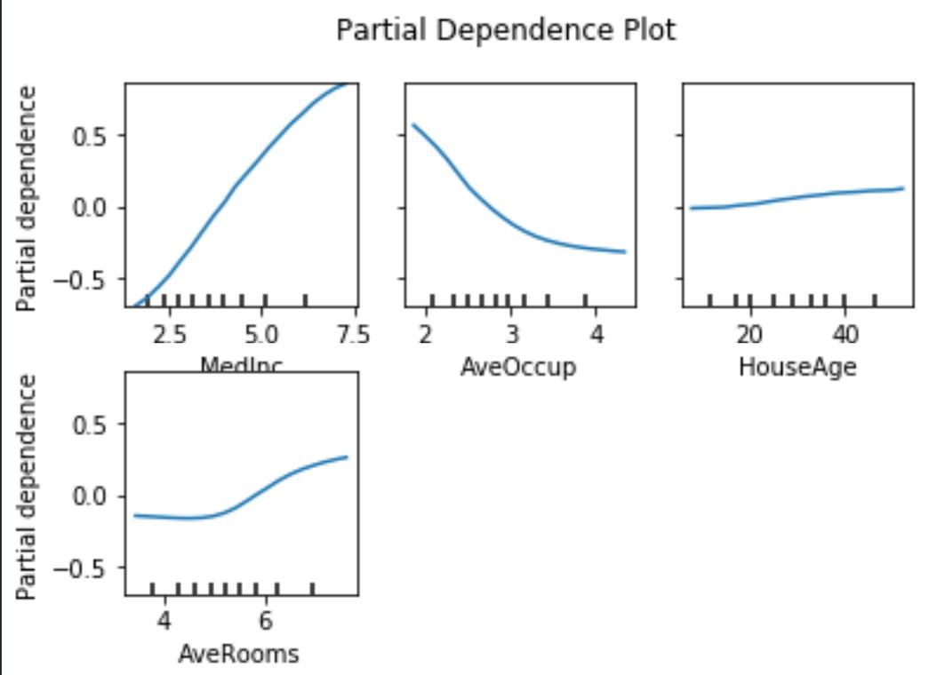

部分依赖图-两个特征
features = ['AveOccup', 'HouseAge', ('AveOccup', 'HouseAge')]
print('Computing partial dependence plots...')
tic = time()
_, ax = plt.subplots(ncols=3, figsize=(9, 4))
display = plot_partial_dependence(
est, X_train, features, kind='average', n_jobs=3, grid_resolution=20,
ax=ax,
)
print(f"done in time() - tic:.3fs")
display.figure_.suptitle(
'Partial dependence of house value on non-location features\\n'
'for the California housing dataset, with Gradient Boosting'
)
display.figure_.subplots_adjust(wspace=0.4, hspace=0.3)

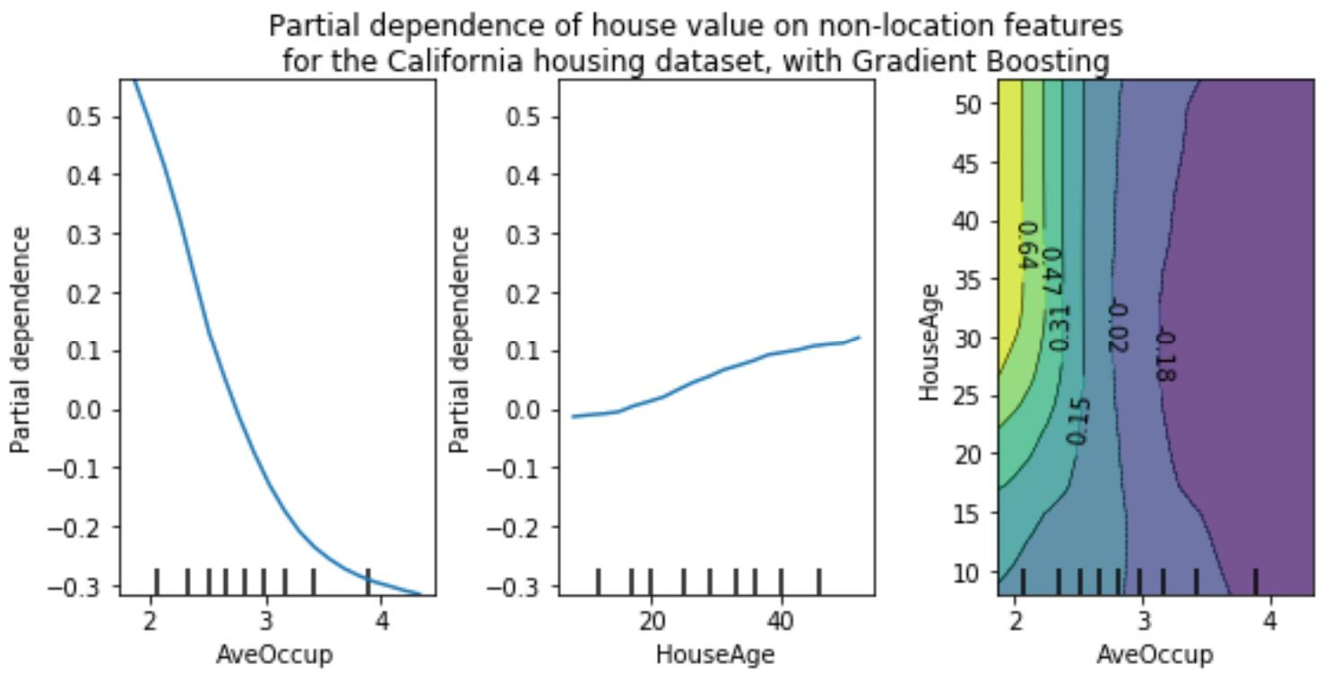

个体条件期望图（Individual Conditional Expectation Plot)
print('Computing partial dependence plots...')
tic = time()
features = ['MedInc', 'AveOccup', 'HouseAge', 'AveRooms']
display = plot_partial_dependence(
est, X_train, features, kind="individual", subsample=50,
n_jobs=3, grid_resolution=20, random_state=0
)
# average / individual

print(f"done in time() - tic:.3fs")
display.figure_.suptitle(
'Individual Conditional Expectation Plot\\n'
)
display.figure_.subplots_adjust(hspace=0.3)
