Welcome to The

Awesome Music Player

Help File

# Add a Song

1. First click the “Add a Song” button in the top right of your Awesome Music Player.

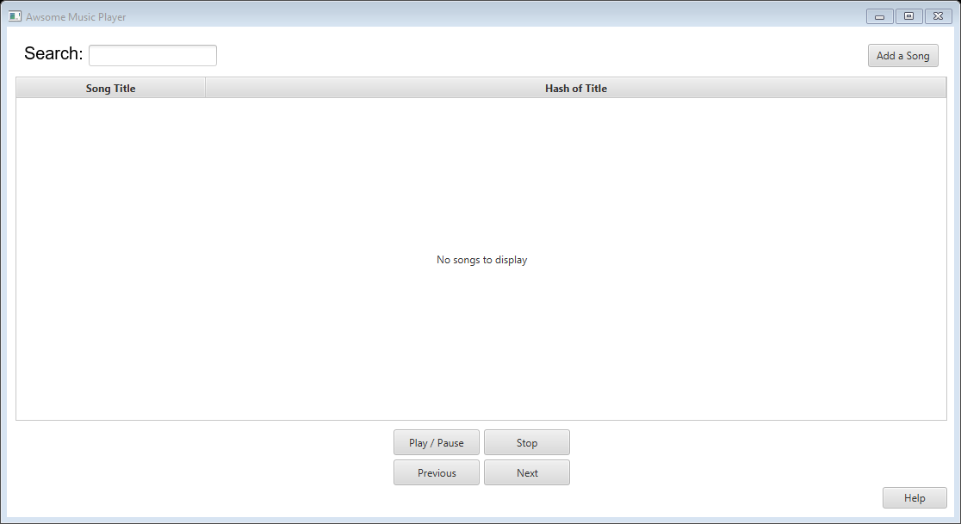

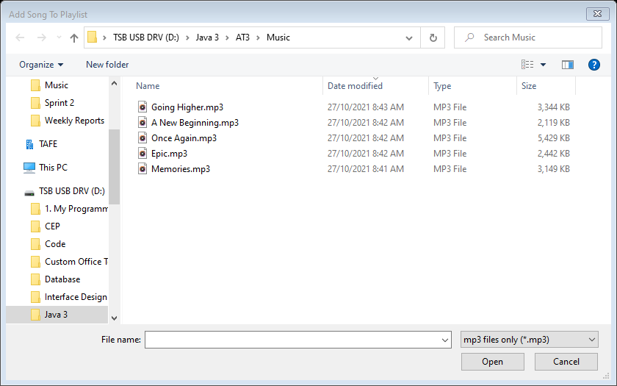

1. After the file selector has loaded navigate to your music files, select one or multiple and flick “Open”.

# Music Player Controls

The controls for your Awesome Music Player are at the bottom in the middle and work the same as any other music player you may have used before.

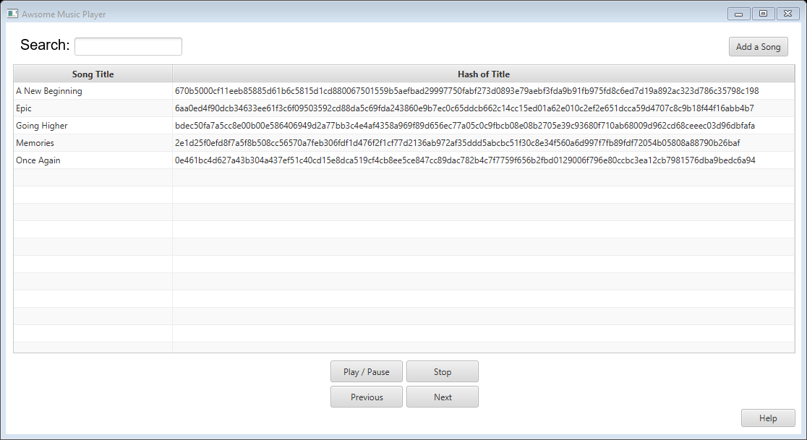

Play/Pause: Will play the first song in the list or will resume playing a previously paused song.

Stop: Will stop the music player. This will make it start from the beginning of the song list again once the play button is clicked.

Next & Previous: Next and Previous tell your Awesome Music Player to either skip to the next song or to go back to the previous one. If the current song is at the end or beginning of the list it will skip to the other end.

# Search for a Song

To search for a song, type in the full title of the song in the search box provided at the top right above the song list.



# Hash

The hash of the song title is displayed in the column next to the song title.



# Load the Help File

To load the help file click the “Help” button in the bottom right of your Awesome Music Player.

