Design Specification

Java III

Andrew Williamson / P113357

2021

Question 1

# Introduction

For this demonstration project I will be making a music player in JavaFX. My music player will include many of the same features as other music players such as the standard controls for play, pause, next, and previous. When a song is added to the list it will be automatically sorted and the sorted list will be displayed. The program will automatically save the list to a csv file which will be loaded again when the program next starts.

## UML Diagram

## Source Control

I will be using GitHub as my source control. I am using GitHub because it is an industry accepted tool that I have experience with.

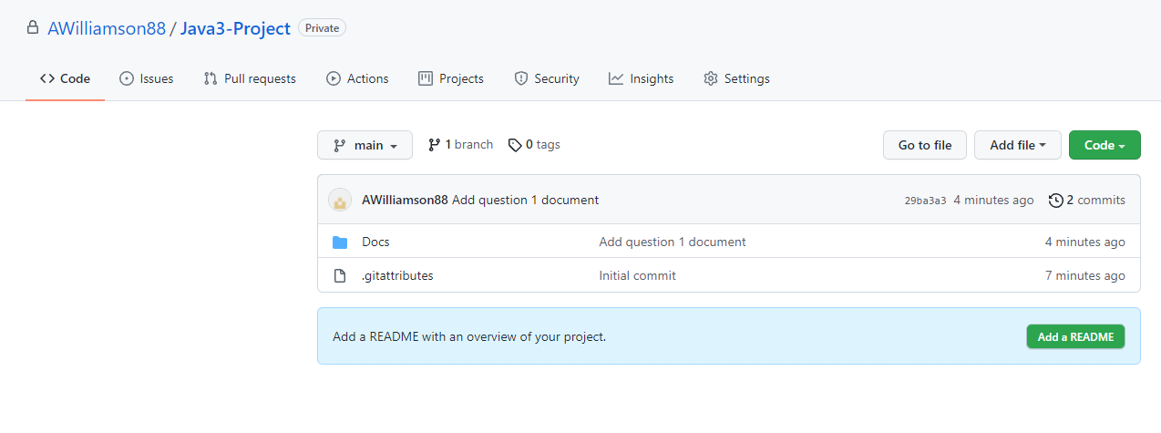

## Test Table

|  |  |  |  |
| --- | --- | --- | --- |
| Case | Data | Expected Result | Actual Result |
| 1 |  |  |  |
| 2 |  |  |  |
| 3 |  |  |  |
| 4 |  |  |  |
| 5 |  |  |  |
| 6 |  |  |  |
| 7 |  |  |  |

## Sample Unit Test

@Test

public void test_Song_Details() {

// Given

MusicPlayerController controller = new MusicPlayerController();

String songpath = “This path”;

// When

Controller.add(songpath);

// Then

assertEquals(songpath, controller.firstSong().SongPath());

}

# Question 2

## GUI Design

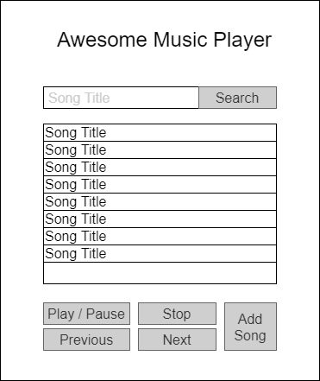

## GUI Features

* 1x Label: The title of the music player.
* 1 x Textbox: To type the title of a song you want to search for in.
* 1 x List View: To display the list of songs in.
* 6 x Buttons:
  + Search
  + Play / Pause
  + Stop
  + Previous
  + Next
  + Add Song: Loads a file dialog to select which song to add.

## Implementation Plan

Java FX using the built-in media player.

## Version Control

As above in section one.

## Test Table

|  |  |  |  |
| --- | --- | --- | --- |
| Case | Data | Expected Result | Actual Result |
| 1 | Add the first song to the list. | The song is added to the list. |  |
| 2 | Add another song to the list | The song is added and the list is sorted. |  |
| 3 | Search for a song in the list | The song is found, Highlighted in the list and starts playing. |  |
| 4 | Search for a song not in the list | The song is not found. Nothing is highlighted in the list. |  |
| 5 | Play a song. | The song is highlighted in the list and plays. |  |
| 6 | Close the program. | The track list is saved to a csv file. |  |
| 7 | Start the program. | The song list is loaded from the csv file. |  |

End of Document