Question 1

Predesign Specification

Java III

Andrew Williamson / P113357

2021

## UML Diagram

## Source Control

I will be using GitHub as my source control. I am using GitHub because it is an industry accepted tool that I have experience with.

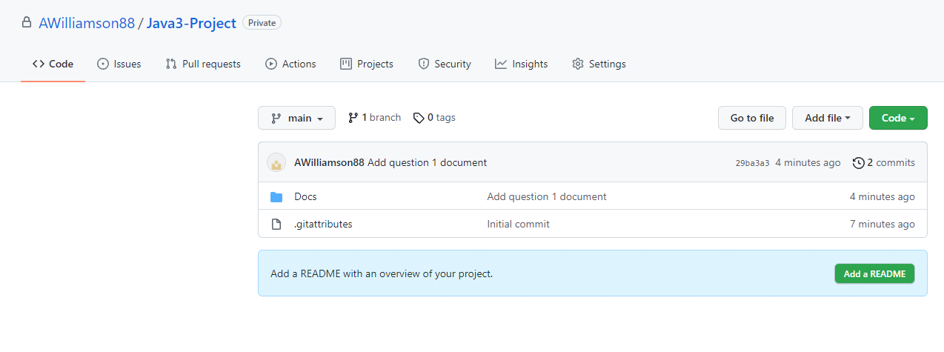

## Test Table

|  |  |  |  |
| --- | --- | --- | --- |
| Case | Data | Expected Result | Actual Result |
| 1 | Add the first song to the list. | The song is added to the list. |  |
| 2 | Add another song to the list | The song is added and the list is sorted. |  |
| 3 | Search for a song in the list | The song is found, Highlighted in the list and starts playing. |  |
| 4 | Search for a song not in the list | The song is not found. Nothing is highlighted in the list. |  |
| 5 | Play a song. | The song is highlighted in the list and plays. |  |
| 6 | Close the program. | The track list is saved to a csv file. |  |
| 7 | Start the program. | The song list is loaded from the csv file. |  |

## Sample Unit Test

@Test

public void test_Song_Details() {

// Given

MusicPlayerController controller = new MusicPlayerController();

String songpath = “This path”;

// When

Controller.add(songpath);

// Then

assertEquals(songpath, controller.firstSong().SongPath());

}

End of Document