Звіт

CPA Programing Essentials in C++

Chapter 1

1.2 - Labs (1)

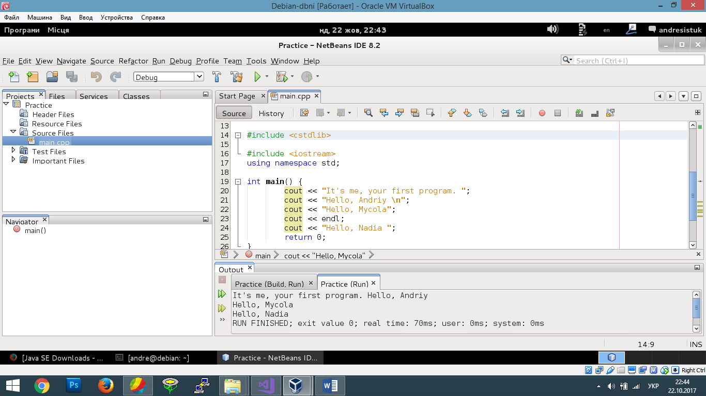

1.3 - Labs (1)

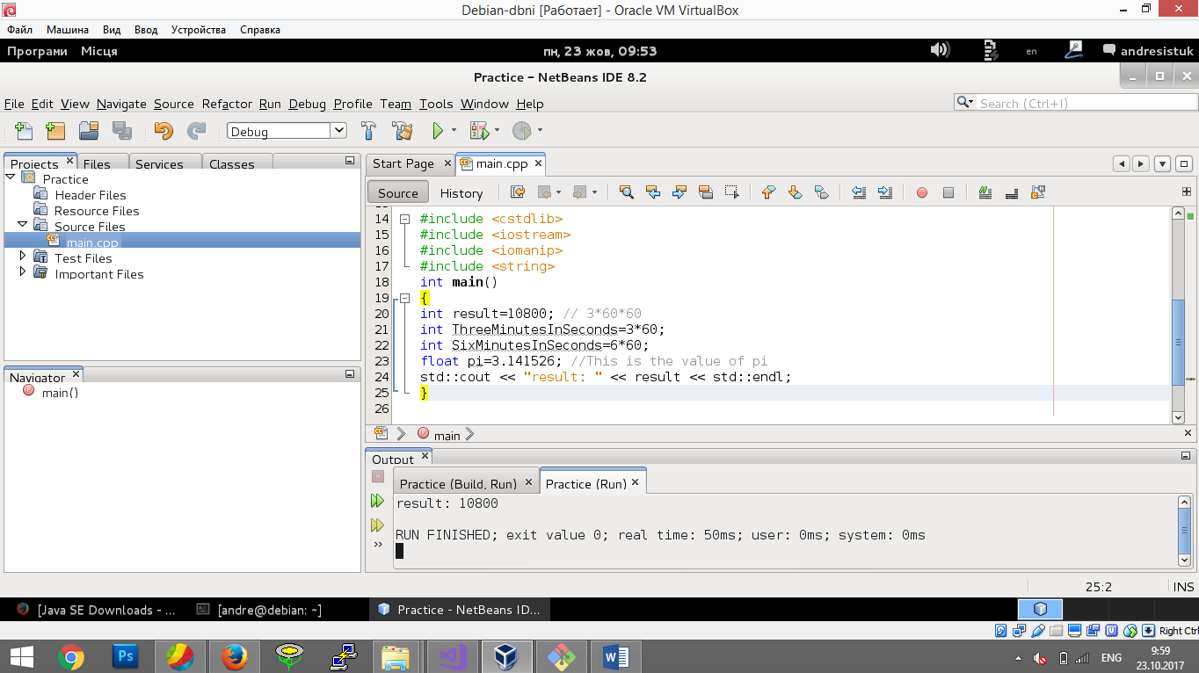

1.4 - Labs (1.4.2 (1))

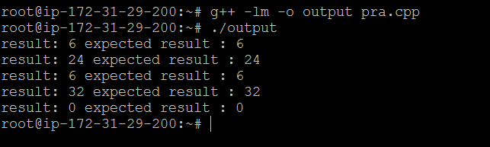

1.4 - Labs (1.4.40 (1))

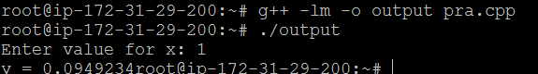

1.4 - Labs (1.4.40 (2))

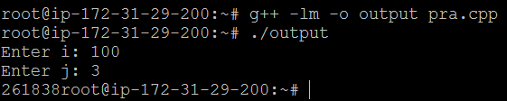

1.6 - Labs (1) 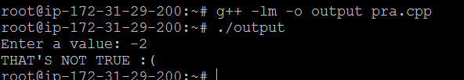

1.7.3 - Labs (1)

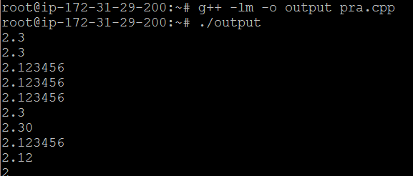

1.7.4 - Labs (2)

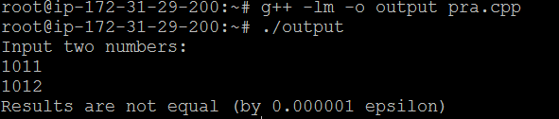

1.7.5 - Labs (3)

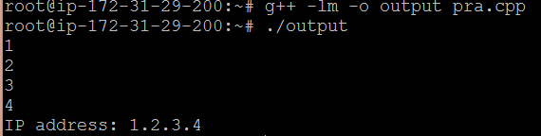

2.1.5 - Labs (1)

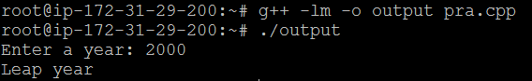

2.1.5 - Labs (2)

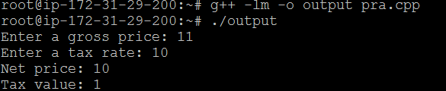

2.1.5 - Labs (3)

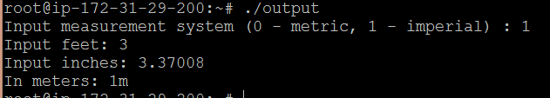

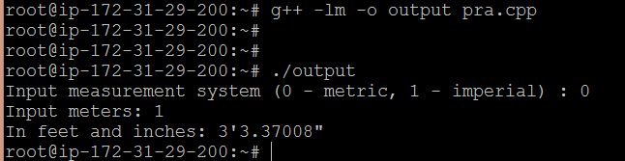

2.1.5 - Labs (4)

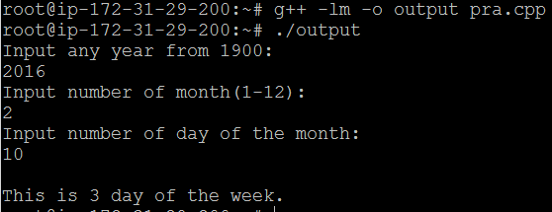

2.1.5 - Labs (5)

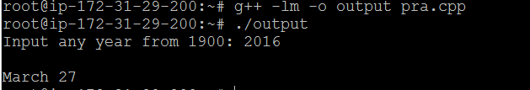

2.2.19 - Labs (1)

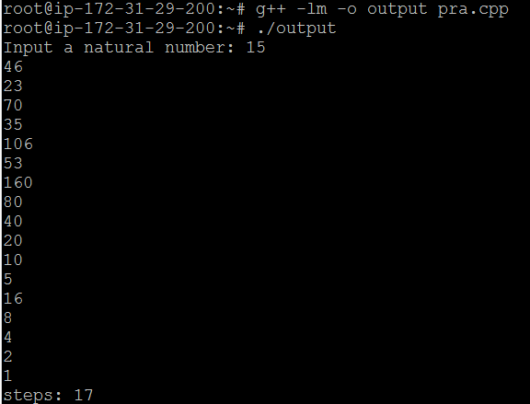

2.2.19 - Labs (2)

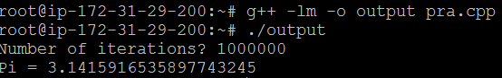

2.2.19 - Labs (3)

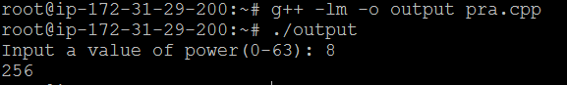

2.2.19 - Labs (4)

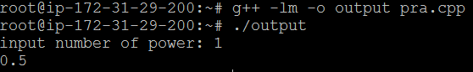

2.2.19 - Labs (5)

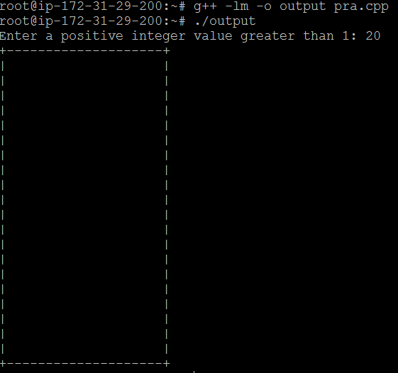

2.2.19 - Labs (6)

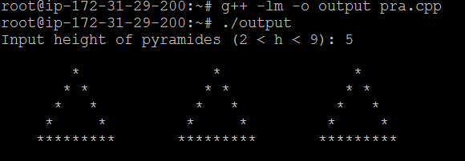

2.2.19 - Labs (7)

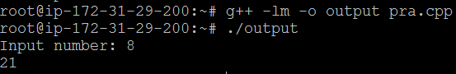

2.2.19 - Labs (8)

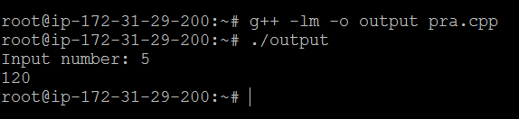

2.2.19 - Labs (9)

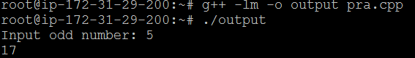

2.4.23 - Labs (1)

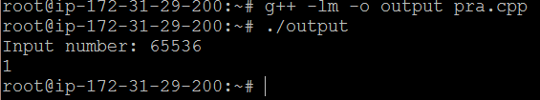

2.4.23 - Labs (2)

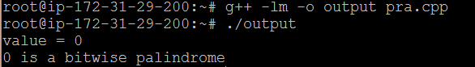

2.5.4 - Labs (1)

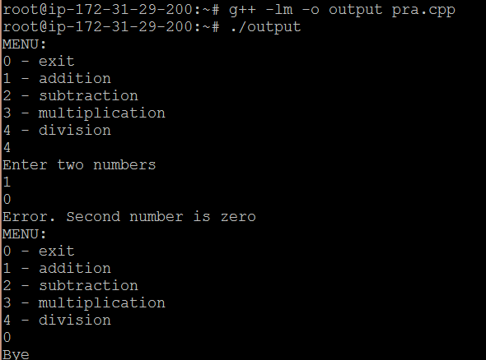

2.9.8 - Labs (1)

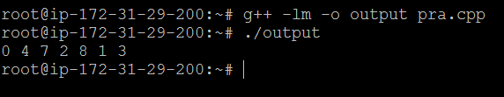

2.9.8 - Labs (2)

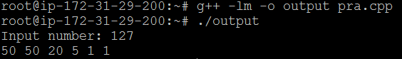

2.9.8 - Labs (3)

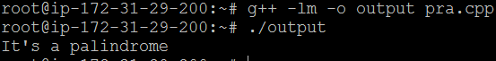

2.9.8 - Labs (4)

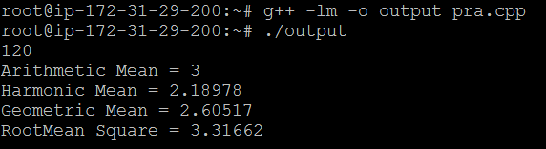

2.9.8 - Labs (5)

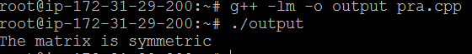

2.11.6 - Labs (1)

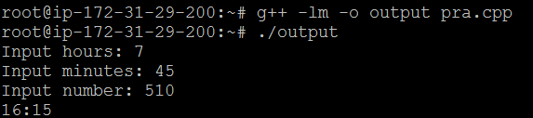

2.11.6 - Labs (2)

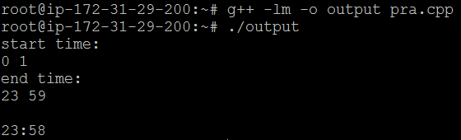

3.2.12 - Labs (1)



3.2.12 - Labs (2)

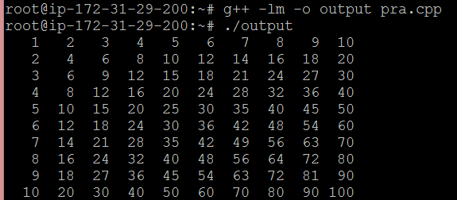

3.4.7 - Labs (1)

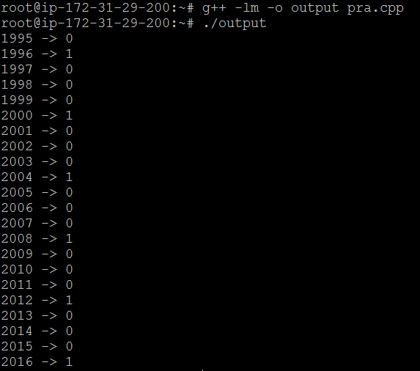

3.4.7 - Labs (2)

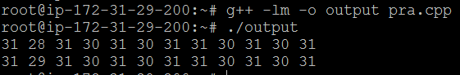

3.4.7 - Labs (3)

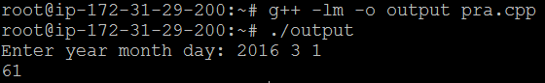

3.4.7 - Labs (4)

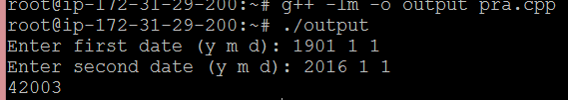

3.4.7 - Labs (5)

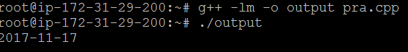

3.4.7 - Labs (6)

