Polarization Rotation of a Long-Duration Narrow-Band Pc5 Pulsation

T. Sarris^{1, 2} and A. N. Wright³

[1] {Lab. for Atmospheric and Space Physics, Univ. of Colorado, Boulder, CO}
[2] {Demokritus University of Thrace, Xanthi, Greece}
[3] {University of St. Andrews, North Haugh, St. Andrews, Fife, Scotland}
Correspondence to: T. Sarris (tsarris@ee.duth.gr)

Abstract
A rare event of a transverse, narrow-band ULF magnetospheric pulsation that lasted for five consecutive days at geosynchronous orbit was reported by Sarris et al. [2007]. In this paper we further investigate this pulsation event, focusing on its polarization signatures. By constructing hodogram plots and performing a detailed analysis of the transverse components of the pulsation, we find that during this event multiple instances of polarization rotation are observed. For one sample instance of an observed polarization rotation we estimate the observed poloidal lifetime by the time taken for the poloidal and toroidal amplitudes to become equal, which we compare with τ = λ / (dω_{Α}/dx), the theoretical approximation to the poloidal lifetime, as calculated in a box-model magnetosphere by Mann and Wright [1995]. Density measurements from the LANL spacecraft and their varying L-shell, as derived from their varying local times are used to calculate a local gradient in the local Alfvén speed, which is used in the calculation of the poloidal lifetime. In addition, density measurements from the LANL spacecraft monitoring L-shells closest to GOES-8 are used to calculate field line resonances at geosynchronous orbit, which show good agreement in frequency with the observed pulsations but also have a local time offset.

- Introduction
A dayside, narrow-band Pc5 pulsation event that was observed for five consecutive days at geosynchronous orbit over successive passages of GOES-8 satellite has been reported by Sarris et al. [2007]. The event was radially polarized, and was observed in the recovery phase after a magnetospheric storm. The frequency of the pulsation was observed to range from 5 to 9 mHz during the first day of the pulsation, with frequency being higher in the pre-noon region; on subsequent days the frequency range of the pulsation narrowed down, until it centred around 5 mHz +/- 0.5 mHz one day before diminishing. Geotail measurements in the outer magnetosphere have shown no connection to external pulsations in the solar wind. Ground magnetometers were used to study the radial extent of the pulsations and to calculate the mode number of the pulsations whenever they were observed on the ground; the mode number was found to range between 20 and 50. The local Field Line Resonance, as calculated from LANL MPA plasma density and the T96 magnetic field model, was found to be close to the observed pulsation frequency.
What was intriguing in these observations was the unprecedented duration of the pulsations, lasting for ~5 days, which indicates a continuous driver of these pulsations, operating on the dayside magnetosphere for the duration of the event. In the theoretical description of ionospheric interaction with magnetospheric pulsations, both the poloidal and toroidal wave components are expected to be heavily damped by driving Pedersen currents in the resistive ionospheric boundaries: a numerical calculation of the ionospheric damping rate of poloidal pulsations by Newton et al. (1978) gave an estimate of τ ~ 0.9-1.5 hours for the poloidal lifetime. Another energy loss mechanism that could lead to the damping of ULF pulsations is the tailward escape of fast-mode energy, following the wave guide geometry, or the process by which ULF energy is lost into the solar wind (Fujita and Glassmeier, 1995; Lee, 1996). The long duration of these pulsations indicates that a mechanism that operates continuously for five days drives the observed Pc5 pulsations.
In Sarris et al. [2007], the observations were presented without explicit reference to the exact cause of the pulsations, even though an internal driver that excites the local field line resonances was suggested. In considering potential internal generation mechanisms, the drifting of ion bunches and the corresponding diamagnetic decrease of the magnetic field, or the presence of an enhanced ring current have been associated with Pc5 ULF waves (Woch et al., 1990). As simulations and observation have shown, the free energy of particles in the tens-keV range that is associated with plasma anisotropy distorts the magnetic field, (Hasegawa, 1971; Southwood, 1974) which in turn responds by oscillating locally. This oscillation happens at the characteristic field-line resonant frequency, which is dependant on the local magnetospheric characteristics such as the field line length, magnetic field strength and local plasma density. In this paper, density observations from multiple LANL geosynchronous satellites are used to show large radial variations in density: these satellites are located at different local times and are hence monitoring different L-shells, which we use to infer a radial gradient in density.
Apart from dampening, various ways have been described by which an excited pulsation can be altered within the inner magnetosphere. One of them is through mode conversion: It has been shown by theoretical calculations (Southwood, 1974) that low-m, externally produced poloidal pulsations can resonantly drive a local field-line resonance in the inner magnetosphere, at the point where the frequency of the poloidal waves matches the local Alfvén resonance frequency (Kivelson and Southwood, 1985; Wright and Rickard, 1995; Mann and Wright, 1995). In the process the energy of the poloidal fluctuation is gradually transferred to toroidal field-line resonances. Thus it is expected that poloidal oscillations have a finite lifetime. In another numerical simulation of a box magnetosphere that were performed by Mann and Wright (1995) it has been suggested that, not only low-m compressional poloidal waves will gradually decay, being transformed to Alfvén waves, but also large-m MHD poloidal Alfvén waves excited internally in an inhomogeneous plasma will have a finite lifetime, gradually being converted to waves of toroidal polarization. Theoretical calculations by Mann and Wright (1995) in the box-model gave τ ~ 13 minutes as an estimate of the time before ideal poloidal pulsations become dominantly toroidal.

- Observations
  - Geosynchronous Magnetic Field Measurements
Geosynchronous magnetic field measurements from satellite GOES-8 (Singer et al., 1996) and the corresponding Dynamic Power Spectra (DPS) over the five-day period that the fluctuations were observed, from 24 to 29 November 1997, were presented in Sarris et al. [2007], in which intense transverse pulsations, mostly in the radial direction, were observed to last for 5 days; here in Figure 1a we present in more detail the radial component of the magnetic field data for the day that the most intense fluctuations are observed, on November 25-26, 2001. In order to separate the ULF field variations perpendicular to as well as along the magnetic field direction, the components of the magnetic field vector are projected in a Mean Field-Aligned (MFA) coordinate system. In this system, points along the average background magnetic field direction, and is obtained from a 30-minute running average of the instantaneous magnetic field direction, centred at the data point being processed; is determined by 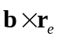, where 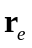 is the unit vector along the line from the earth to the instantaneous satellite position; and is obtained by 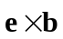, completing the orthogonal system. Thus points in the eastward direction and in the meridional direction, pointing radially outward at the magnetic equator. Waves in the , and directions are referred to as poloidal, toroidal and compressional respectively. In calculating the field components in the MFA coordinate system, in order to remove large-scale variations, a 30-minute running average acts as a detrending procedure that has the effect of subtracting periodicities with frequencies smaller than 0.55 mHz in the spectral analyses presented bellow.
In Figure 1b the Dynamic Power Spectra (DPS) of the radial component of the magnetic field data are plotted. The DPS calculations were performed by sliding a Hanning window through the data and performing a Fast Fourier Transform (FFT) on the subset of the signal within the window. For a 0.512-second sampling frequency, the Nyquist frequency (and hence the maximum frequency we can monitor in this data set) is 976 mHz; in order, however, to better display the fluctuations in the Pc5-range, only frequencies up to 20 mHz are shown in Figure 1b.
On this day pulsations were also observed on the ground, as shown in Sarris et al. [2007]; from these observations mode number m was calculated to be 20-50.

  - Geosynchronous Ion Density Measurements
Plasma density affects significantly the occurrence and frequency characteristics of magnetospheric pulsations. As described by field line resonance theory, shear Alfvén waves in the magnetosphere, whether generated externally or internally, will have predictable frequencies that depend on plasma density, magnetic field strength and on the length of field lines in the vicinity of the fluctuations. Plasma density measurements for this event were acquired by the Magnetospheric Plasma Analyzer (MPA) instruments built by the Los Alamos National Laboratory (LANL) and flown on geosynchronous satellites 1994-084, LANL-97A and 1990-095; the locations of these satellites together with the location of GOES-8 at 12:00 UT every day are marked in the left panel of Figure 2, in GSE coordinates.
Plasma number density from the LoP energy channel (energies ~1eV to 130eV) of MPA on satellites 1, 2 and 3 is plotted as a function of local time in Figure 3; we note here that cold plasma dominates total number density measurements. In this figure the vertical lines indicate local midnight crossings of the satellites. The dates marked correspond to the dates the satellites cross local noon. It can be seen that measurements between the three satellites vary significantly, with satellite LANL 1990-095 generally measuring larger densities in the noon and post-noon region; we attribute the differences in observed plasma densities to the variable L-shells the spacecrafts monitor: The different longitudes of the three spacecraft, as shown in the left panel of Figure 2, causes them to have different angles from the direction of the Earth’s dipole moment, and thus to monitor different L-shells when they cross the same local time. To demonstrate the differences in L-shell we plot in the right panel of Figure 2 the field line through each satellite location when the satellites cross local noon, in the X-Z plane, in GSE coordinates. The position of minimum-B along the traced field lines is marked with a square; geosynchronous orbit is also plotted. Field lines were traced using the T96 magnetic field model (Tsyganenko, 1995), using as input parameters the magnetospheric and solar wind conditions on November 25, the day of most intense fluctuations. These conditions on November 25 were a Dst index of -25, solar wind ram pressure of 1.3 nanoPascals, IMF B_{y} = -5 and B_{z} = 3.0.
In order to compare the local magnetic field conditions at each satellite’s location, the following parameters are listed in Table 1: columns 2 through 5 list the satellites’ name, Longitude, Magnetic Latitude and Time (UT) when they cross local noon. Column 6 lists the minimum magnetic field strength, B_{min} along each of the traced field lines (the location of B_{min} is marked with a square in the right panel of Figure 2). In this table we can see that satellite LANL 1990-095, which measures the largest densities, has the lowest B_{min} along the noon field lines, and is thus located in outer L-shells than 1 and 2. Also LANL 1990-095 is located closest to GOES-8 in longitude and in L-shell, which indicates that density measured at LANL 1990-095 more closely approximates the local plasma conditions at GOES-8 than the other LANL satellites.
In order to get an estimate of the order of magnitude of the radial gradient in density, we calculated L for the three minimum-B magnetic field values by calculating the distance from the Earth that these values are observed, based on a non-tilted T96 magnetic field model. These values are recorded in the seventh column of Table 1. On the last two columns the average density at local noon from the LANL MPA measurements and the local Alfven velocity are listed, the latter calculated from the local measured density and the calculated B_{min} strength.

Satellite | GLong | MLat | UT@  12LT | B_{min} (nT) | L | n_{i}  (cm⁻³) | υ_{A} (km/s)
GOES-8 | -74.7º | 10.5º | 17:00 | 86.4 | ??? | --- | ---
1990-095 | -37.4º | 8.7º | 14:30 | 89.8 | 7.59 | 46 | 585
LANL-97A | 70.5º | -8.4º | 05:08 | 94.6 | 7.55 | 3.8 | 1015
1994-084 | 102.9º | -10.6º | 07:18 | 91.0 | 7.38 | 2.5 | 1340

Table 1: Satellite name, Longitude, Magnetic Latitude and Time (UT) when the satellites cross local noon are listed in columns 1 through 4 respectively. The 5th column lists the minimum magnetic field strength, B_{min} along each of the traced field lines. The 6th column lists the distance of B_{min} location in a non-tilted magnetic field. The 7th column lists density measurements for the three LANL satellites on November 25 1997, averaged over a 1-hour interval around local noon. The 8th column lists the calculated local Alfvén velocity, based on local density measurements.

From the calculation of the dipole L-shells and the local density measurements, as shown in the sixth and seventh columns respectively, a sharp gradient in density can be inferred. In Section 3.3 we discuss further on the implications of density and local Alfvén speed (ninth column) variations. In the same section we also calculate the field line resonant frequencies on November 25, the day of strongest fluctuations, using density measurements from the satellite 3, which was located the closest to GOES-8; we show that the calculated field line resonant frequencies are close to the frequencies of the pulsations measured by GOES-8.

- Discussion

  - Local Density, Alfvén speed and Field Line Resonances
Plasma density can be used to calculate the local Alfvén velocity, 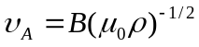, where B is the magnitude of the magnetic field in Tesla, 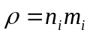 is the plasma mass density, n_{i} is the ion number density, m_{i} is the mass of H⁺ ions (all ions are assumed to be H⁺ here), and μ₀ is the magnetic permeability of space. The results from these calculations are listed above in Table 1. In these calculations a sharp gradient in the Alfvén velocity can be seen, due to the sharp gradient observed in density measurements from the three LANL satellites. The Alfvén velocity can in turn be used to calculate the local Field Line Resonant (FLR) frequency and period of the fluctuations by integration along a field line, using T = 1/f =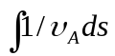. In order to calculate the local FLR frequencies at GOES-8 locations we integrated the field lines passing through GOES-8 orbit from the T96 magnetic field model and used density measurements from satellite LANL 1990-095, which traverses L-shells closest to GOES-8. As seen in Figure 2, although the three LANL satellites are located in the geographic equatorial plane, their separation in local time results in a geomagnetic latitude difference due to the tilt of the magnetic dipole of the Earth towards Greenland. This will cause the three satellites to monitor different L-shells, and thus different plasma populations. A similar effect has been reported by Onsager et al. (2004) for the GOES-8 and GOES-9 satellites. Interestingly, satellite 1990-095 which is closest to GOES-8, where the intense narrow-band pulsations are observed, also measures the highest densities of the three satellites. In calculations of the local FLR frequencies we assumed that ion number density remains constant along a field line: even though an exponential increase is expected as one gets closer to the Earth, however the inverse-relation of FLR periods to the magnetic field strength will cause the integral to diminish close to the field-line foot-points, where density increases significantly. Field lines were traced every 1 hour in local time from locations along GOES-8 orbit, and density measurements from satellite LANL 1990-095 were averaged every one hour in local time.
In Figure 1d we plot the calculated FLR frequencies for the same time interval as the magnetic field data shown in Figure 1a. From this figure it can be seen that, at the time of increased density at LANL 1990-095, the calculated FLR frequency is within the frequency range of the GOES-8 narrow-band pulsation, reinforcing the understanding that the narrow-band pulsations are FLR. A significant local time offset of about 5 hours in local time is observed between magnetic field density measurements, with LANL 1990-095 observing high densities shifted towards the afternoon regions compared to the fluctuations at GOES-8. This could be due to the separation in L-shell between the two spacecraft: In Table 1 it was discussed that GOES-8 monitors fluctuations at larger L-shells, LANL 1990-095 is located inward of GOES-8, and 1994-084 and LANL-97A, which do not measure a significant density increase, are the innermost of the four satellites. It is possible that the high density region, with which we associate the narrow-band fluctuations, has an asymmetry towards evening local times.

  - Hodograms
As discussed in Section 1, large-m MHD poloidal Alfvén waves excited internally in inhomogeneous plasma are expected to have a finite lifetime. This has been demonstrated in an MHD simulation of an idealised box-model magnetosphere by Mann and Wright (1995). In this simulation it has been shown that an initially dominantly poloidal polarization, when oscillating in an inhomogeneous plasma, asymptotically approaches a purely toroidal polarization state at a predictable time rate. Mode conversion was demonstrated in the simulation through a hodogram plot of the transverse components of the fluctuating magnetic field, showing an initially linear fluctuation in the purely poloidal direction gradually mixing with the toroidal component, shown as a circle in the hodogram, and finally being converted to purely toroidal. As noted by Mann and Wright, this would require that the poloidal waves stop being driven by the internal generation mechanism after the initial excitation. Thus if the excitation mechanism remains active it is expected that an initial linearly polarized pulsation will be succeeded by a mixed pulsation, and that the purely toroidal mode will not be observed.
In the event reported herein the pulsations last for days, much longer than the theoretically calculated dampening times; thus we find most reasonable to assume that the pulsations are continuously driven for the duration of the event. By plotting the poloidal versus the toroidal components of the magnetic field data and monitoring it for the 5-day duration of the event, several instances of the early stages of mode-conversion were observed, where an initially purely poloidal pulsation eventually becomes mode-mixed, without being converted to purely toroidal. This feature is an indication of an excitation mechanism that remains active. A plot of such an instance is given in Figure 4: in the first and second panels the poloidal and toroidal components respectively are plotted in time for one hour of day 330 (November 26). In the lower four panels, marked A through D, the toroidal component is plotted versus the poloidal for four 6-minute intervals, marked accordingly in the two upper panels. It can be seen that, following a period of small-amplitude pulsations (panel A), a ~4 nT peak-to-peak mostly poloidal pulsation is initiated (panel B). About 10 to 15 minutes later the pulsation is of equal magnitude in the poloidal and the toroidal directions, as shown in the circular hodogram in the next panel (panel C). However a purely toroidal pulsation is not observed for this time interval. In the survey performed in the whole 5-day period, most of the time the hodograms were random, showing no particular polarization pattern; however linearly polarised fluctuations were often observed, and in few instances they were followed by a clear circular hodogram, similar to panel C of Figure 4. In the whole 5-day period a complete polarization rotation was not positively identified.

  - Calculation of Model Polarization Rotation Time

- Summary and Conclusions
Plasma measurements were acquired from three LANL geosynchronous satellites; these measurements varied significantly between the three satellites, indicating a sharp radial gradient in plasma density. This is explained in terms of the variable L-shell that is traversed by the three satellites, due to their separation in longitude. Density measurements from the LANL satellite closest to GOES-8 together with the T96 magnetic field model were used to estimate the local field-line resonant frequency. Good agreement was found between the calculated resonant frequency and the observed narrow-band pulsation, even though a local time offset was also observed.
By plotting snapshots of the pulsation’s hodogram throughout the whole event several instances of polarization mixing were observed, with features similar to the initial phases of polarization rotation, i.e., an initially radially polarized pulsation was gradually mixed with the azimuthal component, becoming circularly polarized. A full polarization rotation from a purely poloidal to a purely toroidal pulsation was demonstrated through MHD simulations by Mann and Wright (1995); in the example of polarization mixing that was presented, as well as in all instances of polarization mixing observed in the 5-day period, a full rotation of the pulsations could not be distinguished. This reinforces the speculation that the poloidal pulsations are continuously generated in this event, thus not being able to asymptotically reach the purely toroidal polarization as predicted by Mann and Wright.

- Acknowledgements.
We thank Howard Singer for providing high-resolution GOES data for this event.

References
Fujita, S., and K.-H. Glassmeier (1995), Magnetospheric cavity resonance oscillations with energy flow across the magnetopause, J. Geomag. Geoelectr., 47, 1277-1292.
Kivelson, M. G., and Southwood, D. J.: Resonant ULF waves: A new interpretation, Geophys. Res. Lett., 12, 49-, 1985.
Lee, D. H. (1996), Dynamics of MHD wave propagation in the low-latitude magnetosphere, J. Geophys. Res., 101, 15371-15386.
Mann, I. R., A. N. Wright, and P. S. Cally, Coupling of magnetospheric cavity modes to field line resonances: A study of resonance widths, J. Geophys. Res., 100, 19, 441, (doi:10.1029/95JA00820), 1995.
Newton, R. S., D. J. Southwood, and W. Hughes (1978), Damping of geomagnetic pulsations by the ionosphere, Planet. Space Sci., 26, 201-209.
Onsager, T. G., A. A. Chan, Y. Fei, S. R. Elkington, J. C. Green, and H. J. Singer (2004), The radial gradient of relativistic electrons at geosynchronous orbit, J. Geophys. Res., 109, A05221, doi:10.1029/2003JA010368.
Sarris, T. E., X. Li, and H. J. Singer, A long-duration Narrow-band Pc5 Pulsation, J. Geophys. Res., submitted, 2007.
Southwood, D. J.: Some features of field line resonances in the magnetosphere, Planet. Space Sci., 22, 483–491, 1974.
Tsyganenko, N. A. (1995), Modeling the Earth’s magnetospheric magnetic field confined within a realistic magnetopause, J. Geophys. Res., 100, 5599.
Wright, A. N. and Rickard, G. J.: A numerical study of resonant absorption in a magnetohydrodynamic cavity driven by a broad- band spectrum, Astrophys. J., 444, 458–470, 1995.
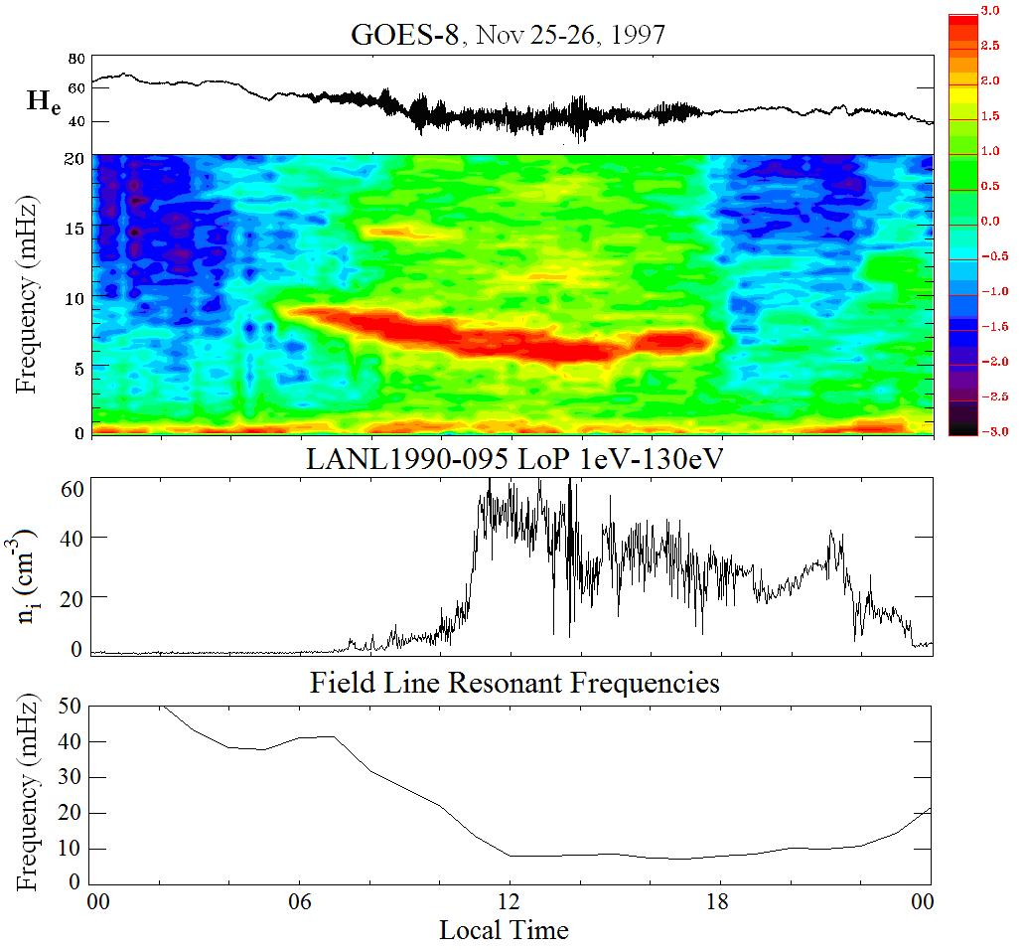
Figure 1: Panel (a.) shows the radial component of the magnetic field, H_{n}, as measured on November 25 by GOES-8; the corresponding Dynamic Power Spectra are plotted on panel (b). On the same day, density measurements at geosynchronous orbit are plotted on panel (c.), as observed by LANL 1990-095, which was close to GOES-8 in local time. Finally, panel (d.) shows the Field Line Resonant frequencies, calculated every 1 hour in local time by integrating field lines traced in the T96 magnetic field model, assuming a homogeneous density along field lines.
H_{n}
a.
b.
c.
d.

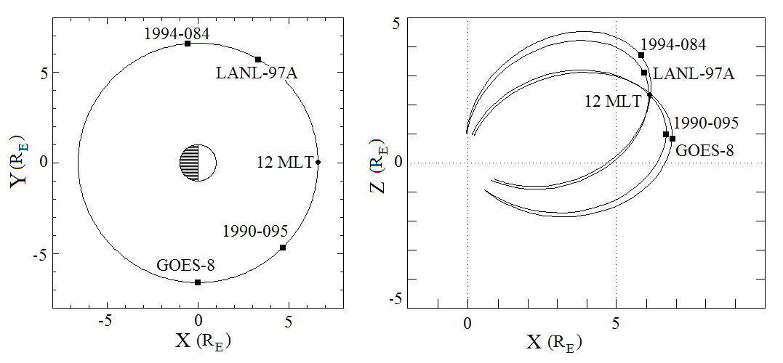

Figure 2: The local time separation of the LANL and GOES-8 geosynchronous satellites, shown in the left panel for 12:00 UT, results in variable angles from the direction of the Earth’s dipole moment, and the monitoring of variable L-shells. The field lines through the satellites when they cross local noon (marked 12 MLT) are plotted in the right panel. The location of minimum-B for each field line is marked with a black square. Minimum-B values along the field lines indicate that GOES-8 is locater farther out in L-shell, followed by 1990-095, 1994-084 and LANL-97A.

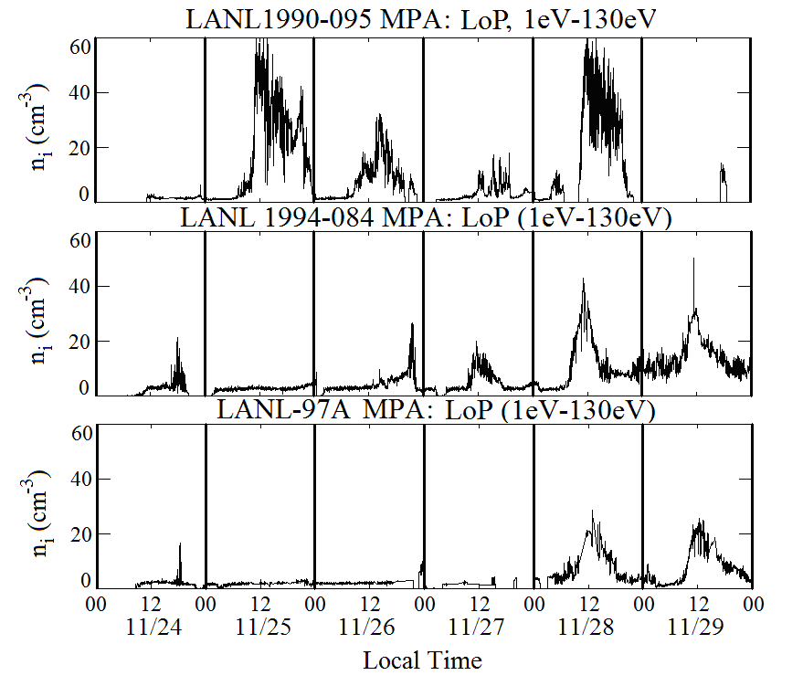
Figure 3: Plasma density (protons) from the LoP energy channel (1-130 eV) of the MPA instrument on three LANL geosynchronous satellites from November 24 to 30 1997. Satellite 1990-095 in the top panel is located on larger L-shells, and is the closest to the L-shells through GOES-8 location.

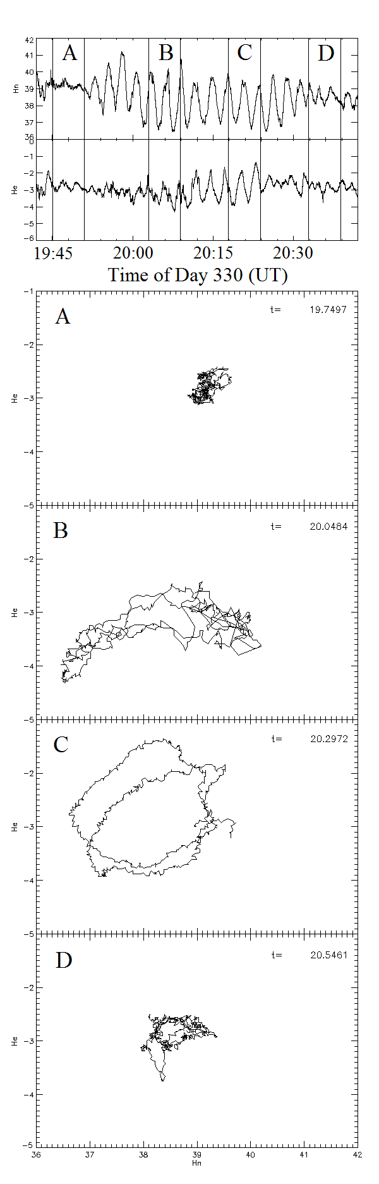
Figure 4: The poloidal and toroidal components are plotted in time for one hour of day 330 (November 26) in the first and second panels respectively. In the lower four panels, marked A through D, the toroidal component is plotted versus the poloidal for four 6-minute intervals, marked accordingly in the two upper panels. Following a period of no pulsations (panel A), a purely poloidal pulsation is initiated (panel B), followed by a circular hodogram (panel C). Mode conversion to a purely toroidal pulsation is not observed (panel D).

