**E-Commerce Prototype**

**Online Shopping**

**By**

**Abdelrahman Wael**

**Logo**

**E-Commerce Prototype**

**Logo**

**Online Shopping**

**Report**

**By**

**Abdelrahman Wael 18200018**

**Ahmed Gamal 18200080**

**Approval**

**This project has been submitted by the team to the following members, (Client Names) with the required features that has been approved by them.**

**Declaration**

**This is a certify that the project is our original work & any material reproduced in this project has been properly achieved our knowledge.**

**©2022  
Our company name  
All rights reserved**

**Abstract**

**The business-to-consumer aspect of product commerce (e-commerce) is the most visible business use of the World Wide Web. The primary goal of an e-commerce site is to sell products online.**

**This project deals with developing an e-commerce website for Online Product Sale & provides the user with a catalog of different products available for purchase in the store, to facilitate online purchase a shopping cart is provided to the user.**

**Python Django, SQLite and a web browser as the backend client. In order to develop an e-commerce website, these technologies must be studied and understood.**

**These include server and client-side scripting techniques, implementation technologies such as Django (OOP), CSS, BOOTSTRAP, HTMLS, relational databases. This is a project with the objective to develop a basic website where a consumer is provided with a shopping cart application and to know about the technologies used to develop such an application. This document will discuss each of the underlying technologies to create and implement an ecommerce website.**

**Table of contents**

**Introduction …………………………………………………………… 5**

**Project Description …………………………………………………………… 6**

**Database Design …………………………………………………………… 7**

**Web Pages details …………………………………………………………… 15**

**Admin Panel Scenario …………………………………………………………… 17**

**Conclusion ……………………………………………………………**

**Introduction**

**E-commerce is fast gaining ground as an accepted and used business enlargement. More and more business houses are implementing web sites providing functionality for performing commercial transactions over the web. It is reasonable to say that the process of shopping on the web is becoming commonplace & easier.**

**The objective of this project is to develop a general-purpose e-commerce store where any kind of product can be bought from the comfort of anywhere through the internet. However, for implementation purposes, this paper will deal with an online shopping for electronics products.**

**An online store is a virtual store on the Internet where customers can browse the catalog and select products of interest. The selected items may be collected in a shopping cart. At checkout time, the items in the shopping cart will be presented as an order. At that time, more information will be needed to complete the transaction. Usually, the customer will be asked to fill or select a billing address, a shipping address, a shipping option, and pay Cash on Delivery. An e-mail notification is sent to the customer as soon as the user is signed up & order placed.**

**Project Description**

* **Any member can register and view active products in stock.**
* **Only registered member can purchase multiple products regardless of quantity.**
* **Contact Us page is available to contact Admin for queries.**
* **There are four roles available:**

1. **Visitor**
   1. **Visitor can view products.**
   2. **Visitor can search available Products**
2. **User**
   1. **User can view and buy products.**
3. **Admin.**
   1. **An Admin has some extra privilege including all privilege of visitor and user.**
      * **Admin can add products, edit product information and add/remove product.**
      * **Admin can add user, edit user information, and can remove user.**
      * **Admin can ship order to user based on order placed by sending confirmation email.**

**Design & Development environment**

* **HTML5**
* **CSS3**
* **Ajax**
* **JavaScript**
* **Django**
* **SQLite**

**Database Design**

**We use built in SQLite Django, with the ability to enlarge the database system with MySQL. We will describe the function of each table below.**

**Database Table:**

**This is our database table for our e-commerce website. We use 7 tables with the ability to create group for a specific employee in the organization, such as sales & operators. We will describe the table details above the database details page.**

1. **Categories Table:**

**We should add categories in our project to have the ability to add products.**

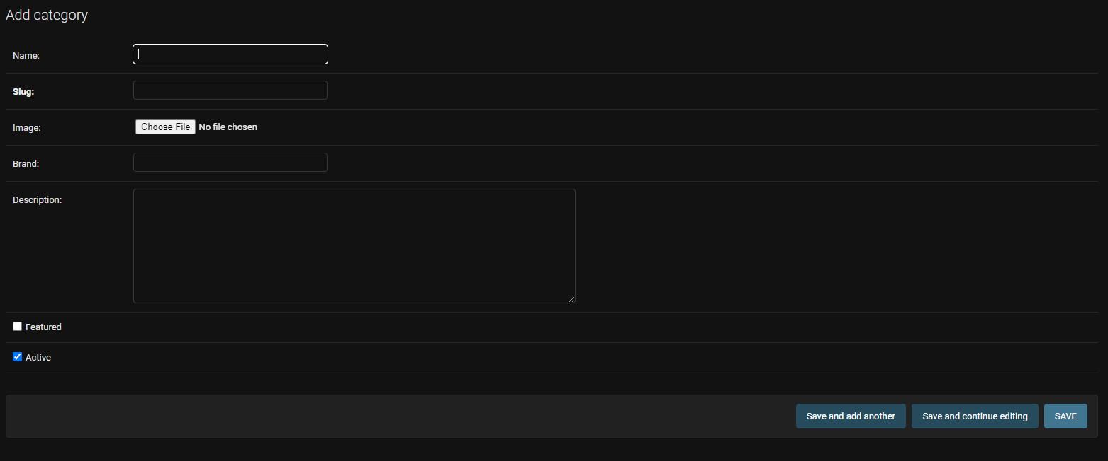

* **ID: This field is unique & generated automatically once you add a category**
* **Name: Category name goes here**
* **Slug: This field is unique & generated automatically once you add a category**
* **Image: Category Image display goes here**
* **Description: Category’s description goes here**
* **Featured: If the category is featured check the box, to appear in the featured section on the web**
* **Active: If the category is active for selling check the box**

1. **Products Table:**

**After adding category, you can a new product.**

* **ID: This field is unique & generated automatically once you add a Product.**
* **Name: Product’s name goes here.**
* **Slug: This field is unique & generated automatically once you add a Product.**
* **Image: Category Image display goes here.**
* **Brand: Brand’s name goes here.**
* **Description: Product’s description goes here.**
* **Price: The selling price goes here.**
* **Category: category’s name goes here linked with the category added in categories table.**
* **Old price: if you want to add an offer, write the old price of the product (make sure that the old price is higher than the current price).**
* **Active: If the Product is active for selling check the box.**
* **Top selling: If the product is from your top selling check the box.**
* **New products: If the product is recently new check the box.**
* **Stock: insert the number of pieces you have for this product.**

1. **Promo Code Table:**

**You can add a Promo code here for discounts.**

Figure Promo

* **ID: This field is unique & generated automatically once you add a Promo code.**
* **Code: code goes here (the Promo code that will be entered to apply a discount).**
* **Percentage: the percentage of the discount that you offer.**
* **Active: If the Promo code is active check the box.**

1. **Carts**

**Every user has one cart to handle his orders, generated automatically once he registered.**

* **ID: This field is unique & generated automatically once you registered & your cart is added.**
* **Total Price: Total Price exist in the cart of the user (didn’t order yet)**

**Note: Cart items are included in the cart table which each product item added by the user will be stored in his cart**

1. **Cart Items**

* **ID: This field is unique & generated automatically once you added a cart item.**
* **User: this field is connected to the user profile via the email address.**
* **Order ID: this field connects to the order id once the user checked out the order.**
* **Ordered: once the user ordered the order the check box became true.**
* **Shipped: if the order is shipped to the user check the box.**
* **Paid: if the order item is paid by the user check the box.**
* **Product: the item name & id that is ordered by the user.**
* **Price: the price of the single unit of the product.**
* **Quantity: the number of quantities from the product.**
* **Total order item price: the total price of the single product by its quantity.**
* **Delete: if you want to delete the cart item check the box then click save.**

1. **Orders**

**Orders table will include all the orders confirmed by the users & waiting for the admin action**

Figure Overall Table

Figure Order Table

* **ID: This field is unique & generated automatically once the user add an order.**
* **Promo Code: if your user added a Promo code its name will be added here**
* **Delivered: if the order is delivered to the user check the box**
* **Paid: if the order is paid by the user check the box.**
* **Comment: if the user added a comment will appear here (also if the admin wants to add a comment its possible & won’t be seen by the user)**
* **Total Price: the total order price with the delivery fees**
* **Cart: the user cart is linked with the email address to the order to revise the order’s data**

**In the overall table the user data will appear including his name, phone number & the date he submitted the order.**

**Web Pages details**

1. **Register page**
2. **Sign In page**
3. **Logout page**
4. **Email Confirmation page**
5. **Reset password page**
6. **Home page**
7. **Store page**
8. **Category page**
9. **Main Category page**
10. **Product Details page**
11. **Checkout page**
12. **Thank you page**

**Flexible to design more pages I under the client conditions.**

1. **Home Page**

**Home Page**

1. **Store Page**

**All Products exist here**

1. **Category Page**

1. **Product Details Page**

1. **Check out page**

1. **Logout page**

1. **Register Page**

1. **Login Page**

**Admin Panel Scenario:**

**Firstly: add “*admin*” to the domain name in the URL, for example:**

**https://”domain_name”.com/admin/**

**then add your admin credentials given by us to access to the dashboard.**

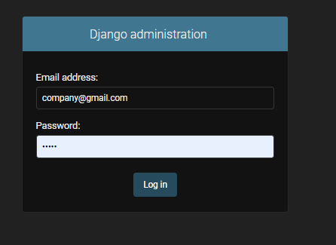

**Secondly: after you access the dashboard you will be able to see page like this:**

**This will give you a full access to all features in the system, the next steps will explain every table in the admin panel view.**

1. **Profile**

**This view will be an example for the view you have.**

**In Profile table you will be able to see all the users on your system, the customers, the sales if exist & any user registered to your system, controlling all his data, viewing editing & deleting.**

**You will be able to give permissions & know every user role in the system.**

**2- Categories**

**In this table you will be able to add all the categories you serve in your website, in order to add a new product, it will be preferred if you add for it a category to be organized better in your system & be reachable to the customer.**

**When you press “add new category” on the right top of the dashboard this screen will appear to you, you will be able to add the name, image, brand & say that if your category is active for your customers or not.**

**3- Products**

**After adding the categories, now you can view, edit & delete in the products table, you can watch every single product from the all overview or in details if you select any product and this window will appear for you:**

**You can also press “add product” button from the top right of the website & this window will appear to you.**

**You can add product name, image, brand name, description, price, select category name from category table, add offer if it exist and choose if it’s active or not.**

**On selecting top selling or new products, it will appear in the website in the new products section & top selling section on the user view in the website.**

**3- Promo code**

**In this table you will be able to add Promo codes to your ordering system in the website, as it will offer your users offers on the total order they created in their cart. If you press “add Promocode” button on the right top of the screen you will be able to add new Promocode & see this window**

**You can add the promocode name, the offer percentage & select if it’s active of not.**

**5- Order**

**Mapping:**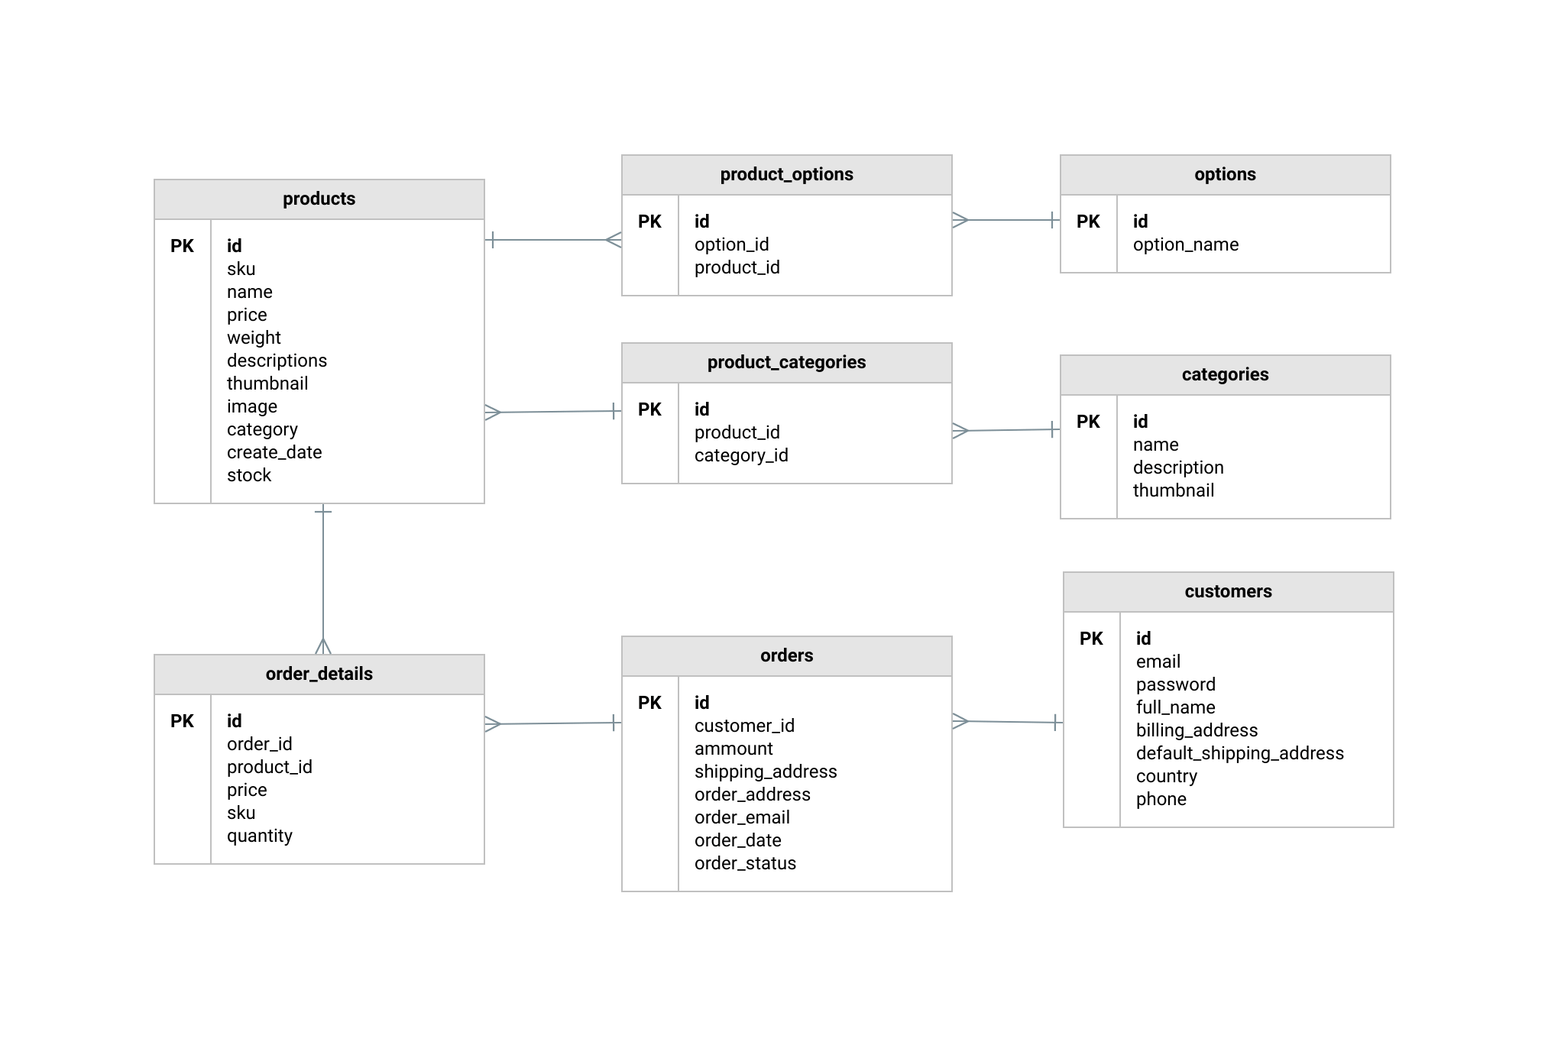

**ERD:**

**Normalization:**

**1NF: First Normal Form**

* **we didn’t need to add first normal form to the system because the database tables are added by the user manually from the dashboard, as we add conditions to the forms not to add values which don’t have a meaning in the system, as we tried to add the fields automatically as possible such as in the slug in the products table.**

**2NF: Second Normal Form**

* **From the rules of the 2nd normal form in the database is to be in the 1st normal form, so it’s not added in the system, also we fix it automatically in the system, which to validate the data in the database the id which is a primary key is added automatically after submitting all data correctly.**