iBeaconSDK说明文档

- 导入iBeaconSDK,添加librariy.
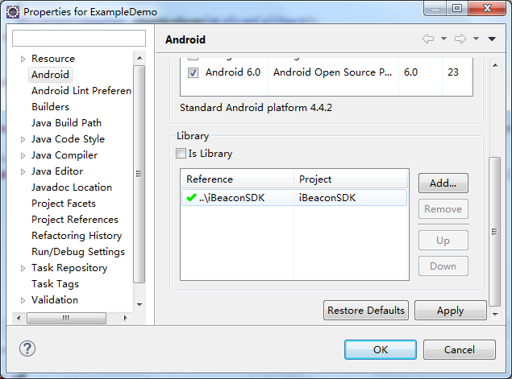
- 添加权限和服务.
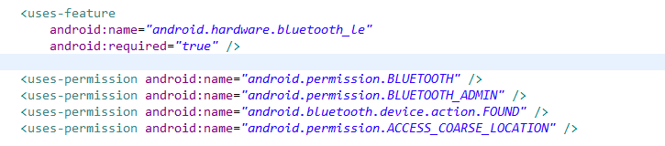
- 判断设备是否支持低功耗蓝牙，并请求打开蓝牙.
if (!getPackageManager().hasSystemFeature(PackageManager.FEATURE_BLUETOOTH_LE)) {
Toast.makeText(this, "ble_not_supported", Toast.LENGTH_SHORT).show();
finish();
}
BluetoothManager bluetoothManager = (BluetoothManager) getSystemService(Context.BLUETOOTH_SERVICE);
mBluetoothAdapter = bluetoothManager.getAdapter();
if (mBluetoothAdapter != null && !mBluetoothAdapter.isEnabled()) {
mBluetoothAdapter.enable();
}
- 获取蓝牙处理对象，在扫描回调中用来处理数据.
private iBeaconClass iBeaconClass;
iBeaconClass = com.axaet.ibeacon.beans.iBeaconClass.getInstance();
- 在扫描回调中，处理数据，获取iBeacon.
BluetoothAdapter.LeScanCallback mLeScanCallback = new BluetoothAdapter.LeScanCallback() {
@Override
public void onLeScan(final BluetoothDevice device, int rssi, byte[] scanRecord) {
if (device != null && rssi != 127) {
iBeacon beacon = iBeaconClass.formToiBeacon(device, rssi, scanRecord);
deviceAdpter.addData(beacon);
}
}
};
- 进行修改前,我们需要绑定服务和注册广播.
registerReceiver(mGattUpdateReceiver, makeGattUpdateIntentFilter());
Intent gattServiceIntent = new Intent(this, BluetoothLeService.class);
bindService(gattServiceIntent, mServiceConnection, BIND_AUTO_CREATE);
/**
* broadcast action
*/
IntentFilter makeGattUpdateIntentFilter() {
final IntentFilter intentFilter = new IntentFilter();
intentFilter.addAction(BluetoothLeService.ACTION_GATT_CONNECTED);
intentFilter.addAction(BluetoothLeService.ACTION_GATT_DISCONNECTED);
intentFilter.addAction(BluetoothLeService.ACTION_DATA_ONGETUUID);
intentFilter.addAction(BluetoothLeService.ACTION_DATA_ONGETOTHER);
intentFilter.addAction(BluetoothLeService.ACTION_DATA_ONGETTH);
intentFilter.addAction(BluetoothLeService.ACTION_DATA_ONSEND);
intentFilter.addAction(BluetoothLeService.ACTION_PASSWORD_SUCCESS);
intentFilter.addAction(BluetoothLeService.ACTION_PASSWORD_ERROR);
return intentFilter;
}
ServiceConnection mServiceConnection = new ServiceConnection() {
@Override
public void onServiceConnected(ComponentName componentName, IBinder service) {
mBluetoothLeService = ((BluetoothLeService.LocalBinder) service).getService();
// After binding service, start the connection device
mBluetoothLeService.connect(address);
}

@Override
public void onServiceDisconnected(ComponentName componentName) {
mBluetoothLeService = null;
}
};

- 连接成功后,我们会在mGattUpdateReceiver中接收到不同的action.
BroadcastReceiver mGattUpdateReceiver = new BroadcastReceiver() {
@Override
public void onReceive(Context arg0, Intent intent) {
String action = intent.getAction();
if (BluetoothLeService.ACTION_GATT_CONNECTED.equals(action)) {
// Connect to a successful
} else if (BluetoothLeService.ACTION_GATT_DISCONNECTED.equals(action)) {
// Connection failed or disconnected
} else if (BluetoothLeService.ACTION_DATA_ONGETUUID.equals(action)) {
// After the connection, by enabling the notification to get to
// the UUID
textUuid.setText(intent.getStringExtra(BluetoothLeService.UUID_DATA));
} else if (BluetoothLeService.ACTION_DATA_ONGETOTHER.equals(action)) {
// After the connection, by enabling the notification to get to
// the majro,minor,period,txpower
}
// If your product does not have the temperature and humidity, it
// will not receive the broadcast.
else if (BluetoothLeService.ACTION_DATA_ONGETTH.equals(action)) {
intent.getIntExtra(BluetoothLeService.TEMPERATURE_DATA, -1);
intent.getIntExtra(BluetoothLeService.HUMIDITY_DATA, -1);
} else if (BluetoothLeService.ACTION_PASSWORD_SUCCESS.equals(action)) {
// Password correct, to modify the parameters
} else if (BluetoothLeService.ACTION_PASSWORD_ERROR.equals(action)) {
// Password error
Toast.makeText(ModifyBeaconActivity.this, "Password error", Toast.LENGTH_SHORT).show();
} else if (BluetoothLeService.ACTION_DATA_ONSEND.equals(action)) {
// Write data to the success of the callback, you can view which
// data is written to success
Log.i("yushu", Conversion.bytesToHexString(intent.getByteArrayExtra(BluetoothLeService.EXTRA_DATA)));
}
}
};
- 在进行修改前，我们需要对修改的数据进行判断，是否符合要求，其中txpower的值在4、0、-6、-23中选择其一.
if (TextUtils.isEmpty(password) || password.length() != 6) {
Toast.makeText(this, "Password length must be 6 characters",
Toast.LENGTH_SHORT).show();
return;
}
if (TextUtils.isEmpty(uuid) || uuid.length() != 32) {
Toast.makeText(this, "uuid length must be 32 characters",
Toast.LENGTH_SHORT).show();
return;
}

if (major > 65535 || major < 0) {
Toast.makeText(this, "0<=major<=65535", Toast.LENGTH_SHORT).show();
return;
}
if (minor > 65535 || minor < 0) {
Toast.makeText(this, "0<=minor<=65535", Toast.LENGTH_SHORT).show();
return;
}
if (period < 100 || period > 9800) {
Toast.makeText(this, "100<=minor<=9800", Toast.LENGTH_SHORT).show();
return;
}
- 在发送数据之前，我们需要验证密码，验证后，我们会在mGattUpdateReceiver中接收到action为BluetoothLeService.ACTION_PASSWORD_SUCCESS或者BluetoothLeService.ACTION_PASSWORD_ERROR,只有接收到BluetoothLeService.ACTION_PASSWORD_SUCCESS时，我们才能进行修改数据.
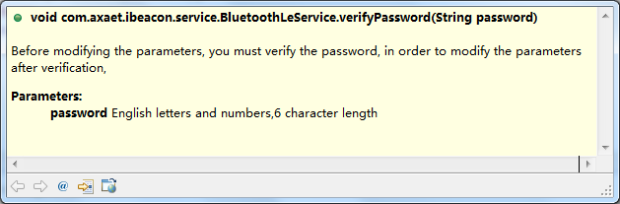
- 密码验证成功后，我们可以进行修改数据，每发送一条命令，需要延时一段时间，再发送其他命令，时间长度不一,需要测试,否则修改不成功.
- 修改UUID,方法,参数要求如下图：
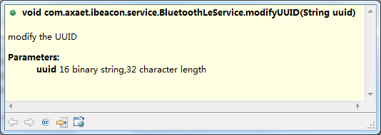
- 修改major,minor, period, txPower等参数, 方法,参数要求如下图：
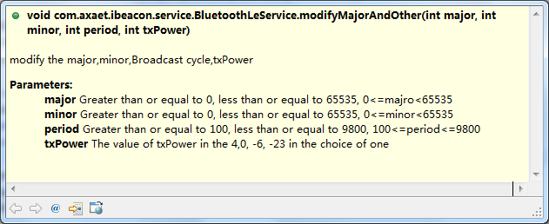

- 修改设备名称, 方法,参数要求如下图：
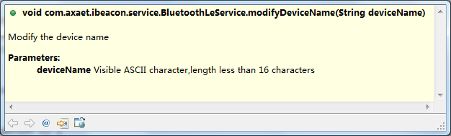
- 修改设备密码, 方法,参数要求如下图：
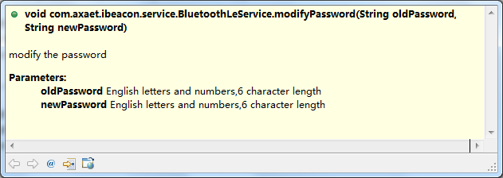
- 所有参数修改完毕后,我们需要关闭设备，这样才能修改成功.
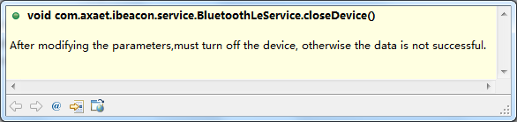
提醒：如果有什么不清楚的，可以查看我们的例子

