Dual Axis Solar Tracking System Using Arduino
PROJECT REPORT
Submitted to:
JAIN (Deemed-to-be University), Bangalore, Karnataka
In partial fulfilment of the University Regulations for the Degree
BACHELOR OF SCIENCE IN PHYSICAL SCIENCE
By
ASHUTOSH. K
(USN: 19BSR17017)
Guide:
Dr. MALATESH AKKUR,
Associate Professor,
Department of Electronics and Renewable Energy
School of Sciences

JUNE-2022

DECLARATION

I ASHUTOSH. K , hereby declare that this project named Dual Axis Solar Tracking System Using Arduino is an original and bonafide work carried out by me under the able guidance of Dr. Malatesh Akkur.

I further declare that this mini project report is not submitted to any other University/College for the award of any degree or diploma.

Signature of the student with date

(ASHUTOSH. K) (19BSR17017)
Place: Bengaluru

ACKNOWLEDGEMENT

I would like to take this opportunity to express my gratitude and appreciation to JAIN (Deemed-to-be University) for having deputed me for this assignment. I want to express my heartfelt gratitude to Dr. Asha Rajiv, Director, School of Sciences, JAIN (Deemed-to-be University) for giving me this opportunity to work on my project.
My sincere thanks also goes to Dr. Malatesh Akkur, Associate Professor, Department of Electronics and Renewable energy, for his constant guidance and encouragement.
I am also thankful to Prof. Manjunatha P S, Associate Professor and HOD, Department of Electronics and Renewable Energy, for his encouragement and guidance.

A special gratitude goes to Assistant Prof. Waheeb Wakeel of life sciences who also helped me to gain valuable insights leading to the successful completion of my project. I am extremely grateful to Dr. Malatesh Akkur and Mr. Waheeb Wakeel for providing necessary resources with my project. I also thank to lab assistant Mr. Ramu for his help in providing lab equipment’s.

__________________________

ASHUTOSH. K
(19BSR17017)
SL NO | TOPIC | Page No.
1 | ABSTRACT AND INTRODUCTION | 5-6
2 | BLOCK DIAGRAM AND SOLAR PANEL | 6-7
3 | TECHNOLOGY USED:  ADURINO  LDR  POWER SUPPLY  STEPPER MOTOR  SERVO MOTOR | 7-10
4 | GEAR AND WORKING | 10-12
5 | PROJECT SIMULATION | 12
6 | FLOW CHART OF THE SYSTEM | 12-13
7 | BLOCK DIAGRAM DESCRIPTION | 14-16
8 | HARDWARE IMPLEMENTATION | 17
9 | Interfacing Dual Axis Solar Tracker Arduino Project Using LDR & Servo Motors | 17-18
10 | Programming Arduino for Dual Axis Solar Tracker Project: | 18-21
11 | FINAL PROGRAM CODE | 21-24
12 | ADVANTAGES, DISADVANTAGES AND APPLICATIONS | 25-26
13 | WORKING AND FUTURE SCOPE | 26-27
14 | CONCLUSION | 28
15 | REFERENCES | 29
TABLE OF CONTENTS

Dual Axis Solar Tracking System Using Arduino

Abstract: -- The goal of this thesis was to develop a laboratory prototype of a solar tracking system, which is able to enhance the performance of the photovoltaic modules in a solar energy system. The operating principle of the device is to keep the photovoltaic modules constantly aligned with the sunbeams, which maximises the exposure of solar panel to the Sun’s radiation. As a result, more output power can be produced by the solar panel. The work of the project included hardware design and implementation, together with software programming for the microcontroller unit of the solar tracker. The system utilised an ATmega328P microcontroller to control motion of two servo motors, which rotate solar panel in two axes. The amount of rotation was determined by the microcontroller, based on inputs retrieved from four photo sensors located next to solar panel. At the end of the project, a functional solar tracking system was designed and implemented. It was able to keep the solar panel aligned with the sun, or any light source repetitively. Design of the solar tracker from this project is also a reference and a starting point for the development of more advanced systems in the future.
Keywords— Solar Panel, Arduino, Single Axis Motor, Power Supply, Stepper Motor, Display.

INTRODUCTION:
With the unavoidable shortage of fossil fuel sources in the future, renewable types of energy have become a topic of interest for researchers, technicians, investors and decision makers all around the world. New types of energy that are getting attention include hydroelectricity, bioenergy, solar, wind and geothermal energy, tidal power and wave power. Because of their renewability, they are considered as favourable replacements for fossil fuel sources. Among those types of energy, solar photovoltaic (PV) energy is one of the most available resources. This technology has been adopted more widely for residential use nowadays, thanks to research and development activities to improve solar cells’ performance and lower the cost. According to International Energy Agency (IEA), worldwide PV capacity has grown at 49% per year on average since early 2000s. Solar PV energy is highly expected to become a major source of power in the future. However, despite the advantages, solar PV energy is still far from replacing traditional sources on the market. It is still a challenge to maximise power output of PV systems in areas that don’t receive a large amount of solar radiation. We still need more advanced technologies from manufacturers to improve the capability of PV materials, but improvement of system design and module construction is a feasible approach to make solar PV power more efficient, thus being a reliable choice for customers. Aiming for that purpose, this project had been carried out to support the development of such promising technology. One of the main methods of increasing efficiency is to maximise the duration of exposure to the Sun. Tracking systems help achieve this by keeping PV solar panels aligned at the appropriate angle with the sun rays at any time. The goal of this project is to build a prototype of light tracking system at smaller scale, but the design can be applied for any solar energy system in practice. It is also expected from this project a quantitative measurement of how well tracking system performs compared to system with fixed mounting method.

BLOCK DIAGRAM:

SOLAR PANEL:
A photovoltaic module is a packaged, connect assembly of typically 6x10 photovoltaic solar cells. Photovoltaic modules constitute the photovoltaic array of a photovoltaic system that generates and supplies solar electricity in commercial and residential applications. Each module is rated by its DC output power under standard test conditions, and typically ranges from 100 to 365 Watts (W). The efficiency of a module determines the area of a module given the same rated output – an 8% efficient 230 W module will have twice the area of a 16% efficient 230 W module. There are a few commercially available solar modules that exceed efficiency of 22% and reportedly also exceeding 24%. A single solar module can produce only a limited amount of power; most installations contain multiple modules. A photovoltaic system typically includes an array of photovoltaic modules, an inverter, and a battery pack for storage, interconnection wiring, and optionally a solar tracking mechanism.
The most common application of solar panels is solar water heating systems.
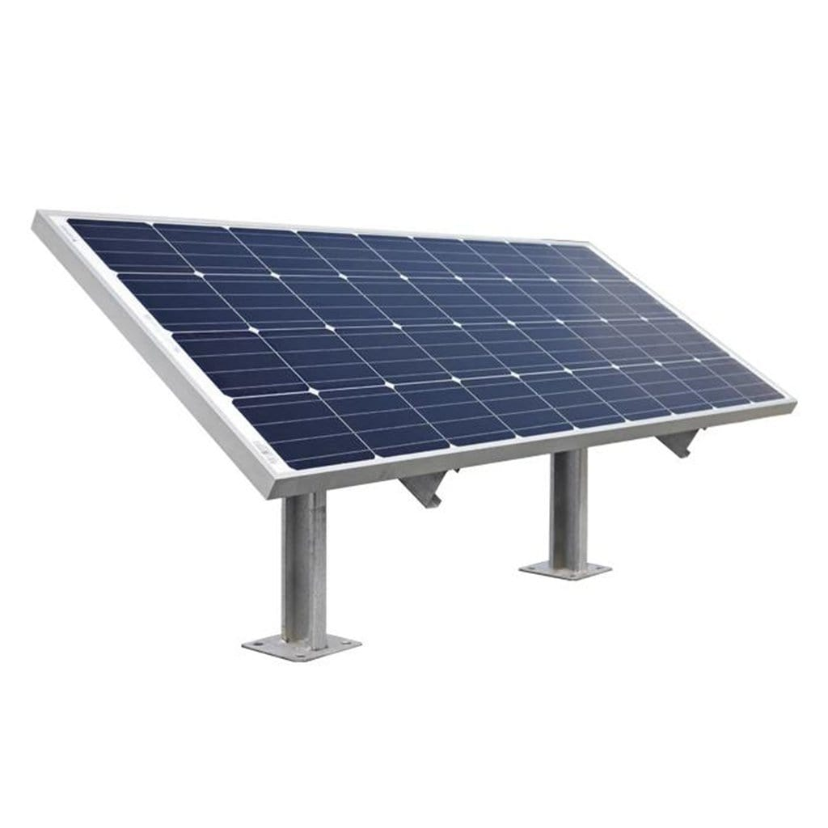

TECHNOLOGY USED:
Arduino: -- The Arduino Uno is a microcontroller board based on the ATmega328. Arduino is an open-source, prototyping platform and its simplicity makes it ideal for hobbyists to use as well as professionals. The Arduino Uno has 14 digital input/output pins (of which 6 can be used as PWM outputs), 6 analogue inputs, a 16 MHz crystal oscillator, a USB connection, a power jack, an ICSP header, and a reset button. It contains everything needed to support the microcontroller; simply connect it to a computer with a USB cable or power it with an AC-to-DC adapter or battery to get started.
The Arduino Uno differs from all preceding boards in that it does not use the FTDI USB-to-serial driver chip. Instead, it features the Atmega8U2 microcontroller chip programmed as a USB-to-serial converter.
"Uno" means one in Italian and is named to mark the upcoming release of Arduino 1.0. The Arduino Uno and version 1.0 will be the reference versions of Arduino, moving forward. The Uno is the latest in a series of USB Arduino boards, and the reference model for the Arduino platform.
The name Arduino comes from a bar in Ivrea, Italy, where some of the founders of the project used to meet. The bar was named after Arduino of Ivrea, who was the margrave of the March of Ivrea and King of Italy from 1002 to 1014.

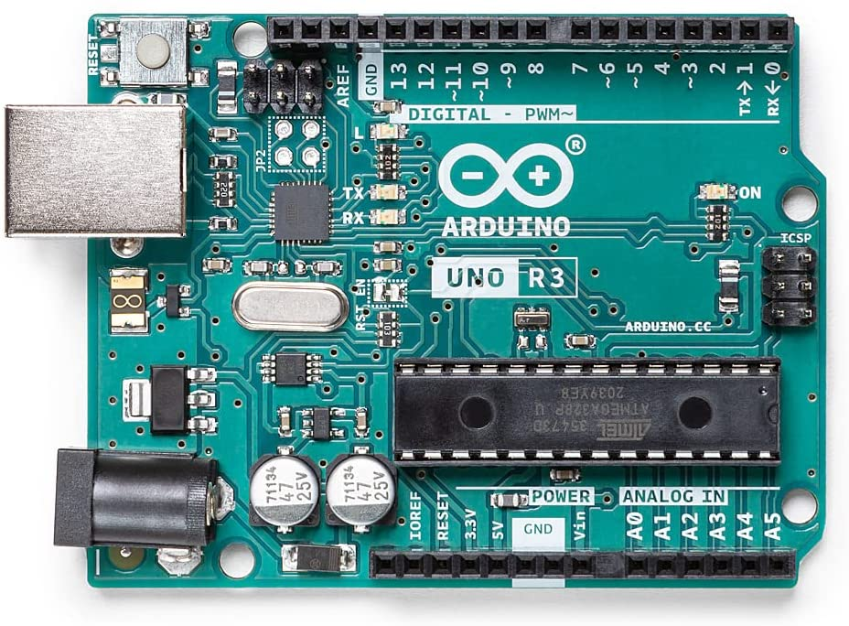

LDR:

• It is a photo-resistor is a device whose resistivity is a function of the incident electromagnetic radiation. Hence, they are light sensitive devices. They are also called as photo conductors, photo conductive cells or simply photocells.
• They are made up of semiconductor materials having high resistance.
• LDR works on the principle of photo conductivity.
Photo conductivity is an optical phenomenon in which the material’s conductivity is increased when light is absorbed by the material.
The most common type of LDR has a resistance that falls with an increase in the light intensity falling upon the device (as shown in the image above). The resistance of an LDR may typically have the following resistances:
Daylight = 5000Ω
Dark = 20000000Ω
Therefore, it is seen that there is a large variation between these figures. If this variation is plotted on a graph, something similar to the figure given below can be seen.

POWER SUPPLY:
A power supply is an electronic device that supplies electric energy to an electrical load. The primary function of a power supply is to convert one form of electrical energy to another. As a result, power supplies are sometimes referred to as electric power converters.

STEPPER MOTOR:
A stepper motor or stepping motor is a dc brushless electric motor that divide a full rotation into a display device is an output device for presentation of information in visual or tactile form. When the input information is supplied has an electrical signal, the display is called an electronic display number of equal step. The motor’s position can then be commanded to move and hold at one of these steps without any position sensor for feedback as long as the motor is carefully sized to the application in respect to torque and speed.
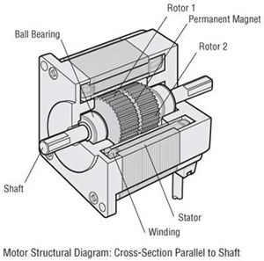

Servo Motor: A Servo motor is a linear or rotary actuator that provides fast precision position control for closed-loop control applications. Unlike large industrial motors, a servo motor is not used for continuous energy conversion. The motor’s speed is proportional to the difference between actual position and desired position. So if the motor is near the desired position it will turn slowly, otherwise it will turn fast. This is called proportional control.
Here in digital control, microprocessor or microcontroller are used for generating the PWM pulses in terms of duty cycles to produce more accurate control signals. The feedback signal corresponding to the present position of the load is obtained by using a position sensor. This sensor is normally a potentiometer that produces the voltage corresponding to the absolute angle of the motor shaft through gear mechanism. Then the feedback voltage value is applied at the input of error amplifier or comparator.

GEAR: A toothed wheel that works with others to alter the relation between the speed of a driving mechanism (such as the engine of a vehicle) and the speed of the driven parts (the wheels).
What do gears do... and how do they do it?
Gears are used for transmitting power from one part of a machine to another. In a bicycle, for example, its gears (with the help of a chain) that take power from the pedals to the back wheel. Similarly, in a car, gears transmit power from the crankshaft (the rotating axle that takes power from the engine) to the driveshaft running under the car that ultimately powers the wheels.
Increase speed: If we connect two gears together and the first one has more teeth than the second one (generally that means it's a bigger-sized wheel), the second one has to turn round much faster to keep up. So this arrangement means the second wheel turns faster than the first one but with less force.

Increase force: If the second wheel in a pair of gears has more teeth than the first one (that is, if it's a larger wheel), it turns slower than the first one but with more force.

Change direction: When two gears mesh together, the second one always turns in the opposite direction. So if the first one turns clockwise, the second one must turn counter clockwise. We can also use specially shaped gears to make the power of a machine turn through an angle. In a car, for example, the differential (a gearbox in the middle of the rear axle of a rear wheel drive car) uses a cone-shaped bevel gear to turn the driveshaft's power through 90 degrees and turn the back wheels.

Four different ways to use gears:
Gears for speed: In this simple gearbox, we got (from right to left) a large gear wheel with 40 teeth, a medium wheel with 20 teeth, and a small wheel with 10 teeth. When we turn the large wheel round once, the medium wheel has to turn twice to keep up. Similarly, when the medium wheel turns once, the small wheel has to turn twice to keep up. So, when we turn the large gear wheel on the right, the small wheel on the left turns four times faster but with one quarter as much turning force. This gearbox is designed for increasing speed.

Gears for force: If we power the same gearbox in the opposite direction, by turning the small wheel, I'll make the large wheel spin a quarter as fast but with four times as much force. That's useful if I need to make a heavy truck go up a hill, for example.

Worm gears: Here we use an electric motor (the gray box on the right) and a long screw-like gear to drive a large gear wheel. This arrangement is called a worm gear. It reduces the speed of the motor to make the large wheel turn with more force, but it's also useful for changing the direction of rotation in gear driven machinery.

Rack and pinion gears: We've probably seen one of these in cliff- and hill-climbing rack railroads, but they're also used in car steering systems, weighing, and many other kinds of machines as well. In a rack and pinion gear, a slowly spinning gear wheel (the pinion) meshes with a flat ridged bar (the rack). If the rack is fixed in place, the gear wheel is forced to move along it (as in a railroad). If the gear is fixed, the pinion shifts instead. That's what happens in car steering: we turn the steering wheel (connected to a pinion) and it makes a rack shift from side to side to swivel the car's front wheels to the left or the right. In simple weighing scales, when you load a weight on the pan at the top, it pushes a rack straight downward, causing a pinion to rotate. The pinion is attached to a pointer that rotates as well, showing the weight on the dial.

Project Simulation:
Here, we will show you a complete overview of this project. Later on, we will discuss its wiring system. But, now we will stimulate this project
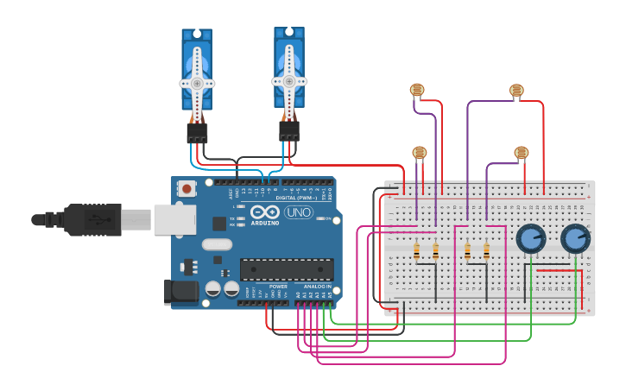
When we power on the Arduino all the sensors and servo motors are into the actions. As you can see the above image. Usually, when we increase the light intensity on the LDR Sensor, the signal is sent to the Arduino. And hence it guides the two servo motors to better place the solar panel. To increase its efficiency. Actually, you can see here as we increase or decrease the light intensity the Servo Motors are into their actions.
Using these two potentiometers you can control the speed of Servo Motors as well.
Flow Chart of the System: The system tracks the Sun autonomously in azimuth and elevation angles. The whole working algorithms are summed up in the flowcharts shown in the below Chart. The sunlight intensity from four different directions is measured by the LDR-based sensing circuit. The voltages VTL, VTR, VBL, and VBR are defined as the sensing voltages produced by the top left, top right, bottom left and bottom right LDRs respectively. In an attempt to draw maximum power from the PV panel, the azimuth and elevation tracking processes can simultaneously proceed until the PV panel is aligned orthogonally to the sunlight. The tracker installation is not restricted to the geographical location. Algorithm for Motor Control The algorithm gives a description of the general steps undertaken for the project:
- There is an input of voltage from the two pairs of LDRs.
2. The inputs are analogue. They are converted to digital values.
3. The two digital values are compared and the differences between them are obtained.
4. The difference between the values obtained is the error proportional angle for the rotation of the servo motor.
5. If the LDR voltages are the same, the servo motors stop. Otherwise, the servo motor rotates until the difference becomes the same.

BLOCK DIAGRAM DESCRIPTION: The main aim of the proposed system is to develop a cost effective instrument using an Arduino Microcontroller based solar tracking system using Bluetooth module for detection of voltage and getting the result in android app. Block diagram of complete system is shown below which consists of power supply, Arduino Uno, LDR sensor, servo motor, and solar panel.

- HC-05 Bluetooth to Serial Port Module: The HC05 Bluetooth Module can be used in a Master or Slave configuration, making it a great solution for wireless communication. It can be used simply for a serial port replacement to establish connection between MCU and GPS, PC to embedded project. The HC05 module has 6 pins Vcc, GND, Tx, Rx, Key and LED. It comes preprogramed as a slave, so there is no need to connect the key pin, unless it is needed to be changed to master mode. The major difference between Master and Slave modes is that, in Slave mode the Bluetooth module cannot initiate a connection; it can however accept incoming connections.

Table of: Pin Description of HC05 Bluetooth Module
PIN NO. | CONFIGURATION
Pin 1 | STATE: NC (No Connection)
Pin 2 | Rx: Tx of Microcontroller
Pin 3 | Tx: Rx of Microcontroller
Pin 4 | GND: Ground
Pin 5 | VCC: +5V
Pin 6 | EN: NC (No Connection)
After the connection is established the Bluetooth module can transmit and receive data regardless of the mode it is running in. If we use mobile phone to connect to the Bluetooth module, we can simply use it in the Slave mode. . The module has a factory set pin of “1234” which is used while pairing the module to a phone. The HC-05 module can build a connection to the other modules.
- Over view of Arduino: Arduino is an open-source electronics prototyping platform, mostly based on small, easy-to-use hardware and software. It can affect devices, like lights, motors and other actuators by receiving input from sensor. All the action performed by Arduino is programmed to the microcontroller on the board via Arduino programming language and the Arduino development environment. Arduino projects can be standalone or communicate with other software applications running on a computer and other types of hardware.
The Arduino Uno board as shown below with the table that shows the specifications of Arduino Uno microcontroller board.

Table.2: Arduino Uno specifications
Microcontroller | ATmega328
Operating Voltage | 5V
Supply Voltage (recommended) | 7-12V
Maximum supply Voltage (not recommended) | 20V
Digital I/O Pins | 14(of which 6 provide PWM output)
Analog Input Pins | 6
DC Current per I/O Pin | 40mA
DC Current for 3.3V Pin | 50mA
Flash Memory | 32KB of which 0.5KB used by boot loader
SRAM | 2KB
EEPROM | 1KB
Clock Speed | 16MHz
HARDWARE IMPLEMENTATION: Complete system assembly of Solar is shown in Fig.1and 2. The system consists of Power supply unit for whole system, Arduino UNO board, HC05 Bluetooth module, two servo motors, solar panel, four LDR sensors fixed on solar panel and voltage divider circuitry.
Figure.2: Complete Hardware assembly
Figure.2: Hardware Assembly with Bluetooth Module

Interfacing Dual Axis Solar Tracker Arduino Project Using LDR & Servo Motors:

- Connect 5volt pin from the Arduino to the Lower horizontal row of the breadboard.
- Similarly, connect the GND pin from the Arduino to a second lower horizontal row of the breadboard.
- Extend the 5 volt and GND Rows to the upper horizontal rows of the breadboard respectively.
- Now connect the power pins of both vertical and horizontal servo motor to the 5 volts.
- Similarly, Connect the GND pin of the Both Horizontal and Vertical Servo motor to the Ground.
- Now, connect the Signal pin of the Vertical Servo Motor to the Digital Pin No. 10 of the Arduino.
- Again, connect the Signal pin of the horizontal Servo Motor to the Digital Pin No. 9 of the Arduino.
- Connect one terminal of both potentiometers to the Ground and Other end terminals of both potentiometer to the VCC 5 volt.
- Now, connect all LDRs one terminal to the 5 volt and other terminals to the Ground Through 10k-ohm resistors.
- Let’s connect the wiper pin of the potentiometer-1 one to the Analog Pin A4 and A5 to another wiper pin of Potentiometer-2.
- Connect bottom left LDR voltage Divider point to A1 pin of Arduino.
- Again, Connect Top Left LDR voltage Divider Point to A0 pin of the Arduino.
- Similarly, Top Right LDR Voltage Divider Point to the A2 pin.
- Finally, Connect the Bottom Right Voltage Divider Point of LDR to the A3 pin of the Arduino.

Programming Arduino for Dual Axis Solar Tracker Project:
#Include is used to include a servo header library file.
#include <Servo.h>
Configuration for Horizontal servo.
The Servo Horizontal is set to 180 degrees.
Servo Horizontal Limit When Signal is High is set to 175 degrees.
Again, Servo Horizontal Limit when Signal value is low is set to 5 degrees.

Servo horizontal; // horizontal servo
int servoh = 180;
int servohLimitHigh = 175;
int servohLimitLow = 5;
// 65 degrees MAX
This is the Servo Configuration for Vertical
The Servo Vertical is set to 45 degrees.
Servo Vertical Limit When Signal is High is set to 60 degrees.
Also, Servo Vertical Limit when Signal value is low is set to 1 degree.

Servo vertical; // vertical servo
int servov = 45;
int servovLimitHigh = 60;

int servovLimitLow = 1;

LDR Pin Connections
ldrlt is for Top Left
ldrrt is for Top Right
ldrld is for Down Left
ldrrd is for Down Right

// LDR pin connections
// name = analogpin;
int ldrlt = A0; //LDR top left - BOTTOM LEFT <--- BDG
int ldrrt = A3; //LDR top rigt - BOTTOM RIGHT
int ldrld = A1; //LDR down left - TOP LEFT

int ldrrd = A3; //ldr down rigt - TOP RIGHT

On void setup, we have attached the vertical and horizontal servo signal pin. And the servo rotation for the horizontal is set to 180 degrees. And similarly, the vertical servo is set to 45 degrees. We have also set a delay of 2.5 seconds.

void setup(){
horizontal.attach(9);
vertical.attach(10);
horizontal.write(180);
vertical.write(45);
delay(2500);

}

In the Void loop() Function, we read the value for the analog pin of the Arduino connected to LDRs. and then calculate the average of vertical and horizontal.

void loop() {
int lt = analogRead(ldrlt); // top left
int rt = analogRead(ldrrt); // top right
int ld = analogRead(ldrld); // down left
int rd = analogRead(ldrrd); // down right
int dtime = 10; int tol = 90; // dtime=diffirence time, tol=toleransi
int avt = (lt + rt) / 2; // average value top
int avd = (ld + rd) / 2; // average value down
int avl = (lt + ld) / 2; // average value left
int avr = (rt + rd) / 2; // average value right
int dvert = avt - avd; // check the diffirence of up and down

int dhoriz = avl - avr;// check the diffirence og left and right

IF and IF-ELSE statements are defined to loop the program and calculate the average values of the respective LDR’s. Finally, this code helps to change the degree of the servo motor. So that it can be more effective.

if (-1*tol > dvert || dvert > tol)
{
if (avt > avd)
{
servov = ++servov;
if (servov > servovLimitHigh)
{servov = servovLimitHigh;}
}
else if (avt < avd)
{servov= --servov;
if (servov < servovLimitLow)
{ servov = servovLimitLow;}
}
vertical.write(servov);
}
if (-1*tol > dhoriz || dhoriz > tol) // check if the diffirence is in the tolerance else change horizontal angle
{
if (avl > avr)
{
servoh = --servoh;
if (servoh < servohLimitLow)
{
servoh = servohLimitLow;
}
}
else if (avl < avr)
{
servoh = ++servoh;
if (servoh > servohLimitHigh)
{
servoh = servohLimitHigh;
}
}
else if (avl = avr)
{
delay(5000);
}
horizontal.write(servoh);

}

At last, we have added the delay of (dtime).

delay(dtime);
}

Now, compile the program and upload it to your Arduino board.

Final Program code/sketch:
#include <Servo.h>

Servo horizontal; // horizontal servo
int servoh = 180;
int servohLimitHigh = 175;
int servohLimitLow = 5;
// 65 degrees MAX

Servo vertical; // vertical servo
int servov = 45;
int servovLimitHigh = 60;
int servovLimitLow = 1;

// LDR pin connections
// name = analogpin;
int ldrlt = A0; //LDR top left - BOTTOM LEFT <--- BDG
int ldrrt = A3; //LDR top rigt - BOTTOM RIGHT
int ldrld = A1; //LDR down left - TOP LEFT
int ldrrd = A3; //ldr down rigt - TOP RIGHT

void setup(){
horizontal.attach(9);
vertical.attach(10);
horizontal.write(180);
vertical.write(45);
delay(2500);
}
void loop() {
int lt = analogRead(ldrlt); // top left
int rt = analogRead(ldrrt); // top right
int ld = analogRead(ldrld); // down left
int rd = analogRead(ldrrd); // down right
int dtime = 10; int tol = 90; // dtime=diffirence time, tol=toleransi
int avt = (lt + rt) / 2; // average value top
int avd = (ld + rd) / 2; // average value down
int avl = (lt + ld) / 2; // average value left
int avr = (rt + rd) / 2; // average value right
int dvert = avt - avd; // check the diffirence of up and down
int dhoriz = avl - avr;// check the diffirence og left and right

if (-1*tol > dvert || dvert > tol)
{
if (avt > avd)
{
servov = ++servov;
if (servov > servovLimitHigh)
{servov = servovLimitHigh;}
}
else if (avt < avd)
{servov= --servov;
if (servov < servovLimitLow)
{ servov = servovLimitLow;}
}
vertical.write(servov);
}
if (-1*tol > dhoriz || dhoriz > tol) // check if the diffirence is in the tolerance else change horizontal angle
{
if (avl > avr)
{
servoh = --servoh;
if (servoh < servohLimitLow)
{
servoh = servohLimitLow;
}
}
else if (avl < avr)
{
servoh = ++servoh;
if (servoh > servohLimitHigh)
{
servoh = servohLimitHigh;
}
}
else if (avl = avr)
{
delay(5000);
}
horizontal.write(servoh);
}

delay(dtime);

}

ADVANTAGE:

• Trackers generate more electricity than their stationary counterparts due to increased direct exposure to solar rays.
•Solar trackers generate more electricity in roughly the same amount of space needed for fixed-tilt systems, making them ideal for optimizing land usage.
• Advancement in technology and reliability in electronics and mechanics have drastically reduced long ter0m maintenance concerns for tracking systems
• Solar cells are free of any noise. On the other hand, various machines used for pumping oil or for power generation are noisy.
•Once solar cells have been installed and running, minimal maintenance is required. Some solar panels have no moving parts, making them to last even longer with no maintenance.

DISADVANTAGE:

•Solar trackers are slightly more expensive that their stationary counterparts, due to the more complex technology and moving parts necessary for their operation.

• Trackers are a more complex system than fixed racking.

• Single-axis tracker projects also require an additional focus on company stability and bankability.

• Solar panels can be costly to install resulting in a time lag of many years for savings on energy bills to match initial investments.
• Generation of electricity from solar is dependent on the country’s exposure to sunlight. That means some countries are slightly disadvantaged.

APPLICATION:

• Solar Photovoltaic plants require continuous orientation towards sun for consistent efficiency output. This product will prove a great boon for them.

•Solar water heating applications can also implement the same technique to heat water throughout the day.

• Concentrated applications like concentrated photovoltaic panels require a high degree of accuracy to ensure the sunlight is directed precisely at the focal point of the reflector or lens.

• Non concentrating applications do not require tracking but using a tracker can improve the total power produced by the system.

• Photovoltaic systems using high efficiency panels with trackers can be very effective.

WORKING:

 There are two light sensing modules. One for East and the other for West.
 Both the sensors send digital information about presence and absence of light intensity to the Micro controller.
 The micro controller decides the output signals for the motor driver so as to drive the motor in CW or ACW direction.
 The motor driver module receives the signals from the micro controller and drives the motor in the specified direction with the specified speed.
 The motor in turn controls the orientation of the solar panel mounting structure. Thus maintaining constant exposure to sunlight throughout the day.

FUTURE SCOPE:
As the proposed prototype is a miniature of main system, it has some limitations which can be mitigated through future developments. A small cardboard is rotated in the system and 12v solar panel is used for analysis.
As a miniature system, it works out well. Larger Solar panel must be integrated with the system to prepare better result and cost analysis. It has been proven through our research and statistical analysis that solar tracking system with single-axis freedom can increase energy output by approximately 20%.Further mechanical enhancement can be done to the prototype, to implement dual-axis tracking.
With a modifications in the design and development, the paper work can be enhanced further, Real Time Clock (RTC) can be interfaced rather than sensors used for seasonal tracking here. Using more powerful motors, the tracking capability and lifetime can be increased, but it will be a little bit costly. But in place of the microcontroller board, using Arduino will make it cheaper, although it will be complicated. Solar trackers, whether single-axis or dual-axis, will help to achieve the optimum solar energy level. Today, it seems very right when it comes to the future of the solar tracker industry.
- Combinations of microprocessor- and sensor-based control systems represent the most commonly used control method as well as the most efficient.
- Active tracking systems use electrical drives to move the axis, which can consume a huge amount of electrical energy because of improper control systems. Therefore, it is necessary to optimize the power consumption of electrical drives, which can be done by reducing the number of motor movements.
- Sensor-based photovoltaic tracking systems are more expensive because of additional sensor devices, but provide lower tracking error (0.14), compared to sensor less photovoltaic tracking systems (0.43-).
- Electric motors used in PV tracking applications are exposed to weather conditions and are therefore designed to withstand strong winds, and high temperatures and humidity.
- The most commonly used electric motor is permanent magnet brushless DC motors as they are easy to maintain.
- Novel innovative tracking systems will include dynamic weather forecasting and cooling of the PV system with wind or water.

CONCLUSION:
In this 21st century, as we build up our technology, population & growth, the energy consumption per capita increases exponentially, as well as our energy resources (e.g. fossils fuels) decrease rapidly. So, for sustainable development, we have to think alternative methods (utilization of renewable energy sources) in order to fulfil our energy demand.
In this project, Single Axis Solar Tracker, we’ve developed a demo model of solar tracker to track the maximum intensity point of light source so that the voltage given at that point by the solar panel is maximum. After a lot of trial and errors we’ve successfully completed our project and we are proud to invest some effort for our society.
An Arduino solar tracker was designed and constructed in the current work. LDR light sensors were used to sense the intensity of the solar light occurrence on the photo-voltaic cells panel. Conclusions of this project is summarized as ,the existing tracking system successfully sketched the light source even it is a small torch light, in a dark room, or it is the sun light rays.
The cost and reliability of this solar tracker creates it suitable for the rural usage. The purpose of renewable energy from this paper offered new and advanced idea to help the people.
This project was implemented with minimal resources. The circuitry was kept simple, understandable and user friendly.
A laboratory prototype has been successfully built and it is tested. The performance of the developed system was experimented and compared with the static panel. Our work demonstrates that dual-axis solar tracking system can assure higher power generation compared to the static panel. The result shows that the dual axis tracking system has 42.75% or more (if the weather condition is pleasant or sunny condition) the average power gain over the static system.
The prototype is achieved with low power consumption, high accuracy, and low cost. Dual-axis trackers are more efficient in tracking the sun, the additional circuitry and complexity were not required in this case.
Solar trackers generate more electricity than their stationary counterparts due to an increased direct exposure to solar rays. There are many different kinds of solar tracker, such as single-axis and dual-axis trackers, which can help us find the perfect fit for our unique jobsite. Installation size, local weather, degree of latitude, and electrical requirements are all important considerations that can influence the type of solar tracker that’s best for us. Solar trackers generate more electricity in roughly the same amount of space needed for fixed tilt systems, making them ideal optimizing land usage. Solar trackers are slightly more expensive than their stationary counterparts, due to the more complex technology and moving parts necessary for their operation.
Some ongoing maintenance is generally required, though the quality of the solar tracker can play a role in how much and how often this maintenance is needed.

REFERENCES:

[1] Jyoti Mishra, Ritula Thakur, Alok Deep “Arduino based Dual Axis Smart Solar Tracker Arduino for Dummies “.
[2] Krishanu Das, Hridi Ghosh, Maitrayee Sengupta “Single Axis Solar Tracking System using Microcontroller (ATmega328) and Servo Motor”
[3] Hanif Ali Sohag, Mahmudul Hasan, Mahmuda Khatun, Mohiuddin Ahmad, “An accurate and efficient solar tracking system using image processing and LDR sensor”, 2nd International Conference on Electrical Information and Communication Technologies, pp. 522-527, 2015.
[4] A. M. Morega, J. C. Ordonez, P. A. Negoias, R. Hovsapian: Spherical Photovoltaic Cells – A Constructal Approach to Their Optimization, OPTIM 2006, Romania
[5] Mousazadeh, H., Keyhani, A., Javadi, A., Mobli, H., Abrinia, K., Sharifi, A. “A review of principle and sun-tracking methods for maximizing solar systems output”. Renewable and Sustainable Energy Reviews. January 2009.
[6] Dual-axis solar tracker: Functional model and full-scale simulations, ‘French development enterprise energy solutions’. March 2013.
[7] Aashir Waleed, Dr. K M Hassan, Umar Siddique Virk, “Designing a Dual Axis Solar Tracker for Optimum Power”, Journal of Electrical Engineering.
[8]Mukul Goyal, Manohar H, Ankit Raj, Kundan Kumar, “Smart Solar Tracking System”, International Journal of Engineering Research & Technology, Vol. 4, No. 2, pp. 367-369, February2015.

