

**Dash – Digital Cash**

Innovative Crypto-currency

**www.dash.org**

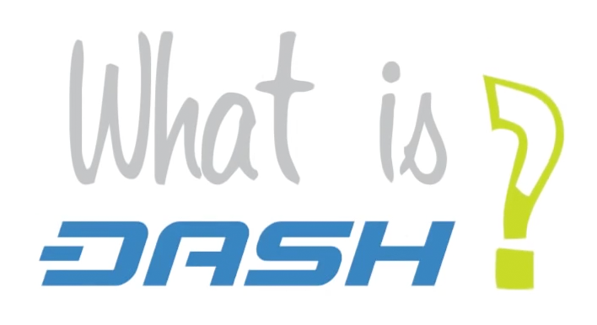

Dash is an open-source project that delivers safe decentralized financial solutions.

The Dash Project Team aims to build and maintain an innovative decentralized payment network which acts as the core of an ecosystem of engaged consumers, merchants, and service providers. This network provides users with a private, fast, and fungible digital currency to be used in both physical and online transactions. Dash Team works on a robust ecosystem of modern digital products and services and will cultivate adoption of this ecosystem through education, promotion, partnerships, and engagement of potential users on the benefits of crypto-currencies and Dash.

Because current digital wallets are clumsy and hard to use, people fear doing something wrong or losing their coins. Dash is solving this problem by creating a new system that’s as easy to use as cash, credit cards or PayPal.

* **Innovative** cryptographic currency
* **Multi-tiered** network
* Properly **incentivized** **infrastructure**
* Project **governance and funding via decentralized framework**
* 30M USD market cap
* More than 10’000 users

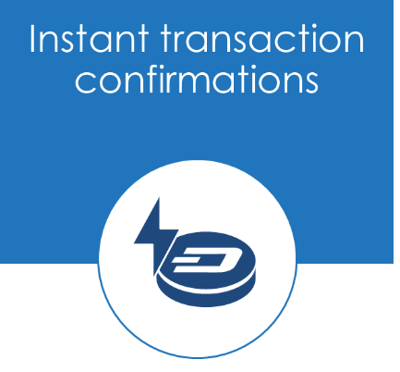While fast relative to bank transfers, most crypto-currencies take a significant amount of time to confirm transactions. Dash solves this with **InstantX** **which fully confirms payments in 1-4 seconds** and uses the second-tier masternode network to lock a transaction. This makes Dash perfect for retail adoption since there is no risk of a double spend with zero confirmations or need to wait minutes for a block confirmation. InstantX has a very low fee which enables small point of sale purchases - for a demonstration visit www.dashndrink.com.

Fungibility is very important for any monetary system. No one should have to worry if their money was used in an illegal transaction. Also, everyone deserves the right to privacy. Dash protects personal spending habits and business trade secrets with system of decentralized mixing called DarkSend. **DarkSend keeps your transactions fungible and private**.

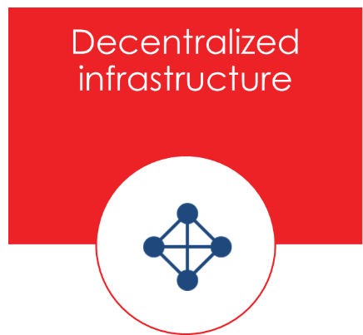Most people are familiar with the single-tier network of Bitcoin. Dash takes things a step further by utilizing a two-tier network. The first tier works the same way as Bitcoin: miners find blocks and post transactions to the blockchain. The second tier, comprised of special servers called **masternodes**, enables additional features such as instant transactions (InstantX), private transactions (DarkSend), and decentralized governance and budgeting.

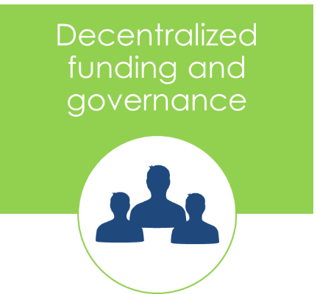Dash has a **decentralized system to govern and fund the future development of Dash projects**. Such projects can be proposed by anyone, the community discusses their merits and finally masternode owners vote on whether or not to approve and pay for the project proposal. If successful, the project is paid directly from the blockchain.

***Dash Strategy***

With self-funding, governance, and a huge team of supporters, Dash is positioned to deliver incredible progress against our strategic goals in 2016. The Dash Project Team has detailed our long-term plans with a focus on five strategic objectives.

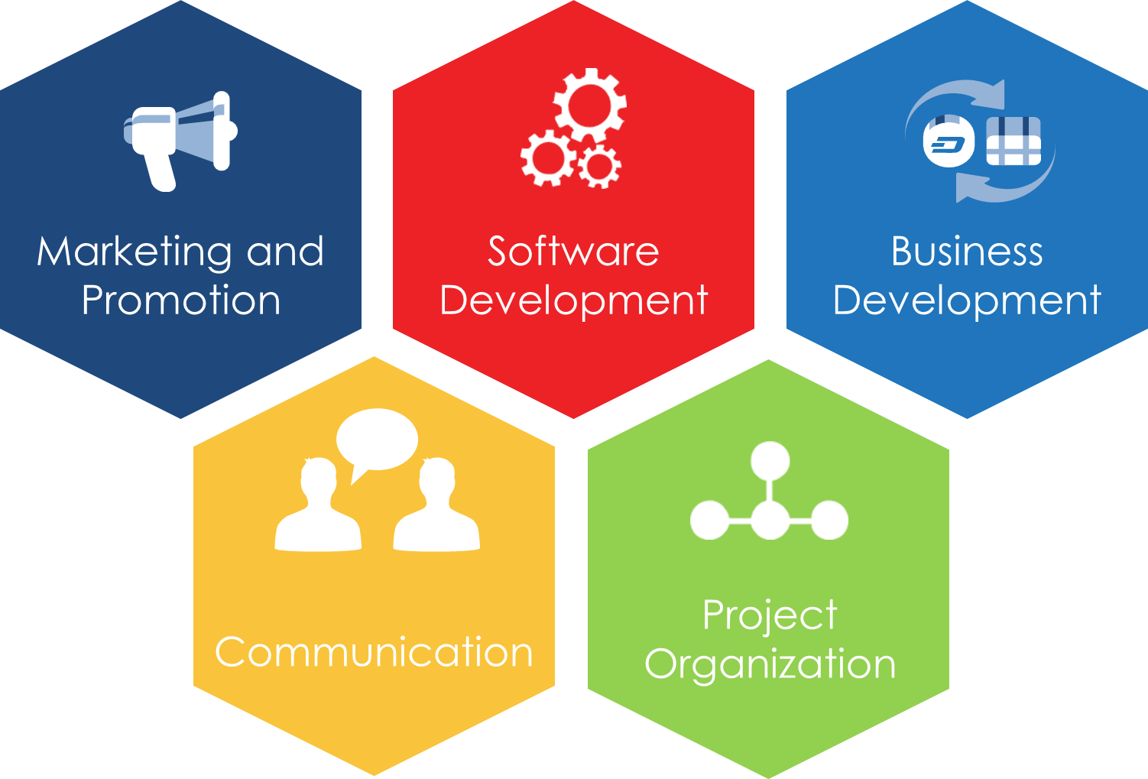

Each of these five objectives are critical, as they will act as guideposts for the entire team as we formulate our roadmap for the current year.

* **Develop leading crypto-currency software** that combines all features of cash and digital money.
* Design and implement a **marketing plan** to position Dash as the leading payment solution in the crypto-industry.
* **Expand the network** by focusing on new adoptions, integrating with existing markets and attracting new financial industry partners.
* Maximize impact through **open and honest communication**, seeking to be transparent and providing access to all information and data.
* Build an **efficient project organizational structure** to support the Dash Project Team, Dash Users and the Dash Community.

***Dash Evolution*** **significantly** **improves the usability of wallets and the blockchain.** We are building a **new type of cryptographic currency** with features that simplify creation of decentralized technology. Dash Evolution is also the name of our next release and introduces a tiered network design and works to provide efficient financial services along with Decentralized API (DAPI) access and a decentralized file system.

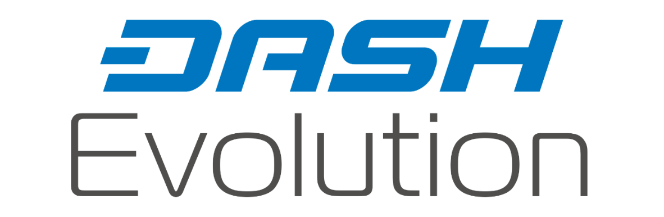

Dash Evolution will no longer store the blockchain in local wallets but will use the masternode network for blockchain storage instead. Personal transactions, notes and all account keys are stored in encrypted decentralized storage system, accessible through the light clients. Thus users cannot lose their wallets - all they need is their account access information, much like a Swiss bank account. This frees the user from massive downloads while also implementing new features:

* **DashDrive** – blockchain and encrypted user data storage in masternodes. This allows for a 10,000x growth of the blockchain without sacrificing performance.
* **DAPI** – decentralized API which allows users to access the network securely.
* **DSQL** – a query language for administering the network via majority quorums (managing users, setting network variables such as sporks on/off, etc).
* **DashPay Wallets** – decentralized light clients connected to the network via DAPI.
* **Primitives** – introduce Users, Groups and Accounts which allow a common way of interacting with the network.
* **Social Wallet** –Dash introduces a social wallet, which allows contacts lists, grouping of users, shared accounts and multi-user merchant account access. Account keys are stored in redundant and encrypted decentralized storage, accessible only to the authenticated user.
* **Quorum Chain** – introduces a permanent stable masternode list, which can be used to calculate past and present quorums.
* **Quorum** - small group of masternodes selected from the Quorum Chain to verify and process transactions and advanced activities.
* **Nearly Unlimited Transaction Speed** – with quorums the transaction speed of the network is estimated to increase to 10,000 transactions per second.



***Dash is Digital Cash***

www.dash.org