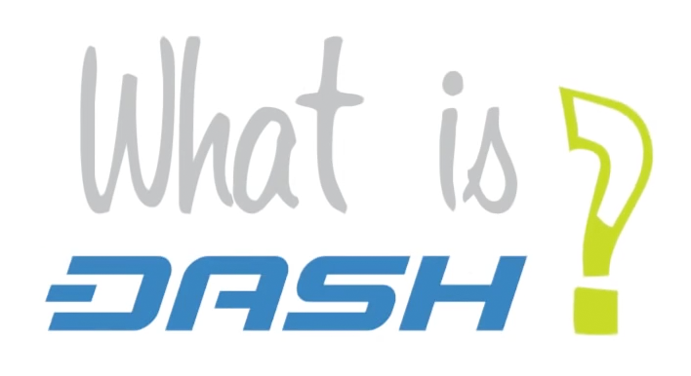

Dash is an open-source project that delivers safe decentralized financial solutions. Dash is like digital cash, which can be spent easily and instantly online and at merchants and service providers worldwide. Dash has a **market cap of $70 million**, over **15,000 users**, and half a million dollars is moved over the network every 24 hours. Dash has a revolutionary governance and funding infrastructure over a decentralized framework and uses over **4000 masternodes** to verify transactions.

Dash **InstantSend** **fully confirms payments in 1-4 seconds** and uses the second-tier masternode network to lock a transaction. This makes Dash perfect for retail adoption and direct payments – it works like a decentralized digital cash.

Instant transaction confirmations

Privacy and fungibility



Dash protects personal spending habits and business trade secrets with system of decentralized mixing called PrivateSend. **PrivateSend keeps your transactions private and fungible**.

Dash utilizes an **innovative two-tier network**. The second tier, comprised of **masternodes**, enables additional features such as instant transactions, private transactions, and decentralized governance and budgeting.

Decentralized infrastructure



Dash has a **decentralized system to govern and fund its future development**. Projects can be proposed by anyone, the community discusses their merits and finally masternode owners vote on whether or not to approve and pay for the project proposal. If successful, the project is paid directly from the blockchain.

Decentralized funding and governance

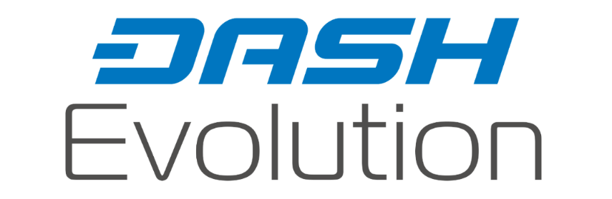

Dash Evolution is a tiered network design and works to provide efficient financial services along with Decentralized API (DAPI) access and a decentralized file system. It significantly improves the usability of wallets and the blockchain.

* **DashDrive** – blockchain and encrypted user data storage in masternodes. This allows for a 10,000x growth of the blockchain without sacrificing performance.
* **DAPI** – decentralized API which allows users to access the network securely.
* **DashPay Wallets** – decentralized light clients connected via DAPI.
* **Social Wallet** – a social wallet, which allows contacts lists, grouping of users, shared accounts and multi-user merchant account access.
* **Nearly Unlimited Transaction Speed** – with Dash Evolution the transaction speed is estimated to increase to 10,000 transactions per second.

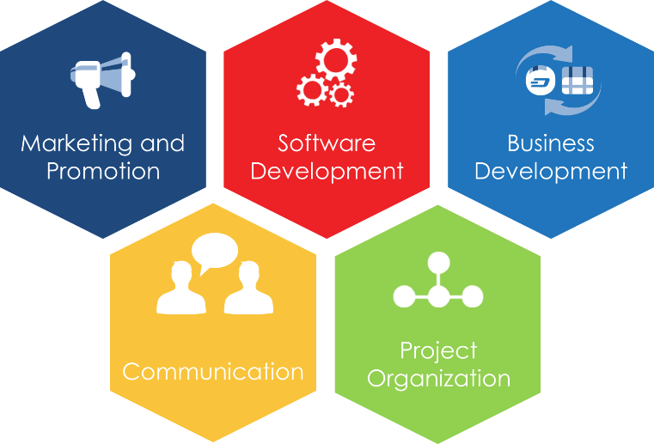

With self-funding, governance, and a huge team of supporters, Dash is positioned to deliver incredible progress against our strategic goals in 2016.

* **Develop leading crypto-currency software** that combines all features of cash and digital money.
* Design and implement a **marketing plan** to position Dash as the leading payment solution in the crypto-industry.
* **Expand the network** by focusing on new adoptions, integrating with existing markets and attracting new financial industry partners.
* Maximize impact through **open and honest communication**, seeking to be transparent and providing access to all information and data.
* Build an **efficient project organizational structure** to support the Dash Project Team, Dash Users and the Dash Community.