Student performance

XGL

2020/6/16

setwd("D:/R/R-exercise/student_performance")  
data <- read.csv('StudentsPerformance.csv')  
library(ggplot2)  
knitr::kable(head(data))

|  |  |  |  |  |  |  |  |
| --- | --- | --- | --- | --- | --- | --- | --- |
| gender | race.ethnicity | parental.level.of.education | lunch | test.preparation.course | math.score | reading.score | writing.score |
| female | group B | bachelor’s degree | standard | none | 72 | 72 | 74 |
| female | group C | some college | standard | completed | 69 | 90 | 88 |
| female | group B | master’s degree | standard | none | 90 | 95 | 93 |
| male | group A | associate’s degree | free/reduced | none | 47 | 57 | 44 |
| male | group C | some college | standard | none | 76 | 78 | 75 |
| female | group B | associate’s degree | standard | none | 71 | 83 | 78 |

# 分布情况  
# 父母教育水平性别和数学分数  
ggplot(data,aes(x=parental.level.of.education,y=math.score,fill=gender))+  
 geom_boxplot(position = 'dodge')# position =dodge是用于分组绘图的

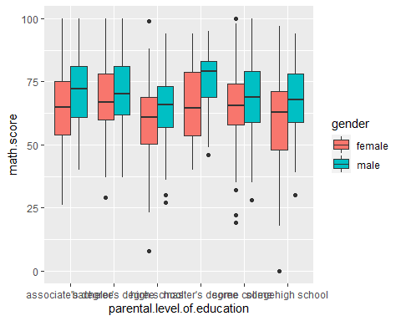

# 父母教育水平和成绩通过  
ggplot(data,aes(x=parental.level.of.education,fill=test.preparation.course))+  
 geom_bar(position = 'dodge')

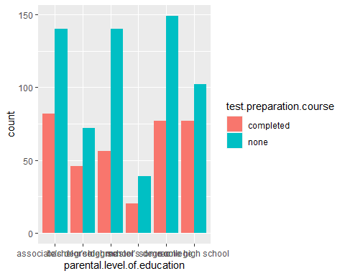

# 性别和阅读成绩  
ggplot(data,aes(x=factor(gender),y=reading.score,fill=gender))+  
 geom_boxplot()+  
 xlab("Gender")

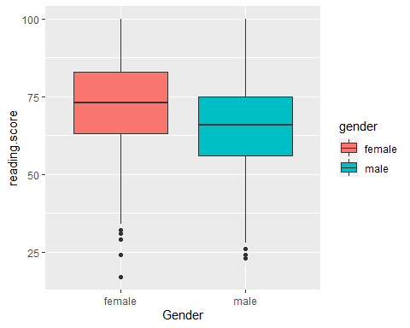

# 种族和数学成绩  
ggplot(data,aes(x=factor(race.ethnicity),y=math.score,fill=race.ethnicity))+  
 geom_boxplot()+  
 xlab("Group")

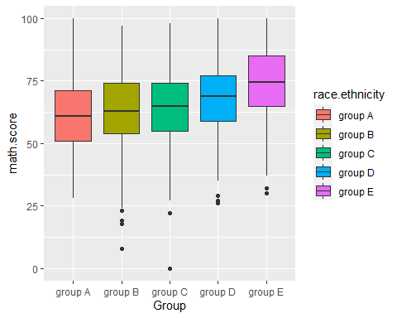

# 午饭和写作成绩  
ggplot(data,aes(x=factor(lunch),y=writing.score,fill=lunch))+  
 geom_boxplot()+  
 xlab("Lunch")

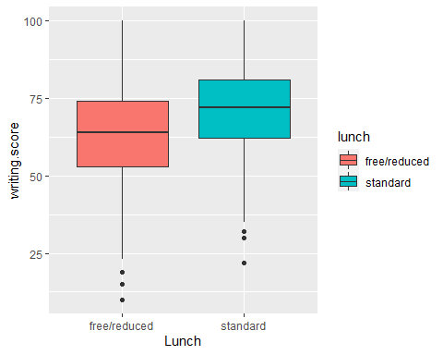

# 父母教育水平和阅读成绩是否合格  
rs <- ifelse(data$reading.score>60,"P","F")  
  
data$rs <- rs  
  
ggplot(data,aes(x=parental.level.of.education,fill=rs))+  
 geom_bar()

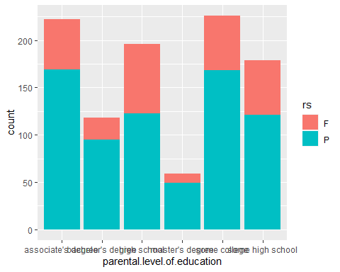

ggplot(data,aes(x=rs,fill=parental.level.of.education))+  
 geom_bar()

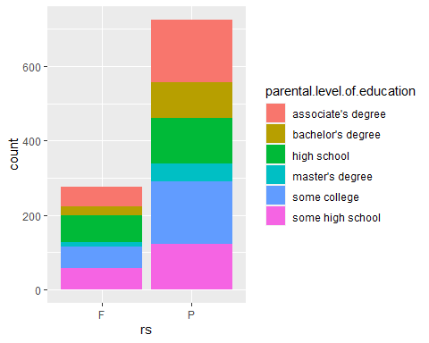

# 父母教育水平和写作成绩是否合格  
ws <- ifelse(data$reading.score>60,"P","F")  
data$ws <- ws  
ggplot(data,aes(x=parental.level.of.education,fill=ws))+  
 geom_bar()

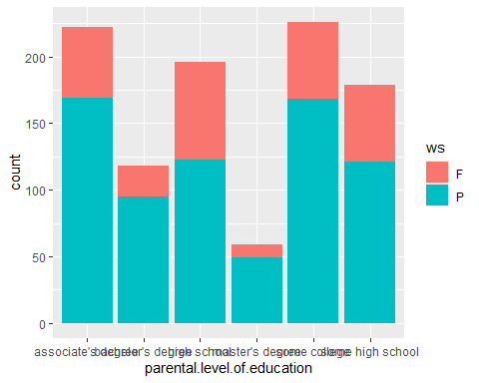

ggplot(data,aes(x=ws,fill=parental.level.of.education))+  
 geom_bar()

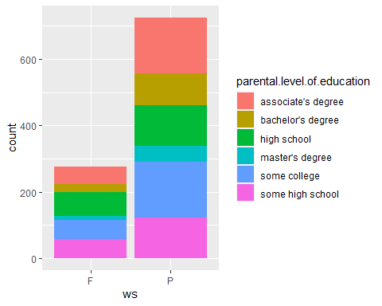

# 总评成绩分布  
a<-data$math.score*0.4+data$reading.score*0.3+data$writing.score*0.3  
score <- function(a){  
ifelse(a>92,"A+",  
 ifelse(a>85,"A",  
 ifelse(a>80,"B+",  
 ifelse(a>75,"B",  
 ifelse(a>70,"C+",  
 ifelse(a>65,"C",  
 ifelse(a>60,"C","NO PASS")  
 )))))  
 )  
}  
data$score <-score(a)  
  
ggplot(data,aes(x=score,fill=factor(score)))+  
 geom_bar()

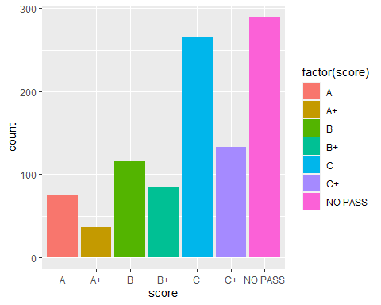

# 阅读成绩和写作成绩的关系  
ggplot(data,aes(x=data$reading.score,y=data$writing.score))+  
 geom_point()+  
 geom_abline()

## Warning: Use of `data$reading.score` is discouraged. Use `reading.score`  
## instead.

## Warning: Use of `data$writing.score` is discouraged. Use `writing.score`  
## instead.

