AXRIK — Weekly Outreach Pack
Prepared 16 July 2026 · Liverpool City Region food & drink · Prep only — nothing has been sent or posted.
Do this first
- Give each business's Instagram/Facebook a 30-second look before contacting — confirm they still take orders by hand/DM.
- Send the 5 messages below yourself (Facebook / Instagram / WhatsApp as noted).
- Post the 2 social captions with their matching images (post-1.png, post-2.png in this folder).
- Mark anyone you contact as 'contacted' in outreach-tracker.csv.
This week's 5 prospects + outreach
1. Graham Eyes Quality Butchers
What they do: Traditional independent butcher (concession on Harington Road, Formby).
Area: Formby, Sefton
Find them: Facebook — 'Graham Eyes Quality Butchers, Harington Road, Formby'
Why a fit: Long-standing local butcher likely taking orders at the counter and over Facebook — the exact JG Foods pattern.
Draft message: Hi — I'm Phil from AXRIK, a local company that builds simple apps for food businesses. I recently worked with JG Foods, a mobile butcher who took every order by hand through social media. Now his customers order through an app on their phone and his weekly delivery round builds itself. I wondered if something similar might save you time on orders at the counter and over Facebook. Happy to show you a 2-minute look, no pressure — here's his story: axrik.com/jg-foods. Cheers, Phil
2. Vineyard Farm Shop
What they do: Family-run Wirral farm and farm shop — fruit, veg and local produce, open 7 days.
Area: Wirral
Find them: Instagram — @vineyardfarmshop
Why a fit: Independent, Instagram-led farm shop; probably fields orders and questions through DMs.
Draft message: Hi — I'm Phil from AXRIK. We build straightforward apps for independent food businesses. I recently helped JG Foods, a mobile butcher who ran every order by hand through social media DMs. Now his customers order through an app and his weekly round sorts itself out. For a busy farm shop fielding orders over Instagram, the same idea could take a lot off your plate. I'd love to show you a quick 2-minute look — no hard sell. Here's what we did: axrik.com/jg-foods. Best, Phil
3. L Hannah Fishmonger & Poulterer
What they do: Fourth-generation independent fishmonger and poulterer (est. 1877) on Rose Lane.
Area: Mossley Hill, Liverpool
Find them: Facebook — 'Hannah's Fishmonger and Poulterer'
Why a fit: Traditional independent serving South Liverpool; orders likely taken by phone, counter and Facebook.
Draft message: Hi — I'm Phil from AXRIK, a local firm building simple apps for food businesses. I recently worked with JG Foods, a mobile butcher who took every order by hand on social media. Now people order through an app on their phone and his weekly round builds itself. For a fishmonger taking orders over the counter and Facebook, the same could save real time each week. Happy to give you a 2-minute look whenever suits — no pressure. His story's here: axrik.com/jg-foods. Cheers, Phil
4. Mr Thompson's Bakery
What they do: Family-owned bakery — cakes, brownies, cookies, cheesecakes; market stall in Ormskirk Thu & Sat.
Area: Ormskirk, West Lancashire
Find them: Website mrthompsonsbakery.co.uk; takes orders via WhatsApp, Facebook & text
Why a fit: Explicitly takes orders across WhatsApp, Facebook and text — a perfect 'scattered DM orders' fit.
Draft message: Hi — I'm Phil from AXRIK. We build easy little apps for independent food businesses. I recently helped JG Foods, a mobile butcher who took every order by hand through social media. Now his customers order through an app and the weekly round builds itself. I noticed you take orders over WhatsApp, Facebook and text — an app could pull all that into one tidy list instead of three inboxes. I'd be glad to show you a 2-minute look, no hard sell: axrik.com/jg-foods. Best, Phil
5. Old Oaks Farm
What they do: Farm shop selling beef, fruit & veg, local coffee, flowers and more, direct to locals.
Area: Neston, Wirral
Find them: Website oldoaksfarm.co.uk; Facebook
Why a fit: Sells meat and veg direct to the community — ordering and collections could be smoothed with a simple app.
Draft message: Hi — I'm Phil from AXRIK, a local company building simple apps for food businesses. I recently worked with JG Foods, a mobile butcher who ran every order by hand through social media. Now his customers order through an app on their phone and his weekly delivery round builds itself. For a farm selling meat, veg and more direct to locals, the same idea could make ordering and collections a lot easier. Happy to show you a quick 2-minute look, no pressure: axrik.com/jg-foods. Cheers, Phil
Follow-ups due
None due this week. The 5 prospects already in the tracker were added today (16 July), so they're not yet due a nudge. First follow-ups will fall due from the week of 23–30 July — I'll flag them then.
Social posts (with images)
Post 1 — AI feature spotlight — parsing orders from messages
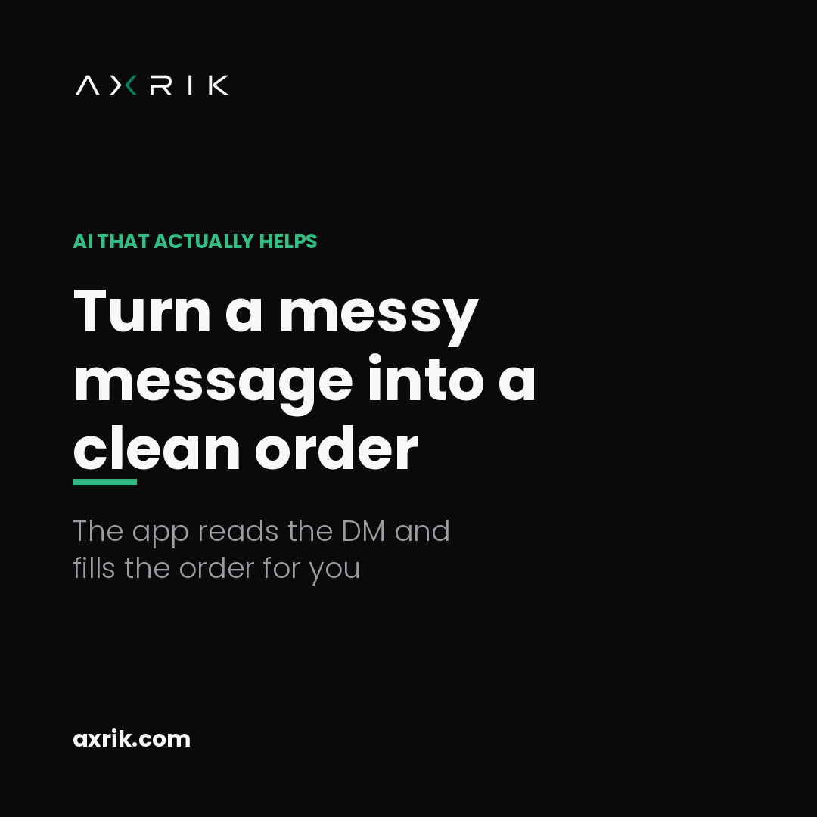
Image file: post-1.png
Caption: Still copying orders out of your DMs by hand? One of the AI features we build into AXRIK apps reads a customer's message — however messy — and turns it into a clean order in your system. No retyping, no missed items, no “did they say two or three?”. You stay in control: it drafts the order, you tap to confirm. It's the kind of quiet, useful AI that gives a small food business its evenings back. Curious what it'd look like for yours? Take a look: axrik.com/jg-foods
Post 2 — Practical tip for small food businesses
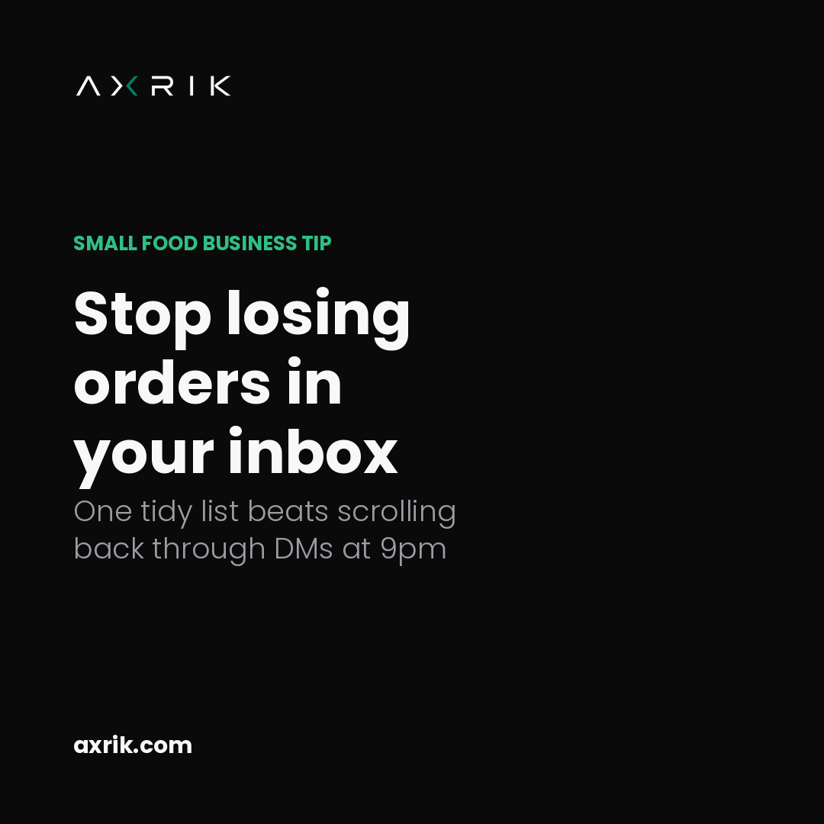
Image file: post-2.png
Caption: A small tip for any food business run through social media: get every order into one place. When orders live across Instagram, Facebook and texts, something eventually slips — a missed message, a double booking, a “sorry, we sold out” you didn't need to send. One simple list of who wants what, and when, is often the single biggest time-saver before you change anything else. It's exactly where we started with JG Foods — one tidy app instead of a full inbox. See how it worked: axrik.com/jg-foods

