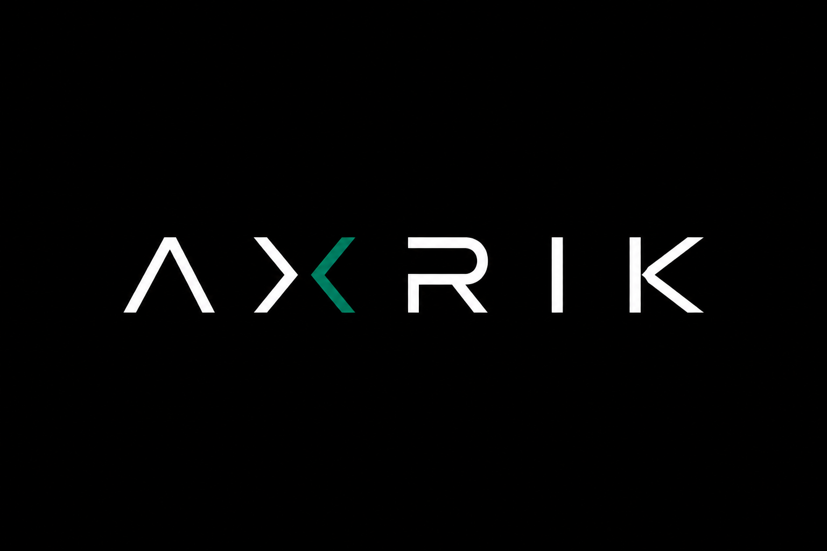
New Client Onboarding Checklist
Client  ________________________________ | Date  ________________________________

01 — DISCOVERY
Business basics
Get the core facts about the business before anything else.
ME | Business name, owner name and contact details confirmed | ☐
ME | Business type understood — what they do, who their customers are | ☐
ME | What they want built — website, admin app, or both | ☐
ME | Why now — what problem are they trying to solve | ☐
ME | Rough go-live target agreed | ☐
CLIENT | Completed the brief or had an initial discovery call | ☐

02 — EXISTING DIGITAL PRESENCE
What they already have
Check this before touching anything — the answers change how the build and handover work.
ME | Do they have an existing website? If yes — URL, who built it, where is it hosted? | ☐
ME | Do they have a domain? If yes — who is it registered with (GoDaddy, 123-reg, etc.)? | ☐
ME | Do they have email on the domain (e.g. jon@business.co.uk)? CRITICAL — if yes, document all MX records before touching DNS | ☐
ME | Are there any other DNS records to preserve (SPF, DKIM, CNAME)? Export them all first | ☐
ME | Do they have social media accounts? Which platforms, what are the handles? | ☐
ME | Do they have Google Business / Maps listing? | ☐
If they have email on the domain: export every DNS record from their current provider and replicate them in Cloudflare BEFORE switching nameservers. Email must never drop.

03 — DOMAIN & INFRASTRUCTURE
Getting DNS under control
Standard AXRIK model — one account per service, client domains under AXRIK Cloudflare.
ME | Domain confirmed — existing or new? | ☐
ME | If new: register under AXRIK Cloudflare. Document as client asset. Cost absorbed by AXRIK or billed to client. | ☐
ME | If existing with another provider: point nameservers to Cloudflare (quickest) or initiate transfer (takes 5-7 days) | ☐
ME | All existing DNS records replicated in Cloudflare before any nameserver change | ☐
ME | New Netlify sites created for website and/or admin app under AXRIK Netlify account | ☐
ME | DNS records added in Cloudflare pointing to Netlify deployments | ☐
ME | HTTPS confirmed live on all URLs | ☐
ME | Staging URL shared with client for review before DNS switch (for clients replacing an existing site) | ☐

04 — BUILD BRIEF
What we need from the client
Collect all assets and decisions before starting the build to avoid rework.
CLIENT | Logo provided — PNG with transparent background preferred | ☐
CLIENT | Brand colours confirmed (hex codes if known, or examples of what they like) | ☐
CLIENT | Product/service list with prices and descriptions | ☐
CLIENT | Photos — product photos, team photos, location photos (phone photos are fine) | ☐
CLIENT | Any copy they want to keep from the existing site | ☐
CLIENT | Pages required confirmed (e.g. Home, About, Products, Contact, Trade) | ☐
CLIENT | Any specific features or integrations discussed and agreed | ☐
ME | Spreadsheets or data files received and analysed if admin app is included | ☐

05 — ACCOUNTS & ACCESS
Third-party services
Only set up what is needed for the build. Tick when account is created and access confirmed.
ME | Supabase project created under AXRIK organisation | ☐
ME | Twilio sub-account created under AXRIK master account (if messaging required) | ☐
ME | EmailJS template set up (if email sending required) | ☐
ME | Google Cloud project created under AXRIK account (if Maps / AI features required) | ☐
ME | GitHub repo created under AXRIK-dev for this client | ☐
CLIENT | Any existing accounts shared (e.g. Facebook Business Manager for social posts) | ☐

06 — GO-LIVE
Launch checklist
Run through these on go-live day. Do not skip the DNS checks.
ME | Client has reviewed and signed off the staging site | ☐
ME | All real data loaded (products, customers, pricing) | ☐
ME | Supabase RLS policies verified — no data leaking between clients or users | ☐
ME | DNS switched — website live at client domain | ☐
ME | Admin app live at admin.[clientdomain] | ☐
ME | HTTPS confirmed on all URLs | ☐
ME | Email still working after DNS switch (send a test) | ☐
ME | Client logged in and tested the admin app on their own device | ☐
ME | Client walkthrough completed — they know how to use the key features | ☐
CLIENT | Stripe billing set up — first monthly invoice sent | ☐

07 — ONGOING
Monthly running costs & billing
Standard AXRIK platform fee covers all running costs. One invoice, one line item.
ME | Monthly platform fee agreed and documented (target: 40-50% margin above actual costs) | ☐
ME | Stripe recurring invoice set up — card on file | ☐
ME | Client understands what is included (hosting, database, domain, messaging, maintenance) | ☐
ME | AXRIK portal access set up so client can log in and see build progress | ☐
ME | Support process agreed — how the client raises issues or requests changes | ☐
If a client stops paying: pause the Netlify deployment. Never withhold the domain — that is their business asset and must be transferred on request.

