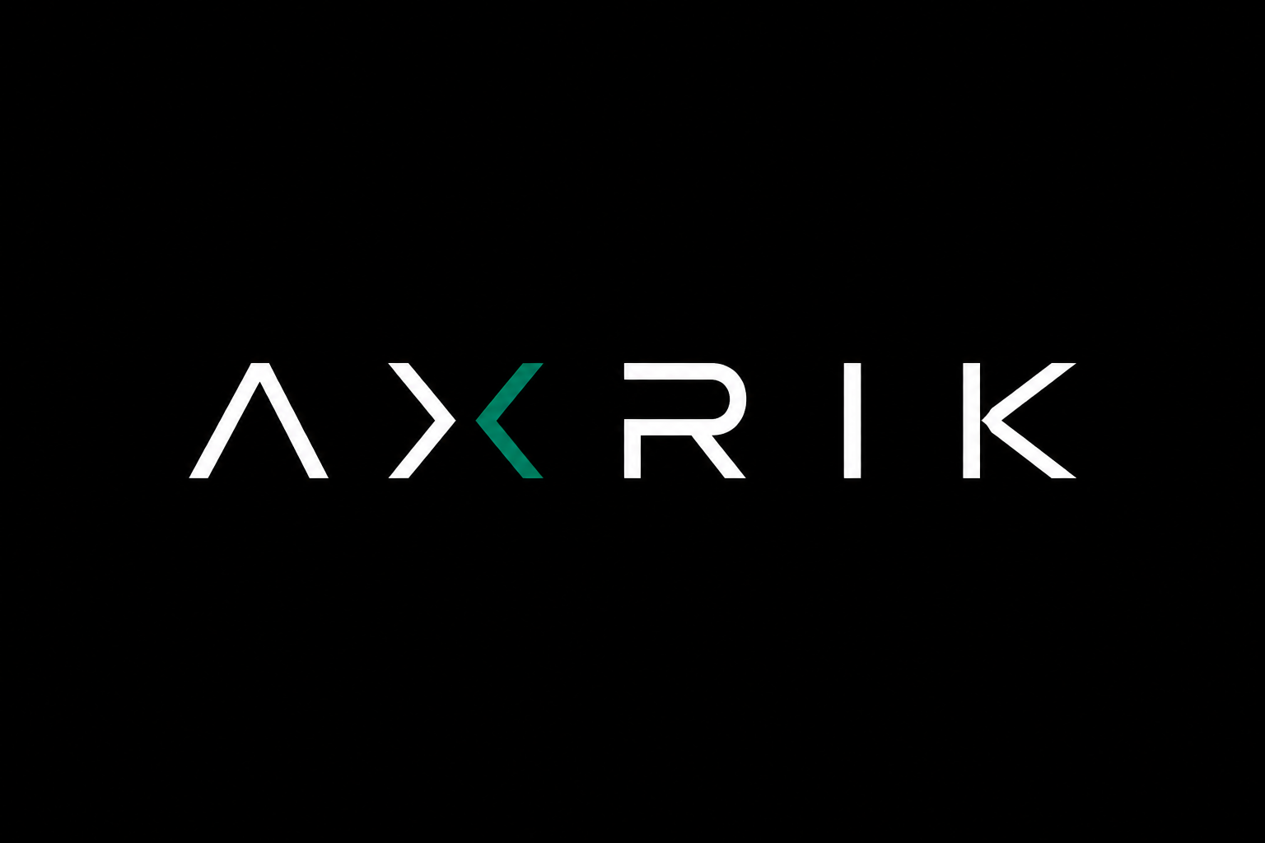

CLIENT TERMS & CONDITIONS
These terms apply to all services provided by AXRIK

These terms set out the agreement between AXRIK ("we", "us") and you ("the Client") when we build a website or web application for your business and/or provide ongoing hosting and platform services.
We've written them in plain English. If anything is unclear, just ask before you sign.

By proceeding with a project or paying an invoice, you confirm that you have read and agreed to these terms.

01 DEFINITIONS

TERM | MEANING
AXRIK | The trading name under which web development and platform services are provided.
Client | The business or individual who has engaged AXRIK to build and/or host a digital product.
Project | The initial build of a website, web application, or both, as agreed in the project brief.
Platform | The ongoing hosting, database, domain management, and maintenance services provided after go-live.
Platform Fee | The monthly recurring payment covering all Platform services, as agreed before go-live.
Go-Live Date | The date on which the Project is published to the Client's live domain and made publicly accessible.
Domain | The web address (e.g. jgfoodsnorthwest.com) registered in the Client's name.

02 THE BUILD AGREEMENT
What we will build
The scope of the Project is agreed between us before work begins, either through a written brief, a proposal document, or a confirmed email exchange. We will build what is described in that agreement.
Any features or pages not included in the original scope are considered additional work and will be quoted separately.
What we need from you
To build your Project, we need you to provide:
— Your logo, brand colours, and any brand guidelines
— Product and service information, descriptions, and pricing
— Photos, copy, and any content you want on the site
— Timely responses to questions and review requests
Delays in providing these materials will delay the Project. We'll let you know if we think this is affecting the timeline.
Timelines
We will agree a go-live target at the start of the Project. Timelines are estimates based on the scope agreed and assume we receive client materials promptly. We will keep you updated if anything changes.
We are not liable for delays caused by late content, change requests, or factors outside our control.
Reviewing and signing off
Before going live, we will share a staging version of your site or app for review. You will have the opportunity to request reasonable changes within the agreed scope.
Once you confirm sign-off — in writing or by email — we will proceed to go-live. Sign-off confirms you are happy with the Project as delivered.
Scope changes
If you ask for changes that go beyond what was originally agreed, we will let you know before doing the work. Additional scope will be quoted and agreed before we proceed. We will never do extra paid work without your approval.

03 PLATFORM & HOSTING
How the platform works
After your Project goes live, we manage all of the infrastructure on your behalf. This includes:
— Website and application hosting via our Netlify account
— Database and authentication via our Supabase account
— DNS management via our Cloudflare account
— Domain renewal (your domain, renewed annually)
— Automated messaging where applicable (e.g. order notifications via Twilio)
— Routine maintenance and security updates
You do not need accounts with any of these services. We handle everything and you pay a single monthly Platform Fee.
Platform Fee
The Platform Fee is agreed before your Go-Live Date and set up as a recurring monthly payment via Stripe. It covers all of the services listed above.
The fee will not change without at least 30 days' written notice from us. If you do not agree to a fee change, you may terminate the agreement in accordance with Section 05.
Availability
We aim to keep your site and application running reliably. We use reputable third-party infrastructure providers (Netlify, Supabase, Cloudflare) and benefit from their uptime guarantees.
We cannot guarantee 100% uptime. Planned maintenance will be communicated in advance where possible. We are not liable for downtime caused by third-party service outages.
Support
Platform clients can contact us to report issues or request minor changes. We will respond to support requests within two business days. Response times for urgent issues (site down, broken functionality) will be faster.
Support covers the platform and what we built. It does not include building new features — those are scoped and quoted separately.

04 OWNERSHIP & INTELLECTUAL PROPERTY
Your domain
Where AXRIK registers a domain on your behalf, we do so through our own Cloudflare account for operational convenience. The domain is your asset. Legal ownership is confirmed upon full payment of the build fee.
We will never withhold your domain. We will transfer it to a registrar of your choice on request — regardless of the status of our relationship. The only circumstance in which a transfer may be delayed is where the build fee has not been paid in full, in which case transfer will proceed upon settlement.
Your content
All content you provide — text, images, logos, product information — remains yours. We do not claim any rights over it.
Your data
All data generated by your site or application (customer records, orders, and so on) belongs to you. On termination of this agreement, we will provide an export of your data in a standard format on request.
The code
The code we write for your Project is built by AXRIK and remains our intellectual property unless we agree otherwise in writing. What this means in practice:
— Your site and application will continue to run on our platform for as long as you pay the Platform Fee.
— If you terminate the agreement and want to take the code elsewhere, we are happy to discuss a code transfer arrangement. This may involve a one-off fee, depending on the project.
— We retain the right to re-use patterns, components, and approaches developed during your Project for other clients. We will never share your specific content, data, or business logic.
Third-party tools
Your Project may include third-party tools or libraries (for example, mapping services or messaging APIs). These are subject to their own licences and terms, which we will flag if they affect you.

05 TERMINATION & OFFBOARDING
Ending the Platform agreement
Either of us can end the Platform agreement by giving 30 days' written notice. Notice should be sent by email.
You will be billed for any days within the notice period. No refunds will be issued for partial months already paid.
If you stop paying
If a Platform Fee payment fails, we will notify you and allow seven days to resolve the payment. If the payment is not resolved, we reserve the right to suspend your site and application by pausing your hosting deployment.
We will not delete your data during suspension. If payment is resolved within 30 days of suspension, we will restore the service. After 30 days, we may terminate the agreement.
We will never withhold your domain. Even if the Platform is suspended, your domain remains yours once the build is paid in full, and will be transferred to you on request.
What happens at the end
When the agreement ends — for any reason — we will:
— Transfer your domain to a registrar of your choice within 5 business days of request
— Provide an export of your data in a standard format on request
— Take down your site and application within 30 days of the agreement end date
We will discuss code transfer options if you want to continue running the application elsewhere.
Ending the Build agreement
If you wish to cancel a Project that is already underway, you will be invoiced for work completed to that point. The amount will be agreed fairly based on the stage of the build.

06 GENERAL
Liability
We will always do our best work. However, our liability to you in connection with any project or service is limited to the fees paid in the 12 months preceding any claim.
We are not liable for any loss of revenue, data, or business opportunity arising from use of your site or application, or from any downtime or service interruption.
Confidentiality
We will keep your business information confidential and will not share it with third parties, except where required to deliver the service (for example, your domain name is visible publicly by its nature).
Changes to these terms
We may update these terms from time to time. If we make material changes, we will notify you by email at least 30 days before they take effect. Continuing to use our services after that date means you accept the updated terms.
Governing law
These terms are governed by the laws of England and Wales. Any disputes will be subject to the jurisdiction of the courts of England and Wales.

AGREEMENT
By signing below, both parties confirm they have read and agree to these terms.

FOR AND ON BEHALF OF AXRIK |  | CLIENT
Signature |  | Signature
Full name |  | Full name
Date |  | Date

AXRIK Client Terms & Conditions · axrik.co.uk · June 2026

