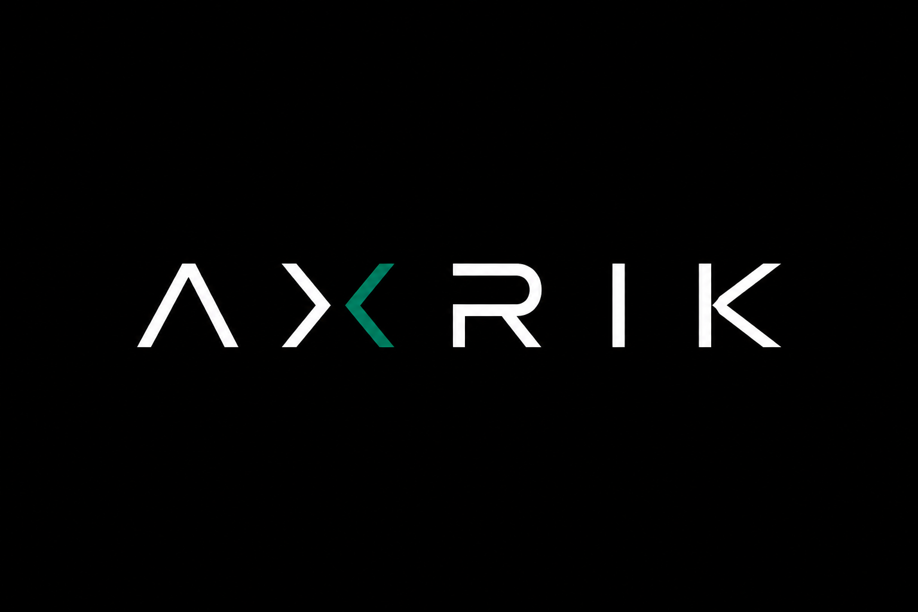

NEW CLIENT GUIDE
From first conversation to go-live and beyond

How to use this guide
This is the single reference for every new AXRIK client. It combines the full onboarding checklist with the detailed setup steps — everything needed to take a client from first call to live product, in one place.
Work through it top to bottom for each client. The checklist tables tell you what to do and who does it. The reference sections give you the step-by-step detail when you need it.

AXRIK owns the infrastructure — one account per service, every client inside it. The client owns their domain and pays a single monthly platform fee. They never log in to Netlify, Supabase, Cloudflare, or Twilio. You handle everything. That is the model.

01 DISCOVERY
Get the core facts before anything else
✓ | WHO | TASK
☐ | AXRIK | Business name, owner name and contact details confirmed
☐ | AXRIK | Business type understood — what they do, who their customers are
☐ | AXRIK | What they want built — website, admin app, or both
☐ | AXRIK | Why now — what problem are they trying to solve
☐ | AXRIK | Rough go-live target agreed
☐ | CLIENT | Completed the brief or had an initial discovery call

02 EXISTING DIGITAL PRESENCE
Check this before touching anything
The answers here change how the build and handover work. Always audit before starting.
✓ | WHO | TASK
☐ | AXRIK | Do they have an existing website? If yes — URL, who built it, where is it hosted?
☐ | AXRIK | Do they have a domain? If yes — who is it registered with (GoDaddy, 123-reg, etc.)?
☐ | AXRIK | Do they have email on the domain (e.g. jon@business.co.uk)? CRITICAL — if yes, document all MX records before touching DNS
☐ | AXRIK | Are there any other DNS records to preserve (SPF, DKIM, CNAME)? Export them all first
☐ | AXRIK | Do they have social media accounts? Which platforms, what are the handles?
☐ | AXRIK | Do they have a Google Business / Maps listing?

If they have email on the domain: export every DNS record from their current provider and replicate them in Cloudflare BEFORE switching nameservers. Email must never drop.

03 DOMAIN & INFRASTRUCTURE
The AXRIK infrastructure model
AXRIK owns one account per service. Every client lives inside it as a site, project, or sub-account. Clients never log in to any of these services — they pay a monthly platform fee and AXRIK handles everything. This is what makes AXRIK scalable and what gives you control.
Netlify — one AXRIK account, unlimited sites. Each client is a site. | Supabase — one AXRIK org, one project per client. | Cloudflare — one AXRIK account, one DNS zone per client domain. | Twilio — one AXRIK master, one sub-account per client. | Google Cloud — one AXRIK account, one project per client for billing clarity.

Checklist
✓ | WHO | TASK
☐ | AXRIK | Domain confirmed — existing or new?
☐ | AXRIK | If new: register via AXRIK Cloudflare account. Cost absorbed into build or invoiced separately. Domain is their asset — ownership confirmed on full build payment.
☐ | AXRIK | If existing elsewhere: point nameservers to AXRIK Cloudflare account (1–24 hrs) or initiate transfer (5–7 days)
☐ | AXRIK | All existing DNS records replicated in Cloudflare before any nameserver change
☐ | AXRIK | Professional email set up via Cloudflare Email Routing (free forwarding to personal inbox)
☐ | AXRIK | New Netlify site(s) created under AXRIK Netlify account
☐ | AXRIK | New Supabase project created under AXRIK organisation (EU West region)
☐ | AXRIK | GitHub repo created under AXRIK-dev organisation (private)
☐ | AXRIK | GitHub repo connected to Netlify — auto-deploy active on main branch
☐ | AXRIK | DNS records in Cloudflare pointing to Netlify deployments
☐ | AXRIK | HTTPS confirmed live on all URLs
☐ | AXRIK | Environment variables added to Netlify (Supabase URL, anon key, any other service keys)
☐ | AXRIK | Staging URL shared with client for review (if replacing an existing site)

Step-by-step reference
1 | Domain — register or transfer  For new domains: log into the AXRIK Cloudflare account and register the domain there. ~£10/year — absorb the cost or add it to the build invoice. The domain is held under AXRIK's account for operational convenience, but it belongs to the client once the build is paid in full. Document it as their asset in your records. For existing domains: transfer to AXRIK Cloudflare (5–7 days, client authorises) or point their nameservers at AXRIK Cloudflare (1–24 hours).
2 | Cloudflare — add a new zone  In the AXRIK Cloudflare account: Add a Site, enter the client domain, select Free plan. If the domain was registered at Cloudflare in Step 1, DNS is already live. For domains transferred in, Cloudflare scans existing records — review carefully, especially MX records if they have email. Email must never drop.
3 | Professional email (free)  Inside the AXRIK Cloudflare account, on the client's domain zone: Email → Email Routing → Create Address. Set e.g. jon@businessname.co.uk to forward to their personal inbox. Cloudflare adds DNS records automatically. Client clicks a verification email — that's the only thing they need to do.
4 | Netlify — create a new site  In the AXRIK Netlify account: Add New Site → Import an Existing Project → GitHub. Authorise Netlify to access AXRIK-dev organisation repos (must grant org access in the OAuth flow — easy to miss). Select the client repo, set publish directory. From this point: push to main → auto-deploy. The client never logs into Netlify.
5 | Supabase — create a new project  In the AXRIK Supabase organisation: New Project. Name it clearly (e.g. jg-foods), strong database password saved securely in AXRIK's password manager, EU West region. The project URL and anon key go into Netlify as environment variables — never hardcode in the repo. The client never logs into Supabase.
6 | GitHub repo  New private repo under AXRIK-dev organisation. Name clearly (e.g. jg-foods). Add a README, clone locally, start building. The client has no GitHub account and needs none.
7 | Connect domain to Netlify  Netlify → Site Settings → Domain Management → Add Custom Domain. Netlify provides a DNS record. Add it in the client's zone in AXRIK Cloudflare. Back in Netlify: Verify DNS Configuration. SSL provisions automatically via Let's Encrypt (a few minutes).

Platform costs & billing
SERVICE | COST / NOTES
Netlify (all client sites on one AXRIK account) | Free → Pro at ~$19/month when needed
Supabase (AXRIK organisation, project per client) | Free tier: 2 projects free. Pro: $25/project/month
Cloudflare (one AXRIK account, all client DNS) | Free
Twilio (AXRIK master, sub-account per client) | Pay-as-you-go per message (~1–2p/SMS)
Google Cloud (AXRIK account, project per client) | Pay-as-you-go; set budget alerts per project
Domain (client asset — registered in client's name) | ~£10/year — absorbed or billed to client
Typical AXRIK cost per active client | ~£18–20/month
Recommended platform fee to client | £35–50/month (40–50% margin)

The lever: if a client stops paying, pause their Netlify deployment in two clicks. You own the infrastructure, so you're never chasing someone while their site is still running. The domain is the one exception — that is their asset and must be transferred on request.

04 BUILD BRIEF
Collect all assets before starting — avoid rework
✓ | WHO | TASK
☐ | CLIENT | Logo provided — PNG with transparent background preferred
☐ | CLIENT | Brand colours confirmed (hex codes if known, or examples of what they like)
☐ | CLIENT | Product/service list with prices and descriptions
☐ | CLIENT | Photos — product photos, team photos, location photos (phone photos are fine)
☐ | CLIENT | Any copy they want to keep from the existing site
☐ | CLIENT | Pages required confirmed (e.g. Home, About, Products, Contact, Trade)
☐ | CLIENT | Any specific features or integrations discussed and agreed
☐ | AXRIK | Spreadsheets or data files received and analysed if admin app is included

05 ADDITIONAL SERVICES
Only set up what is needed for the build — all under AXRIK accounts
✓ | WHO | TASK
☐ | AXRIK | Twilio sub-account created under AXRIK master account (if SMS/messaging required)
☐ | AXRIK | EmailJS template set up under AXRIK account (if email sending required)
☐ | AXRIK | Google Cloud project created under AXRIK account (if Maps / AI features required)
☐ | AXRIK | Budget alert set in Google Cloud for this client's project
☐ | CLIENT | Any existing third-party accounts shared (e.g. Facebook Business Manager for social posts)

06 GO-LIVE
Run through these on go-live day — do not skip the DNS checks
✓ | WHO | TASK
☐ | CLIENT | Reviewed and signed off the staging site
☐ | AXRIK | All real data loaded (products, customers, pricing)
☐ | AXRIK | Supabase RLS policies verified — no data leaking between clients or users
☐ | AXRIK | DNS switched — website live at client domain
☐ | AXRIK | Admin app live at admin.[clientdomain] (if applicable)
☐ | AXRIK | HTTPS confirmed on all URLs
☐ | AXRIK | Email still working after DNS switch (send a test)
☐ | CLIENT | Logged in and tested the admin app on their own device
☐ | AXRIK | Client walkthrough completed — they know how to use the key features
☐ | CLIENT | Stripe billing set up — first monthly invoice sent

07 ONGOING — BILLING & SUPPORT
One invoice. One line item. Client never thinks about infrastructure.
AXRIK bills a single monthly platform fee that covers everything: hosting, database, domain, messaging, and maintenance. The client gets a clean invoice — no separate bills from Netlify, Supabase, or anyone else. Target margin: 40–50% above actual running costs.
Example: JG Foods Platform — £35/month. Actual AXRIK cost ~£18–20/month.

✓ | WHO | TASK
☐ | AXRIK | Monthly platform fee agreed, documented, and set up in Stripe as a recurring invoice
☐ | CLIENT | Card on file in Stripe — first payment taken on go-live
☐ | CLIENT | Understands what is included: hosting, database, domain, messaging, maintenance
☐ | AXRIK | Actual running costs logged — review margin quarterly as client base grows
☐ | AXRIK | AXRIK portal access set up so client can log in and see build progress
☐ | AXRIK | Support process agreed — how the client raises issues or requests changes

If a client stops paying: pause the Netlify deployment in two clicks. You own the infrastructure, so you're never in the position of chasing someone while their site is still running. The domain is the exception — it is their asset and must be transferred on request.

AXRIK New Client Guide · axrik.co.uk · June 2026

