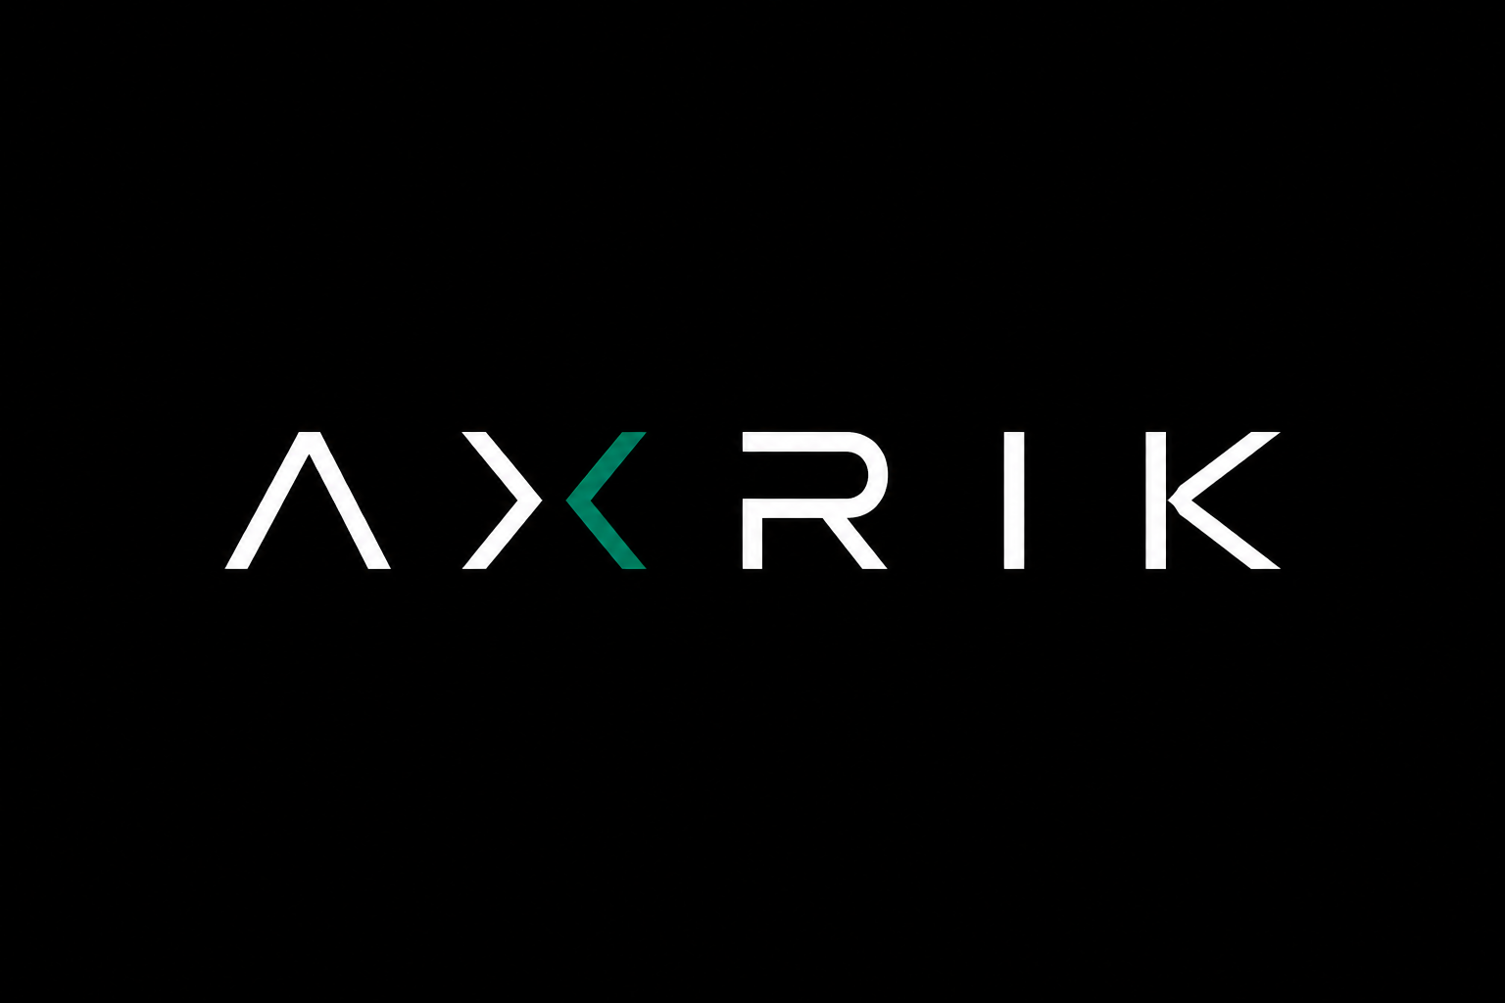
New Client Setup Guide
A step-by-step process for getting a new client’s infrastructure in place
before the build starts. Follow this in order every time.

Overview
Every AXRIK client ends up with:
- A domain they own (registered in their name)
- Cloudflare managing their DNS (free)
- A professional email address forwarding to their existing inbox (free)
- A Netlify account for hosting (free tier)
- A Supabase project for the database and auth (free tier)
- A GitHub repo under your AXRIK account that drives all deployments
You do the build. They own the infrastructure. You never need their login credentials to redeploy.

Before You Start
Ask the client two questions:
1 — Do you already have a domain?
- Yes → skip to Step 3 (Cloudflare). They’ll need to transfer DNS management to Cloudflare or point their existing nameservers at it.
- No → start at Step 1.
2 — Do you already have a Netlify account?
- Yes → ask to be added as a team member (admin role). Skip Step 4.
- No → follow Step 4.

Step 1 — Buy the Domain (Client owns this)
You walk the client through this, or do it on their behalf with their details. Use Cloudflare Registrar (cloudflare.com/products/registrar) — at-cost pricing, no markup, no upsell.
- Go to cloudflare.com and create a free account in the client’s name using their email address
- From the dashboard, go to Domain Registration → Register Domains
- Search for the domain name, confirm it’s available, and purchase
- Pay with the client’s card — cost is typically £8–12/year
- The domain now lives in Cloudflare and DNS is already managed there (no extra step needed)
If client already has a domain elsewhere (GoDaddy, Namecheap etc): Option A (preferred) — transfer to Cloudflare Registrar. Option B — keep domain where it is but change the nameservers to Cloudflare’s.

Step 2 — Set Up Professional Email (Free)
You do this inside the client’s Cloudflare account. Uses Cloudflare Email Routing — completely free. Creates a professional address (e.g. jon@jgfoodsnorthwest.com) that forwards to the client’s existing inbox.
- In the client’s Cloudflare dashboard, go to the domain → Email → Email Routing
- Click Get Started
- Under Custom Addresses, click Create Address
- Set the custom address (e.g. jon@jgfoodsnorthwest.com)
- Set the destination as the client’s existing personal email
- Cloudflare adds the required DNS records automatically
- The client gets a verification email at their personal address — they click confirm
If the client wants a proper separate inbox: upgrade to Google Workspace — £5.20/user/month. Set up through Google Admin rather than Cloudflare.

Step 3 — Set Up Cloudflare for DNS
Skip this if you completed Step 1 — Cloudflare is already handling DNS. Only needed if the domain is registered elsewhere.
- Create a free Cloudflare account (in client’s name and email)
- Click Add a Site, enter their domain name
- Select the Free plan
- Cloudflare scans existing DNS records — review and confirm
- Cloudflare gives you two nameserver addresses
- Log into the domain registrar and replace existing nameservers with Cloudflare’s
- Wait up to 24 hours for propagation (usually under an hour)

Step 4 — Create the Netlify Account (Client owns this)
Client creates the account. You get added as collaborator.
- Go to netlify.com and sign up using the client’s email address
- Choose the Free (Starter) plan
- Once the account is created, go to Team Settings → Members
- Invite your AXRIK email as a member with admin role
- You now have full deployment access without needing the client’s password
Redeployments: you never need to touch Netlify directly after this. All deployments are driven by GitHub (Step 6). Every push to the main branch redeploys automatically.

Step 5 — Create the Supabase Project (Client owns this)
Client creates the account. You get added to the project.
- Go to supabase.com and sign up using the client’s email address
- Click New Project
- Name the project (e.g. jg-foods)
- Choose a strong database password — save this securely in a password manager
- Select the EU West region (closest to UK clients)
- Once created, go to Project Settings → Team
- Invite your AXRIK email as an admin
The Supabase project URL and anon key (found in Project Settings → API) go into Netlify as environment variables — never hardcode them in the repo.

Step 6 — Create the GitHub Repo (You own this)
You do this under the AXRIK GitHub organisation.
- Go to github.com and create a new repository under the AXRIK organisation
- Name it clearly (e.g. jg-foods)
- Set it to Private
- Add a README — tick the box
- Clone it locally and start building
The client does not need a GitHub account. The repo lives under AXRIK and you manage it entirely.

Step 7 — Connect GitHub to Netlify (One-time setup)
This is what makes all future deployments automatic.
- Log into the client’s Netlify account (or use your team member access)
- Click Add New Site → Import an Existing Project
- Choose GitHub and authorise Netlify to access your AXRIK GitHub account
- Select the client’s repo (e.g. jg-foods)
- Set build settings — leave build command blank for plain HTML/JS; set publish directory to / or wherever index.html lives
- Click Deploy Site
From this point on: push to GitHub main branch → site redeploys automatically. No one needs to touch Netlify.
Important: when authorising Netlify, make sure you grant access to your organisation repos — not just personal repos. Easy to miss during the OAuth flow.
Preview deployments: any branch you push to GitHub gets its own preview URL. Test new versions here before merging to main.

Step 8 — Connect the Domain to Netlify
- In Netlify, go to Site Settings → Domain Management
- Click Add Custom Domain and enter the client’s domain
- Netlify gives you a DNS record to add (usually an A record or CNAME)
- Go to the client’s Cloudflare dashboard → DNS → Add the record Netlify provided
- Back in Netlify, click Verify DNS Configuration
- Netlify provisions a free SSL certificate automatically via Let’s Encrypt (takes a few minutes)

Step 9 — Add Environment Variables to Netlify
Sensitive values go into Netlify as environment variables — never in the code.
- In Netlify, go to Site Settings → Environment Variables
- Add SUPABASE_URL — from Supabase Project Settings → API
- Add SUPABASE_ANON_KEY — from Supabase Project Settings → API
- Add any other service keys (EmailJS, Twilio etc.)

Summary Checklist
Tick these off before starting the build.
☐ Domain registered in client’s name via Cloudflare
☐ Professional email set up and forwarding confirmed
☐ Cloudflare managing DNS
☐ Netlify account created in client’s name
☐ Your AXRIK email added as Netlify admin
☐ Supabase project created in client’s name (EU West region)
☐ Your AXRIK email added as Supabase admin
☐ Database password saved securely
☐ GitHub repo created under AXRIK organisation (private)
☐ GitHub repo connected to Netlify (auto-deploy active)
☐ Client domain connected to Netlify with SSL confirmed
☐ Environment variables added to Netlify

If the Client Already Has a Domain

Scenario A — Domain is at Cloudflare already
Nothing to do. Just work with their existing DNS.

Scenario B — Domain is at GoDaddy, Namecheap etc.
- Preferred: transfer to Cloudflare Registrar (client authorises the transfer, takes 5–7 days)
- Faster: change nameservers at the registrar to point at Cloudflare (takes 1–24 hours)
Either way, once Cloudflare is managing DNS, the rest of the process is identical.

Cost Summary for the Client
Item | Cost
Domain registration | ~£10/year
Cloudflare (DNS, email routing, SSL) | Free
Netlify hosting | Free (Starter tier)
Supabase database | Free (up to 500MB)
Email forwarding via Cloudflare | Free
Google Workspace (optional — proper inbox) | ~£62/year
Total minimum | ~£10/year

Notes for Future Clients
- This process takes about 30–45 minutes end to end (excluding DNS propagation wait times)
- All accounts are in the client’s name — they own everything
- You maintain developer access through team/collaborator invites — no shared passwords needed
- As AXRIK grows, look into Netlify’s agency/team plan for managing multiple client sites from one dashboard

Document maintained by AXRIK · Last updated May 2026

