Delivering to More Than One Address: How It Works
AXRIK — prepared for JG Foods
July 2026


What I’ve Built
You asked for a way to handle customers like Billy Bunters, who have more than one site — in their case, two addresses in Birkenhead. You wanted one invoice covering both, split out so you can see what each site owes, with one total at the bottom. That’s exactly what I’ve built.
From now on, any customer can have extra delivery addresses added to their record. Once they do, everything follows on automatically — logging their orders, the invoice, and taking payment. Nothing changes for any of your normal, single-address customers.
Here’s the whole process, step by step.

Step 1 — Add the Extra Site (Once Only)
You only do this once per customer. After that, it’s set up for good.
- Go to Customers.
- Find the customer (e.g. Billy Bunters) and press Edit.
- Scroll down to Delivery sites.
- Type the site’s name or address — for example: 4a Russell Road, Birkenhead, CH42 1RP.
- Press + Add site.
- If they have a third site, repeat step 4 and 5 for that one too.
That’s it. This customer is now set up as a multi-site customer, and every order you log for them from now on will ask which site it’s for.

Step 2 — Log Each Delivery As You Normally Would
Nothing changes about how you log an order — there’s just one extra box.
- Go to Log Order.
- Start typing the customer’s name and pick them from the list, same as always.
- A new box appears: Delivery site. Choose which of their addresses this particular delivery is for.
- Add the items and quantities as normal.
- Pick the delivery day and save.
Do this once for each site’s delivery — so if Billy Bunters wants a delivery to both addresses this week, you’ll log two separate orders, choosing a different site each time.
On the delivery run and the route planner, you’ll see the site address clearly marked next to the order, so there’s no confusion about which of their addresses you’re delivering to.

Step 3 — The Invoice Builds Itself
You don’t need to create anything for this. The moment you log a delivery for a multi-site customer, it automatically starts (or adds to) one running invoice for that customer.
You’ll find it under Finance → Saved invoices & receipts, marked “running tab”. There’s a Running filter button at the top of that list to find it quickly.
Every further delivery you log for that customer — to either site — adds onto that same invoice. Nothing is sent to the customer yet at this point; it’s just quietly keeping score.

Step 4 — Send the Invoice When You’re Ready
When you’re ready to bill the customer — say, at the end of the week — this is the one thing you do by hand.
- Go to Finance → Saved invoices & receipts and press Running to find it.
- Press Finalise & send on their invoice.
- It’s now a proper, finished invoice — download it as a PDF, or send it straight over by email or WhatsApp, same as any other invoice.
Their very next delivery after this automatically starts a brand new running invoice — you don’t need to reset anything.

Step 5 — Taking Payment
This is the important bit you asked me to make sure was right: the invoice is treated as one single bill, even though it lists two sites.
- If the customer pays the whole amount in one go, press Log payment and enter the full total — done.
- If they only pay part of it, log whatever amount they’ve actually paid. The invoice will show “part paid”, with the remaining balance worked out for you automatically.
It doesn’t matter which site the payment relates to — every pound they pay comes off the one total. You’ll never need to split a payment between the two sites yourself.

Side by Side — What You’re Sending Today vs What the Client Gets Now
Same real week for Billy Bunters, same items, same £338.00 total — so you can see exactly what changes for the client.
What you’re sending today:
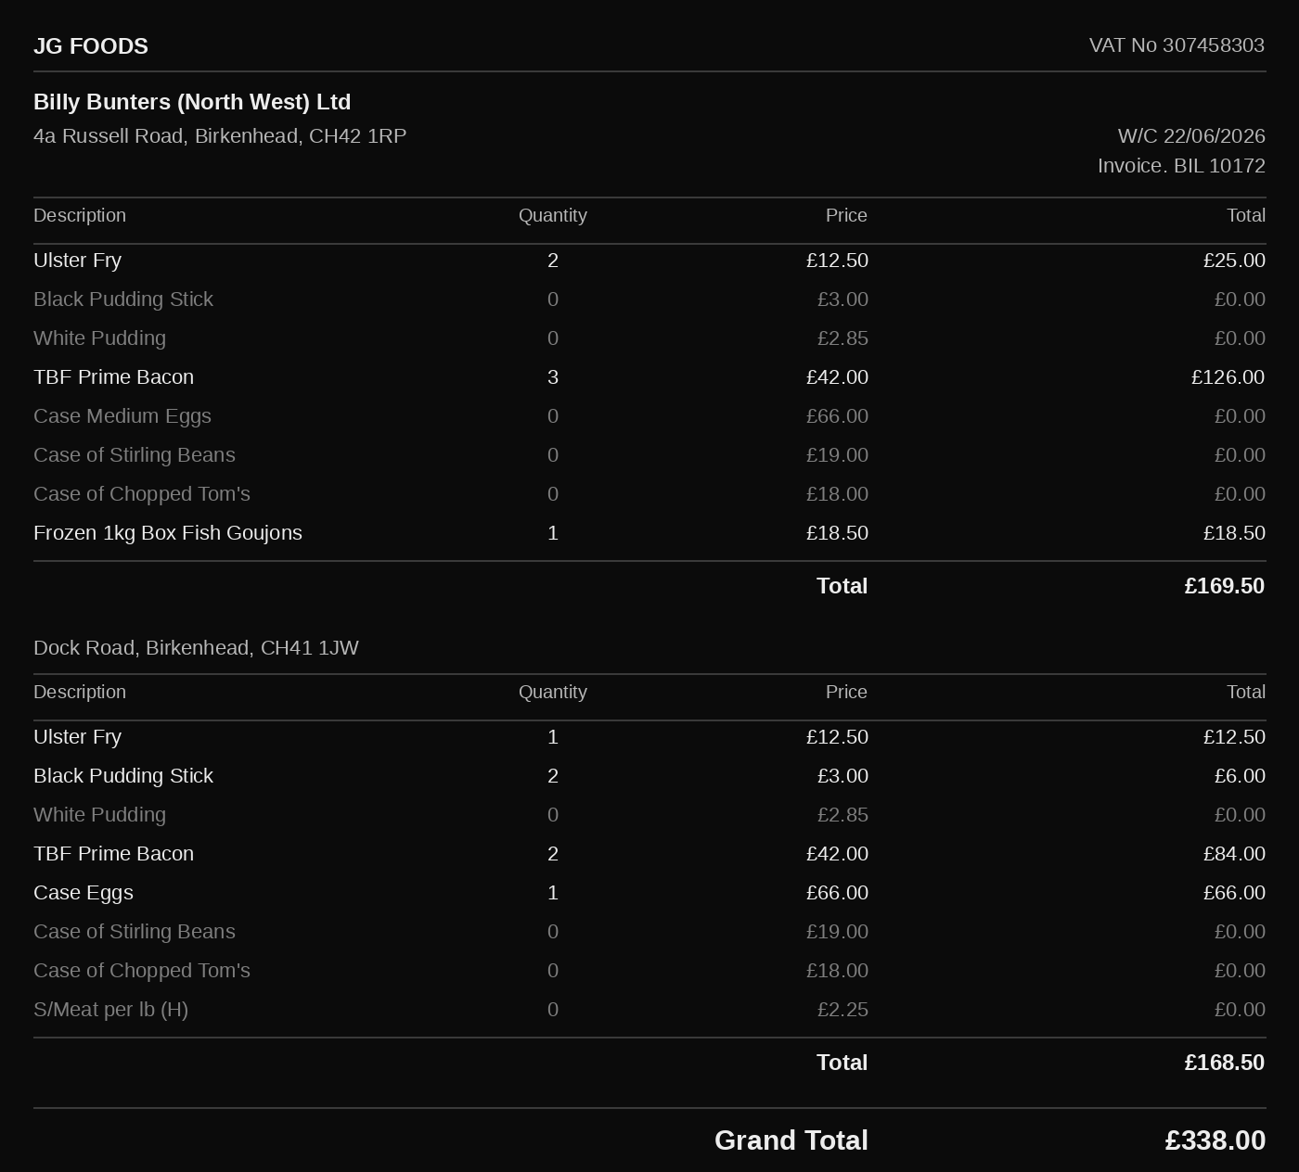
What the client gets from now on:
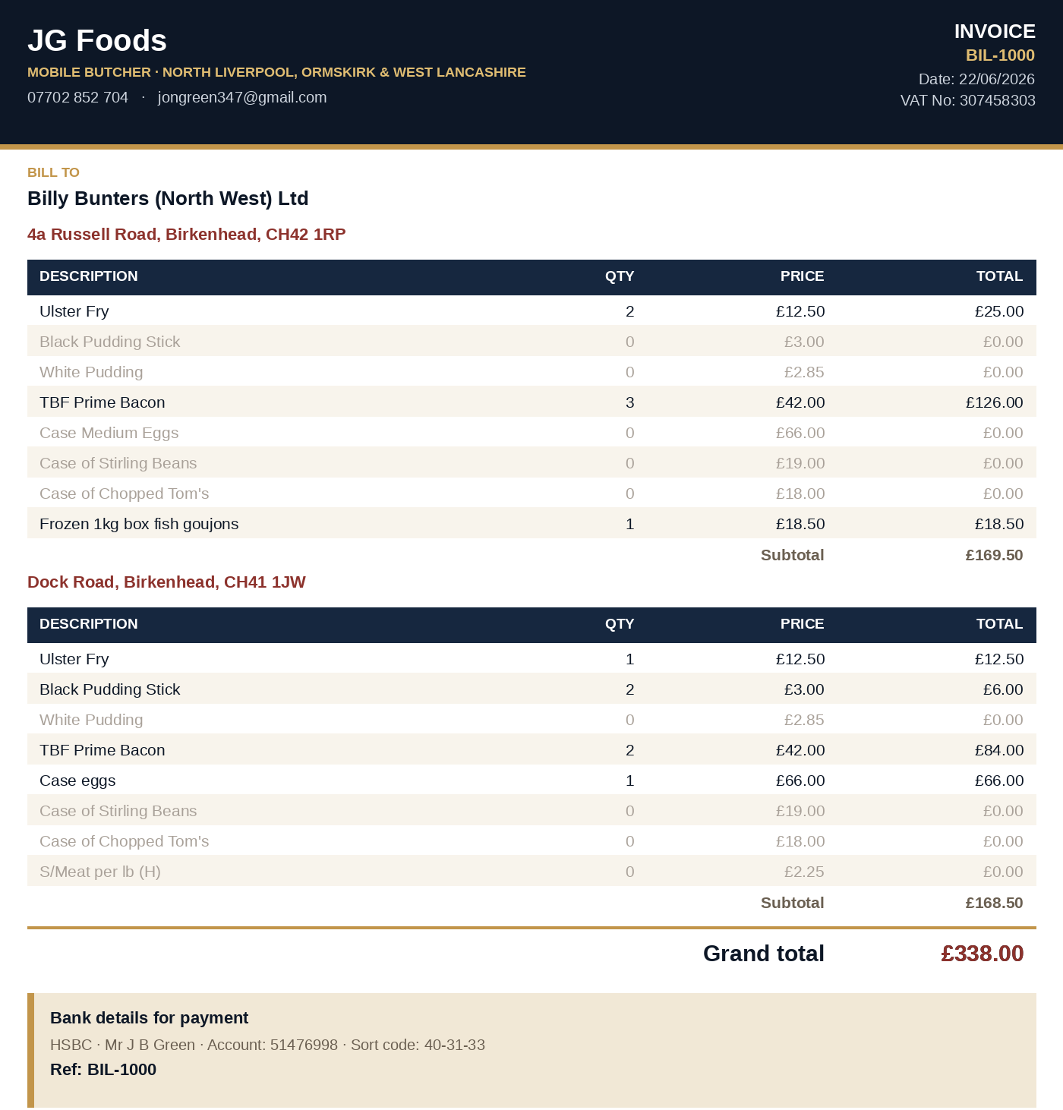
One thing worth knowing: in real use, the app’s invoice won’t actually list products with a zero quantity like the spreadsheet does — it only shows what was genuinely ordered, since it’s built from what’s added in Log Order rather than a fixed template. The zero-quantity rows are only included above so both examples line up item for item — the real invoice will actually be a bit shorter and cleaner than this.
Both examples add up to the same Grand Total: £338.00. If Billy Bunters then pays £200 towards this, the invoice shows £200 paid, £138.00 remaining — one balance, not two.

A Few Things Worth Knowing
- Nothing changes for your normal customers. If a customer only has one address, everything works exactly as it does today — nothing new to learn.
- This works for any customer type — trade or domestic. If a domestic customer ever has two properties you deliver to, the same steps apply.
- Don’t use “Mark paid” on an individual order for a multi-site customer — that button is for a single delivery, and doesn’t make sense once several deliveries are sharing one invoice. Always use Log payment on the invoice itself instead.
- Forgot to pick a site when logging an order? It’s not a problem — it’ll just be labelled “Main site” on the invoice rather than a named address. You can always go back and check the delivery run to see which address it should have been.
If anything here doesn’t make sense once you’re using it, flag it and I’ll talk you through it.

