# **Financial Ghost (FG) - Financial Planner for Fresh Graduates**

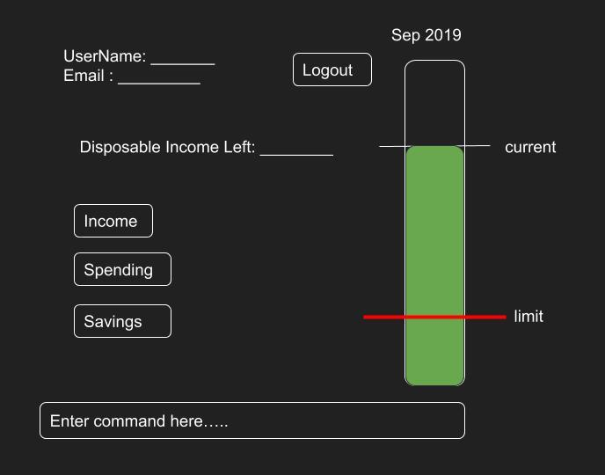

* Financial Ghost (FG) is a desktop application written in Java OOP fashion.
* Developed specifically for fresh graduates of NUS, provides a financial planner available locally on the user’s desktop.
* Allows users to set financial goals, and monitor their income and expenditure.
* Tracks the influx and outgoing of income, guiding users financially for them to be better able to afford any financial goals set.

## 

## **Site Map**

* [User Guide](https://github.com/nusCS2113-AY1920S1/addressbook-level3/blob/master/docs/UserGuide.adoc)
* [Developer Guide](https://github.com/nusCS2113-AY1920S1/addressbook-level3/blob/master/docs/DeveloperGuide.adoc)
* [Learning Outcomes](https://github.com/nusCS2113-AY1920S1/addressbook-level3/blob/master/docs/LearningOutcomes.adoc)
* [About Us](https://github.com/nusCS2113-AY1920S1/addressbook-level3/blob/master/docs/AboutUs.adoc)
* [Contact Us](https://github.com/nusCS2113-AY1920S1/addressbook-level3/blob/master/docs/ContactUs.adoc)

## **Acknowledgements**

* Libraries used: [JavaFX](https://openjfx.io/), [JUnit5](https://github.com/junit-team/junit5)