**INFORMATION**

Write appropriate scripts (m-file) in MATLAB to solve the questions. To solve the questions you may need to do some additional research and study. Show your references as a footnote where necessary. You may discuss and work with your friends to find solutions. However, everyone should **write** their **report alone** and use their own words. Any **cheating, copy-paste, etc.** will result in **zero grade** for students who are involved. A report format is given as part of this homework, use it to write your own report. Your report should include your code, your results (images, graphs, text, etc.), as well as your comments about your code and your results. The **deadline** for the report is **06.11.2019**. You are requested to bring a printed out copy of your report to the first mid-term exam. Reports will be collected during the exam. Any late or no submissions will be graded with a zero.

Good luck.

**QUESTIONS**

1. Write a script (m-file) that will take the artificially colored MRI image named “mri_img.png” in the supplied files (Figure 1) and separate the red tumor from the image. Using imread() function acquire all three red (R), green (G) and blue (B) color channels. You may use thresholding approach while creating the mask. To decide on the threshold values you may use the histogram of each color channel and optimize them by trial and error. After getting the mask use it to segment the image. Using subplot() function  
   put original image, segmentation mask and segmented image on a single row similar to Figure 2.

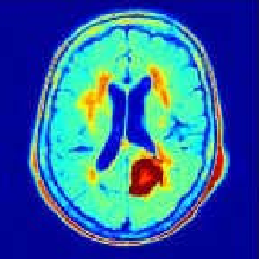

Figure 1 – Artificially colored MRI image[1]

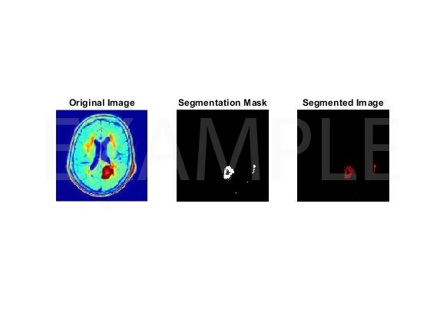

Figure 2 – Example results

1. Write a script (m-file) that will take the stereo audio file named “numbers_and_vowels.m4a” in the supplied files and separate “number” and “vowel” sounds in it. Using audioread() function acquire both left and right channels as well as the sampling frequency. Using a single channel, manually determine and separate each “number” and “vowel” sound. Then, concatenate individually the “number” sounds and all the “vowel” sounds in their respective arrays (you will need to create two different arrays in which the “number” sounds and “vowel” sounds are located sequentially). Then play “number” sounds and “vowel” sounds vectors one after another (not together). Using subplot() function plot original sound, only “number” sounds and only “vowel” sounds on a single column similar to Figure 3.

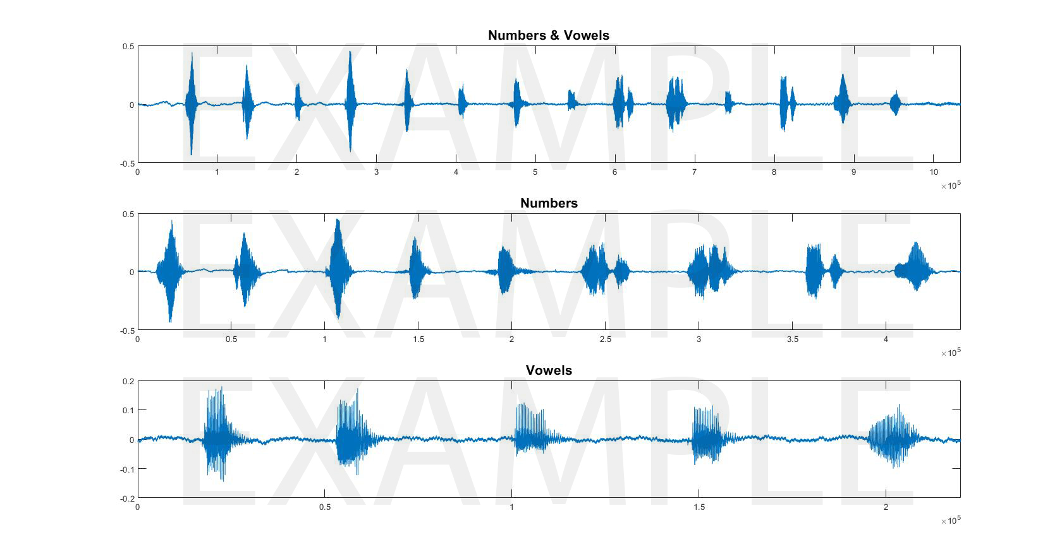

Figure 3 – Example results

1. Wu, M.N., Lin, C.C. and Chang, C.C., 2007, November. Brain tumor detection using color-based k-means clustering segmentation. In Third International Conference on Intelligent Information Hiding and Multimedia Signal Processing (IIH-MSP 2007) (Vol. 2, pp. 245-250). IEEE.