**Report Type: Analytical assignment report**

**Name and Surname: Aya Ahmed Faeek ELGebaly**

**Student Number: 19017602**

**RESEARCH:**

With the help of “MATLAB for Engineers” [1] book and “MathWork” [2] I could do the following:

* To read the audio file I used the audioread()[3] function and store the both left and right channels as a matrix in variable (y) and also store the frequency of our audio in (fs) variable.
* Now we have to extract channel 1 from our sound file: by indexing the first column of the audio file matrix in a new vector. y1= y(:,1); % extraction of channel 1

**NOTE:**

* Sound files in MATLAB have two columns such that the left column is the first channel and the right column is the second channel. If we have all the relevant information (particularly sampling frequency ‘Fs’) we can reproduce the sound from each channel “column” independently and successfully.
* We can see the elements of the matrix which contain the channels by run the variable (y). And you can note that, they are so similar.
* Now we can plot our wave by using plot()[4] function like that: plot(y1). And from the plot you can manually determine the position of each “number” and “vowel” sound by using the ‘data cursor’ tool in MATLAB.

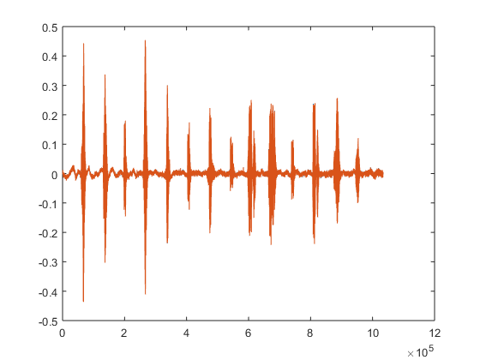

Figure 1 – Channel 1 of the sound wave

* After finding the position ‘manually’ of each number and vowel sound I could separate them by put every unit in different variable.
* Then, we can create 2 arrays, the first array contains the “Numbers” sounds and the second one contains the “vowel” sounds.
* Now we can play the “number sounds“ file and the “vowel sounds” file separately by using sound()[5] functionlike that
* sound(numbers,fs)
* sound(vowels,fs)
* To plot our subplot we can subplot()[6] function which will help us to put our “Numbers&Vowels” ,“Numbers” and “Vowels” plots together.

**CODE:**

|  |
| --- |
| %%  %start  clear  clc  close all  %%  % first we have to read our sound file and save its two channels in a matrix  [sound_matrix,fs]=audioread('numbers_and_vowels.m4a'); % fs variable will store our frequency  first_channel= sound_matrix(:,1); % extraction of channel 1    %%  %our numbers and vowels variables after determine and separate them manually  number1 = first_channel(5.77e4:7.623e4);  nunber2 = first_channel(1.304e5:1.472e5);  a= first_channel(1.962e5:2.128e5);  number3 = first_channel(2.584e5:2.786e5);  number4 = first_channel(3.317e5:3.486e5);  e=first_channel(4.023e5:4.187e5);  number5 = first_channel(4.657e5:4.999e5);  i=first_channel(5.378e5:5.56e5);  number6 = first_channel(5.955e5:6.245e5);  number7 = first_channel(6.645e5:6.944e5);  o=first_channel(7.372e5:7.523e5);  number8 = first_channel(8.052e5:8.302e5);  number9 = first_channel(8.732e5:8.988e5);  u=first_channel(9.452e5:9.607e5);  %%  %our separated vectors    numbers= [number1; nunber2; number3; number4; number5; number6; number7; number8; number9];  vowels= [a; e; i; o; u];    %%  %subplot    subplot(3,1,1),plot(first_channel),title('Numbers & Vowels');  subplot(3,1,2),plot(numbers),title('Numbers');  subplot(3,1,3),plot(vowels);title('Vowels') |

**COMMENTS ABOUT THE CODE:**

I believe in that, good code comments explain why things are done, not what is done. The code itself explains what is done. The need for comments should be minimal. And i tried to identify and simplify my code as well as possible. I used the comment sign ‘%’ to add comment in my code.I started my code with reading the original sound file and save its two channels in a matrix which contain two columns represent the channels of our sound. And the frequency of our sound was stored in fs variable.

I made an extraction for the first channel of the sound’s two channels.

I separated the numbers and vowels signals manually after identify the index of them from the plot of the original sound wave.

After that, I stored each type of signals in different array to make us capable of display them separately.

Using the subplot() function I placed the thee plots in the same screen to reach our result.

**RESULTS:**

The result of our code is showed as follows:-

And you can play the “number sounds“ file and the “vowel sounds” file separately by using sound() functionlike that

* sound(numbers,fs)
* sound(vowels,fs)

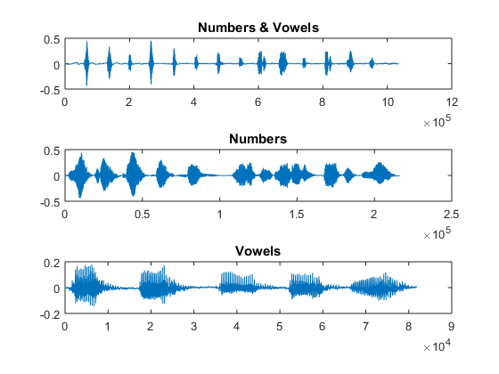

Figure 2 – The subplot of the original wave and the result waves

**COMMENTS ABOUT THE RESULTS:**

The result of my code is so clear (as you can listen to the two sound files clearly) and you can note that:

* we have extracted the sound signals and separated every sound unit and grouped them into two arrays : Numbers array&&Vowels array
* So, you can note that there is no delay between every two signals.