CHATBOTS WITH AMAZON LEX

- TECHNICAL REQUIREMENTS
- Amazon Web Services (AWS) Account
- AWS Management Console
- Amazon Lambda
- Lex Runtime API
- Lex Test Console
- Amazon CloudWatch
- Amazon X-ray
- Build and Test
2. SCENARIO
  - REQUIREMENTS
- Welcome message
- Ask Name
- Place order
- Details of the product(flavour and size)
- Confirmation of the order placed
- Generate the Order number
- Cancel Order along with order number
- Confirmation of cancellation
- Ending the request

  - ARCHITECTURE PATTERNS
Amazon Lex: The chatbot interface
- Amazon Lex is used to build the conversational interface for the chatbot. Lex handles the user's text input and processes the natural language.
- It uses intents, which represent actions the chatbot should take in response to user input.
- Slots are used within intents to capture user-provided data (like a name, date, etc.).
AWS Lambda: Business Logic and Processing
- AWS Lambda functions are invoked from Amazon Lex to process logic and interact with other services (databases, APIs, etc.).
- Lambda functions can be triggered when Lex needs to respond with dynamic data, process user input, or interact with other AWS resources.
- Lambda allows you to decouple your backend processing from Lex and execute business logic without provisioning servers.
Amazon CloudWatch: Monitoring and Logging
- Amazon CloudWatch is used to log and monitor the chatbot's activity and performance.
- CloudWatch logs capture logs from Lex and Lambda, helping developers track requests, responses, errors, and other activity.
- You can create CloudWatch metrics and alarms to monitor the performance and detect issues with the bot or Lambda functions (e.g., failed Lambda executions, errors in processing).

2.3 ARCHITECTURE
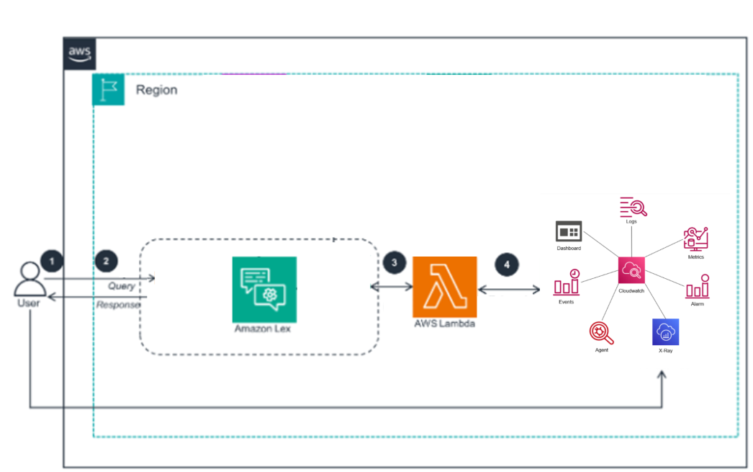
3. AWS SERVICES
3.1 Amazon CloudWatch
3.2 Amazon X-Ray
3.3 Amazon Lambda
3.4Amazon Lex
3.5 Solution Deployment
3. Amazon Lex configuration and build
4. TEST AND EXPLORE YOUR APPLICATION
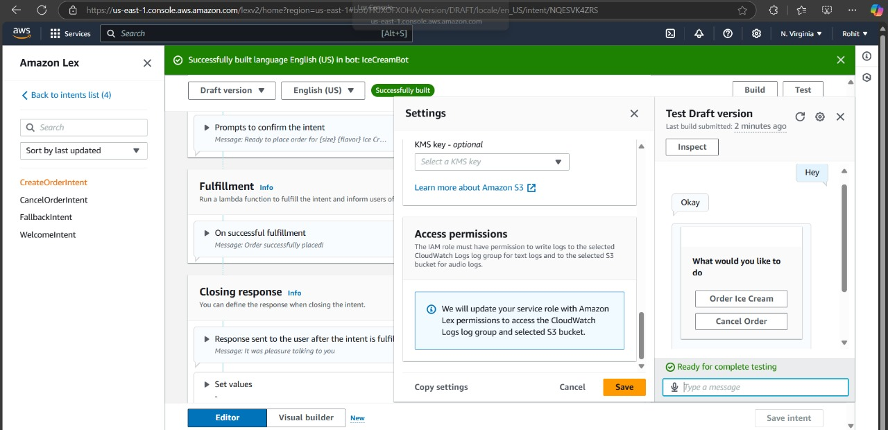
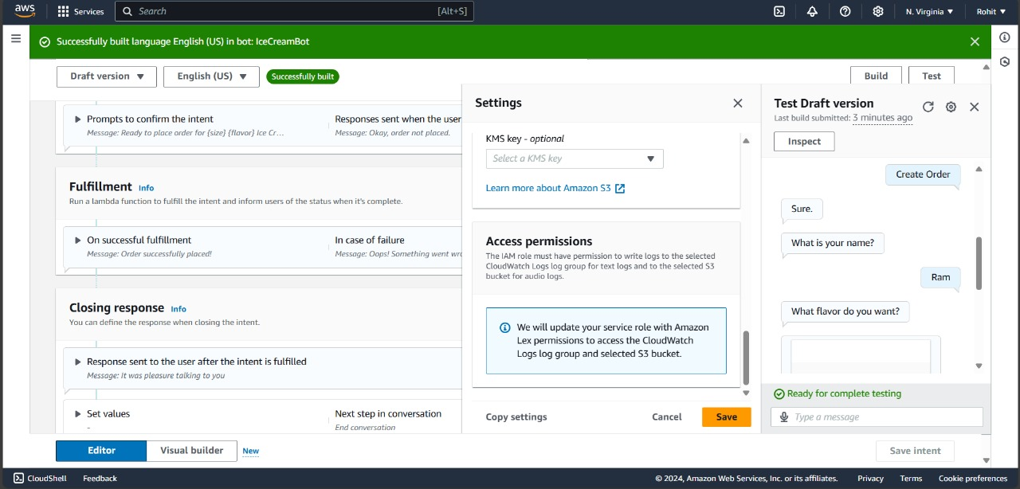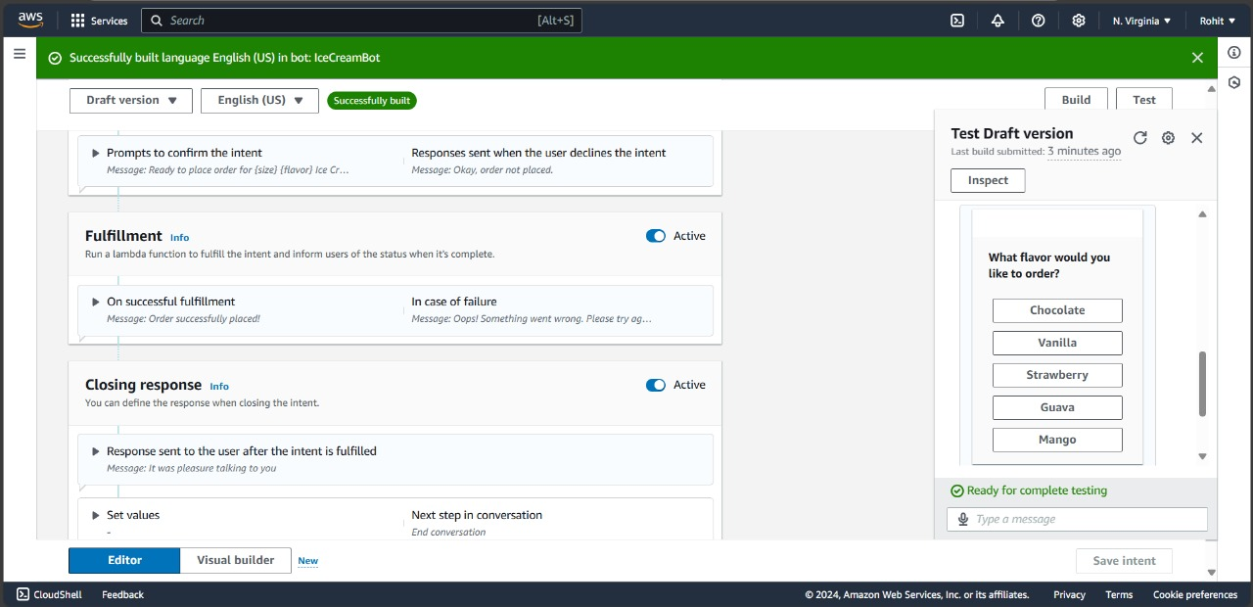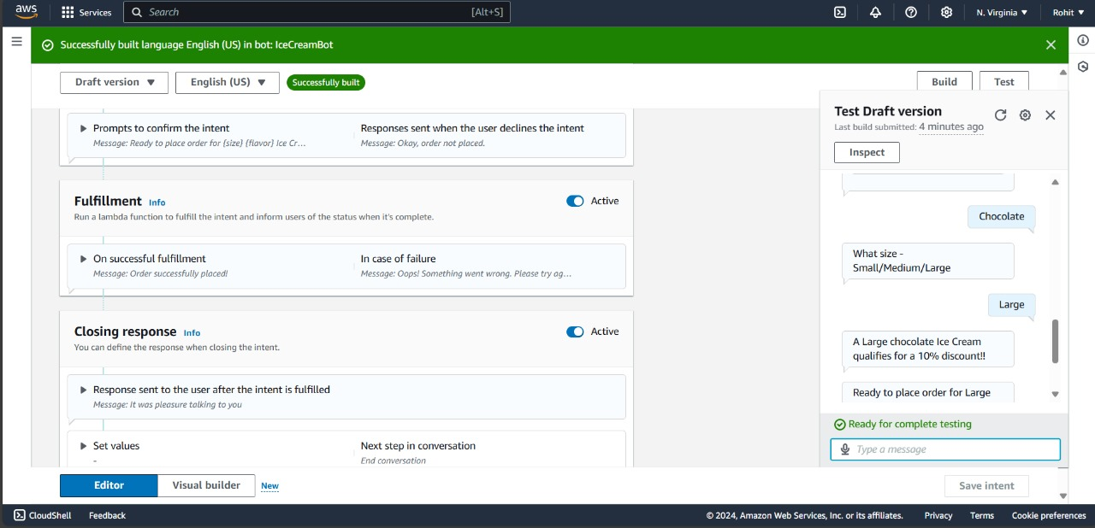
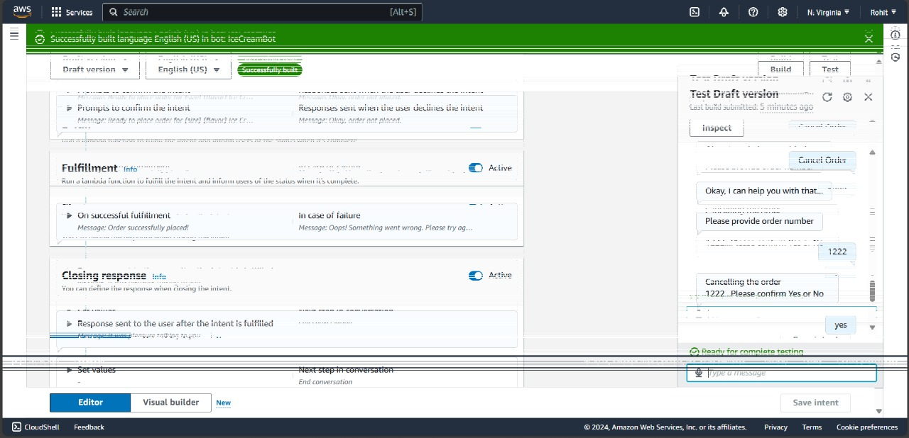
5. CODING THE SOLUTION
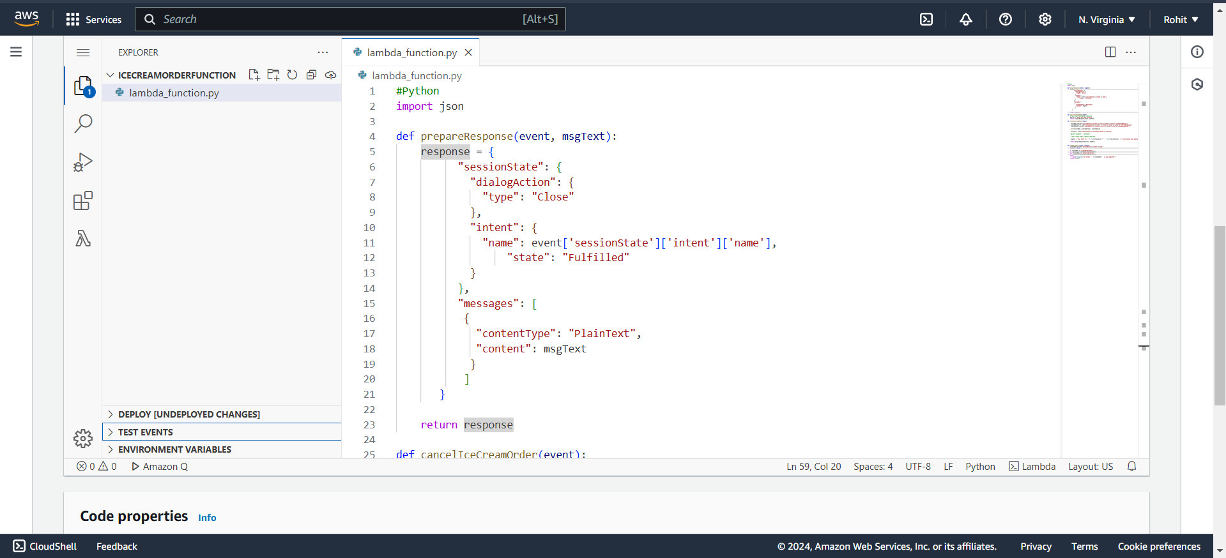
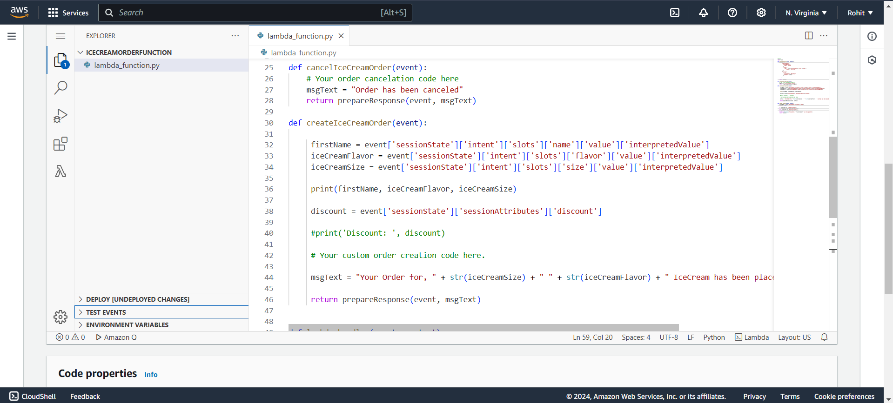
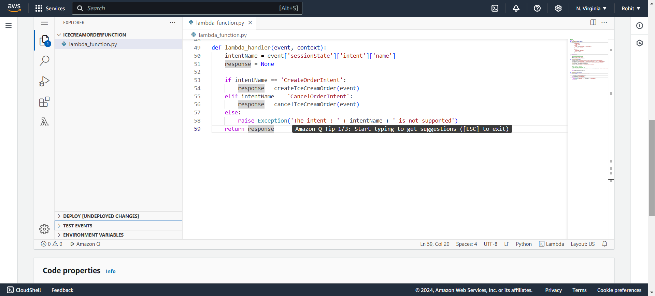
6. SCREENSHOTS

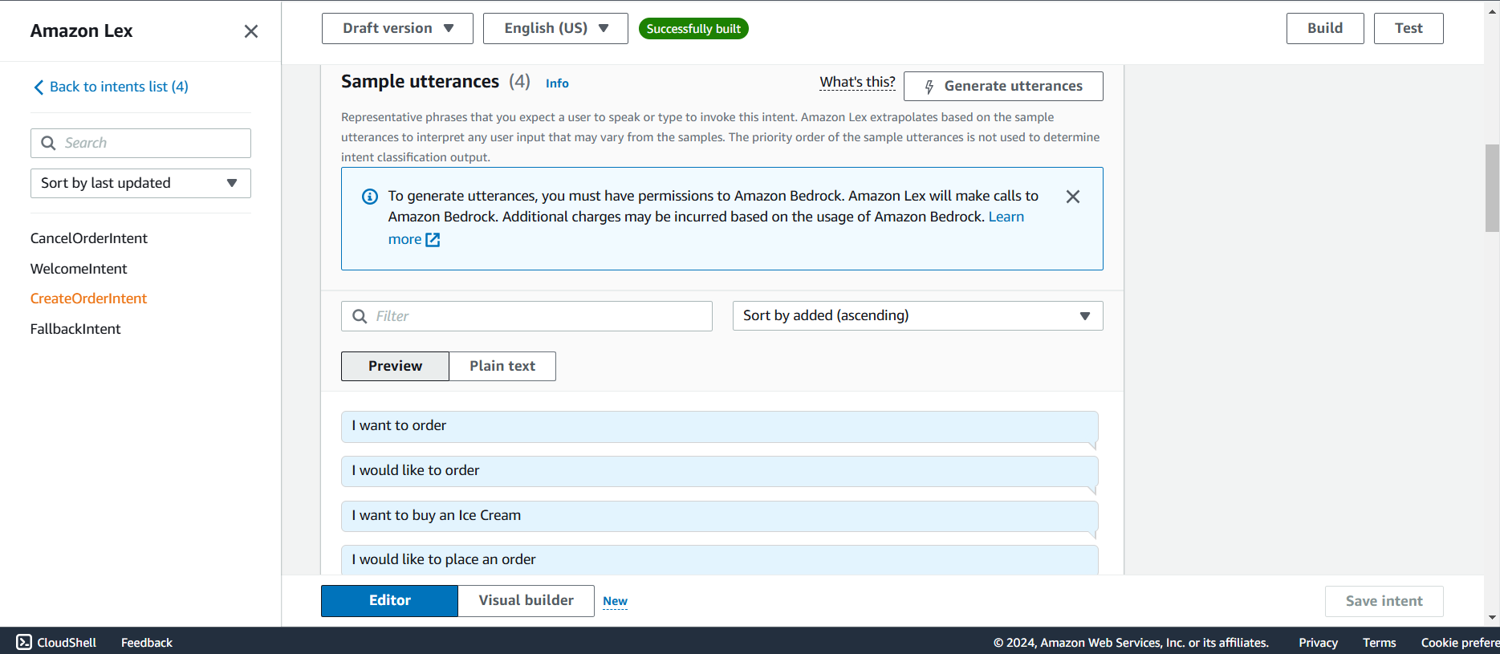
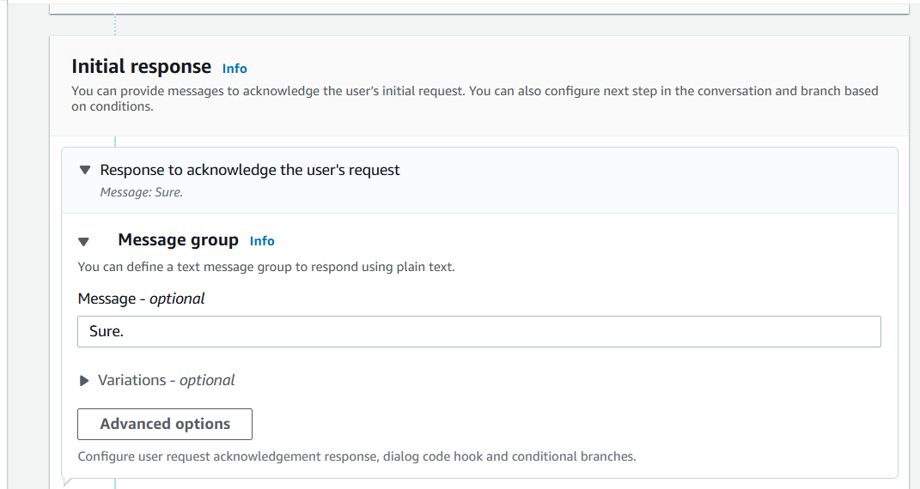
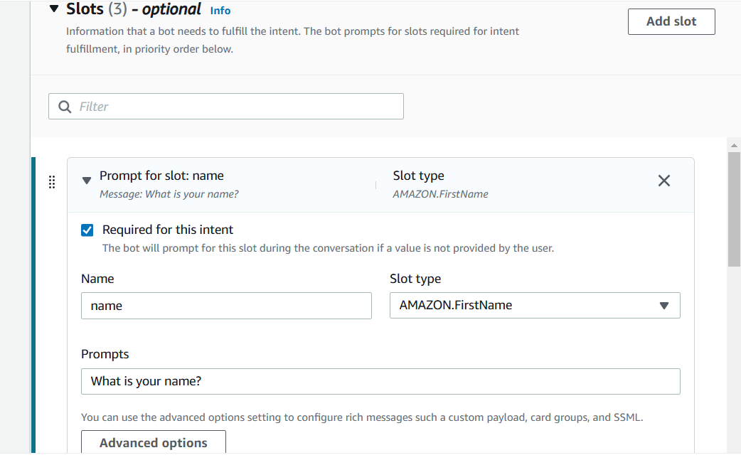
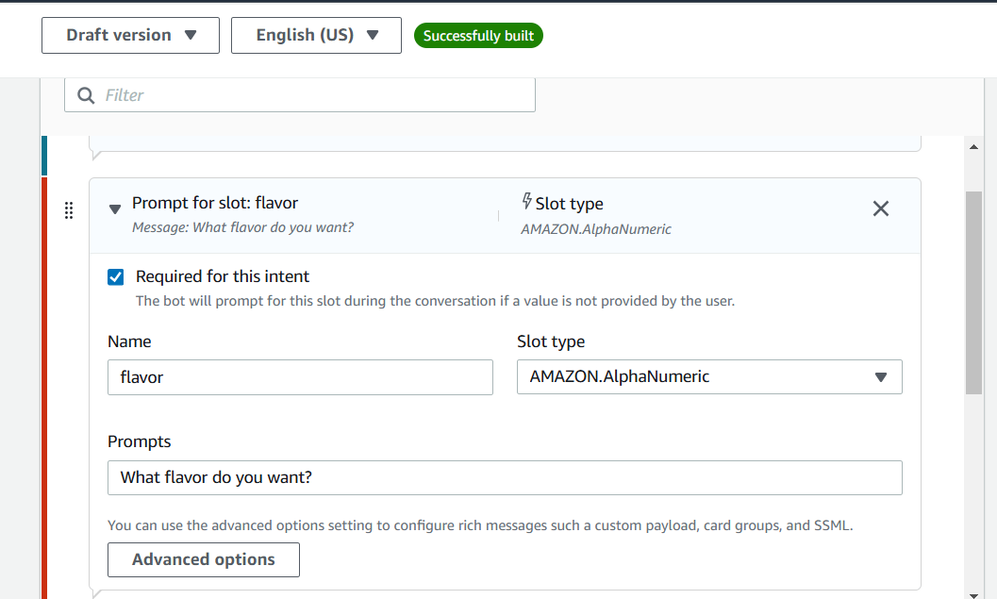
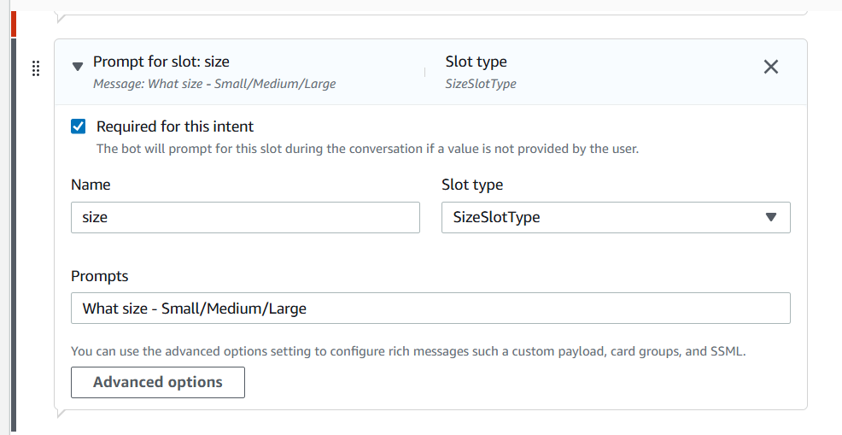

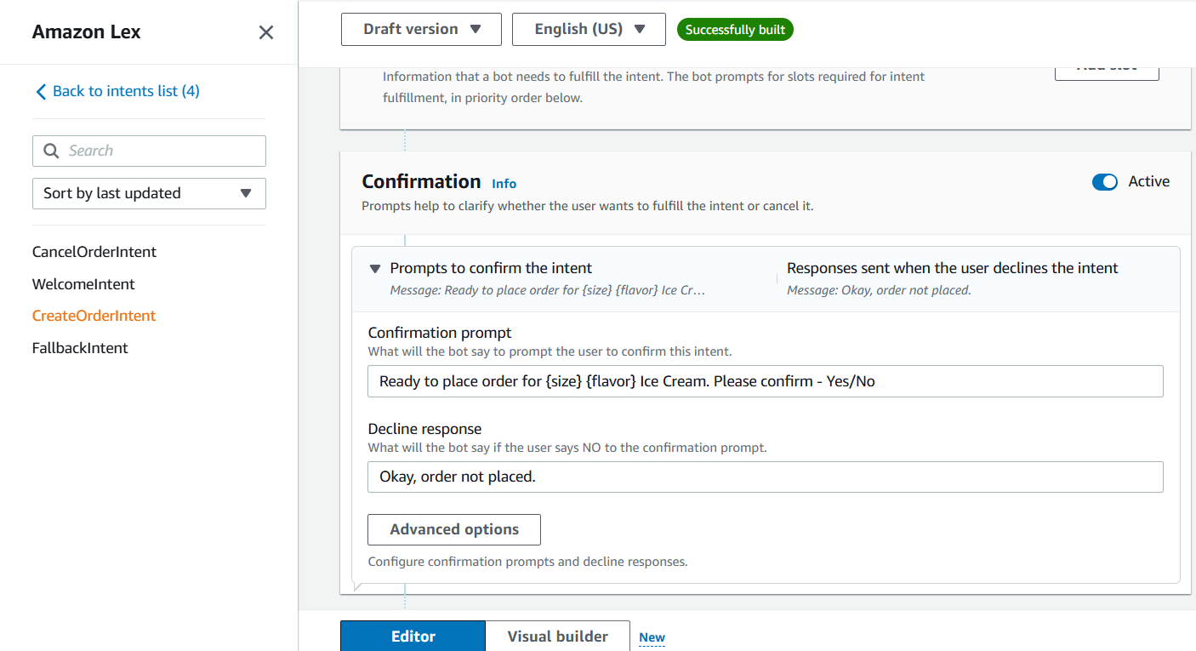
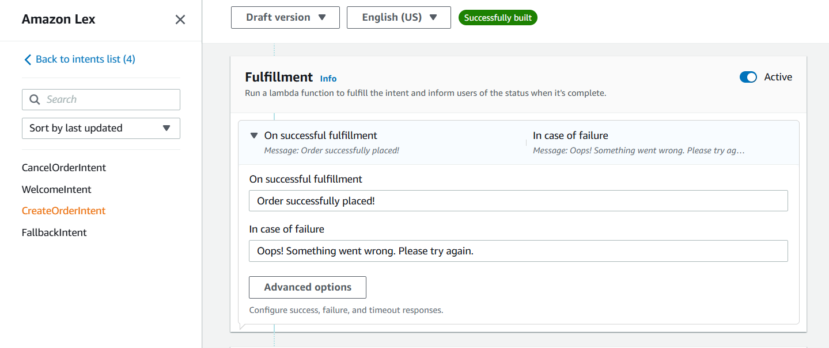
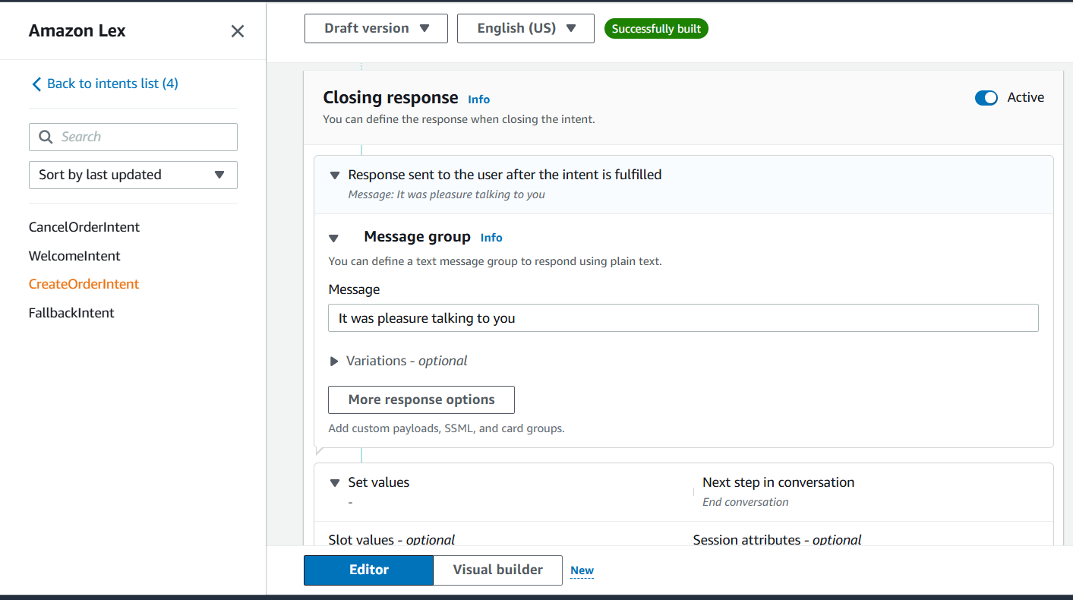

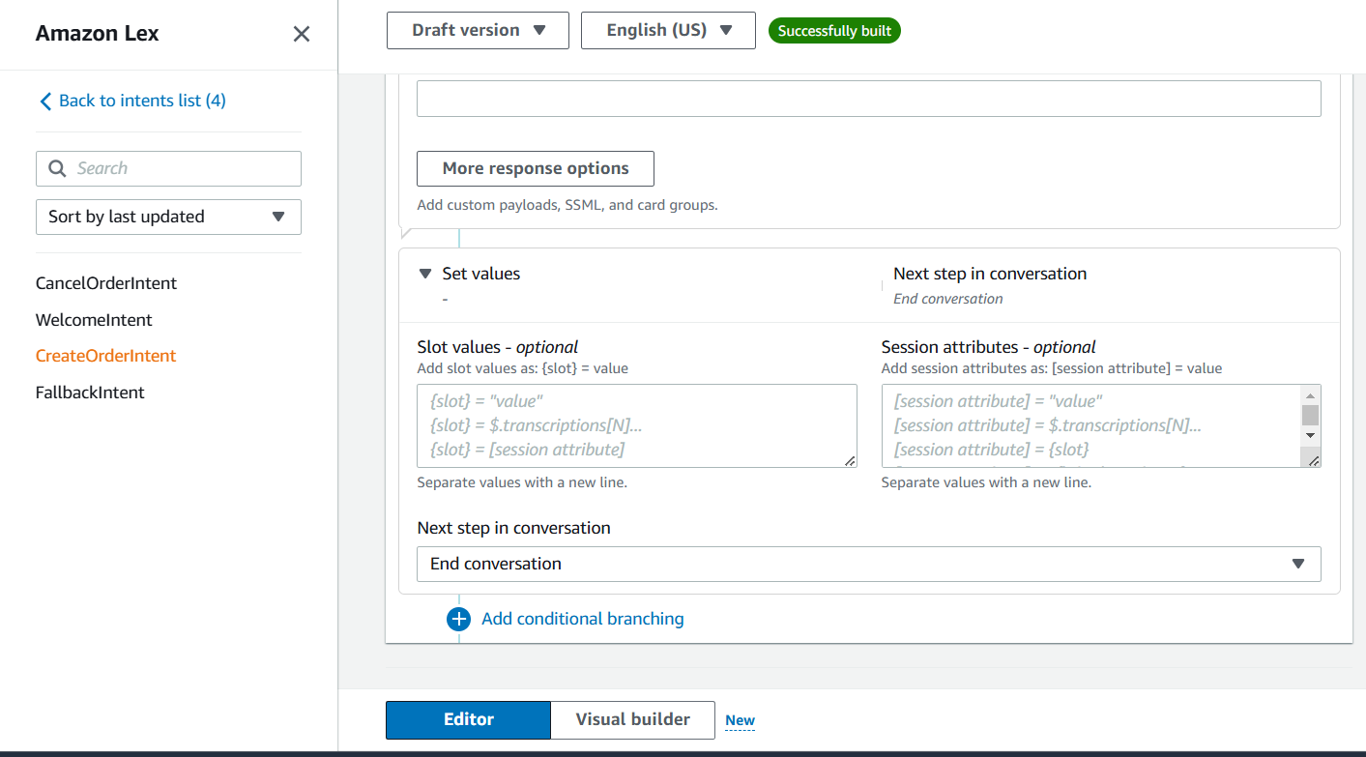
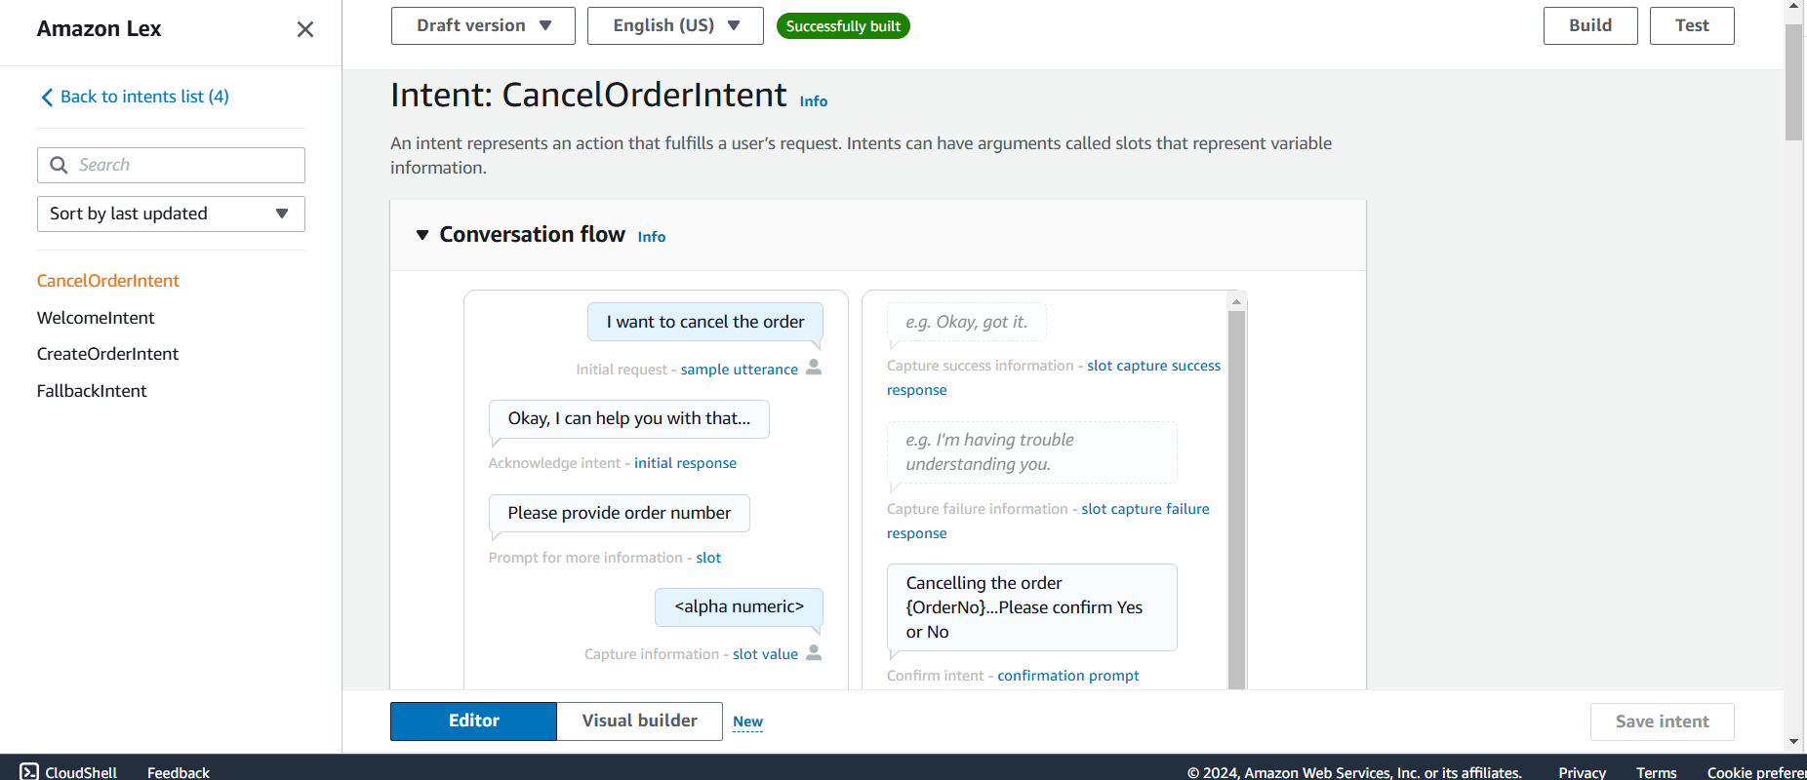
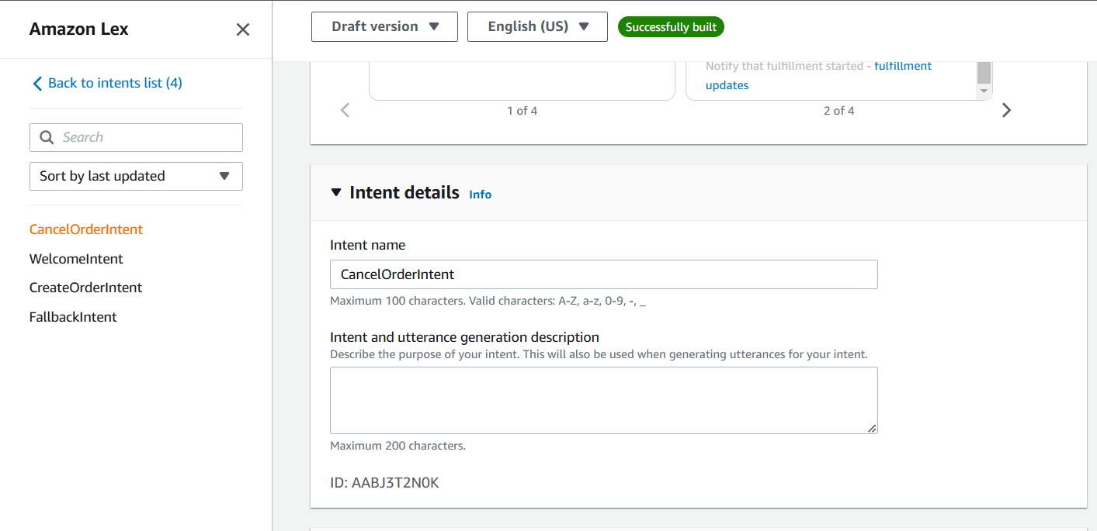
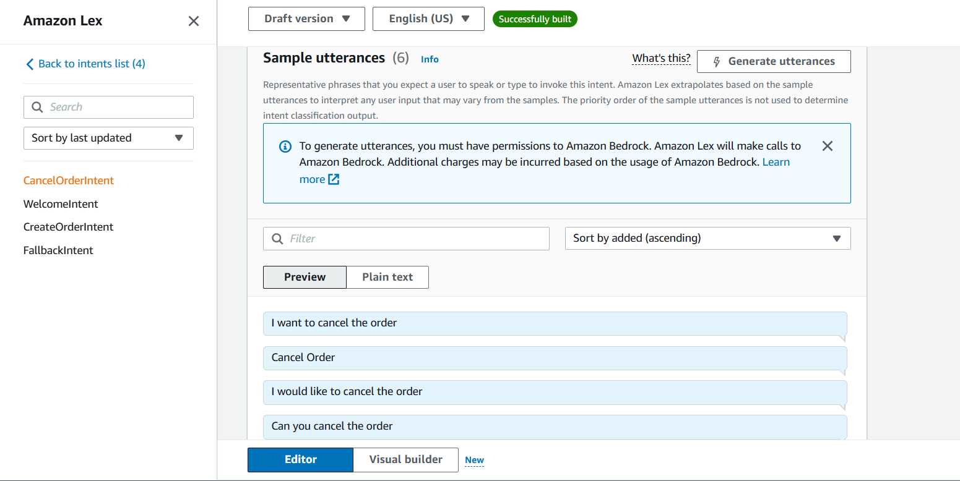
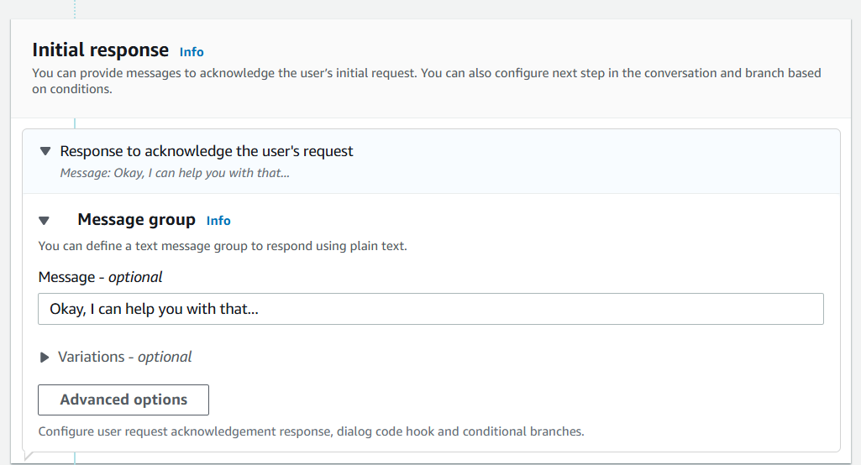
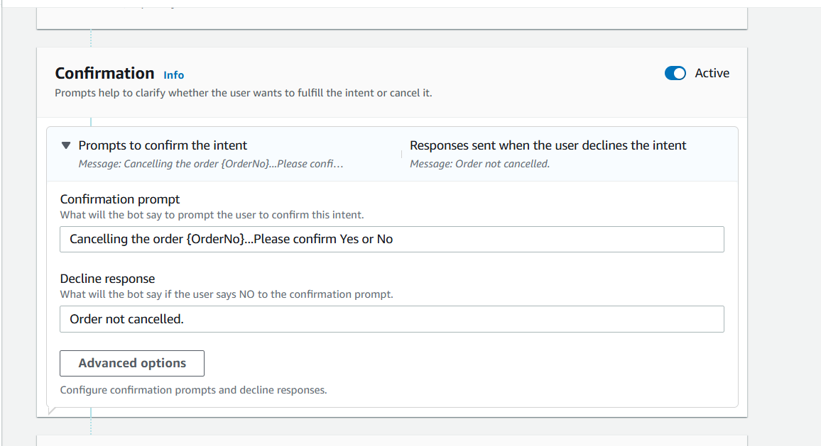
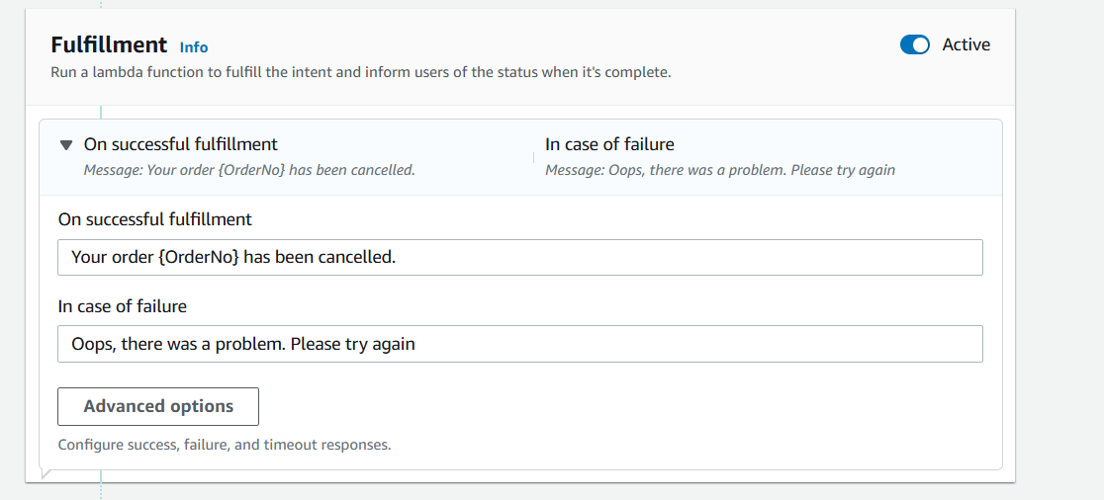
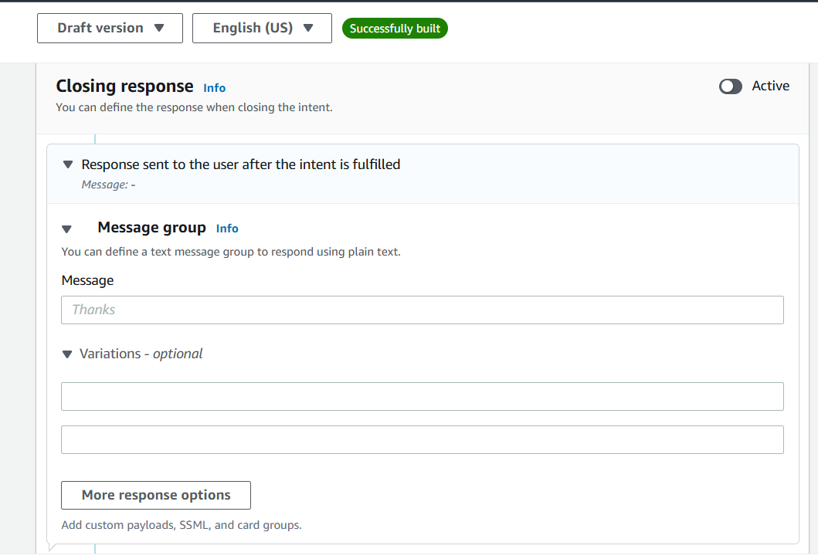
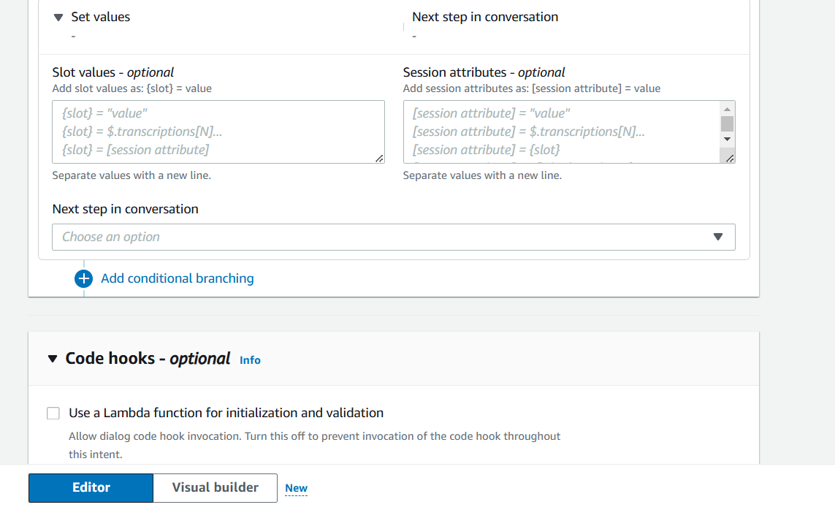
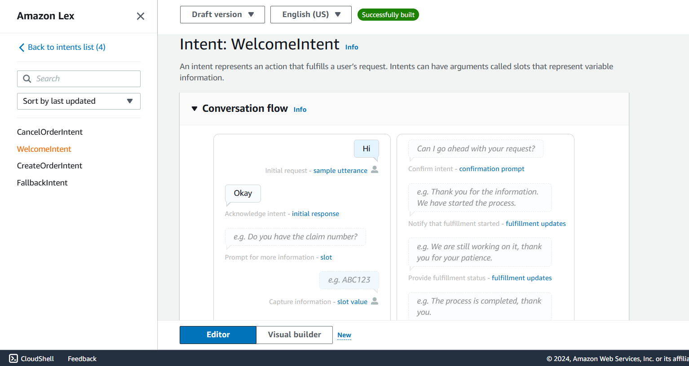
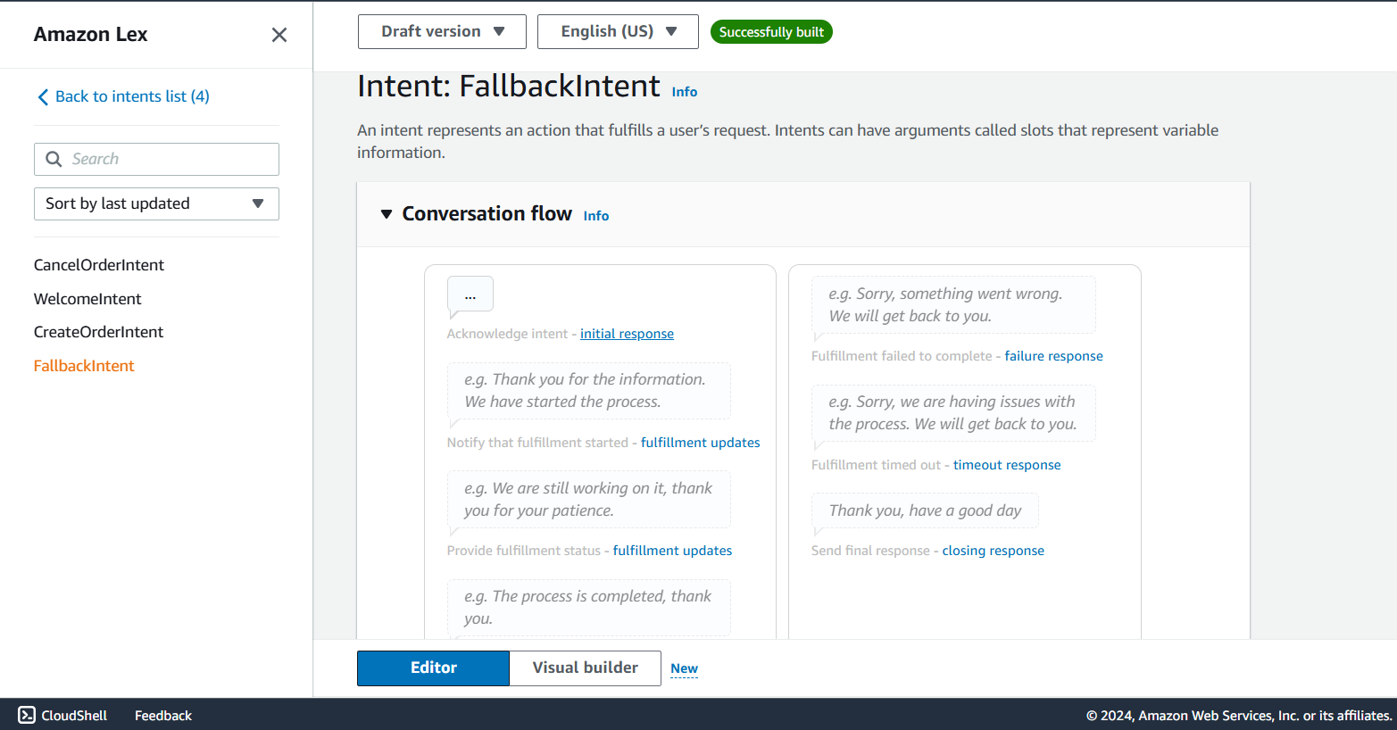

7. FUTURE WORK
For future work on chatbots using Amazon Lex, consider adding multilingual support, user personalization through profile data, and integration with advanced AWS services like Amazon Comprehend for sentiment analysis. Expand omnichannel support to include mobile apps and social media, enhance data privacy and authentication, and incorporate self-learning algorithms for adaptive responses. Implement advanced AI features for improved conversation flow, and optimize scalability using AWS tools like Auto Scaling to manage high user volumes.
8. SUMMARY
We explored the development of intelligent chatbots using Amazon Lex, leveraging its natural language understanding capabilities to create interactive and user-friendly experiences. We outlined the process of designing intents, slots, and fulfillment logic, integrating with AWS services like Lambda for backend processing. The chatbot successfully demonstrated its ability to handle user queries and provide efficient, automated responses. This project showcases the potential of using Amazon Lex for creating scalable and versatile chatbot solutions. Future enhancements could include adding multilingual support, improving personalization, integrating sentiment analysis, and scaling the system for wider user access.

