Cairo University  
Faculty of Computers and Information

**CS251**

**Software Engineering I**

Project Name

Software Design

Team Names

Aya zakaria

Asmaa sabry

Afnan sabry

Nehal tarek

Month & Year

March, 2017

Contents

Team 3

Document Purpose and Audience 3

System Models 3

I. Class diagrams 3

Important Algorithm 5

II. Sequence diagrams 5

Class - Sequence Usage Table 7

Ownership Report 8

Policy Regarding Plagiarism: 8

References 8

# Team

|  |  |  |  |
| --- | --- | --- | --- |
| **ID** | **Name** | **Email** | **Mobile** |
| 2015004 | Aya zakaria | Aya.zakaria2015@gmail.com |  |
| 20145002 | Asmaa sarby | asmaaafnan@hotmail.com |  |
| 20145005 | Afnan sabry | afnansabry@hotmail.com |  |
| 20142016 | Nehal tarek | Nehal_Kontisa@yahoo.com |  |

# Document Purpose and Audience

This document aims to describe the main functions and classes of an educational game through a class diagram and sequence diagram.

**Target audience**

* Developer
* Coder
* Architect

# 

# System Models

## I. Class diagrams

**List down your classes and describe them**

| **Class ID** | **Class Name** | **Description & Responsibility** |
| --- | --- | --- |
| 1 | Person | It's a class for the main attributes for teachers and student such that (Name, password,….etc.) |
| 2 | Account | It's mainly for sign up and sign in operation |
| 3 | Category | It's responsible for holding the categories of the games to make the user choose his game from the category that he is want to |
| 4 | Game | It's mainly for the basic game attributes that will be inherited in both student and teacher accounts |
| 5 | StudentGame | It's an interface for student account with the main functions that will be allowed for the student to do such that (writeComment , rateGame … etc.) |
| 6 | TeacherGame | It's an interface for teacher account with the main functions that will be allowed for the teacher to do such that (creatGame, editGame…etc.) |
| 7 | Database | It's just representation of the model's system and it’s responsible for saving the whole information in the system that will be updated and retrieved according to the other functions in the system |

## 

## II. Sequence diagrams

### Class - Sequence Usage Table

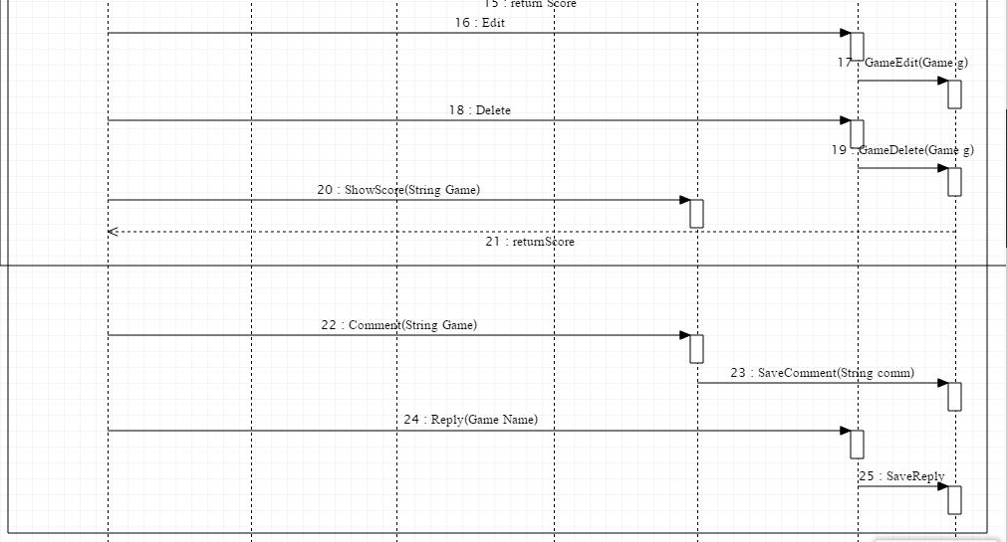

| **Name** | **Sequence Diagrams** | **Overall used methods** |
| --- | --- | --- |
| Account | 1,4 | SignIn(UserName,Password)  SignUp(Account) |
| Game | 13 | Play() |
| TeacherGame | 16,18,24,9 | Edit(Game G)  Delete(Game g)  Reply()  CreateGame(String namegame) |
| StudentGame | 20,22 | ShowScore()  Comment() |
| DataBase | 2,5,7,10,14,17,19,23,25 | Save_Info(Account acc)  Verify(UserName,password)  DisplayGame_in_Category  (String cat)  SaveGame(GameName)  Calculate_Score(String PlayNmae)  GameEdit(Game g)  GameDelete(Game g)  SaveComment(String)  SaveReply() |
| Category | 6 | Choose_Category(String) |

# Ownership Report

|  |  |
| --- | --- |
| **Item** | **Owners** |
| Document purpose and audience | -Aya zakaria  -Asmaa sabry  -Afnan sabry  -Nehal tarek |
| UML diagram | -Aya zakaria  -Asmaa sabry  -Afnan sabry  -Nehal tarek |
| Class diagram table | -Aya zakaria  -Asmaa sabry  -Afnan sabry  -Nehal tarek |
| Sequence diagram | -Aya zakaria  -Asmaa sabry  -Afnan sabry  -Nehal tarek |
| Class - Sequence Usage Table | -Aya zakaria  -Asmaa sabry  -Afnan sabry  -Nehal tarek |